Technologies and Frameworks

The project makes use of following technologies

WEB TOOLKIT (Wt)

Widget centric library that abstracts protocols like HTTP, Ajax and WebSockets and integrates with C++ applications and libraries. The Web Toolkit (Wt) library comes with an application server that acts as a stand-alone Http(s)/WebSocket server or integrates through FastCGI with other web servers.

C++ REST SDK (Casablanca)

The C++ REST SDK enables you to write C++ programs that produce and consume REST services. It takes advantage of the new set of capabilities introduced in C++11 and simplify http based coding with a modern and high performance asynchronous API.

PARALLEL PATTERNS LIBRARY (PPL)

For developing concurrent applications with a layer of abstraction between your application code and the underlying threading mechanism. The PPL is heavily used by the C++ REST SDK.

MySQL C++ CONNECTOR

For interfacing and communicating with the MySQL relational database server.

The project makes use of C++11 features

The project is built on the foundation of the new C++11 language features and makes use of the standard library and new language constructs. The Boost library is also used as a complement to write clean and efficient code.

N-Tier Architecture Design

The project makes use of a 3-Tier design

CLIENT

Responsible for displaying the Web user interface. It makes requests to the service based on user actions. Those requests are performed using the REpresentational State Transfer (REST) to communicate with the service. The client self-hosts a fully functional web server.

SERVICE

Responsible for handling client requests and returning JSON data. It communicates with the SQL database through a data access layer that queries and retrieves information.

DATABASE

Responsible for holding and querying data requested by the service. The data retrieved is relational data in the form of record sets and is returned to the service as JSON objects.

Components and Code Implementation

Description and break down of client and service class design

PROJECT RESTfullClient CLASS DIAGRAM

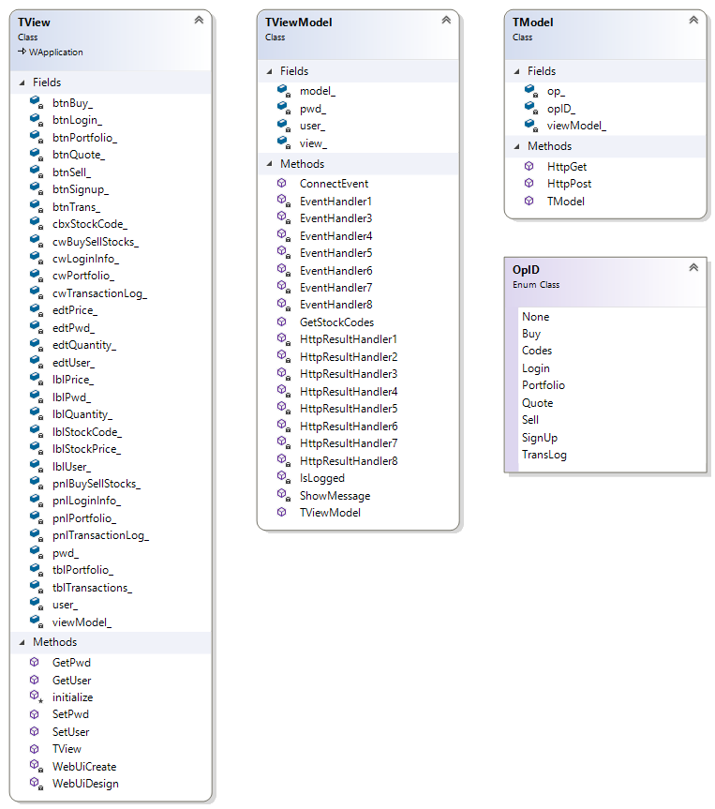

The RESTfullClient project is based on the Model View View-Model (MVVM) design pattern.

The MVVM is a software pattern used by the RESTfullClient project to facilitate the separation between the graphical user interface and the development of the back end logic.

TView Class

This class renders the user interface to the web browser and dispatches user requests to the view-model. It’s derived from the Wt::WApplication class and is responsible for running the message loop of the application and encapsulates the self-contained http web server.

The fields in the TView class represent the user interface elements in the rendered web page. They hold references to those elements and facilitate the manipulation of such elements inside the code.

The viewModel_ private field holds an instance of the TViewModel class and connects its buttons events to the view-model for handling.

The initialize method is called after the class construction and asks the view-model to populate the stock codes combo box via the view-model GetStockCodes method.

The TView class also holds fields for storing and retrieving the user name and password of the logged user for the current session. The family of functions GetUser, SetUser, GetPwd and SetPwd are the getters and setters responsible for that action.

TViewModel Class

This class is responsible for displaying information for the view and communicating to the model.
The TViewModel class main roles are:

- Handling user interface actions generated by the view: For example, the click of the portfolio’s button.
- Requesting data from the model and parsing the JSON returned data. For example: displaying portfolio’s data in the view.

It has access to the view via its view_ field, and it has access to the model via its model_ field.

The ConnectEvent method is called by the view to stablish the connection between the view buttons and the EventHandlerXX family of event handlers.

The EventHandlerXX methods handle the buttons click generated at the view requesting data from the model. The TViewModel class instance invokes the HttpGet and HttpPost methods of the model to requests data asynchronously.

The HttpResultHandlerXX methods are called at the end of an asynchronous call originated by the EventHandlerXX methods and parse the JSON data returned by the model to display it for the view.

TModel Class

This class receives the requests generated by the view-model and make asynchronous REST requests to the wIQserver_mt service. The JSON data received is dispatched back to view-model.

It has access to the view-model via its modelView_ field.

The HttpGet and HttPost methods handle the REST requests. They use the supplied operation identifier (OpID enum class type) as the key to retrieve the callback function from the operations map op_ field.

After retrieving the callback function from the operations map, the retrieved function is invoked sending back the JSON data.

PROJECT wIQserver_mt CLASS DIAGRAM

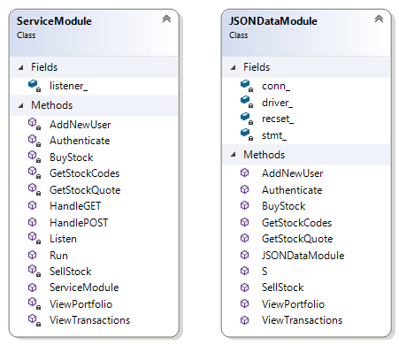

ServiceModule Class

This class represents the REST service and is responsible for accepting client requests and sending back responses.

When the application starts an instance of the ServiceModule class is created and its Run method is invoked.
At Run’s method execution is starts listening for client requests and suspends the main thread.

The client requests are received at the Listen method and it only handles http GET and POST, it does not handle other verbs. After the request is received it is dispatched to the callback method handler HandleGET or HandlePOST.

The HandleGET and HandlePOST methods validate the Uri endpoint and its parameters. After validation the associate business logic method is invoked.

The ServiceModule class publishes the business logic interface that will be consumed by the REST clients.

The public methods:

- AddNewUser
- Authenticate
- BuyStock
- GetStockCodes
- GetStockQuote
- SellStock
- ViewPortfolio
- ViewTransactions

compose the business logic interface and are associated with REST endpoints.

The published methods do not handle the business logic directly but instead they forward the call to an instance method of the JSONDataModule class that has the same method name of the ServiceModule class method.

JSONDataModule Class

This class is responsible for the relational data retrieval and holds the infra-structure for communicating with the database. It opens a connection to the database in its constructor and closes it in the destructor.

The JSONDataModule class methods:

- AddNewUser
- Authenticate
- BuyStock
- GetStockCodes
- GetStockQuote
- SellStock
- ViewPortfolio
- ViewTransactions

implements the business logic methods that return JSON data
.
Those methods have the same methods name exposed by the ServiceModule class.

The private method S is responsible for easing the conversion between SQL string types and the standard wide string type.

