Technologies and Frameworks

The project makes use of following technologies

WEB TOOLKIT (Wt)

Widget centric library that abstracts protocols like HTTP, Ajax and WebSockets which also integrates with existing C++ libraries, as for example, for scientific or engineering applications.

C++ REST SDK (Casablanca)

A library for cloud-based client-server communication in native C++ code using a modern asynchronous C++ API design for high performance.

PARALLEL PATTERNS LIBRARY (PPL)

For developing concurrent applications with a layer of abstraction between your application code and the underlying threading mechanism.

MySQL C++ CONNECTOR

For interfacing and communicating with the MySQL relational database server.

The project makes use of C++11 features

The project is built on the foundation of the new C++11 language features and makes heavy use of the new standard library and language constructs like lambdas.

N-Tier Architecture Design

The project makes use of a 3-Tier design

CLIENT

Responsible for displaying the Web user interface. It makes requests to the service based on user actions. Those requests are performed using the REpresentational State Transfer (REST) to communicate with the service. The client self-hosts a fully functional web server.

SERVICE

Responsible for handling client requests and returning JSON records. It communicates with the SQL database through a data access layer that queries and retrieves information.

DATABASE

Responsible for holding and querying data requested by the service. The data returned to the service is relational data in the form of record sets.

Components and Code Implementation

Description and break down of client and service class design

PROJECT RESTfullClient CLASS DIAGRAM

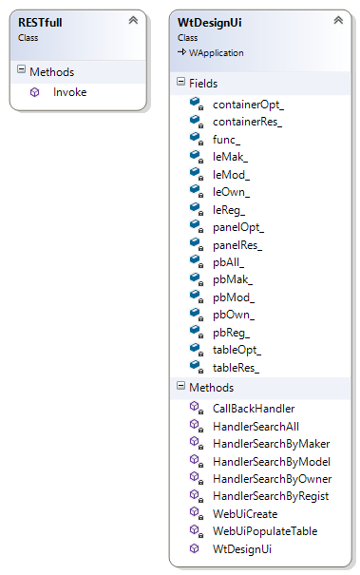

WtDesignUI Class

This class renders the user interface to the web browser and handles user requests. It uses the PME (Properties, Methods and Events) paradigm. It derives from Wt::WApplication and is responsible for running the message loop of the application and encapsulates the self-contained http web server.

The fields (or properties) in the class are associated with the UI elements in the rendered web page. They hold references to those elements and facilitate the manipulation of such elements inside the code.

The HandlerSerachXXX family of methods is responsible for handling the user request. These methods handle the events generated by UI elements such as the click of a button or the enter key press inside a text box.

When handling the events the class RESTfull is instantiated to communicate with the service. After asynchronously receiving the reply from the service it calls back on the method CallBackHandler.

The CallBackHandler method retrieves the JSON data and forwards it to the method WebUiPopulateTable.

The WebUiPopulateTable method iterates through the received data and update the UI to reflect it.

PROJECT RESTfullService CLASS DIAGRAM

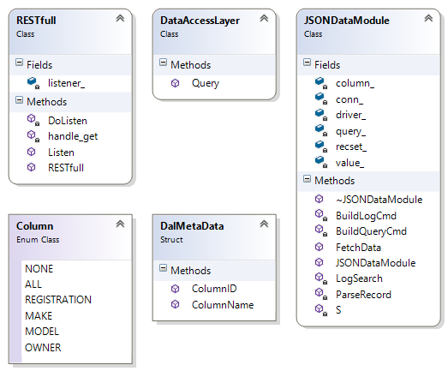

RESTfull Class

This class is the backbone of the service and is responsible for accepting client requests. It listens for client requests in an asynchronous task and suspends the main thread.

The client requests are received by the RESTfull::Listen method. After the request is received it is dispatched to the callback method RESTfull::handle_get. It only handles http GET, it does not implement other verbs.

The RESTfull::handle_get method verifies the integrity of the parameters received by validating the Uri endpoint and checking for empty values. After that it instantiate a DataAccessLayer object that will retrieve the data.

DataAccessLayer Class

This class is responsible for forwarding the query received by RESTfull::handle_get. It functions as a proxy to the data module that process data retrieval.

Its only method is DataAccessLayer::Query that instantiate a JSONDataModule object to retrieve JSON data.

JSONDataModule Class

This class is responsible for the relational data retrieval and holds the infra-structure for communicating with the database. It opens a connection to the database in its constructor and closes it in the destructor.

The JSONDataModule::FetchData is where the query happens. It builds the query statement by calling the JSONDataModule::BuildQueryCmd, executes the query and parses the record set into a JSON object.

After performing the query it logs the search via a call to the JSONDataModule::LogSearch method. The JSONDataModule::BuildLogCmd method builds the statement for inserting the searched values into the database search log table.

DalMetaData Class

This class is responsible for translating between REST endpoints and table columns.
When the client makes a request it chooses which column to search for and the name of the column acts like the REST endpoint to be used.

The DalMetaData::ColumnID receives a string column name and returns an enumeration representing the endpoint.

The DalMetaData::ColumnName receives an enumeration representing the endpoint and returns a string representing the column name.

Column Enum Class

This class abstracts between REST endpoints and the database columns of the search table.

