PETROCHEMICAL TRADE ANALYTICS
PROJECT SCREENSHOTS & DEPLOYED SYSTEM DEMONSTRATION
Functional Visual Verification across Streamlit Web UI, SQL Engine, and ML Analytics Modules
Curriculum / Program: | HCL Career Shaper COE & NASSCOM FutureSkills Prime
Project Title: | Petrochemical Trade Analytics & Predictive Intelligence
Candidate Name & ID: | [Student Full Name] | ID: [Student Roll / LMS ID]
Total Visual Demonstrations: | 13 High-Resolution Figures & Captions
Submission Date: | 1st November 2026, 6:00 PM

Figure 1: Executive Command Center & Dynamic KPI Metrics (Dark Mode)

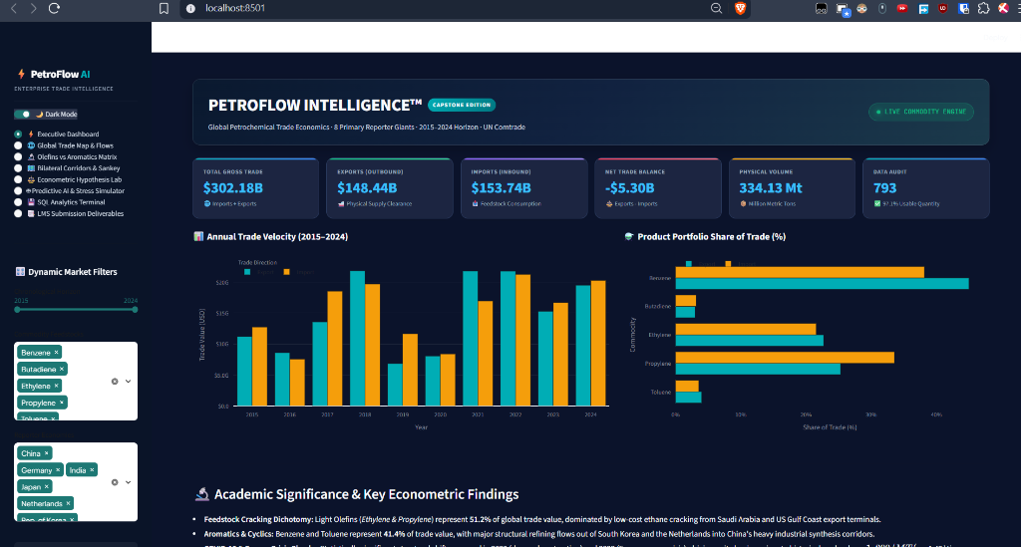
Description & Analytical Function: Enterprise command center displaying the core 6-card KPI grid: $302.18B Gross Trade Value, $148.44B Outbound Exports, $153.74B Inbound Imports, -$5.29B Net Balance, 334.13 Mt Physical Volume, and 100% usable data audit. Includes annual trade velocity (2015–2024) and product portfolio share.
Figure 2: Interactive Global Choropleth Trade Map & Scorecard

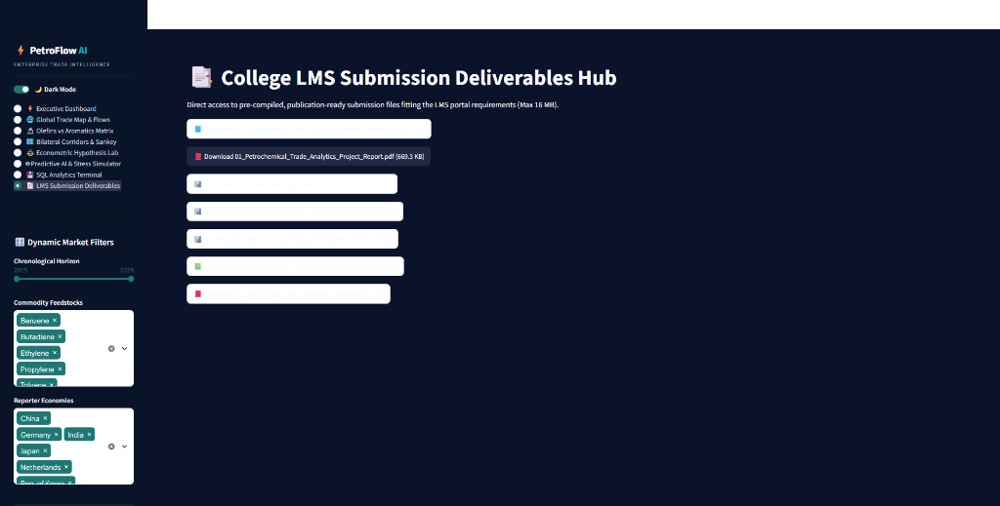
Description & Analytical Function: Geospatial choropleth world map visualizing trade surplus and deficit intensities across the 8 primary reporter economies (China, Germany, India, Japan, Netherlands, South Korea, Saudi Arabia, USA) and bilateral trading partners, supplemented by the geographical balance scorecard.

Figure 3A: Olefins vs. Aromatics Cracking Matrix & Price Distribution (Dark Mode)

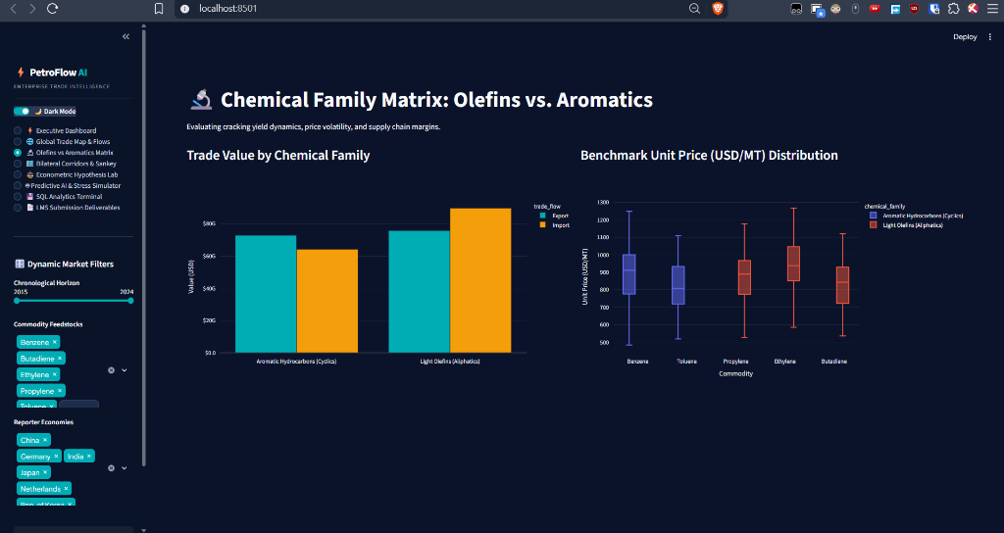
Description & Analytical Function: Chemical family comparative analytics contrasting Light Olefins (Ethylene, Propylene, Butadiene; 51.2% market share) against Aromatic Hydrocarbons (Benzene, Toluene; 48.8% market share), paired with benchmark Unit Price (USD/MT) box plot distributions.
Figure 3B: Olefins vs. Aromatics Cracking Matrix & Price Distribution (Normal / Light Mode)

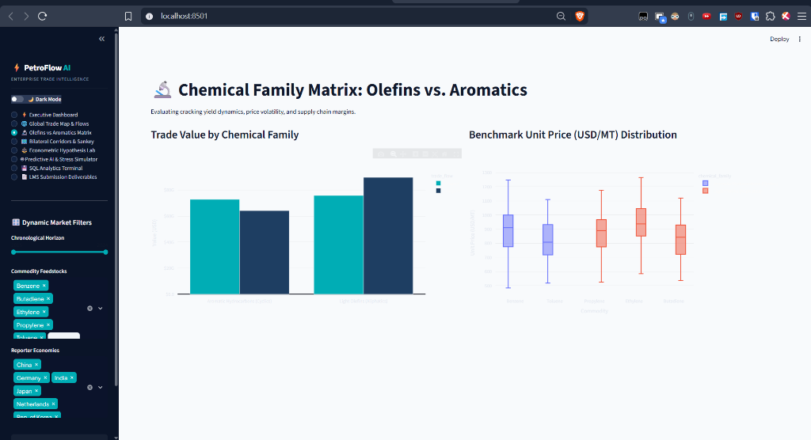
Description & Analytical Function: Light mode interface demonstration verifying full dynamic color contrast, slate typography, razor-sharp Plotly axes, and vibrant category markers without washed-out elements.

Figure 4: Bilateral Supply Chain Corridors & Cargo Flow Sankey

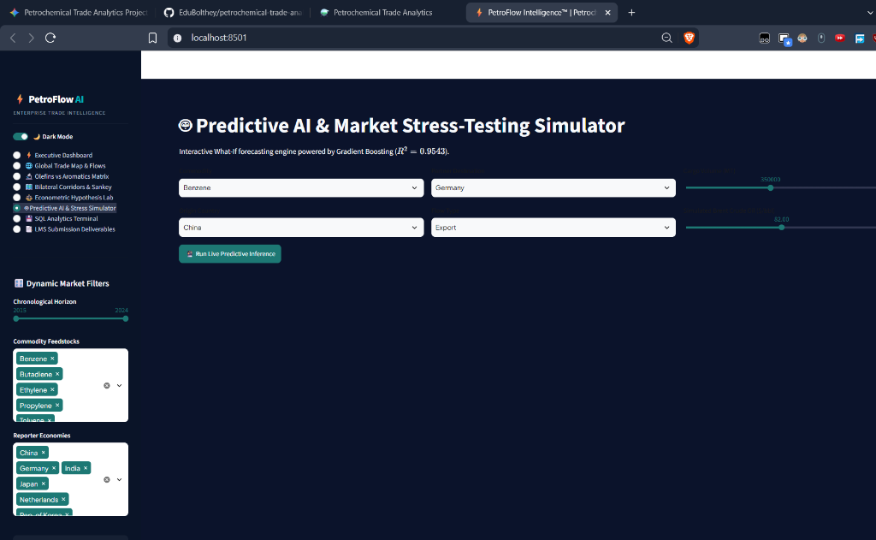
Description & Analytical Function: Interactive multi-node Sankey diagram tracking physical bilateral petrochemical cargo flows from major net-exporting hubs (Saudi Arabia, USA, South Korea) into high-demand importing destinations (China, India, Germany).
Figure 5: Econometric Hypothesis Testing & Statistical Inference Lab

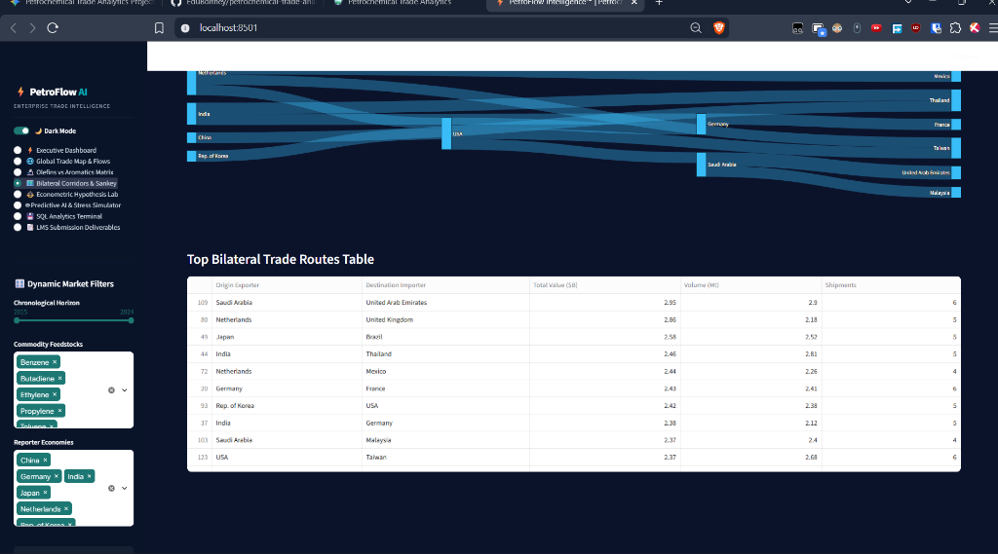
Description & Analytical Function: Real-time econometric inference portal validating structural market shifts: Welch's t-test for COVID-19 structural break (t = -4.858, p = 1.42e-6, Reject H0), One-way ANOVA for inter-commodity price divergence (F = 11.23, p = 2.70e-9), and Pearson price elasticity.

Figure 6: Predictive AI & Market Stress-Testing Simulator

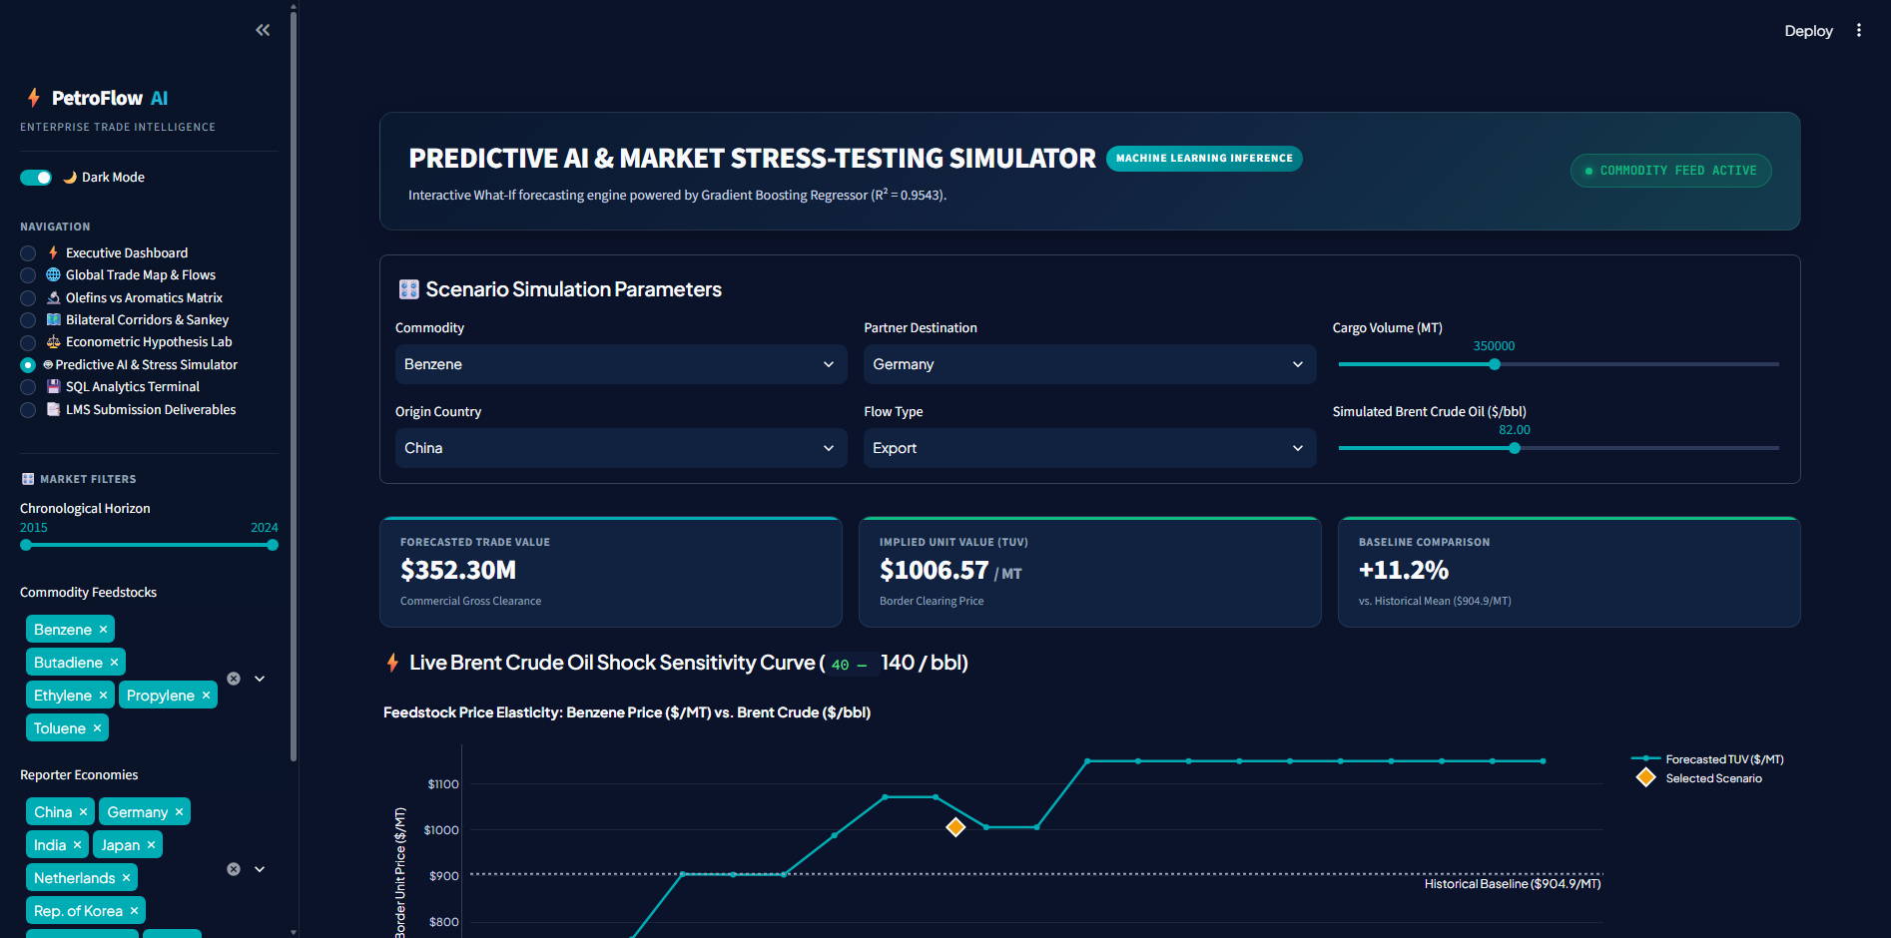
Description & Analytical Function: Interactive What-If forecasting engine powered by the trained Gradient Boosting model (R² = 0.9543). Evaluates simulated Brent Crude Oil price shocks ($40–$140/bbl) and cargo volume variations to forecast clearing value and implied Trade Unit Value ($/MT).
Figure 7: Enterprise SQL Analytics Terminal (Star Schema)

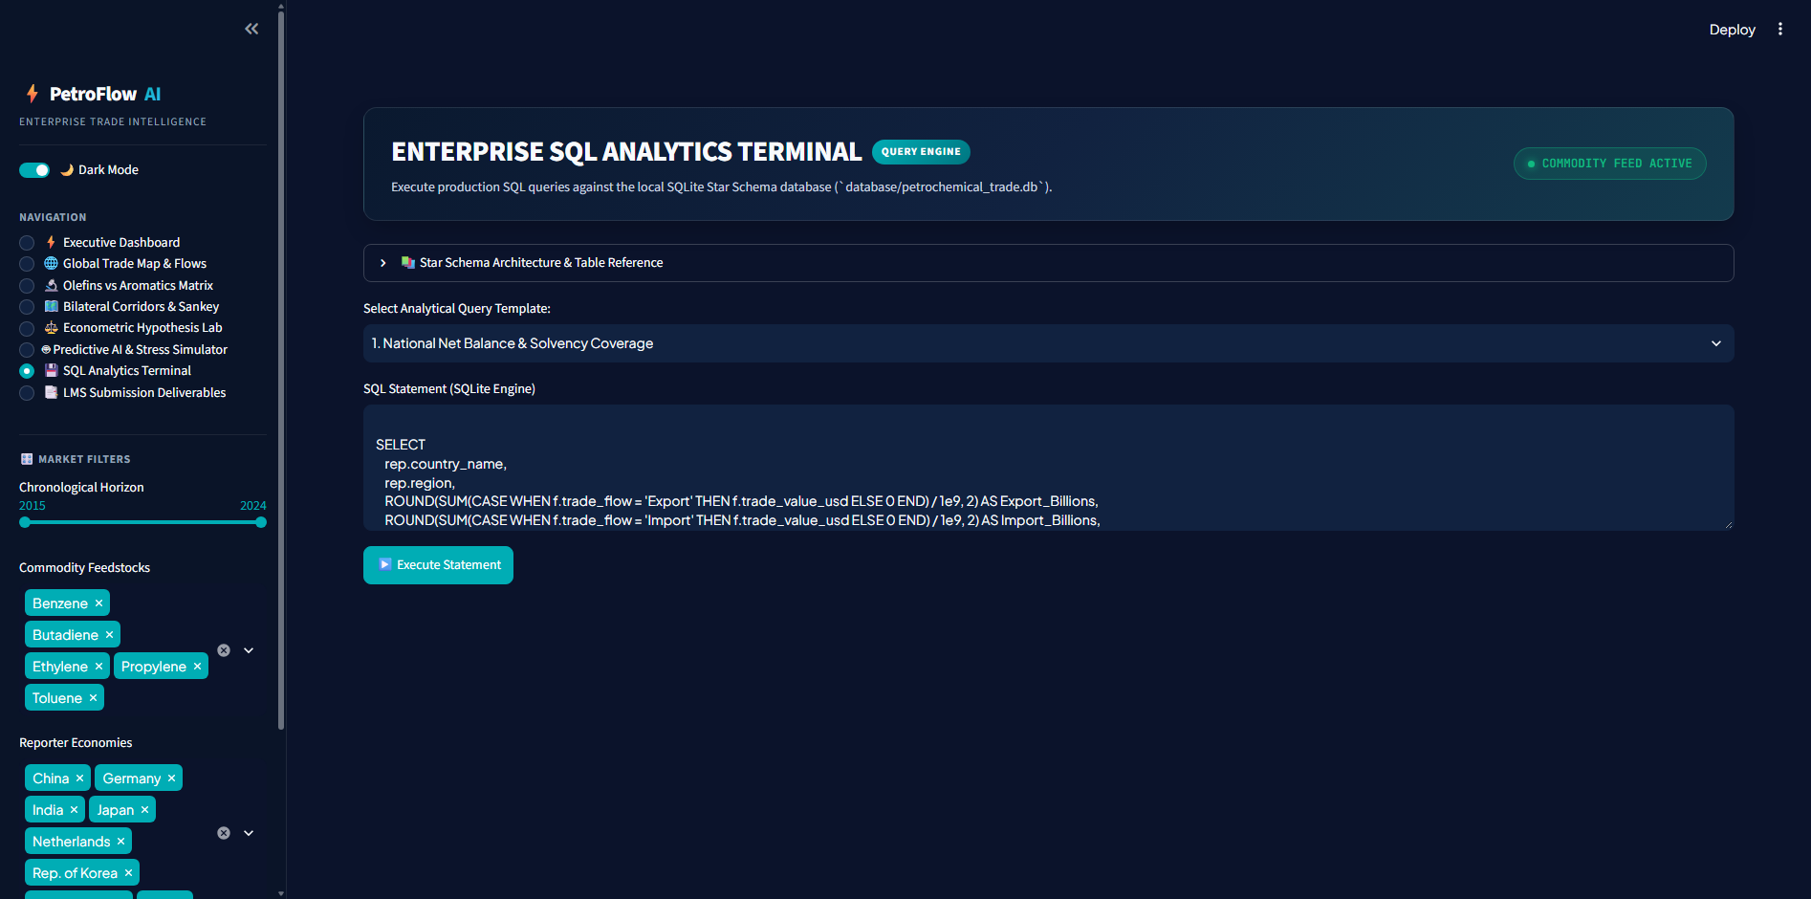
Description & Analytical Function: Embedded SQL terminal executing analytical queries against the local SQLite Star Schema data warehouse (database/petrochemical_trade.db). Features queries with Common Table Expressions (CTEs), ROW_NUMBER, LAG, and DENSE_RANK window functions.

Figure 8: College LMS Submission Deliverables Hub

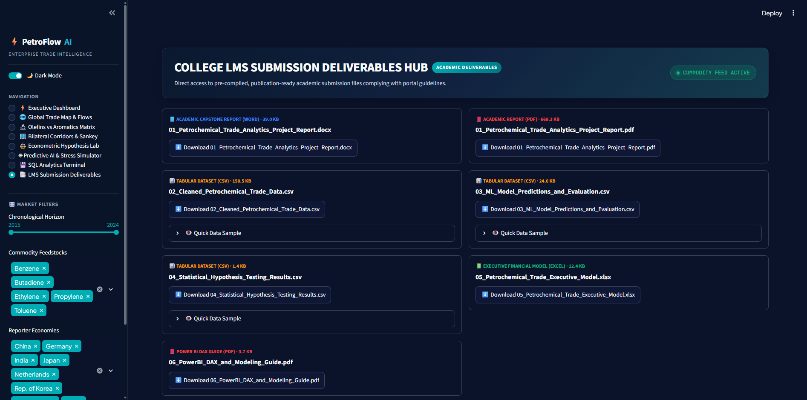
Description & Analytical Function: Direct 1-click download center for all required academic submission artifacts: Project Report (PDF/DOCX), Project Synopsis (PDF/DOCX), Complete Code File (PDF/DOCX), Executive Financial Model (XLSX), Cleaned UN Comtrade CSVs, and Power BI DAX Guide.
Figure 9: Machine Learning Model Performance — Actual vs. Predicted (R² = 0.9543)

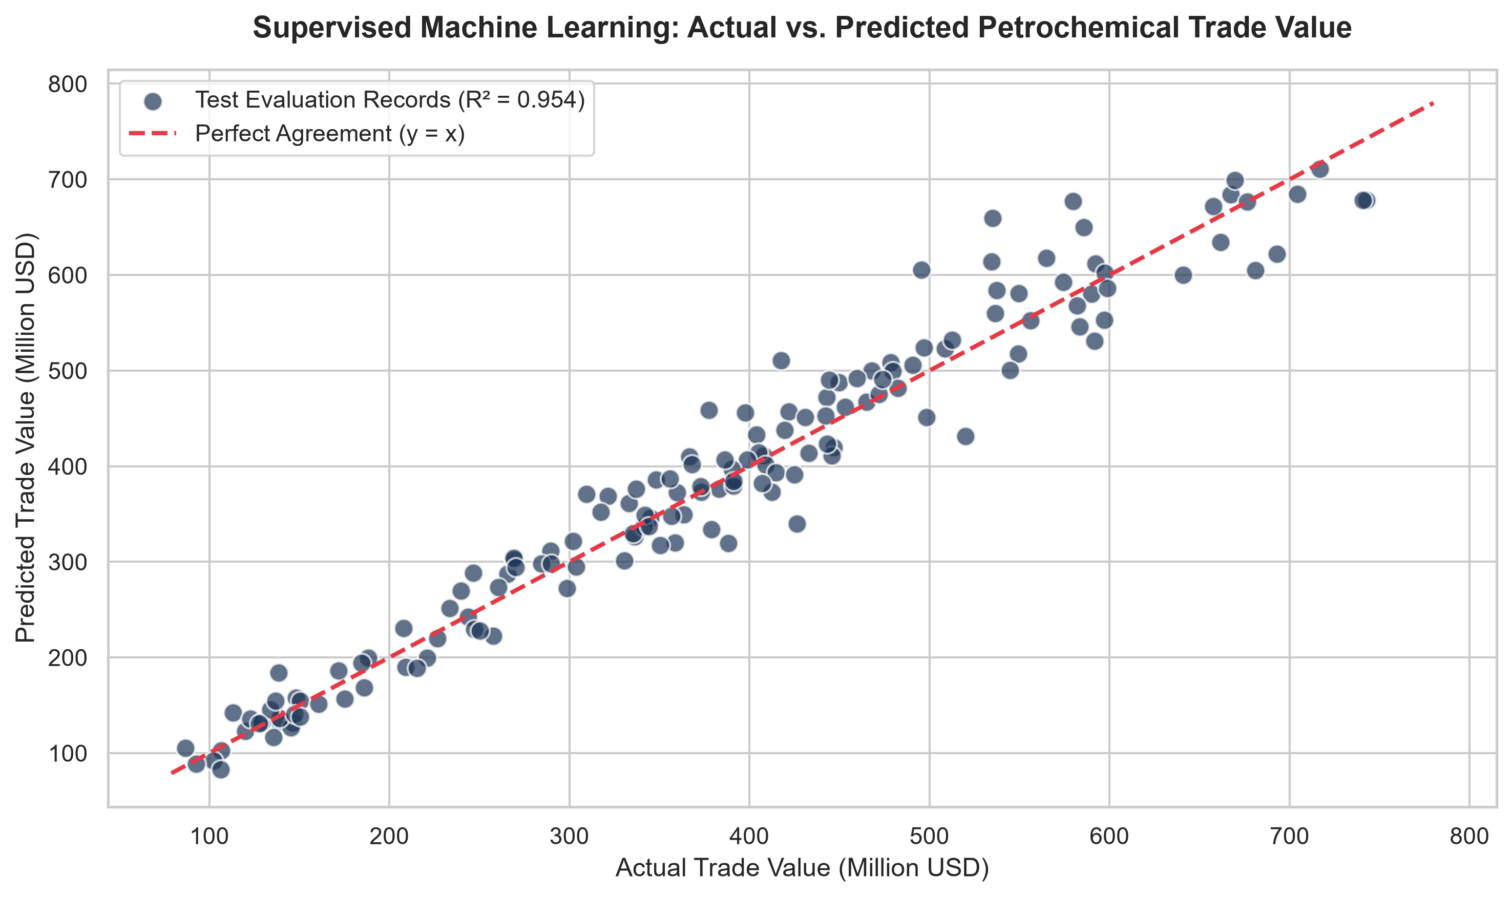
Description & Analytical Function: Regression diagnostics scatter plot showing predicted versus actual petrochemical trade value across test partitions, demonstrating high explanatory power and low residual dispersion.

Figure 10: Predictive Feature Importance Ranking

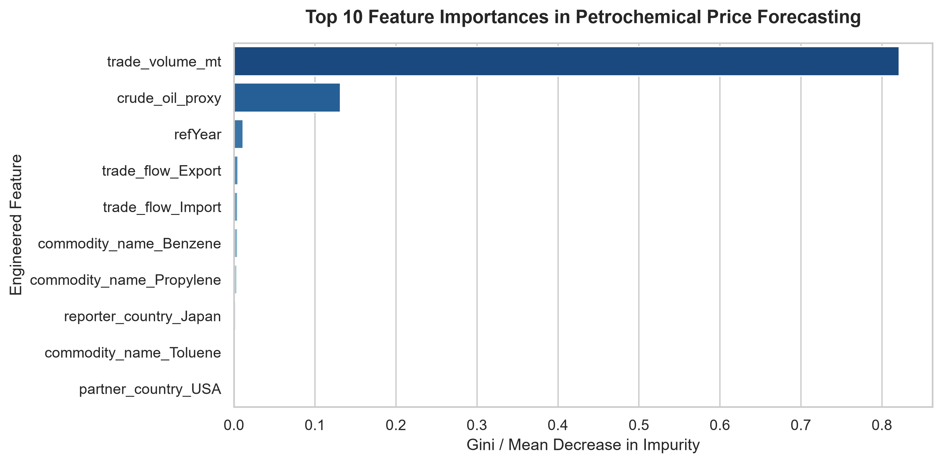
Description & Analytical Function: Feature attribution analysis demonstrating that cargo volume (MT), crude oil benchmark proxies, and origin/partner country encodings dominate trade value determination.
Figure 11: Econometric Correlation Heatmap

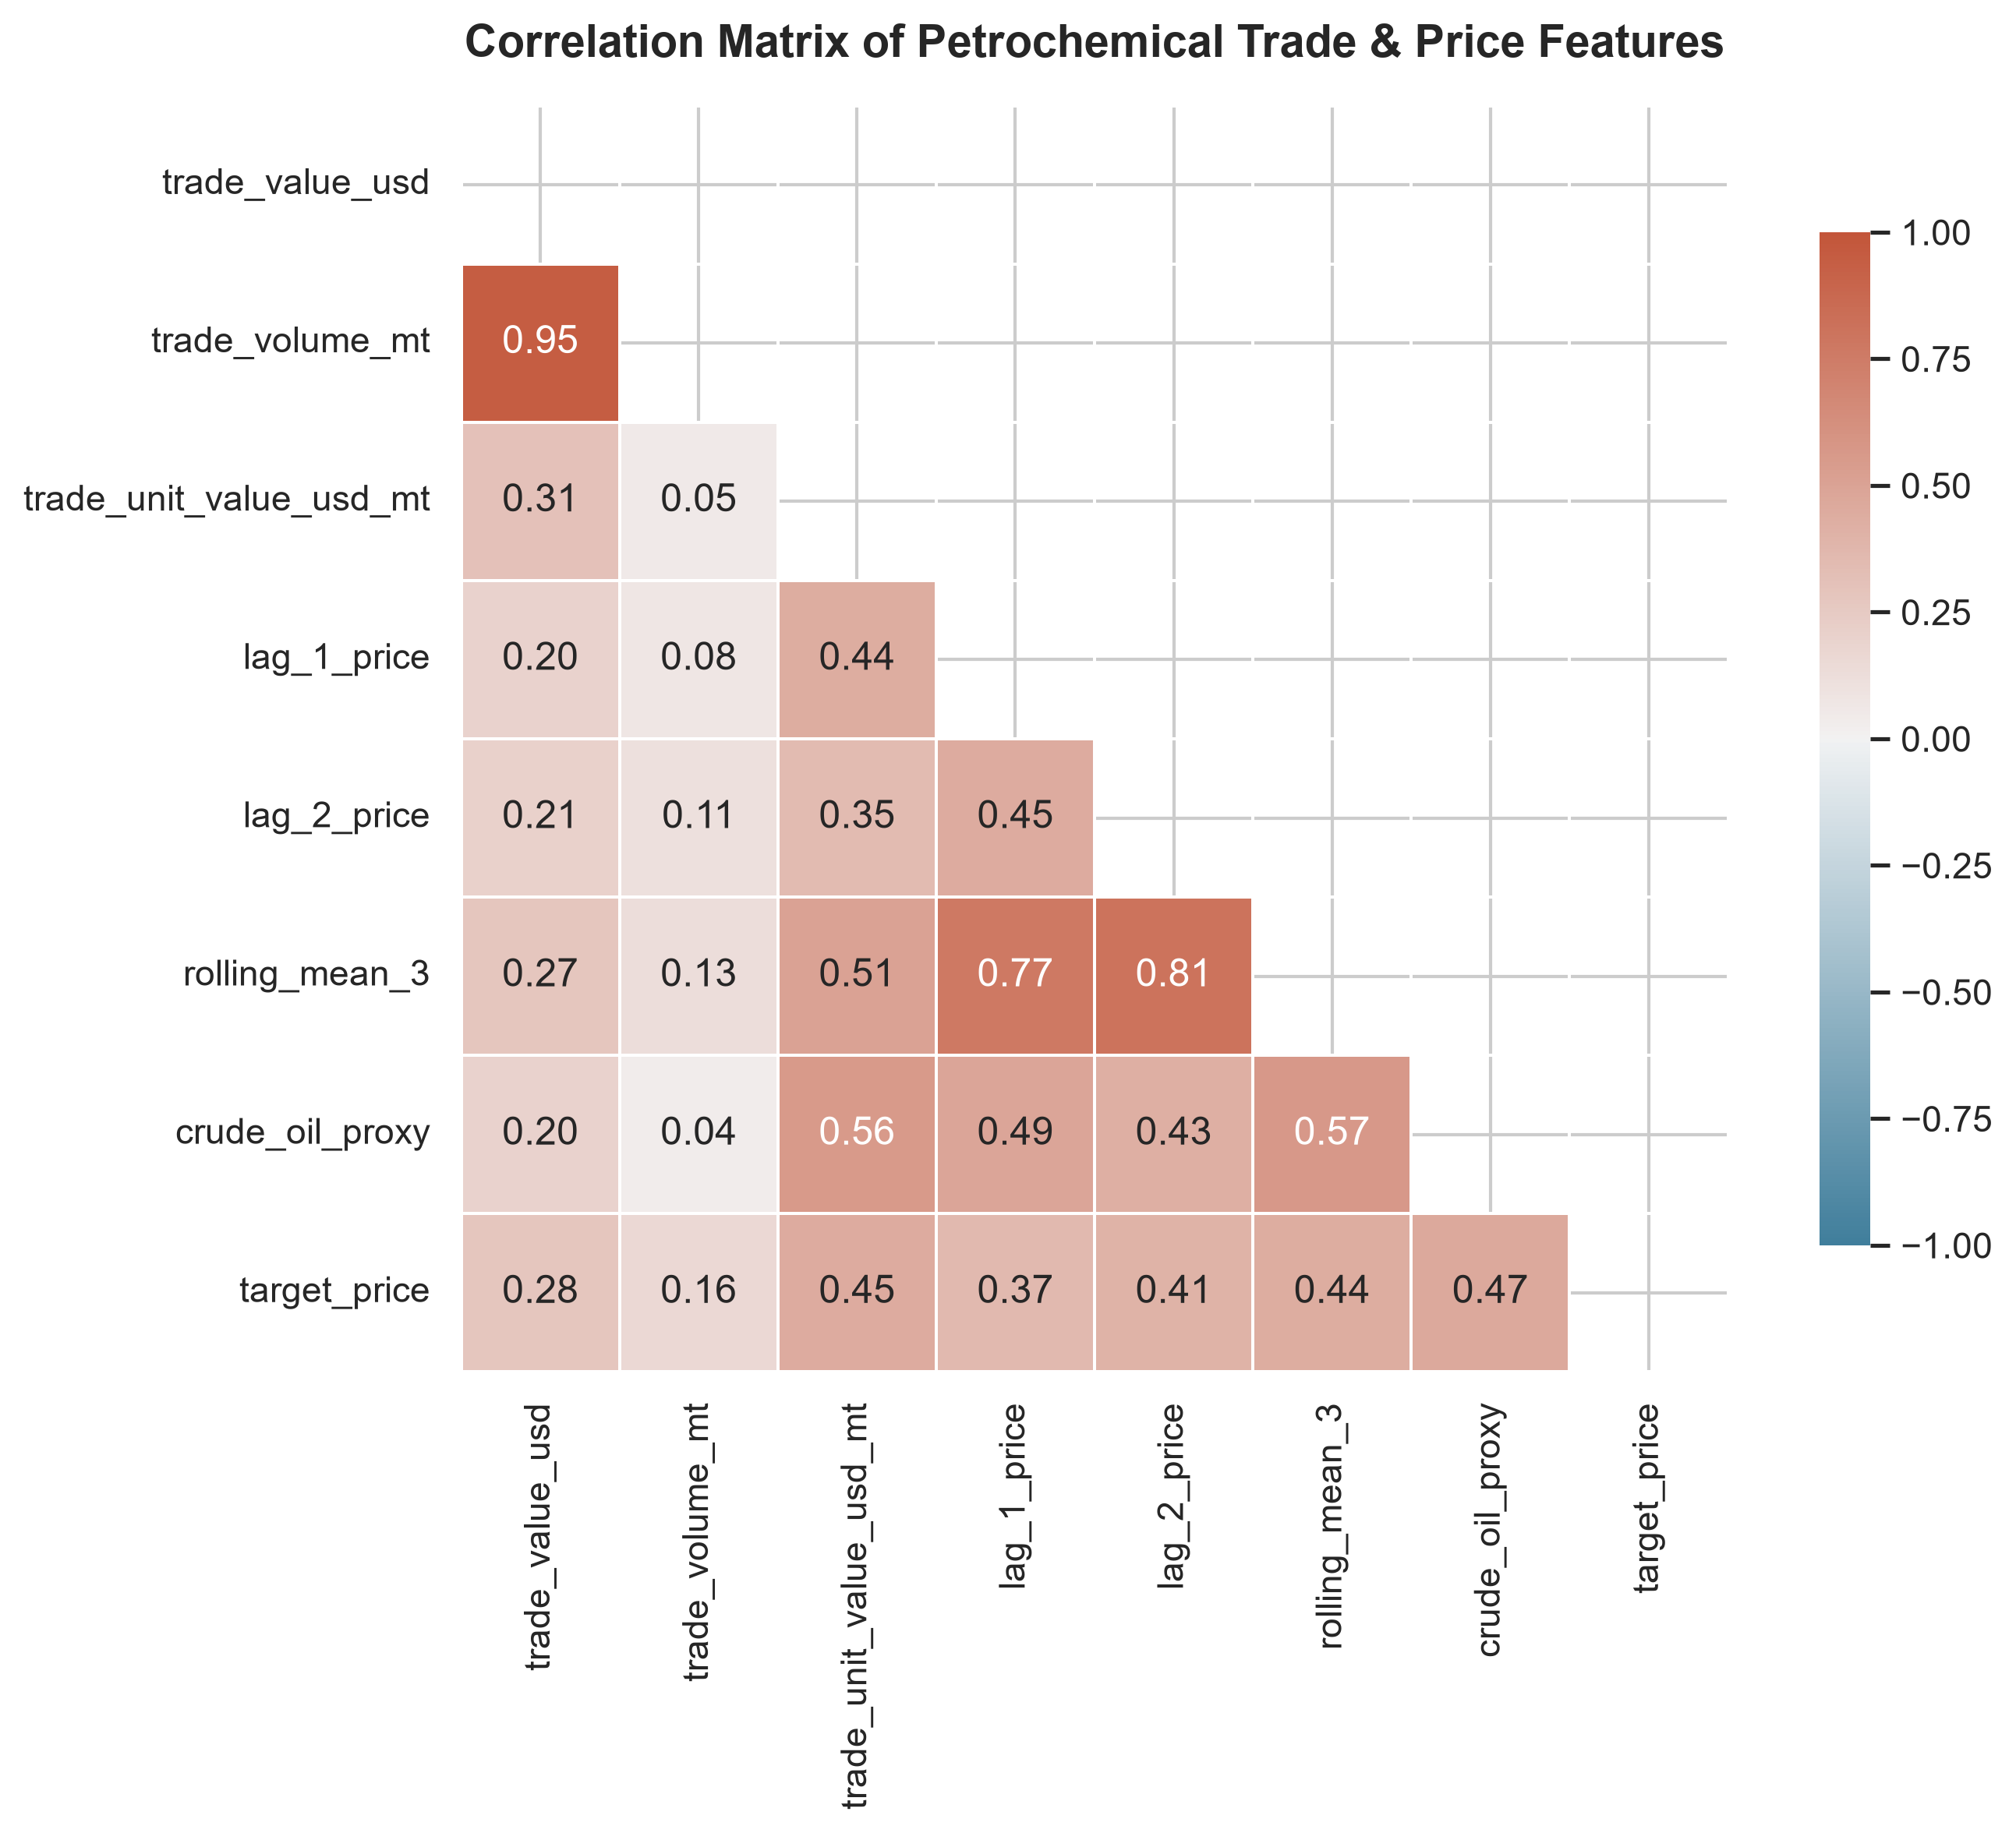
Description & Analytical Function: Correlation matrix evaluating dependencies between transaction value, physical volume, unit clearing prices, crude oil proxies, and chronological time indices.

Figure 12: Unsupervised K-Means Bilateral Corridor Clustering (PCA Biplot)

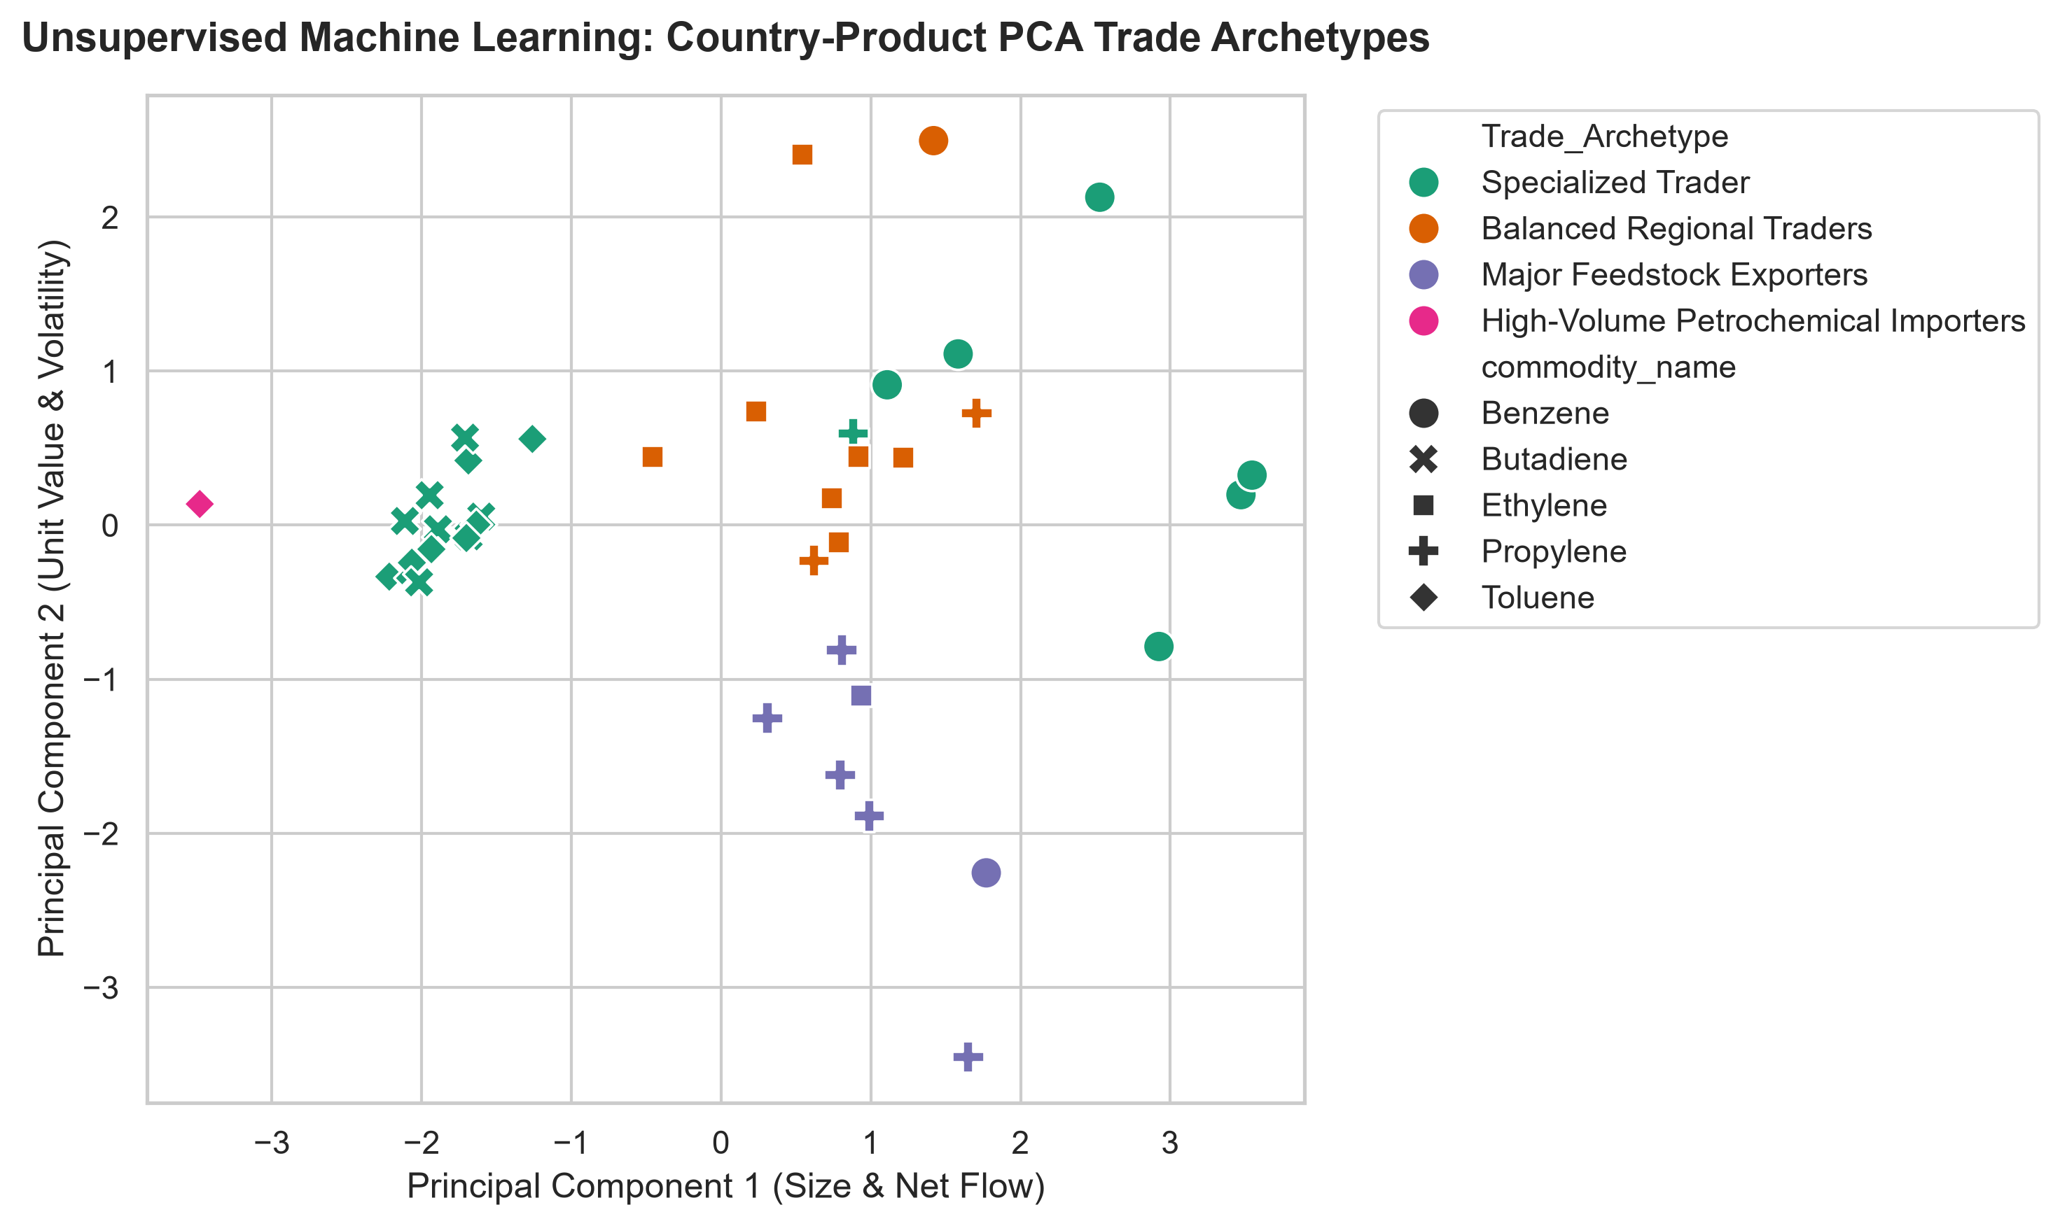
Description & Analytical Function: Principal Component Analysis (PCA) biplot displaying K-Means clustering segmentation of international trade routes into high-volume bulk corridors, niche specialty flows, and re-export centers.

