**DigiPic: A DIGITAL PHOTOGRAPHY E- LEARNING SYSTEM**

**FOR LPU CAVITE**

An Undergraduate Thesis

Submitted to the Faculty of the

College of Engineering, Computer Studies and Architecture

Lyceum of the Philippines University-Cavite

In Partial Fulfillment

of the Requirements for the Degree of

Bachelor of Science in Information Technology

with specialization in Web and Mobile Technology

**JUSTINE PAUL C. CANLAS**

**KIAN LOYD A. GAJO**

**SHAWN ADRIAN T. MIGUEL**

**NIÑO LLOYD A. MOQUIRING**

August 2026

# 

# ACCESS LEAF

**Bachelor of Science in Information Technology**

**with Specialization in Web and Mobile Technology**

**JUSTINE PAUL C. CANLAS**

**KIAN LOYD A. GAJO**

**SHAWN ADRIAN P. MIGUEL**

**NIÑO LLOYD A. MOQUIRING**

**DigiPic: A DIGITAL PHOTOGRAPHY E- LEARNING SYSTEM**

**FOR LPU CAVITE**

**JOVEN B. CAJIGAS**

Research Adviser

Date: ______________

|  |  |
| --- | --- |
| **This thesis can be made available to the general public** | **YES or NO** |
| This thesis can be accessed only after consultation with the author/s and thesis **adviser** | **YES or NO** |
| **This thesis can be accessed only by those bound by confidentiality agreement** | **YES or NO** |

**___________________** **___________________**

**JUSTINE PAUL CANLAS KIAN LOYD A. GAJO**

**______________________**  **_______________________**

**SHAWN ADRIAN P. MIGUEL NIÑO LLOYD A. MOQUIRING**

**_______________________**

**JOVEN B. CAJIGAS**

# ACCEPTANCE SHEET

This thesis entitled **DigiPic: A DIGITAL PHOTOGRAPHY E-LEARNING SYSTEM FOR LPU CAVITE** prepared and submitted by **JUSTINE PAUL C. CANLAS, KIAN LOYD A. GAJO, SHAWN ADRIAN T. MIGUEL**, **NIÑO LLOYD A. MOQUIRING,** in partial fulfillment of the requirements for the degree of **BACHELOR OF SCIENCE IN INFORMATION TECHNOLOGY WITH SPECIALIZATION IN WEB AND MOBILE TECHNOLOGY** is hereby accepted.

**JOVEN B. CAJIGAS**

Research Adviser

**_______________________**

Date Signed

Accepted in partial fulfillment of the requirements for the degree of **BACHELOR OF SCIENCE IN INFORMATION TECHNOLOGY WITH SPECIALIZATION IN WEB AND MOBILE TECHNOLOGY.**

**ARNEL M. AVELINO, PhD**

Dean, College of Engineering, Computer Studies, and Architecture

**_______________________**

Date Signed

**MARK** IRVIN C.CELIS**, DBA**

Vice President for Academic Affairs

**_______________________**

Date Signed

# AUTHOR PERMISSION STATEMENT

Title of work: DigiPic: A Digital Photography E-Learning System for LPU Cavite

We hereby grant the LPU-Cavite Academic Resource Center a non-exclusive, worldwide, royalty free license to reproduce, upload, and disseminate this work in whatever form subject to the provisions of applicable laws, the provision of the LPU IPR policy and in any contractual obligations.

Furthermore, I also would like to grant the following rights to LPU-Cavite Academic Resource Center:

* To allow the LPU-Cavite Academic Resource Center to share/provide the work to the requesting party for the purpose of teaching, research and/or personal study either in print or electronic/digital format.
* To give open access to the above-mentioned work, thus allowing “fair-use” of the work in accordance with the provisions of the IPC of the Philippines (Republic Act No. 8293), especially for teaching, scholarly and research purposes.
* To allow LPU Constituents only to have access to the above-mentioned work.

**JUSTINE PAUL C. CANLAS**

**KIAN LOYD A. GAJO**

**SHAWN ADRIAN P. MIGUEL**

**NIÑO LLOYD A. MOQUIRING**

AUGUST 2025

# CERTIFICATE OF ORIGINALITY

Title of work: DigiPic: A Digital Photography E-Learning System for LPU Cavite

We hereby declare that this thesis is our own work and that, to the best of our knowledge and belief, contains no material previously published or written by another person nor material to which to a substantial extent has been accepted for award of any other degree or diploma of a university or other institute of higher learning, except where due acknowledgment is made in the text.

We also declare that the intellectual content of this thesis is the product of our work, even though we may have received assistance from others on style, presentation, and language expression.

**______________________** ____**___________________**

**JUSTINE PAUL CANLAS KIAN LOYD C. GAJO**

**______________________**  **_______________________**

**SHAWN ADRIAN P. MIGUEL NIÑO LLOYD A. MOQUIRING**

Attested by:

**_______________________**

**JOVEN B. CAJIGAS**

Research Adviser

Noted by:

Dean, College of Information and Computer Science

**_______________________**

Date Signed

# ACKNOWLEDGMENT

We are extremely grateful to all those who have supported and contributed to the completion of this capstone project that marks a significant milestone in my academic journey. Allow me to thank a few people who made this success possible.

**JUSTINE PAUL C. CANLAS**

**KIAN LOYD A. GAJO**

**SHAWN ADRIAN P. MIGUEL**

**NIÑO LLOYD A. MOQUIRING**

# TABLE OF CONTENTS

|  |  |
| --- | --- |
|  | **PAGE** |
| Title Page | i |
| Access Leaf | ii |
| Acceptance Sheet | iii |
| Author Permission Statement | iv |
| Certificate of Originality | v |
| Acknowledgment | vi |
| Table of Contents | vii |
| List of Tables | viii |
| List of Figures | ix |
| List of Appendices | x |
|  |  |
| **CHAPTER I: INTRODUCTION** | |
| Background and Rationale of the Study | 1 |
| Objectives of the Study | 2 |
| Significance of the Study | 4 |
| Scope and Limitation | 5 |
|  |  |
| **CHAPTER II: REVIEW OF RELATED LITERATURE** | |
| Literature Review | 6 |
| Conceptual Framework | 15 |
| Definition of Terms | 20 |
|  |  |
| **CHAPTER III: METHODOLOGY** | |
| Research Design | 23 |
| Sampling Technique | 24 |
| Participants of the Study | 25 |
| Research Locale | 25 |
| Research Instrument | 26 |
| Data Gathering Procedure  System Development Process  System Architecture | 26  27 27 |
| Data Analysis | 28 |
| Ethical Considerations | 28 |
|  |  |
| **CHAPTER IV: RESULTS AND DISCUSSION** | |
| Results and Presentation of Data  ** Presentation of Project Design, Result of Testing, Evaluation and Validation | 29 |
| Discussion  ** Analysis and Interpretation of Data | 35 |
| **CHAPTER V: SUMMARY, CONCLUSION AND RECOMMENDATIONS** | |
| Summary and Conclusion | 45 |
| Recommendations | 48 |
|  |  |
| **LITERATURE CITED** | 51 |
|  |  |
| **APPENDICES** | 72 |

# LIST OF FIGURES

|  |  |  |
| --- | --- | --- |
| **FIGURE** |  | **PAGE** |
| 1 | Conceptual Framework | 22 |
| 2 | System Architecture | 28 |
| 3 | Use Case Diagram | 41 |
|  |  |  |
|  |  |  |
|  |  |  |
|  |  |  |
|  |  |  |
|  |  |  |
|  |  |  |
|  |  |  |

# LIST OF APPENDICES

|  |  |  |
| --- | --- | --- |
| **FIGURE** |  | **PAGE** |
| A | Letter of Request | 81 |
| B | Survey Questionnaire | 82 |
| C | Informed Consent Form | 83 |

# CHAPTER I

**INTRODUCTION**

## **Background and Rationale of the Study**

With the rise of social media has significantly reshaped the field of photography, affecting how images are produced and viewed. This shift has given way to emerging trends, distinct visual styles, and new career opportunities within the realm of photography (Sliz, 2024). A clear shift toward authenticity has emerged, as audiences increasingly appreciate raw, unedited moments rather than polished perfection. This evolving preference is influencing photographers to embrace a more sincere and realistic style in their work. (Sliz, 2024). Photography transcends boundaries and serves as a powerful medium for global storytelling, especially through social media. Several photographers have shared their perspectives on how these platforms influence their artistic expression, broaden their audience, and shape their creative journey. They explore both the inspiration drawn from diverse content and the challenges of visibility shaped by platform algorithms. Additionally, they reflect on how elements such as likes, shares, and hashtags impact the evolving landscape of photography. (Watkins, 2025). According to an article by Marc Schenker (n.d)., the choice of camera angle “imposes a great deal of impact in photography,” influencing both aesthetic and emotional reception. The angle from which a subject is captured—be it from above, below, or at eye level—significantly affects how an audience perceives and emotionally connects with the image. A low-angle shot often portrays the subject as strong or authoritative, while a high-angle perspective can make the subject appear weak or less significant. These camera angle decisions are not just about visual appeal; they play a crucial role in shaping the story and message conveyed through the photograph.

With the widespread use of smartphones, mobile photography has become an essential part of everyday life. However, capturing high-quality images similar still requires proper photography knowledge and techniques. Current photography learning tools often fall short, as they mainly focus on theoretical lessons without offering hands-on practice. Existing photography learning tools are often limited in scope. They tend to concentrate on theoretical content delivered through static modules or video lectures, which do not simulate real-world scenarios or provide interactive experiences. These platforms rarely offer adaptive guidance, or opportunities to apply concepts in a dynamic setting, which are critical for developing practical photography skills. Furthermore, the lack of personalized learning pathways and interactive challenges makes it difficult for users to apply what they have learned to real-world photography techniques. (Zhao, 2022).

A study conducted by Su et al. (2021) from Google Research highlighted how crucial image composition is in photography. The researchers explained that even ordinary subjects can appear visually appealing when composed properly, while poor composition can make interesting subjects look unattractive. Their study developed an AI-based system that gives real-time suggestions to users on how to adjust their camera view before taking a photo, such as shifting angles or zooming. Their findings showed that helping users compose their shots before capturing, instead of relying only on editing or cropping after, resulted in better photos 79% of the time during user tests.

Given these problems, DigiPic will serve as the solution by offering a comprehensive digital photography learning system developed for LPU Cavite that aims to help users improve their photography skills. This e-learning platform aims to empower students how to capture better photos by guiding them on correct shooting angles, framing, and composition techniques. The mobile application is equipped with features such as account registration, personalized modules, educational modules, interactive photo-taking challenges, and a collaborative gallery where users can upload their photos, receive feedback, and engage with peers through likes and comments. Additionally, progress tracking, notifications, and profile management enhance the user’s learning experience by making it dynamic and user centered. To support educational delivery and platform administration, DigiPic includes a web-based admin portal that allows administrators to manage content, quizzes, user accounts, and community moderation. This system ensures that learning materials remain updated, relevant, and aligned with the users' skill levels. It also allows the administration to track user engagement and performance metrics through dashboards and analytics.

## **Objectives of the Study**

The study aims to design and develop a digital photography learning system called DigiPic for LPU Cavite students. Specifically, it intends to:

1. Design a mobile-based platform with features including:
2. It will allow account registration and login for users.
3. Users are allowed to change and reset their password if forgotten.
4. An analytics dashboard will be provided to track and display the user's progress, performance, and engagement.
5. It will present educational photography content involving angle shots such as low angle, high angle, bird’s-eye view, and eye-level.
6. It will allow users to complete tasks that simulate real-world photo-taking scenarios and submit their outputs
7. The system will provide a collaborative content community that allows users to share their photo albums with others to promote interactivity.
8. It will allow users to interact with others through features such as likes and comments.
9. Users will receive notifications regarding new educational modules, challenges, and quizzes.
10. The system will provide profile management that allows users to update their profile and personal information.
11. Log-out feature that allows users to end their session with the application.
12. Develop a separate web-based platform for admin that has the following features:
13. Enables the admins to log in to their accounts
14. It will provide a dashboard of user statistics, engagement, and overall platform activity.
15. The system will provide a module for administrative personnel to upload, update, and manage e-learning contents regarding photography.
16. Admin will be able to upload quizzes and challenges that will help users improve their learning and skill development.
17. The administration can view, monitor, and manage the users' accounts, including password reset and deactivation.
18. The system will handle Content Management System (CMS) for administrators.
19. Admins are able to review and manage user-generated content to ensure the community guidelines are being followed properly.
20. The administration can send announcements and updates to inform users about new content, quizzes, and challenges.
21. The system will provide a module to send bug reports to the IT support team.
22. Log-out feature that allows admin to end their session with the application.
23. Develop a separate web-based platform for IT support that has the following features:
24. Enables the IT support to log in to their accounts
25. IT support is able to respond to technical issues reported by users or admin.
26. The IT support team is able to help resolve login or password reset issues that cannot be resolved by the administrator.
27. Apply minor updates, backup content, and user data periodically.
28. IT support has the ability to grant, modify, and revoke administrative access to users.
29. Log-out feature that allows IT support to end their session with the application.
30. Use **Android Studio, Kotlin, Firebase, HTML, CSS** and **Visual Studio** for development.
31. Conduct **functionality and** **compatibility testing** and evaluate system performance using **ISO 25010 and MARS** frameworks based on the following metrics:

**ISO 25010:**

Functional Suitability

1. Performance Efficiency
2. Compatibility
3. Usability
4. Reliability
5. Security
6. Maintainability
7. Portability

**MARS:**

1. Functionality
2. Aesthetics
3. Information Quality
4. Engagement

## **Significance of the Study**

DigiPic development aligns with the trifocal mandate of the university, teaching, research, and community outreach through offering a new and engaging platform that complements digital photography instruction. This research presents a sophisticated mobile learning instrument that departs from traditional pedagogy by incorporating gamified modules, interactive multimedia, and user-centric design to foster not only technical skill but also creative thinking in the art of photography.

**General Public** – For the general public, Digital Photography E-Learning System provides an easy-to-use platform that promotes lifelong learning, creative discovery, and digital learning in photography. It offers a solid and overall platform for learning photography without the essential of standard classroom environments, bridging between professional training and common interest among the general public. As mobile technology becomes an ever more integral part of present-day living, DIGIPIC enables users of all backgrounds to unlock their potential and exercise their right to artistic expression, also enriching culture and enabling individual development.

**Lyceum of the Philippines** – **Cavite** – DigiPic aims to enhance the university's dedication to delivering state of the art, skill-oriented learning experiences in the discipline of visual and media arts. It enables incorporation of photography training, or photo college, into academic curricula through the provision of a self-paced, experiential learning system that monitors progress, and facilitates peer interaction. The platform aligns the university towards its vision of becoming a valued digitally responsive, socially conscious, and student-centered learning community.

**Learners and Photography Enthusiasts** – DIGIPIC serves a large base of users whether students at the CFAD, professional photographers to be, and photography hobbyists as well as new learners that is interested in photography. The system provides an interactive learning experience that promotes hands-on study, technical command, and creative problem-solving. With real-world photography simulation, challenge-based learning, and peer-sharing functions, anyone can improve their skills and join a collaborative learning process. Whether utilized in academic environments or for personal development, DIGIPIC offers a welcoming, inspiring environment for photography instruction.

**Instructors and Administrators** – With a dedicated admin interface, teachers and academic managers get an admin panel to access content management features, user performance statistics, and moderation system functions. These features enhance the delivery of instruction, make administrative reporting easier, and provide transparency in monitoring student learning outcomes.

**IT Support and System Developers** – This research allows future developers and IT professionals to investigate the design and development of a learning system. It promotes best practice in mobile application development, data management, UI/UX design, and cloud integration and helps advance the wider field of educational technology.

**Future Researchers** – This study provides an example model for future research in creating mobile-based, multimedia-rich learning applications. It presents a replicable development process, evaluation framework (ISO 25010 and MARS), and measuring metrics that can be used as a starting point for other academic fields wishing to enhance teaching through interactive technology.

## **Scope and Limitations**

This research aims to design and implement DigiPic: A Digital Photography Learning System based platform for the learners of Lyceum of the Philippines University (LPU) Cavite specifically. The client of this project is an instructor in the university with professional experience in photography to ensure the pedagogy as well as relevance of the educational material. DigiPic aims to help students with basic camera angles and shot techniques such as low angle, high angle, bird’s-eye view, and eye level via interactive instruction modules, simulated exercises, and actual submissions. A web-based admin interface will also be designed to aid the client in controlling user accounts, tracking content submissions, and viewing analytics for assessing student performance.

However, like all systems, the research has a number of limitations. DigiPic will only focus on learning photography composition using camera angle shots and won’t cover general topics like lighting effect techniques, photo editing, or post-processing. The system will be developed specifically for the Android operating system, which could be a limitation for users of iOS or cross-platforms. The administrative functionalities like content moderation, user analysis, and account management will be limited to the web-based application and made available to the client or other designated faculty members only. While the system offers automated feedback, there is no real time instructor grading. Instead, a pointing system will be used to track the progress of the users.

# CHAPTER II

**REVIEW OF RELATED LITERATURE**

This section reviews the existing literature regarding mobile and web-based applications, centralizing the way to enhance digital learning platforms, particularly in photography education. The review is categorized under six themes: Mobile-Based Learning Systems, Multimedia-Enhanced Instructional System, Interactive Learning System, Cloud-Integrated System, Modular Learning System, and Self-Paced Learning System. Furthermore, this chapter includes a review of related literature, related studies, conceptual framework, and definition of terms.

## **Definition of Mobile and Web Applications**

Many mobile and web-based learning systems can provide wide audience accessibility and improve educational disciplines. “Digital tools in education are reliable due to the potential to make a productive and effective learning system (Subaih et al., 2021).” This concept aligns with Digipic’s goal to create elevated access and implement user-friendly design tailored to teach photography.

## **Impact of Mobile and Web Applications**

Educational mobile and web applications have a big influence on learners’ behavior and skill capabilities due to digital content. Chinamasa and Ncube (2023) stated that e-learning systems with relevant content, interactivity, and high usability can influence students’ learning preferences. This contribution for DigiPic’s goal is to elevate the system through personalized learning modules, instinctive interfaces, and community-based interaction features, tailored for students towards photography lessons.

## **Benefits of Mobile and Web Applications**

If mobile and web applications are consistent, these will give great advantages not only for personal self-growth but also for digital education systems. Kristanto (2021) made digital photography education with a constructive approach resulting students improving their knowledge and learning outcomes due to interactive modules. This approach adopts Digipic’s objective to provide photography modules, hands-on photo practices, and real-time assessments to improve their skills in photography.

## **Type of System: Learning System**

There are different types of learning systems based on their purpose, functionality, and scope. Some learning systems are designed for educational content and assessments, while others have interactive and personalized experiences with advanced features. Each type of learning system benefits educational purposes to increase skills, self-growth, and efficiency from learning experiences and engagement to others.

## **Mobile-Based Learning System**

Mobile learning systems can be used for students anywhere on the go for self-paced learning regardless of sch. Santiago et. al (2021) stated that mobile learning integrates accessibility to education and learning style extensions, increasing the students’ learning pace. DigiPic uses this system to learn anytime and anywhere dedicated to students.

## **E-Learning System**

The E-Learning system is the use of digital technologies to provide educational content, manage assessments, and investigate the interaction between students and instructors with the use of Internet. Subaih et al. (2021) emphasizes the nature of e-learning systems that can learn both synchronously and asynchronously to avoid burnout and pressure. This system is aligned with DigiPic’s objective to provide accessible lesson modules, taking quizzes, real-time progress and task feedback, and showing dashboard report progress to improve students’ retention and understanding the learning outcomes.

## **Multimedia-Enhanced Instructional System**

Multimedia-enhanced systems can integrate multimedia types like text, audio, and video to elevate the learning system for better learning retention and immersive experience. In a learning environment, Lu, Liu and Bai (2022) supports the use of multimedia types in digital learning systems because integrating with it can promote better student engagement and retention. This concept applies with DigiPic’s task to make multimedia-rich lessons with photography challenges and real-time feedback to increase the interaction time with the content.

## **Interactive Learning System**

Inversely to passive learning, an interactive learning system gives way to promote active involvement of learners with the building team of collaborators. Yusof, Dolah, and Musa (2024) stated that interactive digital methods are required in modern times as photographers need to use modern tools to learn and practice photography. This applies to DigiPic’s integration to build an e-learning system with good benefits such as foster critical thinking, increasing imaginative power, and skill training.

## **Cloud-Integrated Learning System**

Storing all the data in the cloud while tracking down student progress and quick access in the cloud is the main duty of having a cloud-integrated learning system. “Cloud-based systems can keep the students’ current learning progress and reenter lessons to recap what is missing for further train their photography skills (González-Carrasco et al., 2021).” DigiPic offers cloud service to access and use the learning modules from multiple devices.

## **Modular Learning System**

DigiPic is becoming a modular learning system that separates into small and manageable groups for each student’s pace of learning. Serrano (2023) pointed out the importance of having a modular learning system, to recognize its incremental process for adjusting the required settings of a camera. This is the crucial tool to let students focus on what is needed to adjust.

## **Self-Paced Learning System**

Self-paced e-learning systems are important for learners’ progress to feel self-paced without pressure of schedules. Katsaris and Vidakis (2021) said implementing this function provides benefits to learners such as increased engagement, reduce cognitive load, and influence actions from learning outcomes. This supports DigiPic’s motive to create an e-learning system with lesson module access, take quizzes, practice angle capture techniques, and learn the basic concepts of photography.

## **Photography Course Lessons**

Improving self-discipline and skills are essential to build an e-learning system dedicated to practice-based courses, like photography. Sukmana and Sudarma (2021) pointed out the effectiveness of project-based e-learning systems to increase learners’ study and demonstration of photography practice. DigiPic implementing a similar approach by integrating lessons with challenges and photo submissions to have real-time feedback and iterative times to train the right skills of photography.

## **Quiz and Hands-on Practices**

This feature is crucial for any digital learning systems, to oversee the progress and areas for improvement of each student. Serrano (2023) emphasizes the nature of quizzes and hands-on practices to become tools for sharpening and building up the skill capabilities to the limit with their acquired knowledge. DigiPic integrates this feature to challenge students’ efforts of photography skills from learning the lessons, ensuring a complete approach.

## **Dashboard Progress**

Progress dashboard is a vital feature in any digital learning system; this serves as a review of the whole progress and growth areas. This feature encourages students to continue their learning journey by reading the results and capacity of hardworking efforts. This inherits DigiPic’s objective to look at their lesson progression, quiz scores, and milestones for improvement.

## **Functionality**

To have a seamless application with user experience, functionality is a must for making high-quality digital learning systems. Ndirangu et al. (2018) said that easy navigation, interactive elements, and fast performance of a digital learning system influence increased user engagement and satisfaction. DigiPic organizes the interface into a neat and intuitive UI for photography lessons, quizzes, and hands-on tasks. This can do most basic tasks as well such as login function, view dashboard statistics, and submission of outputs without errors.

## **Aesthetics**

To increase user involvement and satisfaction, the digital learning system requires a neat and beautiful design. Bencsik et. al (2021) highlighted the effectiveness of a well-designed digital education system that can promote student motivation and immersive learning experience. This criterion aligns the inspiration of photographic arts for DigiPic with the use of clean and modern layouts, attracting people to use the app for longer time.

## **Quality**

The quality of digital learning systems is crucial because it is a way to let the system evaluate to have reliability, performance, and usability. ISO 25010 Standard gets the benefit to inspect the system to ensure it has functionality, efficiency, security, and maintainability. DigiPic applies this kind of standard to justify the need to have optimal apps, with a smooth and uninterruptable experience.

## **Economy**

Digital Learning System building is not complete without planning out the economic budget from the tools and resources for app development. Serrano (2023) pointed out that the development costs and maintenance costs can be considered. DigiPic is a cost-effective system that using paid scalable resources for development while providing them high-quality learning experience.

## **Scalability**

Scalability is crucial to e-learning system as number of users increasing and need to expand the contents by updates and maintenance. Dristas and Trigka (2020) noted that scalability must have resilient system architectures to continue evolving with new features. DigPic implements cloud-based system using Firebase, to expand the overall content, support the user count and enhance future new functionalities without performance issues.

***Development Technologies***

## **Visual Studio Code**

Visual Studio Code is the most common code editor to make a project with multiple programming languages and tools, to become a system developer. There are a lot of mobile and web applications that acknowledge the importance of a versatile coding environment. DigiPic uses this coding editor for web development to admins with working functionalities and neat webpage design.

## **Firebase**

Firebase is a platform for mobile applications that provides real-time databases, authentication, and cloud storage. González-Carrasco et. al (2021) pointed out that Firebase serves as a tool for scalability to digital learning systems. DigiPic used this tool to handle user data, track progress, and repository storage.

## **HTML and CSS**

HTML and CSS formed a standard backbone for web development, providing design and formation of web pages. Based on what Bencsik et al. (2021) stated, these tools are the foundation to make quick action and user-friendly web platforms. DigiPic employs these to create a frontend interface for web version of the system, making it more appealing and accessible, especially to the functionalities.

## **Kotlin**

Kotlin is an Android app development programming language dedicated to Android, supported by Google. Tanwirulaulub (2025) clarified that Kotlin can be used as a material to build e-learning system with safe and operative without issues. With Kotlin, DigiPic employ this tool to build a structured and efficient learning platform.

## **Android Studio**

Android Studio is the leading and official IDE for Android development to collaborate the tools and features for building high standard quality mobile applications. Iskandar et al. (2023) recognizes the power of Android Studio for designing and building educational e-learning systems to various Android phones. This will help in DigiPic’s system development to have mobile-based app with learning photography lessons, quiz modules, and photo practices.

***Standard Metrics Used***

## **MARS (Mobile App Rating Scale)**

Evaluating the mobile app quality to look for ratings of engagement, functionality, and user experience is the purpose of MARS Evaluation Tool. Framework testing is essential to ensure that mobile apps meet the objectives and educational goals. DigiPic will be evaluated using MARS to rate the app on how engaging, functional, and user-friendly the app dedicated for photography learning.

## **ISO 25010 (Software Quality Evaluation Standard)**

ISO 25010 standard inspect the software’s reliability, usability, and maintainability. González-Carrasco et. al (2021) emphasize that the quality standards are crucial to have a guaranteed balanced software. DigiPic will be evaluated against the standard to meet the highest quality criteria.

## **Related Studies Review**

**Gamification and the History of Art in Secondary Education: A Didactic Intervention (Serrano, 2023)**

Serrano (2023) applied a digital Art History course for secondary school students. Their study shows positive impacts, proving that the students who went through this digitally enhanced learning situation showed improvement in their level of engagement and an increased level of motivation to carry on studying the subject matter. This study focuses more particularly on how blending simple, interactive functionalities within a digital learning system can enhance a more exciting and interactive learning environment. This may increase the engagement level of students with further appreciation and love for visually related studies.

This research's results on increased involvement and motivation via online interventions highly verify the purpose of DigiPic to inspire more user engagement and commitment in learning photography, especially for its content and interactive nature.

**Digital Learning System with Interactive and Collaborative Elements (Er, 2022)**

In his study, Er (2022) elaborately investigated the potential of contemporary digital learning systems and how their interactive and collaborative nature affect the development of students. The research comprehensively concluded that advanced systems enhance the imaginative capacity of learners to a great extent and directly help in their specialization in different academic and applied fields.  
  
The focus on collaborative and interactive elements in Er's research closely corresponds with DigiPic's intention of developing an adaptive learning platform that boosts user imagination and expertise in photography, enabling users to monitor their improvement and interact with others.

**Digital Tools in Learning Systems (Ferroukhi et al., 2020)**

Ferroukhi et al. (2020) explored the key promise of digital equipment integrated in learning mechanisms to significantly improve the overall quality of visual products, significantly highlighting the high-definition look of images. Their experiential findings, more evidently witnessed in dental aesthetic research, consistently revealed a quantifiable improvement in the accuracy and better quality of photographs taken through the tactical use of sophisticated digital tools.  
  
Ferroukhi et al.'s showed of how digital components increase the image accuracy aligns with DigiPic's technique. This research proves that DigiPic's goal to use of digital elements for accurate image taking and skill practice, which is a essential aspect of successful photography education and analysis the users.

**Augmented Reality (AR) in Photography Learning Apps (Zhao et al., 2022)**

Zhao et al. (2022) did research on investigating the real-world applications of Augmented Reality in photography learning software. According to their findings, incorporating AR features was found to be beneficial to users in hands-on practice exercises and enhancing the learning process to be more interactive and experiential.

Zhao et al.'s results on the effectiveness of AR, hands on training can influence DigiPic's design. This shows that adding AR features would greatly improve the DigiPic's ability to deliver more engaging and effective active training in learning photography angle shots and techniques.  
  
**Digital Art Education with Interactive Media Interaction (Kim, Lee, Choi, 2022)**  
Digital Art Education involving interactive media interaction has the ability to provide immediate feedback and practice hands-on to help student acquire and refine their skills in photography (Kim, Lee, Choi, 2022)  
  
The results by Kim, Lee, and Choi highlight the effectiveness of interactive media with feedback in real time for skills acquisition. This concept is explicitly implemented in DigiPic to help students acquire and refine their photography skills through exercising and real-time guidance within the interactive modules.  
  
**The Impact of the Increasing Popularity of Digital Art on the Current Job Market for Artists Wang and Wang, 2021)**  
DigiPic is not only for studying all about photography but provides a chance to meet the employment need for digital artists. Wang and Wang (2021) noted that there are some entertainment and marketing sectors that require talented artists in the future.  
  
Wang and Wang's explanation regarding the need for proficiency in digital artists and the use of customized experiences in acquiring skills aligns with the overall goal of DigiPic. It shows the validity of DigiPic's design as a system that develops high skilled photography by equipping users with awareness for future employment needs in the relevant creative fields.  
  
**Interactive Mobile Tools in Photography Learning Apps (Wu and Jia, 2021)**  
Wu and Jia (2021) did research on how effective interactive mobile tools tailored for the use of photography learning applications can be. Their study indicated that these tools were of great use to novice photographers as they allowed them to train themselves and improve their photography effectively. One of the major findings was the primary impact of instant feedback offered by these technologies, which was a prime guide for the learners during their skill acquisition process, facilitating an iterative and self-directed learning experience adapted to personal advancement and comprehension.  
  
Wu and Jia's study highlighted that the effectiveness of interactive mobile tools and timely feedback for learning beginners independently. This supports directly DigiPic's design concept of giving an iterative learning environment with ongoing feedback so that the students can learn photography skills conveniently and efficiently.

**On the signature pedagogy of photography courses from the perspective of visual communication design Yuanyuan Xu (2021)**  
Yuanyuan Xu (2021) explored the unique teaching strategy of photography courses, particularly from the viewpoint of visual design. This research undergo into how photography education is organized to helpfully teach the students the principles of users delivering messages and ideas through visual means like photography.  
  
This study on visual communication design is highly relevant to DigiPic, as it emphasizes the importance of a thoughtfully designed instructional approach. DigiPic aims to embody these principles by offering structured lessons and practical exercises that specifically train users in visual communication through photography, making sure the system aligns with effective pedagogical practices in the field.  
  
**Optimizing Student Photography Skills Through Development of Project Based E-Learning in Photography Courses (Sukmana and Sudarma, 2021).**  
Sukmana and Sudarma (2021) performed a research mainly targeting the optimization of students' photography skills via strategic project-based e-learning development and implementation in formal photography courses. Their in-depth study highlighted how such a specific pedagogical practice can significantly enhance students' command over both theoretical and necessary practical aspects of photography, hence addressing directly prevalent challenges usually encountered in traditional learning outcomes.  
  
This research study follows DigiPic's approach, specifically its emphasis on practical and skill acquisition. By using a project-based learning model, DigiPic is able to offer an orderly and adjustable setting under which users can implement conceptual learning and extend the users photography capabilities considerably.  
  
**Digital peer feedback on visual ideas: a study of eighth-grade students in visual art (Forslind, Hrastinski, and Forsler, 2023)**  
Forslind, Hrastinski, and Forsler (2023) study on the effectiveness of digital peer feedback as a tool for developing visual ideas among eighth-grade students in visual art education. Through their study, they investigated how the students employ digital tools, e.g., mobile phones to take visual ideas and online sites for peer commenting and sharing, to offer constructive criticism to their colleagues. The results indicated that participation in computer-aided peer review activities has the potential to positively enhance students' capabilities for creating and improving their visual ideas, to develop self-regulated learning, and collaborative skill acquisition in an iterative creative process.  
  
This research provides useful recommendations for DigiPic, specifically regarding incorporating peer review mechanisms. It proposes that by implementing digital technologies for sharing images and allowing peer critique, DigiPic might develop a strong collaborative learning system, where users can obtain constructive feedback, improve their photographic compositions, and enhance their visual communication skills better.

**Digital Game-Based Learning Using In-Game Photo Modes (Mago, 2023)**Mago (2023) studied theat the possibility of digital game-based learning by applying in-game photography modes as training tools for photographic abilities. The investigation checked how video game photo modes, which feature in other games like Red Dead Redemption 2, Honkai Star Rail and The Last of Us Part II, enable users to learn about fundamental photography such as composition, lighting, framing, and visual narrative. The study emphasized that such virtual spaces mimic actual conditions of photography, allowing learning to happen through innovative exploration without commercial camera use. Through the use of gameplay as a learning platform, the study revealed that gamers acquired enhanced sensitivities to visual aesthetics and technical knowledge through repeated practice and self-discovery.

This study is closely in line with DigiPic's goal by confirming that interactive simulations are usable learning platforms for photography students. The results of Mago's work are usable in DigiPic's vision of providing a digital platform where users can develop their skills and interactive challenges regardless of whether they have access to advanced equipments.

## **Synthesis**

The collected related literature and related studies have a strong relevance and effectiveness of digital platforms for mobile and web-based systems. These studies revealed that these tools and resources have the benefit to enhance learning experience, engagement and productivity, and skill improvement. These also support the DigiPic’s conceptual framework to know the process of multimedia integration, self-paced learning, and system interactivity work together in practice-based courses like photography. Scholar researchers Yusof et al. (2024), Zhao et al. (2022), and Kim et al. (2022) discussed the important components to build a good digital photography education. To further support the objectives, other technical research studies of Iskandar et al. (2023), González-Carrasco et.al (2021), and Tanwirulqulub (2025) verified their proposals to use Android Studio and Firebase as the tools for building a scalable, quick-respond, and neat experience to e-learning systems.

In comparison, most existing systems centralize general e-learning, while DigiPic invents a digital photography educational system to have mobile integration. With the studies of Forslind et. al (2023) and Wang & Wang (2021), their proposed studies only have no joint benefits working together, but DigiPic can enjoy benefits all at once to feel the results of learning experience and skill improvement with photography challenges, collaborative feedback, and dashboard progress. Some of the previous applications with feedback result, DigiPic implements the app to have modular learning, real-time feedback, cloud-based storage, and photo sharing and posting into one platform. With additional features that are not found in traditional photography lessons, DigiPic provides a digital application to interact with others, and collaborate digitally with the benefit of a comprehensive and accessible system.

## **Conceptual Framework**

**Figure 1**

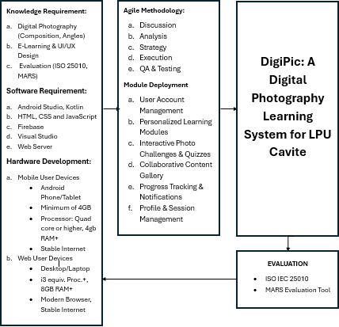

*Conceptual Framework on the DigiPic: A Digital Photography System for LPU Cavite*

The figure above shows the conceptual framework under which DigiPic: A Digital Photography Learning System for LPU Cavite is developed and evaluated. This framework is organized into three primary components: Input, Process, and System Output with a general evaluation criterion that ensures quality.

During the Input stage, the required requirement for successful development of the Digital Photography Learning System is outlined. Knowledge needs include experience in digital photography concepts, specifically composition and different angle shots, and skill in designing e-learning platform interfaces and user interface/user experience (UI/UX) concepts. This stage also involves familiarity with system evaluation methods such as ISO 25010 and MARS frameworks. Software Requirements enumerate the requisite development tools and platforms, e.g., Android Studio, Kotlin, Firebase as the backend and database solution, web technologies like HTML, CSS, JavaScript, Visual Studio, and necessary web server environment. Hardware Requirements describe the standard specifications for the users' devices, such as Android smartphones/tablets with sufficient processors and RAM, and stable internet connectivity for mobile users. For administrative support and IT help web access, typical desktop/laptop specs with recent browsers and reliable internet are taken into account.

The Process area describes the arranged process of building Digital Photography e-Learning System and its key features. Development follows Agile Methodology, an iterative process that includes cycles of discussion, thorough analysis, strategic planning, development (coding and implementation), and strict quality assurance and testing to reflect ongoing improvement and flexibility. Module Deployment outlines the major features incorporated into the DigiPic system. This encompasses user account management (sign-up, login, profile), the main learning modules, interactive photo challenges and quizzes for practical usage and for testing knowledge, a community content gallery for sharing and user interaction, complete progress monitoring and alerts to stimulate learners, and effective profile and session management functions.

The result of this process is the resulting DigiPic: A Digital Photography Learning System for LPU Cavite, designed to allow students to better their photography skills. The usability and performance of this system will be tested against ISO 25010 Standards to ensure its reliability, usability, performance, and overall suitability for its intended purpose.

## **Definition of Terms**

For the readers to fully comprehend this study, the following are the notable terms that have been utilized in the study:

**Agile Methodology** – A method of software development that is iterative and incremental, with an important focus on collaboration and flexibility of functional pieces through ongoing cycles of planning, analysis, design, execution, and testing.  
  
**Angle Shots** – Detailed camera angles used in photography to create a specific visual effects or show subjects, including techniques like low angle, high angle, bird's-eye view, and eye-level.  
  
**Collaborative Gallery** – A user feature in the DigiPic system where users can post and get feedback on their photos from users through likes and comments.  
  
**Composition (Photography)** – The intentional organization of visual elements in a photographic composition, required for producing visually appealing, balanced, and effective photos.  
  
**DigiPic** – A web-based photography e-learning system created for Lyceum of the Philippines University-Cavite to increase the photography skills of its users through modules, situational challenges, Quizzes and social interaction.   
  
**Digital Photography** – The art and technique of shooting and recording images using electric sensors instead of film, including techniques dealing with light, focusing, composition, and post-processing.  
  
**E-Learning System** – An education platform that utilizes digital technologies and connectivity on the internet to provide instruction content, conduct assessments, and administer learner interactions with education resources.  
  
**Firebase** – A full-featured web and mobile app development platform from Google, used as the backend service of DigiPic, with features such as real-time database, authentication, and cloud hosting.  
  
**Interactive Photo Exercises** – A hands-on activities within the DigiPic framework that copies the actual photography situations, so users can practice techniques learned and present their creative efforts for assessment, frequently in conjunction with built-in quizzes to ascertain if understanding is being transferred.  
  
**ISO 25010** – A global software product quality standard that specifies an extensive model for assessing different attributes of a system, such as its functional suitability, efficiency in performance, compatibility, usability, reliability, security, maintenance, and portability.  
  
**Learning Modules** – Independent units of instructional material within the DigiPic environment, organized to sequentially instruct particular digital photography principles and capabilities through lessons, illustrations, and embedded quizzes.  
  
**Mobile Application** – An application program specifically coded to run on portable hardware such as smartphones and tablets, used as the main user interface to access the DigiPic instructional content.  
  
**Web-Based Platform** – A computer program that is accessed through a web browser on the internet, used in the DigiPic for the management control (Admin Portal) and technical support activities (IT Support Portal).

**Trifocal**

**pedagogy**

# CHAPTER III

**METHODOLOGY**

## **Research Design**

This project will utilize a quantitative research design combined with the Agile development methodology to effectively guide the design, development, and evaluation of the system. Agile methodology is a flexible approach that breaks complex projects into smaller, manageable cycles known as sprints. Each sprint consists of planning, implementation, testing, and review stages, enabling incremental development of functional components and immediate incorporation of user feedback. By emphasizing regular evaluation and continuous improvement, Agile ensures the development process remains responsive and aligned with user needs (Laoyan, 2025).

To objectively measure the system’s effectiveness and user experience, a quantitative research approach will be employed. This includes task-based assessments, structured questionnaires, and well-known evaluation frameworks like the Mobile App Rating Scale (MARS) and ISO 25010. These tools evaluate important aspects such as overall program quality, usability, functionality, aesthetics, and engagement. This approach ensures that the results are accurate, reliable, and applicable by methodically gathering and evaluating numerical data. These discoveries will directly guide incremental improvements inside the Agile cycles.

Together, these research and development methods will help achieve DigiPic's objective of developing a practical, user-oriented digital photography learning platform. Integrating quantitative evaluation within Agile’s iterative process ensures responsive improvements based on accurate, data-driven insights into the system’s usability, effectiveness, and user engagement.

## **Sampling Technique**

The study will utilize purposive sampling, specifically the quota sampling method, as the main technique for selecting respondents. Purposive quota sampling is a non-probability sampling technique wherein the researcher deliberately selects participants based on predefined criteria to achieve specific quotas. This method ensures that the selected sample accurately represents the key groups that the study intends to examine, thus ensuring relevant and reliable findings. The quota groups range from the primary educational beneficiaries (students), administrative oversight (faculty/admin), and technical support (IT staff) as long as the participants are interested in using the system.

## **Participants of the Study**

The participants who are involved in the evaluation of **DigiPic: A Digital Photography E-Learning System** are constituted within the target users of the application. These include:

**Aspiring Photographers and General Individuals** who have little to no skills experience in photography but are willing to learn to take photography lessons for gaining photography skills. These groups serve as supporting users for an additional audience to evaluate the DigiPic application.

**Photography Instructors and Educators** who speak on the insights and thoughts of the app’s effectiveness. They also serve as a consultant to see if the app is relevant and adheres to the existing course standards.

## **Research Locale**

DigiPic was conducted in Lyceum of the Philippines University – Cavite (LPU Cavite), a private, non-sectarian university that is known for its strong commitment and academic excellence, digital innovation, and academic performance.

The university offers a wide range of programs, it includes under the College of Fine Arts and Design, a course in visual arts and media arts, especially digital photography, as a core component of the department’s curriculum. This makes DigiPic designed to enhance students’ creativity and technical skills, a perfect fit for implementing at Lyceum of the Philippines University – Cavite.

Lyceum of the Philippines University – Cavite was selected as the research locale due to its emphasis on offering dynamic, student-centered learning experiences and its receptiveness to technology-driven learning. Examining the DigiPic system’s usability, effectiveness, and educational value was made possible by the university’s varied student body.

Through the system’s implementation at Lyceum of the Philippines University – Cavite, the researchers were able to gather relevant feedback from a broad range of users, including the administrators in technology management, students, and students with different degrees of photography knowledge.

## **Research Instrument**

The main research tool used by the researchers to evaluate the efficacy, usability, and overall experience of system of DigiPic, the questionnaire was based on the Mobile App Rating Scale (MARS) and the ISO/IEC 25010 Software Quality Model which evaluated important elements such as functionality, engagement, and aesthetics.

The surveys and user experience testing are the primary research instruments to be used for the study. This will evaluate students’ opinion and behaviors about photography, including the learning experience and overall feedback towards the app. The degree which participants agreed with various statements related to their experience with the system was gauge using a 5-point Likert scale. This tool was given to students to gather data on the system’s effectiveness and learning impact.

## **Data Gathering Procedure**

Data gathering for DigiPic is crucial for both development and evaluation of the system. This method helps the need to assess and meet the needs and expectations of the app for intended users—students, instructors, and IT support staff. The proponents use both qualitative and quantitative methods to gather relevant data and support the system’s design.

1. **Preliminary Research**

Relevant data have gathered through review of related literature and research existing photography learning systems to bridge the problem gap, add more features, and gain user preferences.

1. **Interviews and Surveys**

Structured formal interviews and surveys have been conducted to the selected participants to gather requirements on building the DigiPic app. These are important to gather what are the requirements of the system like UI/UX design, app features, etc.

1. **Direct Observation**

A direct observation was conducted with selected learners to evaluate their behavior towards e-learning systems, challenges in learning, and expectations of interface. This phase shapes the UI/UX design from initial evaluations to make a cleaner and neater interface of the app.

1. **System Testing and Feedback**

Theusability testing was conducted once the initial app is developed. To acquire feedback on the user’s thoughts while using the app, the participants were asked to perform specific tasks. Feedback results were gathered for the refinement and final adjustments to use DigiPic for development.

1. **Evaluation and Documentation**

All the compiled feedback, user evaluation results, and performance ratings were used to final system evaluation and make a final documentation of the results with conclusion and recommendations of the study for future development.

## **System Development Process**

Agile Methodology is the main SDLC tool for this project in system development. It is also where iterative development and testing could make a improvement application process.

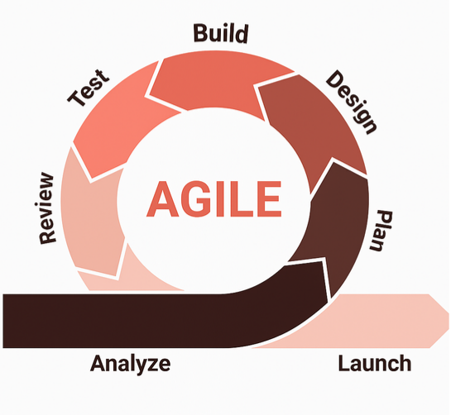

This involves the following stages:

1. **Planning and Design –** The UI, app features, and user experience elements will be tailored to the students and school theme standards.
2. **Development - Android Studio** and **Kotlin** are for application development, while **Firebase** for user data management and feedback functionality in real-time.
3. **Testing –** The application will proceed in a series of tests where users serve as guide to see what functionalities needed to add or dismissed.
4. **Implementation –** After the app passed the testing phase, the app will be released to the participants for final evaluation of its effectiveness and user satisfaction.

## **System Architecture**

**Figure 2**

*The System Architecture for DigiPic: A Digital Photography e-Learning System for LPU Cavite*

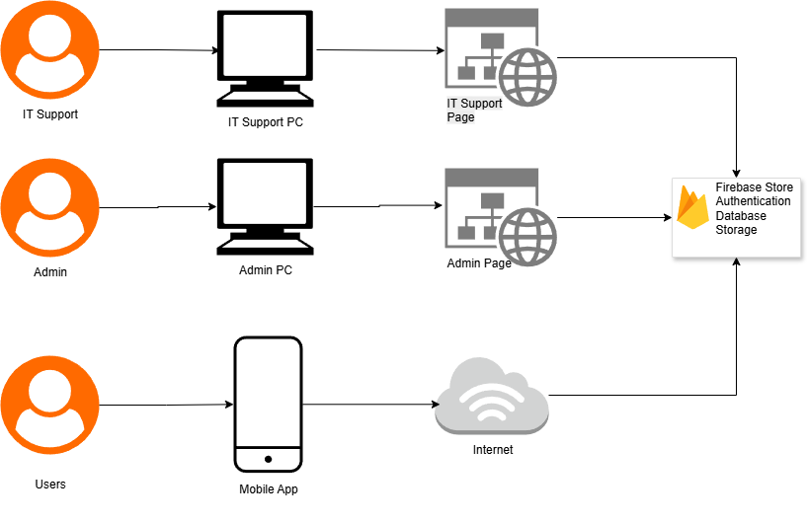

The architecture of DigiPic was designed a mobile application that utilizes Firebase as its backend infrastructure. DigiPic implements elient-server model with three primary user types: Users (learners and students), Admins, and IT Support Staff. The user side provides access via mobile application; this will give way to learners to use the app for educational journeys. The administrative staff handles and overlooks user accounts, course materials, and system maintenance via web browsers. This architecture allows consistent interaction between users and system services with Firebase to take care of backend functions like authentication, content sharing, and real-time updates.

**Use Case Diagram**

**Figure 3**

**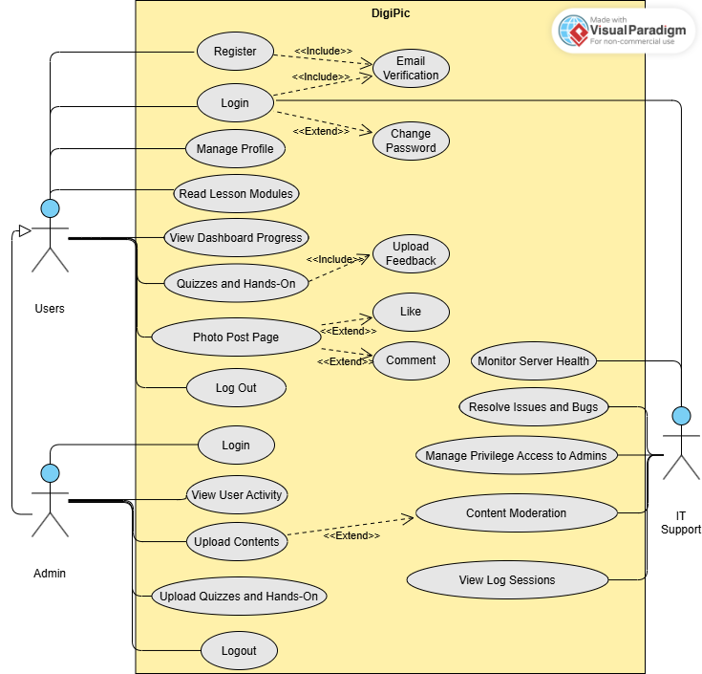***The Use-Case Diagram for DigiPic: A Digital Photography e-Learning System for LPU Cavite*

Figure 3 represents the Use Case Diagram of DigiPic, showing the various interaction between users and its core functionalities. The system supports three main functions: the users, admins, and IT support. Users can perform common user action such as account registration, login access, and profile management. They can also read photography lessons, upload and share images through post page, take quizzes and hands-on activities, and view their dashboard progress.

Admins can login to their accounts in the same manner as users but with different approaches. They inspect user progress throughout the photography lessons, uploading lesson resources, and making quizzes and hands-on activities. They can help users to gain access from users.

At the same time, the administrators have gained access to manage and operate the system. They can view analytics of the server, user and admin activity, privilege management, resolve incoming issues and bugs, and content moderation. They can also do content moderation, view log sessions of both admin and users, and maintain server and app runtimes. These tasks ensure the high standards and provide non-threatening content to show within the system. Overall, this diagram explains the functional boundaries of DigiPic system, showcasing how the service and feature interaction works with different user types.

**Flow Chart**

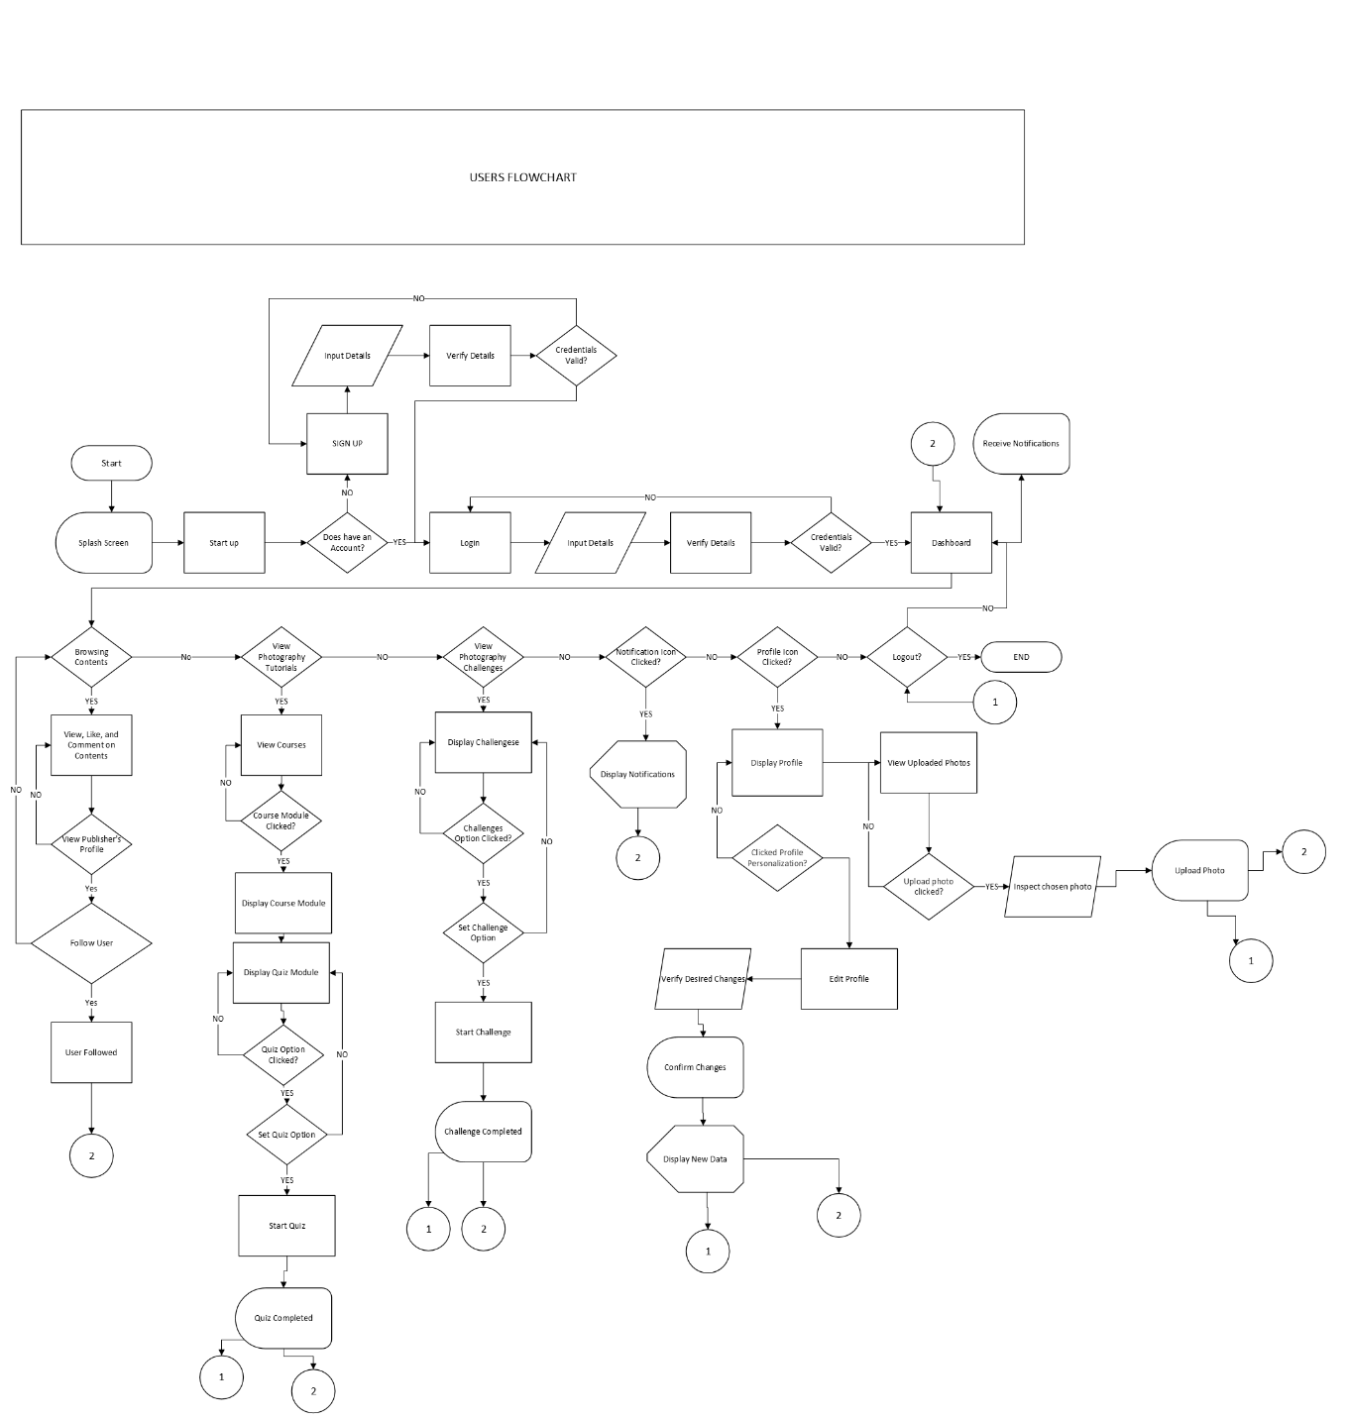

**Figure 4 User Flowchart**

Figure 4 presents the User Flowchart. It begins with the splash screen and startup process that allows users to create a new account or log in with their existing account. Once the account is verified, the users are directed to the dashboard where they can access a variety of options including viewing photography content, taking part in challenges, managing their profile, and checking notifications. Users can choose courses, view modules, take quizzes, and complete challenges in the learning section. In addition, the platform facilitates social interaction by allowing users to like and comment on content, browse and follow other users, and receive notifications. Additionally, Users can also change their profile information and upload their own photos. When the user signs off of the system, the session ends.

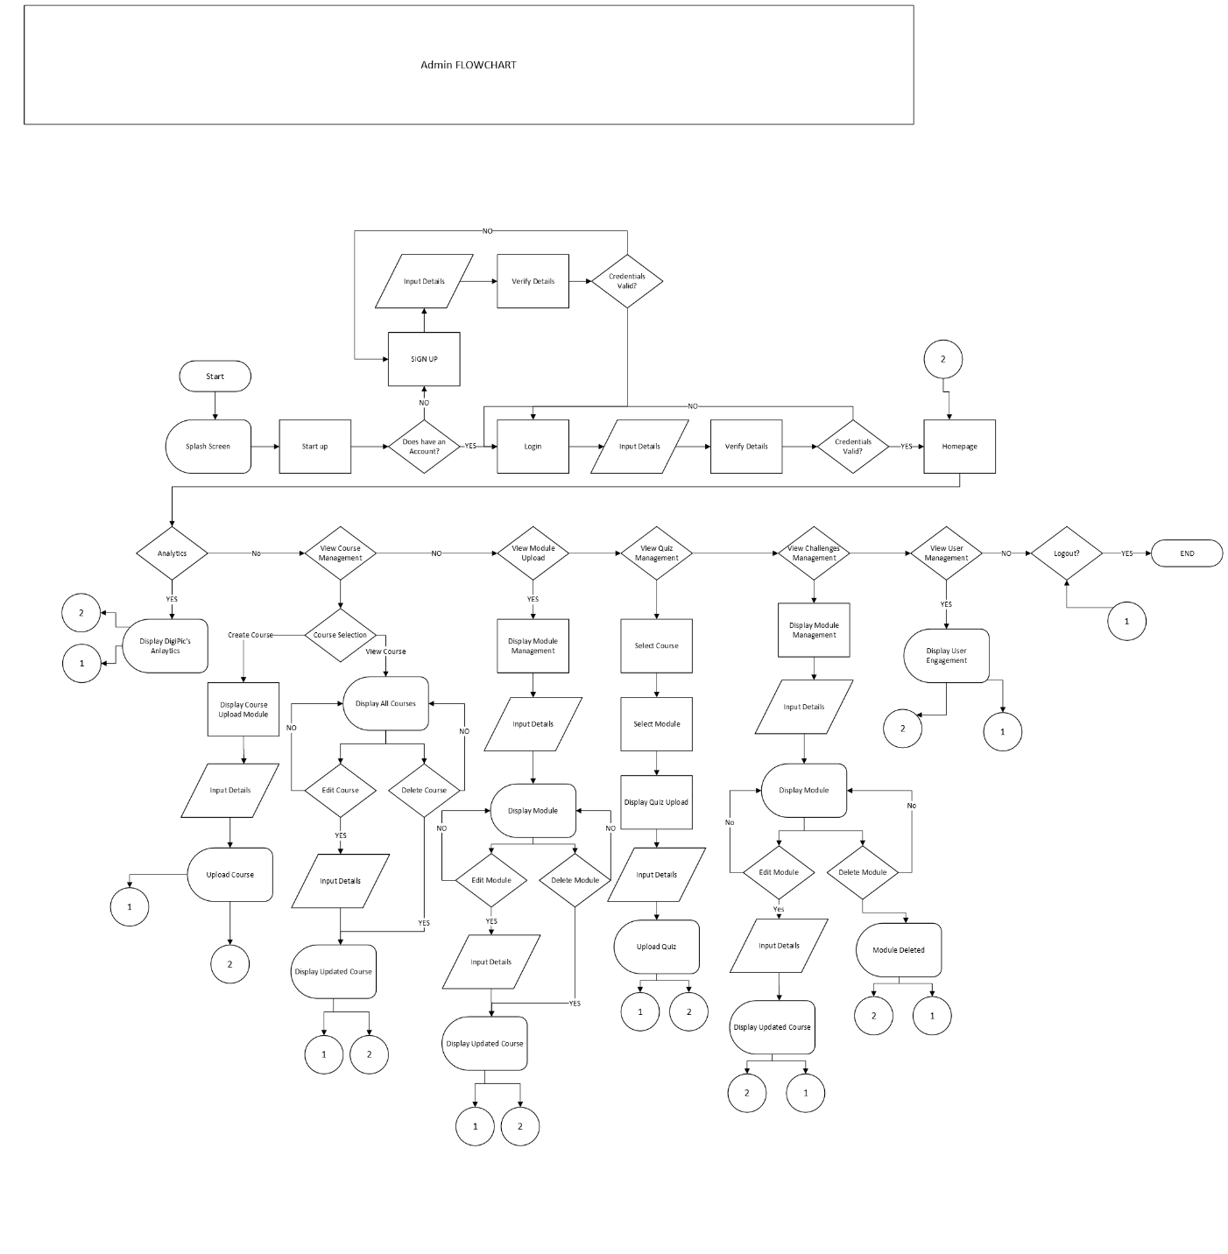

**Figure 5 Admin Flowchart**

Figure 5 shows the admin flowchart begins with the splash screen, and startup, then goes to the sign up or login process with their valid credentials. After authentication, the admins can now access the homepage where they can do various administrative tasks. These include viewing analytics, managing courses, modules, quizzes, challenges, and monitoring user accounts. Admins can also create, edit, delete, and upload course and module contents as well as giving users challenges and quizzes. The analytics show the user’s performance and their engagement with the system. Admins can also monitor the activity of users. The administrator has the option to end their session by logging out after the tasks are completed.

## **Data Analysis**

Qualitative and quantitative methods are the tools used in the study for data analysis. Here are the reasons:

1. **Qualitative Analysis –** user feedback and observation data are used to evaluate the critical criteria for the app.
2. **Quantitative Analysis –** pre-test and post-test survey results are used to measure the improvements in student’s photography knowledge and skills.

## **Ethical Considerations**

In an IT research or capstone project, ethical considerations made a significant role in ensuring that the project is conducted responsibly and aligns with professional and societal standards. Here are key ethical considerations to keep in mind:

**1. Data Privacy and Confidentiality**

* **Sensitive Information Protection**: Researchers must ensure that any personal or sensitive data (e.g., health, financial, or identifiable information) is protected and handled with strict confidentiality.
* **Data Anonymization**: If the research involves user data, it's crucial to anonymize it to prevent identification of individuals.
* **Compliance with Data Protection Laws**: Adherence to laws such as GDPR (General Data Protection Regulation) or HIPAA (Health Insurance Portability and Accountability Act) is essential when handling sensitive data.

**2. Informed Consent**

* **Participants’ Knowledge**: When involving human subjects in your research (e.g., surveys, testing), it is important to obtain their informed consent. Participants should be fully aware of what the study involves and any risks.
* **Voluntary Participation**: Participation should be voluntary, without any form of coercion or undue influence, and subjects should be allowed to withdraw at any time.

**3. Intellectual Property and Plagiarism**

* **Original Work**: Capstone projects should avoid plagiarism, ensuring proper citation of sources and acknowledgment of previous research.
* **Copyright and Licensing**: Use of third-party software, libraries, or tools should respect copyright and licensing agreements.

**4. Cybersecurity and Protection from Harm**

* **Ensuring Security**: If the project involves software development, ethical consideration must include building secure and resilient systems to protect users from cyber threats.
* **Avoiding Harm**: Projects should avoid causing harm to individuals or systems, whether through negligence, vulnerabilities, or malicious design.

**5. Bias and Fairness**

* **Algorithmic Bias**: If the project involves algorithms, ensure that they are fair and unbiased. Biased systems can lead to discriminatory outcomes, so fairness should be a priority.
* **Transparency**: Be transparent about how data is used and analyzed to prevent hidden biases from affecting results.

These ethical considerations ensure that an IT capstone project or research is conducted responsibly, safeguarding the interests of individuals, society, and the broader tech community.

# LITERATURE CITED

Lu, Y., Liu, S., & Bai, Y. (2022). Analysis of Digital Photography Technology in the Era of Big Data. *Mobile Information Systems*, *2022*. <https://doi.org/10.1155/2022/3880755>

Yusof, N. S. M., Dolah, J., & Musa, M. R. A. (2024). Changing Roles of Photographer in Media Evolution and Methods in the Digital Age. *Quantum Journal of Social Sciences and Humanities*, *5*(6), 467–473. <https://doi.org/10.55197/qjssh.v5i6.532>

Subaih, R. H. A., Sabbah, S. S., & Al-Duais, R. N. E. (2021). Obstacles Facing Teachers in Palestine While Implementing E-learning During the COVID-19 Pandemic. *Asian Social Science*, *17*(4), 44. <https://doi.org/10.5539/ass.v17n4p44>

Chinamasa, E., & Ncube, M. (2023). FACTORS INFLUENCING E-LEARNING ACCEPTANCE IN TEACHER EDUCATION INSTITUTIONS: STUDENTS’ AND LECTURERS’ VIEWS. *International Journal of Education Humanities and Social Science*, *06*(01), 80–93. <https://doi.org/10.54922/ijehss.2023.0474>

Kristanto, A. (2021). Integration of a Constructivism Approach in E-learning Photography Subjects: Feasibility and Effectiveness in Learning. *Journal of Education Technology*, *5*(2), 167–174. <http://dx.doi.org/10.23887/jet.v5i2.33380>

Wayan Ilia Yuda Sukmana, A. I., & Komang Sudarma, I. (2021). *Optimizing Student Photography Skills Through Development of Project Based E-Learning in Photography Courses*. <https://doi.org/10.2991/assehr.k.210407.238>

Santiago Jr, C. S., Leah Ulanday, M. P., Jane Centeno, Z. R., Cristina Bayla, M. D., & Callanta, J. S. (2021). Flexible Learning Adaptabilities in the New Normal: E-Learning Resources, Digital Meeting Platforms, Online Learning Systems and Learning Engagement. *Asian Journal of Distance Education*, *16*(2), 38. <https://asianjde.com/ojs/index.php/AsianJDE/article/view/580/355>

Katsaris, I., & Vidakis, N. (2021). Adaptive e-learning systems through learning styles: A review of the literature. *Advances in Mobile Learning Educational Research*, *1*(2), 124–145. <https://doi.org/10.25082/AMLER.2021.02.007>

Bencsik, A., Mezeiova, A., & Samu, B. O. (2021). Gamification in higher education (case study on a management subject). *International Journal of Learning, Teaching and Educational Research*, *20*(5), 211–231. <https://doi.org/10.26803/IJLTER.20.5.12>

Tanwirulqulub, M. (n.d.). *Designing E-Learning Applications As An Android-Based Student Learning Media With The Waterfall Method*. *1*, 2025. <https://doi.org/10.14710/jtsiskom.8.2.123-129>

Dritsas, E., & Trigka, M. (2025). Methodological and Technological Advancements in E-Learning. In *Information (Switzerland)* (Vol. 16, Issue 1). Multidisciplinary Digital Publishing Institute (MDPI). <https://doi.org/10.3390/info16010056>

Wang, V., & Wang, D. (2021). The Impact of the Increasing Popularity of Digital Art on the Current Job Market for Artists. *Art and Design Review*, *09*(03), 242–253. <https://doi.org/10.4236/adr.2021.93019>

González-Carrasco, I., García-Sánchez, J. N., García-Peñalvo, F. J., & Conde, M. Á. (2021). *Gamification in higher education: A systematic review of recent trends*. Education and Information Technologies, 26(5), 5165–5197.

Serrano, M. C. (2023). Gamification and the History of Art in Secondary Education: A Didactic Intervention. Education Sciences, 13(4), 389. <https://doi.org/10.3390/educsci13040389>

Ferroukhi, M., Bourzgui, M. L., Zaoui, N. M., El-Khadiri, T., & Bahije, Y. K. (2020). Digital Tools in Learning Systems. *Computer Aided Design and Applications, 17*(4), 840-848. [https://doi.org/10.14733/cadaps.2020.840-848](https://www.google.com/search?q=https://doi.org/10.14733/cadaps.2020.840-848)

Er, M. H. (2023). Game-Based learnıng, collaboratıve learnıng, and peer assessment in the photography department. *JOURNAL OF ACADEMIC SOCIAL RESOURCES*, *8*(Cilt 8 Sayı 50), 2718–2735. <https://doi.org/10.29228/asrjournal.70582>

Kim, D., Lee, H., & Choi, J. (2022). *Effect of interactive media on digital art education*. *Computers & Education, 180*, Article 104452.<https://doi.org/10.1016/j.compedu.2022.10445>[2](https://doi.org/10.1016/j.compedu.2022.104452)

Zhao, G., Zhang, L., Chu, J., Zhu, W., Hu, B., He, H., & Yang, L. (2022b)*. An Augmented Reality-Based Mobile Photography Application to Improve Learning Gain, Decrease Cognitive Load, and Achieve Better Emotional State. International Journal of Human-Computer Interaction,* 39(3), 643–658. <https://doi.org/10.1080/10447318.2022.2041911>

*Wu, X., & Jia, J. (2021b, September 23)*. Tumera: Tutor of Photography Beginners. *arXiv.org.* [*https://arxiv.org/abs/2109.11365*](https://arxiv.org/abs/2109.11365)

Sukmana, A. I. W. I. Y., & Sudarma, I. K. (2021). Optimizing student photography skills through development of project based E-Learning in photography courses. *Advances in Social Science, Education and Humanities Research/Advances in Social Science, Education and Humanities Research*. <https://doi.org/10.2991/assehr.k.210407.238>

Xu, Y. (2021, September 24-26). *On the signature pedagogy of photography courses from the perspective of visual communication design*. Paper presented at LearnXDesign 2021: Engaging with challenges in design education, Jinan, China. <https://doi.org/10.21606/drs_lxd2021.09.201>

Bencsik, A., Mezeiova, A., & Samu, B. O. (2021). Gamification in higher education (case study on a management subject). *International Journal of Learning, Teaching and Educational Research*, *20*(5), 211–231. <https://doi.org/10.26803/IJLTER.20.5.12>

Forslind, E., Hrastinski, S., & Forsler, I. (2023). Digital peer feedback on visual ideas: a study of eighth-grade students in visual art. *Interactive Learning Environments*, 1–18. https://doi.org/10.1080/10494820.2022.2164785

Mago, Z., Wojciechowski, Ł. P., Balážiková, M., & Shelton, A. J. (2023). Learning by Playing. A case study of the education in photography by Digital Games. *Journal of Education Culture and Society*, *14*(1), 465–479. <https://doi.org/10.15503/jecs2023.1.465.479>

Sliz, H. R. (2024, February 8). *The Impact of social media on photography Trends | Hanna Renee Sliz | Arts & Culture*. Hanna Renee Sliz | Arts & Culture | Hanna Renee Sliz’s Arts & Culture Site. <https://hannareneesliz.net/the-impact-of-social-media-on-photography-trends/>

Aperture & Light. (2025, February). *Framing the future: Is social media transforming our photography?* | Sheen Watkins <https://hannareneesliz.net/the-impact-of-social-media-on-photography-trends/>

Schenker, M. (n.d). *What shooting from different angles means for your photograph | Contrastly*. | Marc Schenker <https://contrastly.com/what-shooting-from-different-angles-means-for-your-photograph/>

Laoyan, S. (2025, February 20). What is Agile Methodology? (A Beginner’s Guide) [2025] • Asana. *Asana*. <https://asana.com/resources/agile-methodology>

Su, Y., Vemulapalli, R., Weiss, B., Chu, C., Mansfield, P. A., Shapira, L., & Pitts, C. (2021, April 15). *Camera View Adjustment prediction for improving image composition*. arXiv.org. <https://arxiv.org/abs/2104.07608>

# APPENDICES

* **Gantt Chart**
* **Budget Allocation**
* **Web Hosting**
* **Communication Letter with Client**
* **Endorsement Letter**
* **Consultation Log Sheets**

APPENDIX A