Sign up on Namecheap and create free domain

1. Sign in into your github account <https://education.github.com/globalcampus/student>
2. Once logged in, use button “Explore more offers” to view student pack offers.

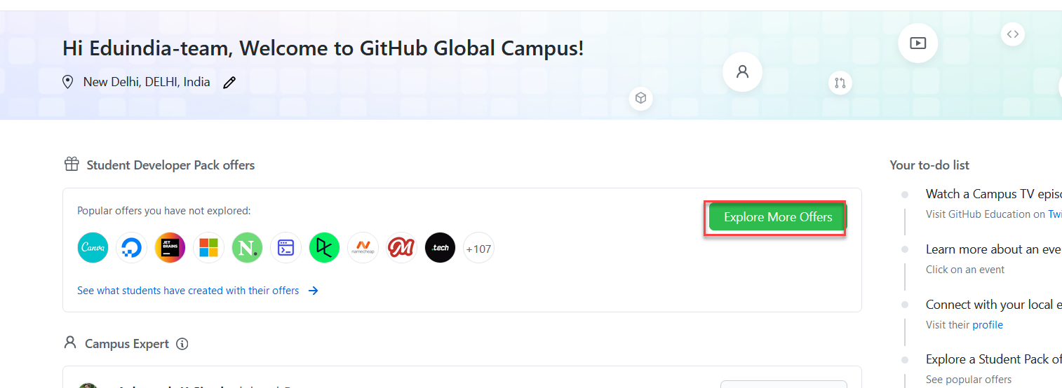

1. Now check for Namecheap offer and use the link (2) provided to get started

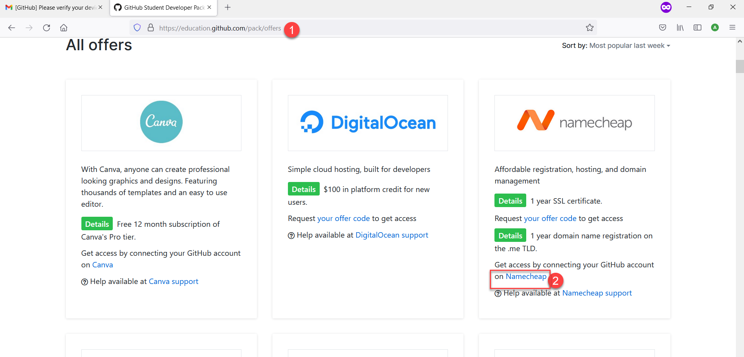

1. Now, once you redirect to Namecheap, it should prompt you to authorize your Github account with Namecheap.

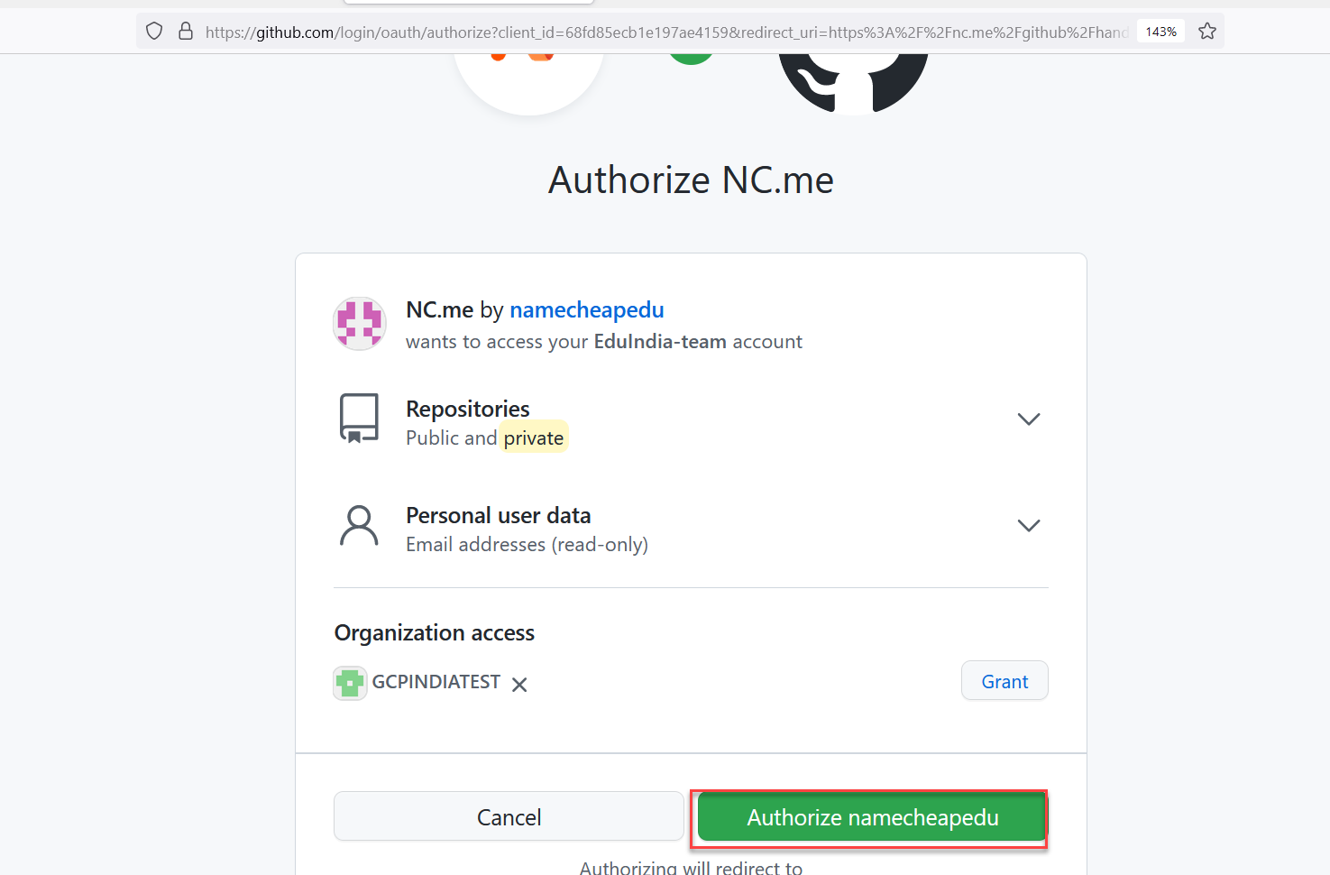

1. Now, search for your desired domain name (I am searching for navimumbai.me)

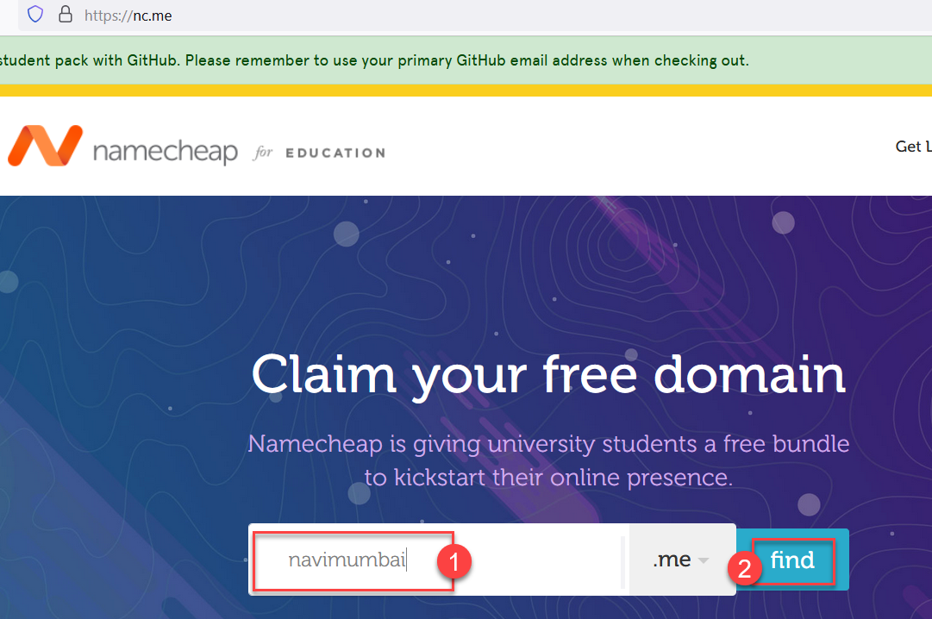

1. It should show you results (change the name if old one is not available and search again)

Click on Add, once you confirm that domain chosen is available.

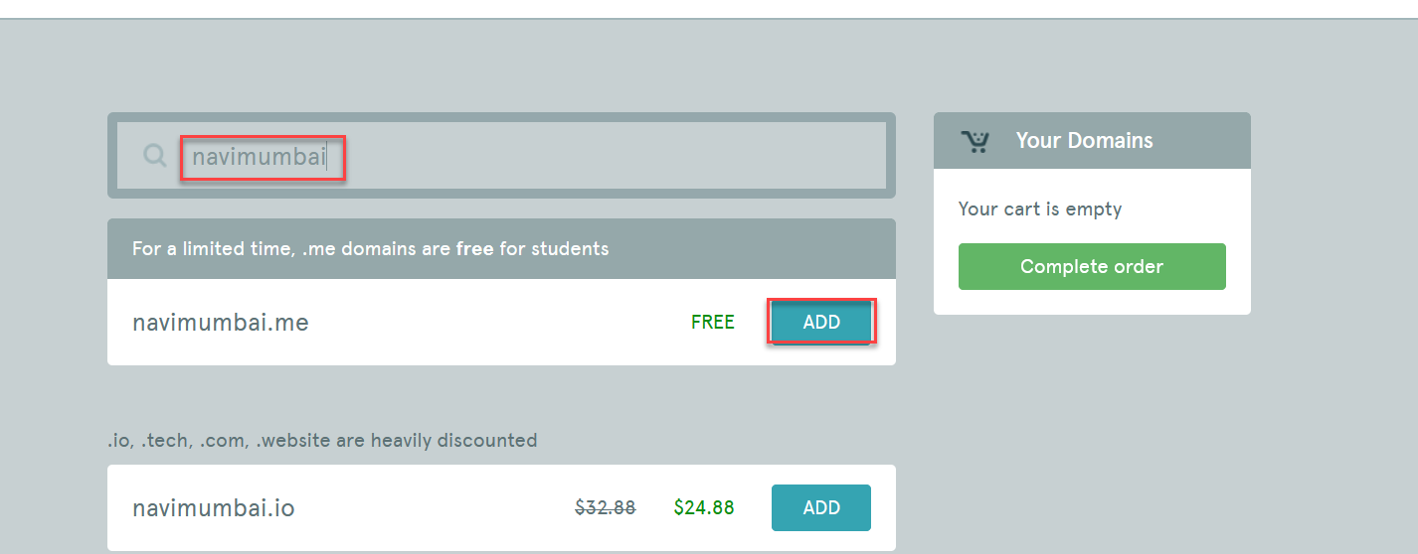

1. Next page, select the github pages offer and then enter your email account (primary email of your github, it must be the same email where you have registered for student pack).

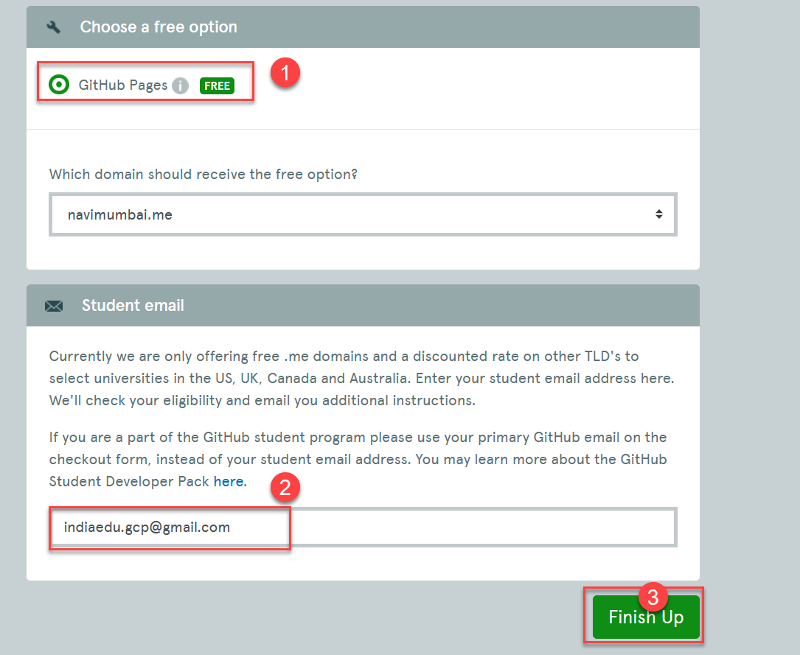

1. On next screen, you have to create a new account on Namecheap. Enter name and expected password for Namecheap and click REGISTER button.

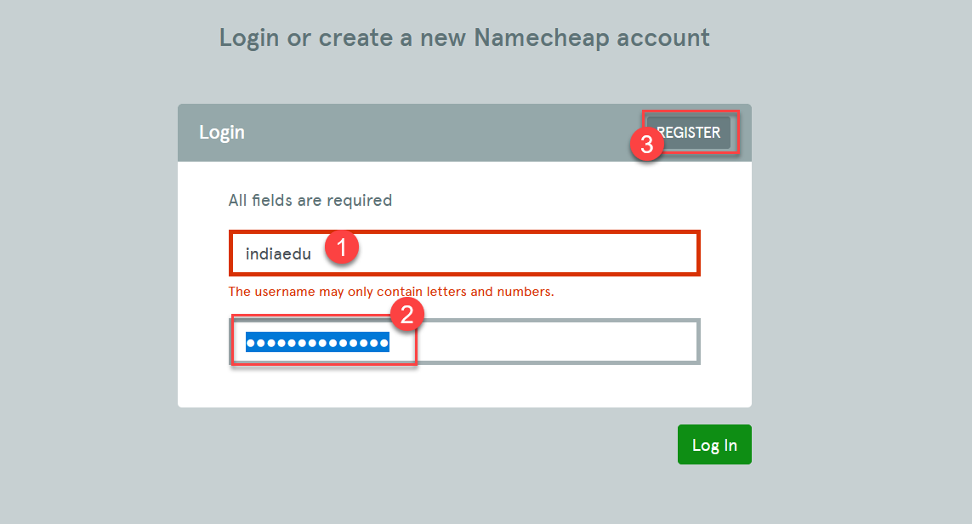

1. On next screen, just fill in all the personal details and click “create” button.

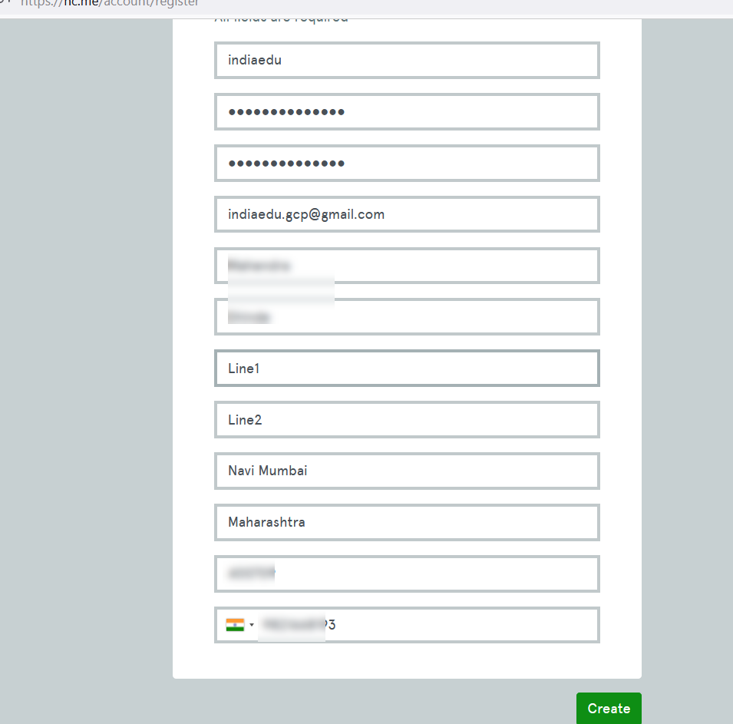

1. Confirm your order on next page.

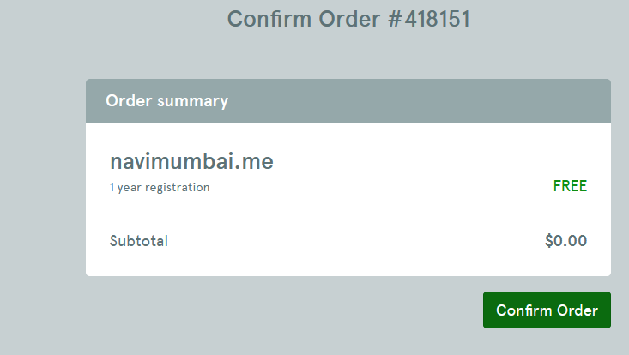

1. Now just login into <https://namecheap.com> with newly created account.

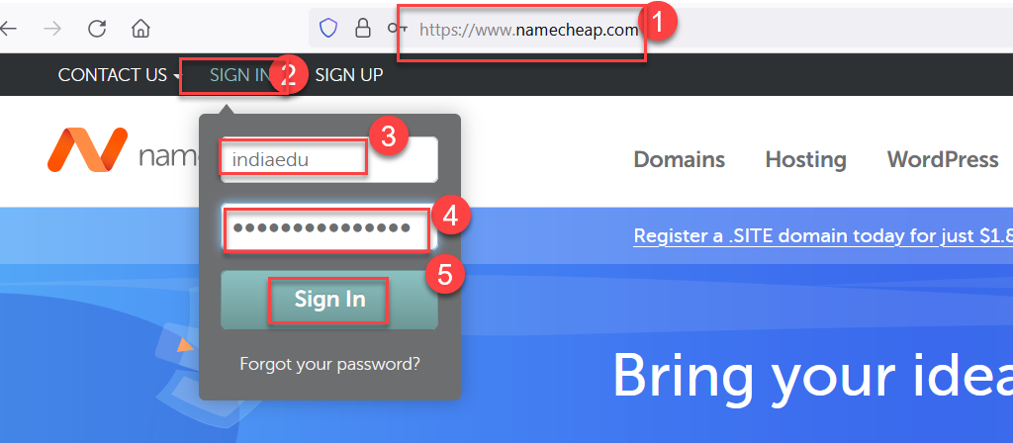

1. You need to enter the verification code (sent to your email / inbox)

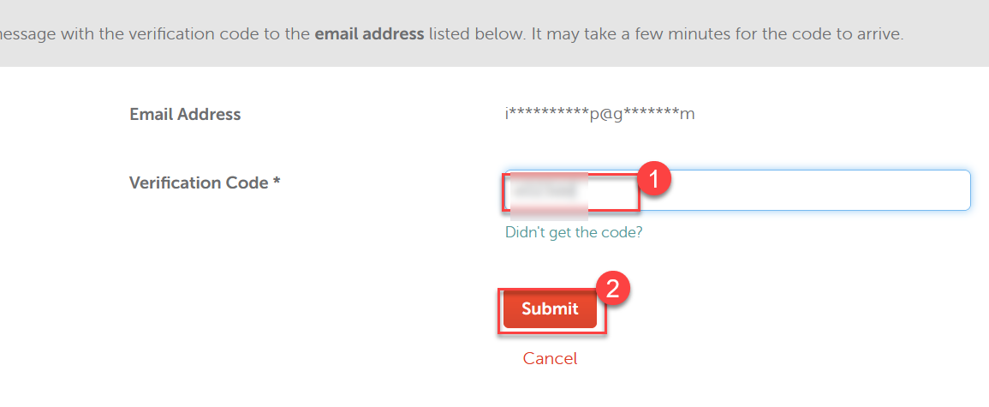

1. You should be able to get list of all domains you have purchased (just one now)

