Supplementary material — Reassessing the reported increase in asthma mortality in Brazil: reproduction and age-specific reanalysis, 2014–2021
Supplementary Table S1. Death records by year and stage of case selection. ªAfter the COVID-19-related exclusion (B34.2, U07.2 or “COVID-19” in the cause-of-death lines) and removal of duplicate records. The last column is the sample of the reproduction: asthma deaths above 6 years of age with a valid date of birth.
Year | All records | Asthma (J45–J46) | After exclusionsª | Valid birth date | Age >6 years
2014 | 1,227,039 | 2,129 | 2,129 | 2,127 | 2,041
2015 | 1,264,175 | 2,232 | 2,232 | 2,231 | 2,148
2016 | 1,309,774 | 2,249 | 2,249 | 2,247 | 2,190
2017 | 1,312,663 | 2,477 | 2,477 | 2,476 | 2,423
2018 | 1,316,719 | 2,307 | 2,306 | 2,302 | 2,249
2019 | 1,349,801 | 2,488 | 2,488 | 2,486 | 2,426
2020 | 1,556,824 | 2,735 | 2,708 | 2,705 | 2,678
2021 | 1,832,649 | 2,488 | 2,459 | 2,459 | 2,428
Total | 11,169,644 | 19,105 | 19,048 | 19,033 | 18,583

Supplementary Table S2. Deaths (upper panel) and rates per 100,000 (lower panel) by year. The crude national rate uses deaths above 6 years of age and the total population; the age-standardised rate uses the 2014 Brazilian age distribution within completed ages of 7 or more. Rates for the age groups are per 100,000 persons of that age. Population: IBGE 2018 projection.
Series | 2014 | 2015 | 2016 | 2017 | 2018 | 2019 | 2020 | 2021
Deaths
Crude national rate | 2,041 | 2,148 | 2,190 | 2,423 | 2,249 | 2,426 | 2,678 | 2,428
Age-standardised (Brazil 2014) | 2,035 | 2,142 | 2,187 | 2,418 | 2,243 | 2,419 | 2,677 | 2,423
Ages 5–34 | 182 | 189 | 184 | 172 | 200 | 218 | 236 | 210
Ages 7–34 | 171 | 174 | 179 | 164 | 190 | 208 | 232 | 202
Ages 35–59 | 452 | 485 | 515 | 567 | 504 | 524 | 709 | 591
Rate per 100,000
Crude national rate | 1.012 | 1.056 | 1.067 | 1.172 | 1.079 | 1.154 | 1.265 | 1.138
Age-standardised (Brazil 2014) | 1.123 | 1.144 | 1.132 | 1.209 | 1.089 | 1.140 | 1.230 | 1.078
Ages 5–34 | 0.182 | 0.190 | 0.186 | 0.175 | 0.204 | 0.224 | 0.244 | 0.219
Ages 7–34 | 0.181 | 0.186 | 0.192 | 0.177 | 0.207 | 0.228 | 0.256 | 0.224
Ages 35–59 | 0.719 | 0.756 | 0.787 | 0.851 | 0.743 | 0.759 | 1.011 | 0.830

Supplementary Table S3. Age groups as constructed in the original analysis, reproduced with the 2018 projection. ªLabelled “below 18” in the original analysis; the numerator contains deaths at 7–17 years and the denominator the population aged 0–17. ^{b}Mean over 2015–2021 of the relative difference from the 2014 rate, which is the quantity reported by the original analysis. Rates per 100,000 in the stated age group.
Group | Deaths 2014 / 2021 | Rate 2014 / 2021 | Change 2014–2021 (%) | Mean relative variation^{b} (%) | Slope | p
Ages 7–17ª | 43 / 37 | 0.076 / 0.069 | −9.2 | +12.1 | −0.0005 | 0.852
Ages 18–59 | 580 / 756 | 0.478 / 0.587 | +22.9 | +16.5 | 0.0212 | 0.044
Ages ≥60 | 1,412 / 1,630 | 5.853 / 5.203 | −11.1 | −1.9 | −0.0712 | 0.135

Supplementary Table S4. Count models with population offset (post hoc analysis), 2018 projection unless stated. ªPearson chi-square divided by degrees of freedom in the Poisson model; values well above 1 indicate overdispersion. The age-adjusted model uses nine age bands as a factor. For ages 5–34 and 7–34 the negative binomial model is equivalent to the Poisson model. ^{b}Annual change (%) from quasi-Poisson models with the 2024 projection, with the p value in parentheses.
Series | Dispersionª | Quasi-Poisson, annual change (%) | p | p, neg. binomial | 2024 denominators^{b}
Crude national rate | 5.91 | +2.25 (0.32 to 4.22) | 0.029 | <0.001 | +2.40 (0.022)
Age-adjusted, ages ≥7 | 3.11 | +0.00 (−1.12 to 1.14) | 0.994 | 0.104 | +0.29 (0.602)
Ages 5–34 | 1.07 | +4.04 (1.20 to 6.96) | 0.013 | <0.001 | +4.22 (0.011)
Ages 7–34 | 1.13 | +4.65 (1.64 to 7.75) | 0.009 | <0.001 | +4.83 (0.007)
Ages 35–59 | 5.54 | +2.78 (−1.08 to 6.79) | 0.130 | 0.036 | +2.84 (0.123)

Supplementary Table S5. Sensitivity to the standard population and to the population projection (post hoc analysis). For each row the slope is in rate units per year, from ordinary least squares on eight annual values. The WHO standard population is applied in five-year bands, and the age-standardised rows for ages 7 or more use the 5–9 band at three fifths of its weight.
Specification | Rate 2014 | Rate 2021 | Change (%) | Slope | 95% CI | p
Ages ≥7, age-standardised
Brazil 2014 standard, 2018 projection (primary) | 1.123 | 1.078 | −4.0 | 0.0002 | (−0.0213 to 0.0217) | 0.983
Brazil 2014 standard, 2024 projection | 1.128 | 1.112 | −1.5 | 0.0040 | (−0.0176 to 0.0255) | 0.668
WHO standard, 2018 projection | 1.095 | 1.049 | −4.2 | −0.0001 | (−0.0207 to 0.0205) | 0.990
WHO standard, 2024 projection | 1.102 | 1.080 | −2.0 | 0.0031 | (−0.0176 to 0.0237) | 0.727
Ages 5–34
Crude group rate, 2018 projection (primary) | 0.182 | 0.219 | +20.3 | 0.0080 | (0.0023 to 0.0138) | 0.014
Crude group rate, 2024 projection | 0.183 | 0.222 | +21.7 | 0.0085 | (0.0026 to 0.0144) | 0.012
WHO standard, 2018 projection | 0.178 | 0.208 | +16.9 | 0.0069 | (0.0015 to 0.0122) | 0.020
WHO standard, 2024 projection | 0.179 | 0.213 | +19.1 | 0.0075 | (0.0021 to 0.0130) | 0.015

Supplementary Table S6. Kitagawa decomposition of the change in the crude rate, completed ages 7 years and older (post hoc analysis). Rates and components per 100,000; population from the IBGE 2018 projection. The two components sum to the change in the crude rate. ªAge-composition component as a percentage of the change in the crude rate; it exceeds 100% when the age-specific-rate component is negative, that is, when changes in age-specific rates partly offset the effect of the changing age composition.
Years compared | Crude rate, start / end | Change | Age composition | Age-specific rates | Composition share (%)ª | Ages ≥60 in composition (%)
2014–2021 | 1.123 / 1.258 | +0.135 | +0.191 | −0.057 | 142 | 95
2014–2019 | 1.123 / 1.276 | +0.154 | +0.138 | +0.016 | 90 | 95
2014–2020 | 1.123 / 1.401 | +0.278 | +0.171 | +0.107 | 62 | 94
2015–2021 | 1.171 / 1.258 | +0.087 | +0.167 | −0.081 | 193 | 95
2016–2021 | 1.184 / 1.258 | +0.073 | +0.140 | −0.067 | 191 | 95
2014–2018 | 1.123 / 1.194 | +0.071 | +0.107 | −0.036 | 151 | 94
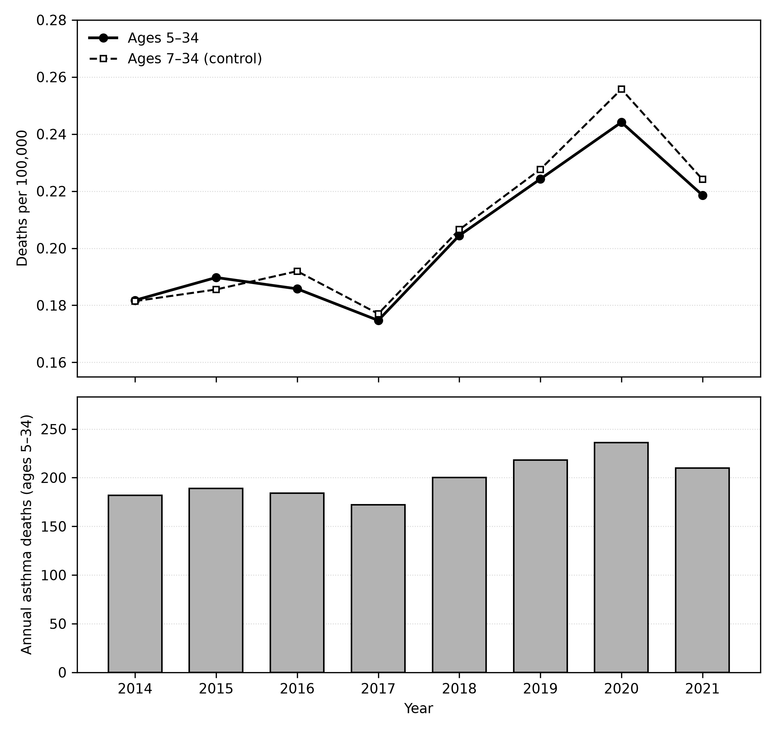
Supplementary Figure S1. Asthma mortality at ages 5–34 years, Brazil, 2014–2021. Upper panel: rate per 100,000 at ages 5–34 (solid line, filled circles) and at ages 7–34, the control group matching the age filter of the original analysis (dashed line, open squares). Lower panel: annual asthma deaths at ages 5–34. Population from the IBGE 2018 projection.
Age-specific Kitagawa contributions for each pair of years are available in the repository (reanalysis/data/kitagawa_age_contributions.csv).

