This assignment was implemented using the libraries LibRaw and OpenCV for C++. LibRaw handles DNG file decoding, while the image processing techniques were done with OpenCV.

# BAYER IMAGE

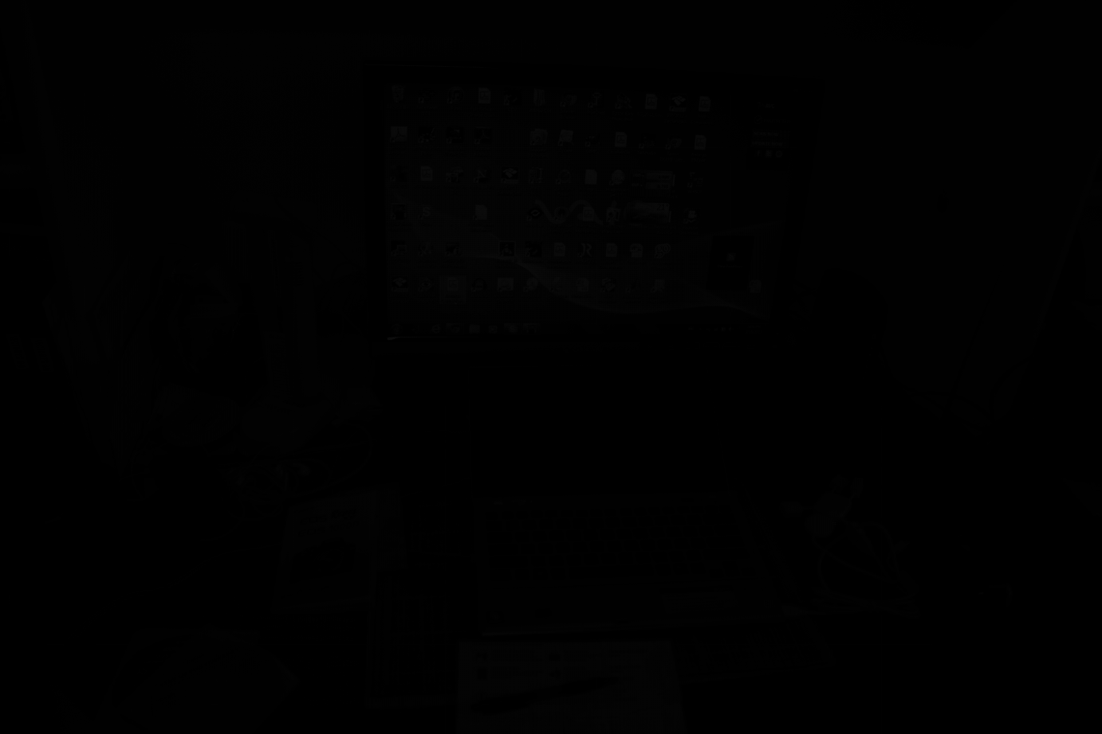

As expected, the raw Bayer image is dark and unintelligible. At this step, LibRaw has already done its decoding job, and the values were black level subtracted.

# DEMOSAICKING

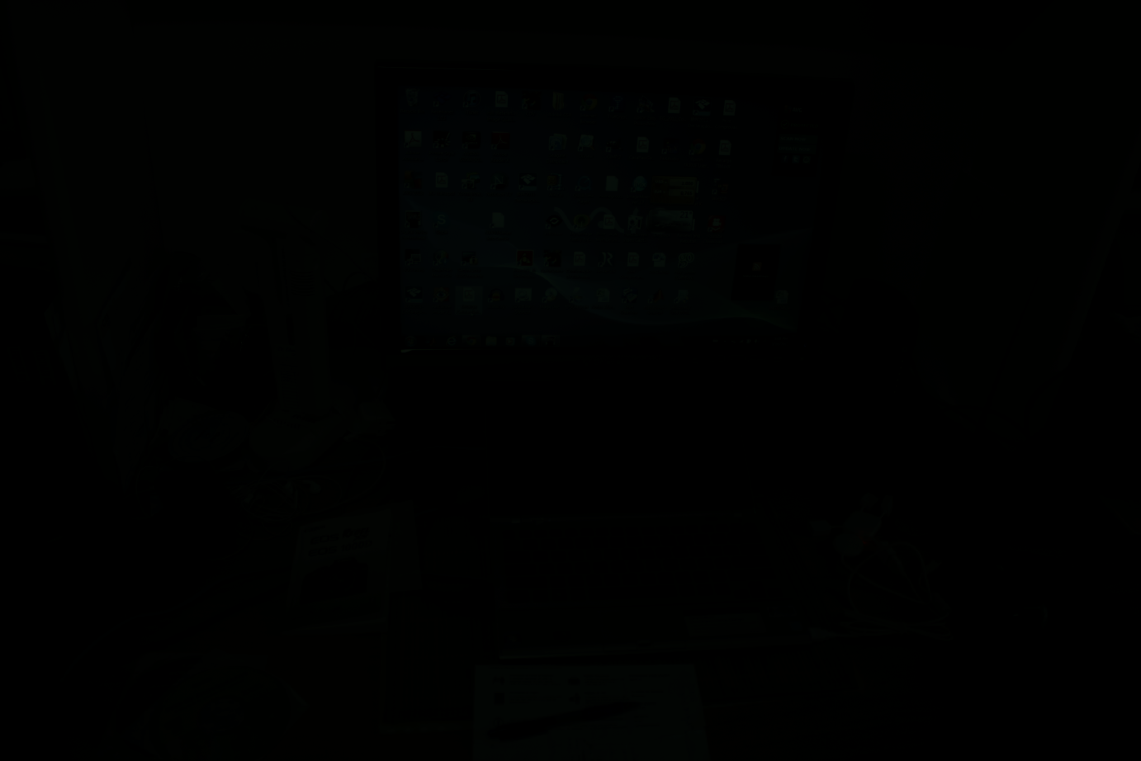

In the demosaicked image, we can see a bit more details, but the whole scene is still too dark.

# NORMALIZATION

This is an additional step that was not requested by the assignment but that I found necessary to work properly. The raw values decoded by LibRaw were clamped in the range , yet *uint16_t* goes up to 65535. This is what makes the image too dark. Thus, a normalization step happened, where each pixel is linearly multiplied to spread across the whole 16-bit range.

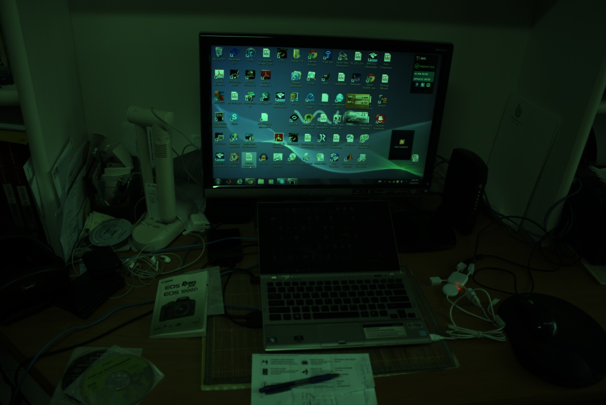

We can finally see the scene of the original image, but the colors are off, since they’re mostly green.

# WHITE BALANCE

To fix this, we need to perform white balance correction for each channel, but taking the average of each and multiplying the values by the .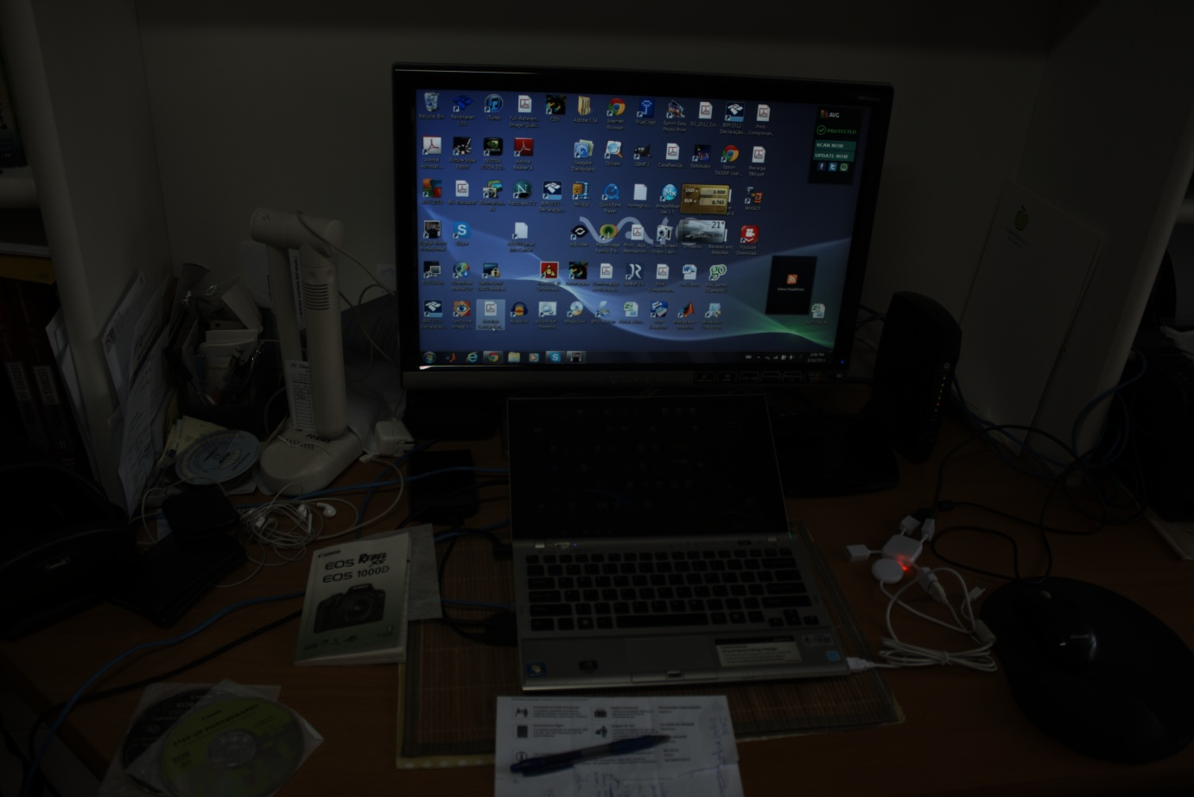

Now the colors are balanced. However, the image is still dark.

# Gamma CORRECTION

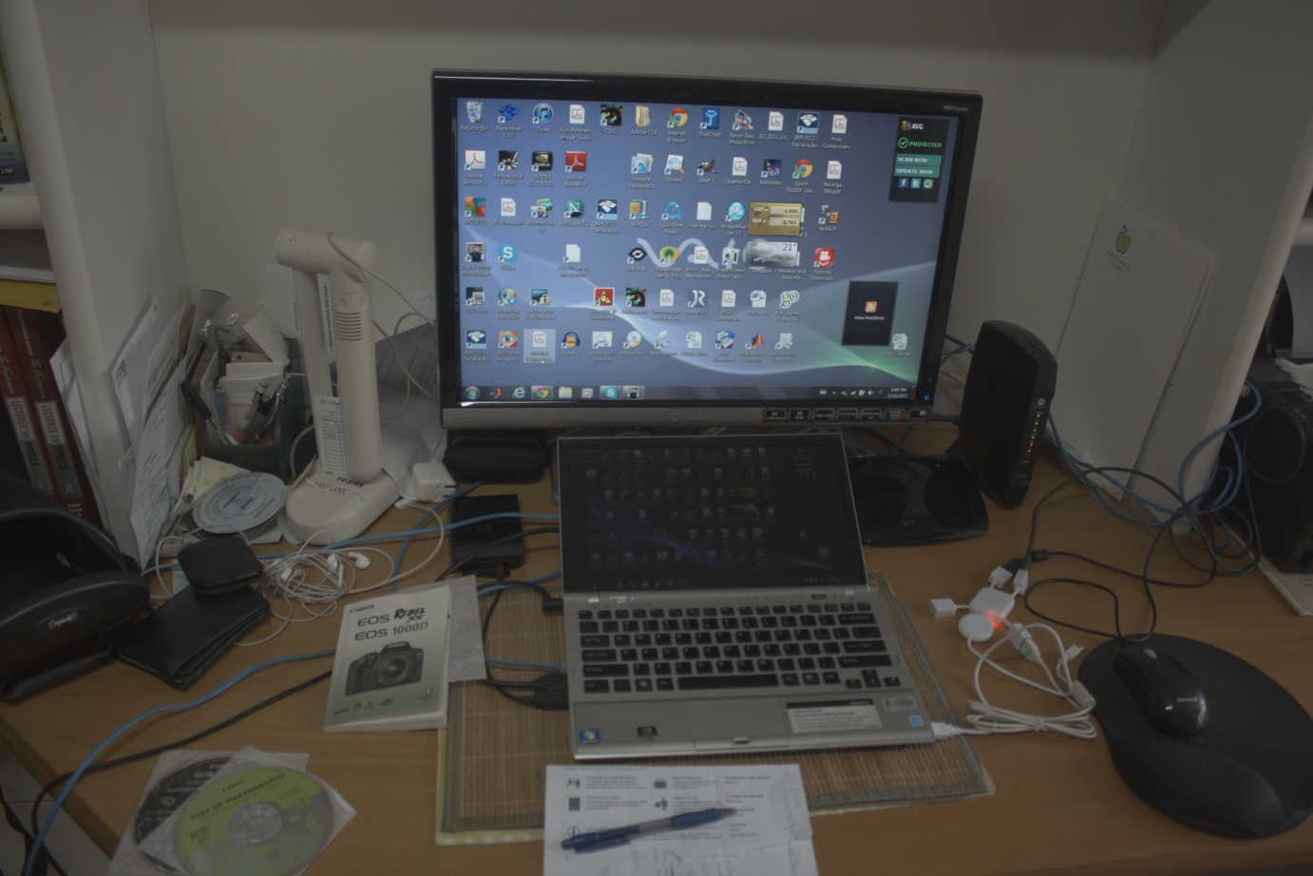

Performing gamma correction with the standard clears the image, although at the cost of de-saturating it.

Smaller values, such as seem to improve on this aspect.