Monitoramento de Alterações de Solo com Técnicas de Processamento de Imagens de Satélite
Augusto J. D. Arraga¹, Eduardo A. Reinert², Matheus B. Demmer³, Vinícius V. S. Silva⁴
¹Departamento de Sistemas e Computação
Universidade Regional de Blumenau (FURB) – Blumenau, SC – Brazil
aarraga@furb.br, eareinert@furb.br, mbdemmer@furb.br, vvssilva@furb.br

1. Tabela Comparativa e Discussão Crítica de Estudos Recentes sobre Detecção de Alterações de Solo com Imagens de Satélite
Seguindo o tema de Detecção de Alteração em Cobertura de solo, escolhemos os seguintes artigos para basearmos nosso desenvolvimento:
- “A Coarse-to-Fine Deep Learning Based Land Use Change Detection Method for High-Resolution Remote Sensing Images”, por Mingchang Wang ,Haiming Zhang, Weiwei Sun, Sheng Li, Fengyan Wang and Guodong Yang
- “Deep Learning for Land Cover Change Detection”, por Oliver Sefrin, Felix M.Riese and Sina Keller
- “Land use/land cover classification using machine learning models”, por Subhra Swetanisha, Amiya Ranjan Panda, Dayal Kumar Behera

Referente aos artigos, construímos a seguinte tabela comparativa entre cada um:
Relatório | Metodologia Utilizada | Fonte de Dados | Resultados Obtidos | Conclusões
A
B
C

2. Descrição do Problema
O presente trabalho tem como objetivo monitorar alterações no solo ao longo do tempo utilizando imagens de satélite da missão Copernicus Sentinel-2. A detecção de mudanças visa apoiar ações de gestão ambiental e planejamento territorial, utilizando técnicas de processamento de imagens para identificar transformações na cobertura do solo em áreas específicas.

3. Montagem da Base de Dados
As imagens foram obtidas por meio da API do Google Earth Engine (GEE), vindas da base de dados “COPERNICUS/S2”, utilizando a biblioteca Python da GEE que permite a coleta automática de todas as imagens disponíveis em uma região de interesse (no nosso caso, da cidade de Blumenau) e as salva no Google Drive. Foram selecionadas imagens entre os anos de 2016 e 2025 (sendo 2016 a data mais antiga presente na base de dados), totalizando 94 imagens GeoTIFF válidas para uso posterior.

4. Preparação dos Dados
As imagens obtidas através da API do Google Earth Engine foram nomeadas com base em sua data de captura, que pode ser resgatada através dos metadados da imagem (ex.: BLU_2018-03-16.tif”. As bandas resgatadas para cada imagem podem ser visualizadas abaixo (tabela retirada da documentação do dataset):
Tabela 1. Bandas presentes em todas as imagens da base de dados resgatada do GEE
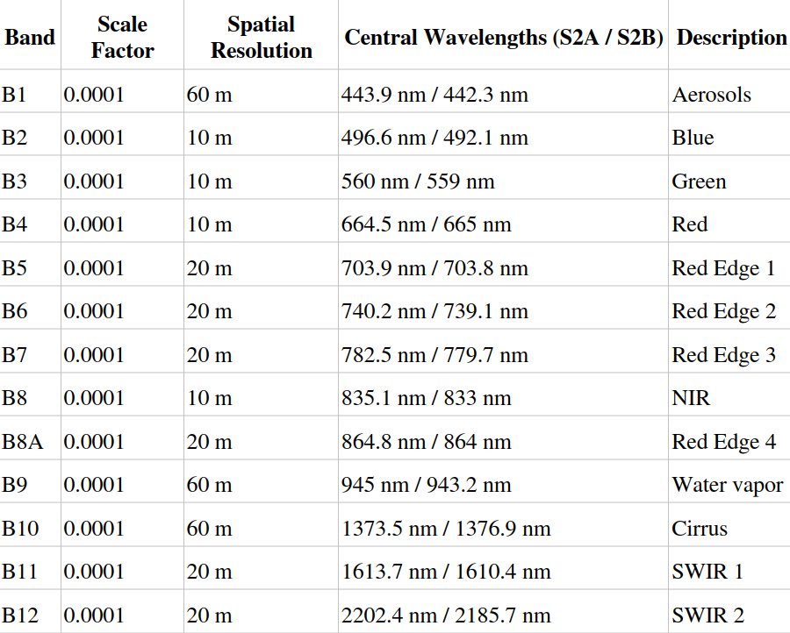

Todas as imagens foram tratadas e organizadas para análise temporal e espacial das mudanças posteriormente.

5. Métodos para Detecção de Mudanças
Para realizarmos as detecções de mudanças nos quadrantes de Blumenau, utilizamos algumas abordagens. Abaixo, a descrição detalhada para cada uma das abordagens.

5.1 Método por Subtração de Bandas/Índices
Para a aplicação deste método de detecção de mudanças, nós resgatamos as informações relacionadas as bandas de cada imagem, e construímos os índices espectrais relacionados a este tipo de alteração que buscamos detectar.

==============================================================

1. General Information
All full papers and posters (short papers) submitted to some SBC conference, including any supporting documents, should be written in English or in Portuguese. The format paper should be A4 with single column, 3.5 cm for upper margin, 2.5 cm for bottom margin and 3.0 cm for lateral margins, without headers or footers. The main font must be Times, 12 point nominal size, with 6 points of space before each paragraph. Page numbers must be suppressed.
Full papers must respect the page limits defined by the conference. Conferences that publish just abstracts ask for one-page texts.

2. First Page
The first page must display the paper title, the name and address of the authors, the abstract in English and “resumo” in Portuguese (“resumos” are required only for papers written in Portuguese). The title must be centered over the whole page, in 16 point boldface font and with 12 points of space before itself. Author names must be centered in 12 point font, bold, all of them disposed in the same line, separated by commas and with 12 points of space after the title. Addresses must be centered in 12 point font, also with 12 points of space after the authors’ names. E-mail addresses should be written using font Courier New, 10 point nominal size, with 6 points of space before and 6 points of space after.
The abstract and “resumo” (if is the case) must be in 12 point Times font, indented 0.8cm on both sides. The word Abstract and Resumo, should be written in boldface and must precede the text.

3. CD-ROMs and Printed Proceedings
In some conferences, the papers are published on CD-ROM while only the abstract is published in the printed Proceedings. In this case, authors are invited to prepare two final versions of the paper. One, complete, to be published on the CD and the other, containing only the first page, with abstract and “resumo” (for papers in Portuguese).

4. Sections and Paragraphs
Section titles must be in boldface, 13pt, flush left. There should be an extra 12 pt of space before each title. Section numbering is optional. The first paragraph of each section should not be indented, while the first lines of subsequent paragraphs should be indented by 1.27 cm.

4.1. Subsections
The subsection titles must be in boldface, 12pt, flush left.

5. Figures and Captions
Figure and table captions should be centered if less than one line (Figure 1), otherwise justified and indented by 0.8cm on both margins, as shown in Figure 2. The caption font must be Helvetica, 10 point, boldface, with 6 points of space before and after each caption.

Figure 1. A typical figure
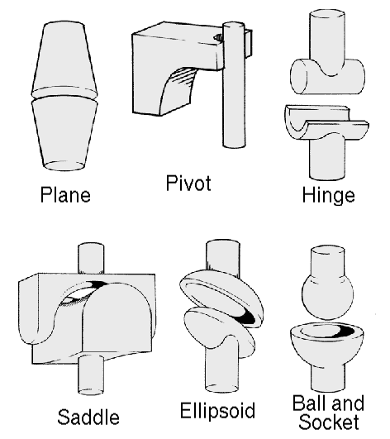
Figure 2. This figure is an example of a figure caption taking more than one line and justified considering margins mentioned in Section 5.
In tables, try to avoid the use of colored or shaded backgrounds, and avoid thick, doubled, or unnecessary framing lines. When reporting empirical data, do not use more decimal digits than warranted by their precision and reproducibility. Table caption must be placed before the table (see Table 1) and the font used must also be Helvetica, 10 point, boldface, with 6 points of space before and after each caption.
Table 1. Variables to be considered on the evaluation of interaction techniques


6. Images
All images and illustrations should be in black-and-white, or gray tones, excepting for the papers that will be electronically available (on CD-ROMs, internet, etc.). The image resolution on paper should be about 600 dpi for black-and-white images, and 150-300 dpi for grayscale images. Do not include images with excessive resolution, as they may take hours to print, without any visible difference in the result.

7. References
Bibliographic references must be unambiguous and uniform. We recommend giving the author names references in brackets, e.g. [Knuth 1984], [Boulic and Renault 1991]; or dates in parentheses, e.g. Knuth (1984), Smith and Jones (1999).
The references must be listed using 12 point font size, with 6 points of space before each reference. The first line of each reference should not be indented, while the subsequent should be indented by 0.5 cm.

References
Boulic, R. and Renault, O. (1991) “3D Hierarchies for Animation”, In: New Trends in Animation and Visualization, Edited by Nadia Magnenat-Thalmann and Daniel Thalmann, John Wiley & Sons ltd., England.
Dyer, S., Martin, J. and Zulauf, J. (1995) “Motion Capture White Paper”, http://reality.sgi.com/employees/jam_sb/mocap/MoCapWP_v2.0.html, December.
Holton, M. and Alexander, S. (1995) “Soft Cellular Modeling: A Technique for the Simulation of Non-rigid Materials”, Computer Graphics: Developments in Virtual Environments, R. A. Earnshaw and J. A. Vince, England, Academic Press Ltd., p. 449-460.
Knuth, D. E. (1984), The TeXbook, Addison Wesley, 15th edition.
Smith, A. and Jones, B. (1999). On the complexity of computing. In Advances in Computer Science, pages 555–566. Publishing Press.

