|  |
| --- |
| EDUAP |
| WordMat |
| Manual |

|  |
| --- |
| Mikael Samsøe Sørensen  01-01-2012 |

# Introduction

WordMat is an add-in for Word that allows you to perform a variety of mathematical operations directly from Word. It targets the Danish Gymnasium.

The program is free and released under the GNU General Public License. <http://www.gnu.org/licenses/gpl.html>

Thanks to Bruno Fischer for this english translation of the manual

Mikael Samsøe Sørensen

Nyborg Gymnasium

[www.eduap.com](http://www.eduap.com)

# Contents

1. Introduction 2

2. Contents 3

1. General 6

Commands 6

2. Maths fields, Equations and the Equation editor 7

Entering aMath field 7

Word keyboard shortcuts inside a Math field 7

Keyboard shortcuts in WordMat 8

Numbered equations 8

3. Settings 10

CAS Settings 10

Significant figures 10

Complex numbers 10

Scientific notation 10

Units 11

Angle 11

Show solution conditions 11

Exact ? 11

Very high precision 11

Insert Explanation 12

Insert Maxima command 12

Notation 12

Separators 12

Index / subscript 13

Advanced Settings 14

Keyboard shortcuts 14

Restart Wordmat 14

Automatically check for updates 14

Start automatically with Word 14

4. Calculation 15

Principles 15

Logarithms 15

Implicit multiplication sign 16

Built in Complex Functions: 16

5. Definition of variables and functions 18

Examples of variable definitions: 18

Examples of function definitions: 19

Examples of equation definition 19

Physical Constants 20

Assumptions 20

6. Lists 21

7. Equation Solving 23

Solving Equations Symbolically 23

Numerical solution of an equation 23

Interval-method 25

Newton-Raphson method 25

Solving Inequalities 25

Systems of equations 26

Differential Equations 27

Systems of differential equations 29

System of differential equations with Excel and Euler method 30

8. Graphing 32

Graphing applications 32

Gnuplot 32

Graph 33

GeoGebra: 34

Excel: 35

Microsoft Mathematics: 35

3D Graphs 36

Direction Field 39

Statistical Diagrams 39

Specific charts 41

9. Regression 43

Linear, exponential, power or polynomial regression models 43

User-defined regression 43

10. Summation and products 45

11. Calculus 46

Limits 46

Differential calculus 47

Integral calculations 47

12. Matrix and vector calculations 49

Matrices 51

13. Triangle Solver 54

14. Units 55

15. Special functions 58

Maxima 58

Lambert W function 58

Programming 59

16. Tips 60

17. Mac 61

18. Microsoft Mathematics commands 62

Expression manipulation 62

Equation Solving 62

Differential and integral calculus 63

Statistics 64

Vectors and Matrices 65

19. Troubleshooting 66

WordMat-related errors 66

Word-related Errors 68

Errors related to Word 2007 69

Microsoft Mathematics 69

20. Tips for Technicians 70

# General

WordMat is an add-in for Word that allows you to perform a variety of mathematical operations directly from Word. Some calculations are performed by WordMat, but most are performed by using the features in other programs. The other programs used are:

* Excel
* Maxima - [http://maxima.sourceforge.net](http://maxima.sourceforge.net/)
* GeoGebra - [www.geogebra.org](http://www.geogebra.org)
* GnuPlot - [http://www.gnuplot.info](http://www.gnuplot.info/)
* Graph - <http://www.padowan.dk>

Maxima, GeoGebra, gnuplot and Graph are open, free programs that can be downloaded from the net. They are installed with WordMat.

Maxima is an advanced CAS program originally developed at MIT in 1968. The program's later life is a long story, but the program has a long time been a commercial leading product in its territory (under the name MacSyma). In 1998, the program was made free under the GNU public license, and its development is now carried out by an independent group.

## Commands

Most commands are executed from the WordMat menu, but there are also a number of keyboard shortcuts to commonly used functions.

When a command is executed by Maxima you might get a window while the calculation is made, where you can choose to stop the calculation. You can risk sending a command to Maxima which takes a very long time to calculate.

# Maths fields, Equations and the Equation editor

The built-in equation editor in Word is pretty good. However, to use it optimally, It’s a big advantage to know some keyboard shortcuts:

## Entering aMath field

Alt + = Inserts a new equation

With WordMat installed you can also use the shortcut alt+M. But be aware that alt + shift switch keyboard layouts on most computers. All three keys must therefore be pressed. If you accidentally press alt + shift and then have problems with characters, simply press alt + shift again to switch back.

## Word keyboard shortcuts inside a Math field

When inside a Maths field, the following shortcuts are valid. Enter a space directy after entering a shortcut, in order to see the result in professional format.

|  |  |  |  |  |  |
| --- | --- | --- | --- | --- | --- |
| Lineær | Prof. | Lineær | Prof. | Lineær | Prof. |
| a/b |  | \rightarrow eller -> |  | \quadratic |  |
| / |  | \Rightarrow |  | \int |  |
| a^x |  | \Leftrightarrow \Updownarrow |  | \int_1^3 |  |
| a_x |  | \inc |  | \sqrt |  |
| \cdot |  | \propto |  | \cbrt |  |
| \times |  | \degree |  | \qdrt |  |
| +- |  | \lambda |  | \sqrt(5&4) |  |
| <= |  | \Lambda |  | v\vec |  |
| \approx |  | \pi |  | v\hat |  |
| \ne |  | \dd / \dd x  Differential d |  | (1) space, left arrow, enter | enter repeatedly increases dimension of the vector |
| \infty |  | \eqarray(2x=1@x=2) |  | (\matrix(1@2@3)) |  |
| \vee |  | \wedge |  | (\matrix(1&2@2&3)) |  |
| \in | ∈ | \partial |  |  |  |

## Keyboard shortcuts in WordMat

Beyond knowing the shortcuts to enter mathematics in the equation editor in Word, it becomes much easier and faster to work with WordMat if you know the keyboard shortcuts.

New equation Alt+M

Multiplication sign Alt+G

Calculate Alt+b or Altgr+Enter

Solve equation Alt+L

Simplify Alt+o

Settings Alt+i

Define: Alt+d

Delete definitions: Alt+S

Plot Graph Alt+P

Units on/off Alt+E

Auto/exact/num Alt+N

Convert to LaTex Alt+t

Previous result(s) Alt+r (Adds results from previous mathematics field. Repeatedly pressing alt+r jumps further back. Each press jumping an equal-sign characters or mathematics field. Expressions of only one character is skipped.

Once you have the correct term it is converted easily to professional layout using right arrow and spaces)

## Numbered equations

Word does not have a built-in command to enter numbered equations, but WordMat add this functionality. Click the arrow below the ”New Equation” button in the WordMat ribbon. You will be offered the option to insert a numbered equation.

|  |  |  |
| --- | --- | --- |
|  |  |  |

In the Wordmat settings you can find an option to write the equation in the left side

|  |  |  |
| --- | --- | --- |
|  |  |  |

Every time a new numbered equation is inserted the number is automatically increased by 1.

Instead of inserting numbered equations via the menu, the shortcut alt + m may be used, as if you wished to enter a normal (not numbered) mathematics fields. Just press alt+m 2 times in order to get a numbered equation. An ordinary mathematics field can always be made numbered (or not-numbered, if it is already numbered) by pressing alt+m again in an existing mathematics field.

If you insert a numbered equation between two existing numbered equations, then all the numbers in the document are updated so that they are in order. If a numbered equation is deleted there *isn’t* an automatic update. To update numbers use the '*Refresh equation numbers*' from the '*Insert equation*' button.

If you need to reset or put the equation number to a specific value, you can select the equation number and choose *'Set equation number*' from the '*Insert Equation*' button. Note that subsequent numbered equations will then be numbered from the new permanent value.

Since equation numbers are dynamic, it may be difficult to refer to them. For this purpose, you can use '*Numbered equation for reference*'. When this type of equation number is inserted, you are prompted to enter a name for the equation when it is inserted. To reference equations click '*Insert reference to equation*' from the '*Insert Equation*' button. Then you get the opportunity to choose from the names you have previously specified to the equations.

In settings it is possible to change the type of number written to two numbers separated by a dot.

|  |  |  |
| --- | --- | --- |
|  |  | (.) |

Next time you insert an equation, the last number increases by one.

|  |  |  |
| --- | --- | --- |
|  |  | (.) |

The first number can only be changed by using the *'Set equation number'*, or even better by using the '*Insert equation section number*'. This inserts a number in the document that increases the first number by 1 and resets the second number to 1. Typically the number is placed in a header as the numbering of chapters or sections. (It is also possible to input the number hidden when not in use).

# Settings

Th sections describes the settings of Wordmat, accessible by clicking ”Setting” in the WordMat Ribbon.

## CAS Settings

### Significant figures

Changes the number of significant digits in calculations. Can be set between 2 and 16

The setting applies to calculations with decimal numbers. There may well be more digits after considering the exact expression.

Note that this setting alters the number of significant digits, not the number of digits after the decimal. This means that if you put the number of digits low, eg 2 digits then the number is often entered in scientific notation

### Complex numbers

If you checkmark this in settings the letter *i* will be reserved for the imaginary part of the complex numbers.

Example: complex on

The equation is solved for x by WordMat.

Example: complex off

The equation had no solutions in the domain ℝ for variable x

### Scientific notation

All figures in the expression greater than 10 or less than 1 will be written in scientific notation

Note that if “numeric” is checked, the results can also be specified in scientific notation if it is is between and

### Units

See the section on units

### Angle

Switches between degrees and radians

### Show solution conditions

If this checkbox is set, the conditions for the validity of the indicated equation solution are given.  
Example:

*The equation is solved for x by WordMat.*

*Løsningsbetingelser:*

This feature is not yet fully tested, and may give incorrect results, when used for complicated expressions

### Exact

Three settings are available:

* Num Always try to report the result as a decimal. If variables are included in the expression, all non-variable elements are reduced to decimals. Example:
* Exact Always try to report the result exactly. However, it may sometimes be necessary to reduce it to a decimal

When Exact is checked, simplifications of the expression (more sophisticated than with auto and num) may take place. However, in rare cases the calculation may take a very long time. If it happens, Press stop and try auto.

* Auto Calculate returns by default both the exact and numerical results, unless they are identical[1]. If there is a decimal in the expression, the result is returned as a decimal.

### Very high precision

Increases the number of digits retained for internal calculations in decimal numbers by Wordmat. It can be an advantage in certain calculations that involve many calculations, as uncertainty otherwise accumulate and may impair the precision of the result.

Example: (Do not calculate this exactly, as WordMat locks)

First without high precision:

The red digits are incorrect. Here is the same calculation with very high precision:

This feature is not fully tested, as it makes use of a completely different type of floating point numbers in Maxima. Works only with calculation, not equation solving.

### Insert Explanation

When activated, WordMat Inserts a short explanation when performing CAS functions.

The equation is solved for x by WordMat.

### Insert Maxima command

When activated, in all CAS calculations, WordMat writes the command which is sent to the Maxima CAS.

## Notation

### Separators

Here you can set the decimal separator and the list separator. There are two options for separators. The first one uses (, and ;) , the other uses (. and ,).

Example:  
*Danish English*  
12,345 (2;4) 12.345 (2,4)

Note that there is a function in WordMat ribbon, section 'Other/ Symbols', to switch from one syntax to another throughout the document. However, this setting is valid only in the mathematics fields. These functions can only be used if you have been using consistently either one or the other syntax.

The default setting is Danish. That is, a comma is used as decimal separator and semicolon as list separator.

In Danish commas are often used as list separators, if it can not be misunderstood to the context. Therefore WordMat also trying to determine from the context of a comma if is a decimal or list separator. If a comma is surrounded by figures, it means it is the decimal separator, otherwise it is interpreted as list separator.

Example:  
f(a,b) 1,23 Here a comma is used in two different contexts, and interpreted differently.

But sometimes, you must use the semicolon. For example,

f(1,2;3,4)

unless you put spaces before and after the comma:

f(1,2 , 3,4)

### Index / subscript

It is possible to use a subscript to give variables and functions more meaningful names. Examples:

In mathematical notation, subscript is also used to refer to elements of lists, vectors and matrices. This feature requires that the corresponnding setting is turned on.

Example:

An array requires two indices. The first index denotes the row, the second denotes the column.

Vectors are considered as (n x 1) matrices so two indices must be used

Indexes may also be variables or expressions. Here, all the elements in the list l are added together.

Be careful with commas as list separator! Above, spaces are used everywhere in decimals[2]

Even with the index setting ”on”, you can easily use a subscript to give variables and functions more meaningful names, and you get more freedom to write what you want as a subscript. The downside is that you must be careful what you call its index:

Here, the “a” of the index set to such a variable name is fixed. cannot be accessed.

If the index setting is not enabled you can still access the elements of lists and matrices. The notation is slightly different.

## Advanced Settings

### Keyboard shortcuts

Click this button to see the keyboard shortcuts and restore them if they have been overwritten.

### Restart Wordmat

Click this button to restart Maxima. This will probably not be needed since WordMat does it automatically if needed, but in case of unexplained errors, It might be attempted.

### Automatically check for updates

Every time WordMat start, it will verify whether there is a new update ready. In this case you will be directed to the website where it can be retrieved.

### Start automatically with Word

If this is ticked WordMat will always be started simultaneously with Word. The advantage is that you do not have to wait at the invocation of WordMat. If you have a slow computer, you might experience a longer startup for Word. However, if you have a recent computer with multiple processor hearts, you will not experience that slower Word startup

# Calculation

## Principles

A calculation is an evaluation of an expression and most often results in a number:

A calculation may be carried out in 3 ways:

* Item ”Calculate”in the WordMat ribbon
* Keyboard shortcut: Alt + B or AltGr + enter
* Right-clicking the expression and select "Calculate" (in Danish ”Beregn” in the context menu)

Examples:

If the expression can not be evaluated as a number, the reduced expression is returned. (Note, however, that there are more advanced ways to reduce an expression, using the item ”Reduce” in the ribbon)

Example:

The expression to be calculated should be in an math field. You can select a portion of the equation field, if you wish only that part to be evaluated. If the cursor just stands in a mathematics field with nothing selected, all the box is evaluated unless ”equal to” characters are included in the field. If equal signs are included in the math field, only the last part of the math field is calculated. You might write

The result is inserted immediately after the expression, with an “equal” character in between. How it is written depends on the settings (Exact or numeric). When Auto is selected, two results are returned: an exact result and a decimal number, unless they are identical.

## Logarithms

Base-10-logarithm:

Natural logarithm:

By default, the output is written with the same type of logarithm as the input. If no logarithms are in the input, ln (x) is the default choice. Through the settings, you can force the output to be either log(x) or ln(x).

Logarithms with any base are supported in input :

## Implicit multiplication sign

WordMat tries to insert implicit multiplication signs where it is not ambiguous. Examples:

It can be ambiguous when a letter is standing in front of a bracket. In that case it is understood as a function:

Examples of ambiguous entries:

is not because a is understood as a function.

is not because it is understood as the variable x2.

is not because it is understood as variable ab.

## Built in Complex Functions:

realpart, imagpart, rectform, polarform, abs, arg

When you turn on complex numbers you get the option to put output to polar notation.   
This is polar notation:

Example: (radians on)

When complex numbers are on, the symbol ∠ is reserved for this notation

Type this: \angle → ∠

If polar notation output is switched on, All numbers will be written in polar notation as output.

Polar notation depends on the angle unit setting:

degrees:

radians:

# Definition of variables and functions

One can define variables and functions, which can then be used in the expressions placed after the definition in the document. Definitions can be created in several different ways, and several expressions can be defined in a mathematics field if they are separated by the list separator (comma or semicolon depending on the settings).

## Examples of variable definitions:

Definition by starting equation box with define: (Alt + d)

Definition using ≔ or ≡ or ≝

The shortcut to ≡ is \ equiv . The shortcut to ≝ is \ defeq (but does not work on all computers?!)

Now, the following calculations are made:

Note the distinction between uppercase and lowercase letters in variable and function names. That is, f(x) and F(x) are not the same function. Definition Names can be one or more letters. Subscript can be used in a name and numbers also, but a name can not start with a number. Customary Greek letters are also supported. They entered like \rho.

Variable definitions can contain other variable names.

It is permitted to place all the space you think is appropriate in mathematics field to make it more readable.

A definition can be used from the point in the document definition is made onwards until one of the following command. (Alt + S)

(or, in Danish)

This command deletes all definitions. Remember to use it when you no longer need definitions, since you might wish to create a new variable with the same name than a previously defined variable. Also note that the speed of calculations can be affected if you use too many definitions at the same time. Using 'delete def:' avoids a significant slowdown in large documents.

You can also delete individual variables and functions:

And delete a function f(x)

In the Wordmat ribbon, there is an item called definitions. It can be used if you cannot remember the syntax for defining or undefining variables or functions.

## Examples of function definitions:

The definitions can then be used to calculate, for example:

Definitions may also be use in equations to solve

It is also possible to define functions of several variables. One must then pay attention to the list separator to use.

Note that WordMat determines list separator out of context, so you can write f (x,y) but not f (2,3) unless you type a space right after the comma: f (2, 3).

## Examples of equation definition

It's probably not something one want to use very often, but it can be done

This equation can then be referred to as Eq1, and solved. For example:

The equation is solved for r by WordMat.

Note that when solving an equation in this way a)WordMat cannot automatically find the variables and b)you get a warning that there is not an equal-sign with the equation.

## Physical Constants

One of the items of the ribbon button ”definitions” is a section called ”physical constants”. (click the right down arrow to see it). You may use this to easily insert definitions for the most common physical constants and most usual values. Select the constants to use and press OK, then add these as definitions in the document.

Examples:

## Assumptions

It is possible to restrict the solutions to equations by narrowing the domain of the variable in its definition

examples:

The assumptions can also be entered in the field with temporary definitions / assumptions when solving equations. Here the character # is used as ≠.

Example: (In settings / CAS Settings / trigonometric equations: select “all solutions”)

The equation is solved for x by WordMat.

# Lists

A list is an ordered series of mathematical objects. It will typically be numbers. Lists entered with brackets around it, each element separated by the list separator. For example,

Computations can be performed on lists. Lists can be defined and passed as arguments to functions. Lists are typically interesting to use when doing many calculations of the same type.

Examples:

See also the index / subscript for how to accessing the individual elements of a list.

The menu miscellaneous / Table can convert tables to lists and vice versa. It can be used to manipulate a table or parts thereof.

Example: We have the following table

|  |  |
| --- | --- |
| x | y |
| 1 | 34,5 |
| 2 | 45,3 |
| 3 | 51,1 |
| 4 | 60,3 |
| 5 | 67,7 |

We would like to substract 30 from the numbers in the second column and take the log of the result.  
First select the numbers in the right column and choose from the menu/ribbon 'Miscellaneous / Table / Table → List'. You get:

The list is defined by the notation L≔ at the beginningfront. Now the substraction can be performed by the computation:

Now select the list and use the menu item 'Miscellaneous / Table / List → Table'

|  |
| --- |
| 0,6532125 |
| 1,184691 |
| 1,324282 |
| 1,481443 |
| 1,576341 |

The column can now be copied in the table we started with

|  |  |
| --- | --- |
| X | Y |
| 1 | 0,6532125 |
| 2 | 1,184691 |
| 3 | 1,324282 |
| 4 | 1,481443 |
| 5 | 1,576341 |

# Equation Solving

The equation to solve must be entered using the Equation editor. The equation can be highlighted by the cursor, but if the equation consists in everything in the mathematics field, the cursor can just be positionned inside the mathematics field while you press the 'Solve equation (s)' button or use the shortcut: Alt + L.

If WordMat fails to solve an equation, it may sometimes succeed if you use symbols everywhere and assign numerical values afterwards. Some other times it is better to put the numbers in first. It may also sometimes be advantageous to put decimal number instead of fractions, but not always.

The time it takes to find a solution may be vary greatly depending on the type of equation.

If WordMat fails to solve the equation symbolically, it is possible to use numerical methods.

## Solving Equations Symbolically

Examples of equations that can be solved symbolically:

Equations can also be solved for subexpressions. For example, you can solve a cosinus equation for cos (C) instead of just C (requires angle set to radians). Or solve a capital projection formula for 1 + r Instead of r. You must then enter manually the expression in the solution box. It is not in the list of variables.

One can also solve an equation of a function instead of a variable:

You can for instance solve this equation for f(x), but you have to manually enter f(x) as the variableI it will not be listed in the list of variables.

With trigonometric equations as the following:

Only one solution will be returned. If you want all solutions to trigonometric equations must first go to settings / CAS / trig equations and set the option to "all solutions".

If several variables are involved in the equation, one can set variables to a value in the box that appears when choosing the variable. These definitions are not saved, but noted in the document if explanations are enabled.

## Numerical solution of an equation

If an equation can not be solved symbolically and there is only one unknown in the equation, a numerical solution is automatically suggested. One can also actively choose in the menu ”Solve equation (s)” to ”solve the equation using numerical method”.

Example:

If you click ”solve using numerical method”, you get the dialog box:

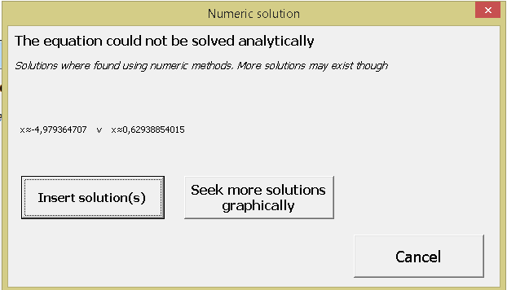

WordMat tries to find all solutions to the equation, but there is no guarantee that all solutions are found, and it can take a while. Solutions are written as they are found, so you may well find that the set of solutions is slowly growing.

Note also the central button of the dialog box, which makes it possible to solve the equation graphically.

example:

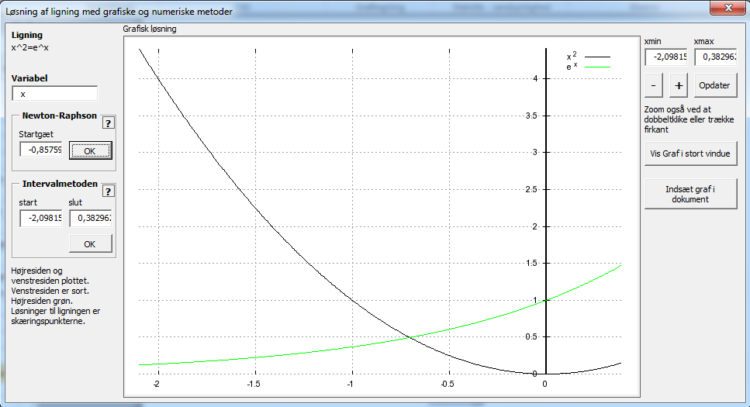

You are automatically shown a graph in which the left side and right side of the equation are plotted. The solutions to the equation are the x-coordinates of the intersections of these graphs. You can zoom out to get an overview of how many solutions exist and zoom in on a specific solution to set it more accurately. When you are zoomed in on a solution, you can choose between two different numerical methods, each having its strengths and weaknesses.

### Interval-method

This method takes an interval as input. By default this is set to appear in the graph window. There must be exactly one solution in the range otherwise an error is returned. This is the most reliable method if you have zoomed in and found one solution in the window.

### Newton-Raphson method

A fast and effective method that can find a very accurate solution, provided an initial guess is available. For a detailed description see Wikipedia: <http://en.wikipedia.org/wiki/Newton's_method>

Unfortunately, the Newton-Raphson method also has its disadvantages.

* If no solution is found, it enters an infinite loop and it becomes necessary to press stop.
* If there is a solution, there is no guarantee that it will be found, especially if the initial guess is far from it.
* Only one solution is ever found, even if there are several. What solution is found depends on the initial guess.
* There is a risk that a solution is found which is not a real solution.

WordMat can also use a variant of this method to solve systems of equations numerically. Since it is one of the types of Newton's method, it needs an initial guess for each variable.

## Solving Inequalities

Solving inequalities is much the same as solving equations, but the method is not quite as robust as when solving equations, so if it fails, you can try solving the corresponding equation or solving the equation with numerical / graphical methods.

Equations with inequalities are not supported yet.

Examples:

*The inequality is solved for x by WordMat.*

Slightly more complex:

*The inequality is solved for x by WordMat.*

The Graph programm has a great feature to display graphically the solutions to an inequality. If an inequality is highlighted and Graph is clicked in the ribbon/menu, the solution is shown automatically, as for the previous example:



## Systems of equations

Alternativt kan man angive alle ligningerne i samme matematikfelt adskilt af ∧ (indtastes \wedge )

Write the equations of the system of equations in succession in different equation boxes. Select the equations which are part of the equation system and click 'Solve equation (s)', or use Alt + L.

Alternatively, you can specify all the equations in the same mathematics field separated by ∧ (enter \ wedge)

The number of variables to solve the system for must be the same as the number of equations.

The 'eliminate variable' item under ”Solve equation” can be used to reduce a system of equations for fewer equations with certain variables eliminated. Note also that the order of the equations may have an influence.

Examples:

Derivation of formula for a and b in power function

*The system of equations is solved for b,a by WordMat's 'solve equation' function,*

Intersection between circle and straight line:

*The system of equations is solved for x,y by WordMat's 'solve equation' function,*

## Differential Equations

WordMat can solve ordinary differential equations of the first and the second order.

You can use the standard notation for differential calculus. Here are three ways to enter the same differential equation.

|  |  |
| --- | --- |
|  | A differential equation is solved by clicking "Solve Differential Equation" under "Solve the Equation (s)". Then you get this dialog box:  WordMat will attempt to identify the independent variable and the dependent variable. Make sure its choice is correct.  If the differential equation includes a function such as f(x) instead of a variable such as y. then you have to write the function as f(x) and not just f.  Enter any initial condition. If there is none, click ’ok’. you will just get the general solution with c as constant. |

The result of the above becomes:

*Differentialligningen løses vha. CAS-værktøjet WordMat's 'Løs differentialligning' funktion*

If you specify an initial condition, It will also appear in the comment.

Example of a differential equation of the second order.

|  |  |
| --- | --- |
|  | Here you get more possibilities since you may enter initial conditions or boundary conditions.  If none is entered you get the general solution with the constants c1 and c2.  Initial conditions  Enter the first two y (..) = and y '(..) =  Boundary conditions:  Enter the first y (..) = and the last y (..) = |

The result of the above becomes:

*Differentialligningen løses vha. CAS-værktøjet WordMat's 'Løs differentialligning' funktion med randbetingelserne y(0)=1 og y(1)=2*

Here, the general solution of the logistic differential equation is determined

*Differentialligningen løses vha. CAS-værktøjet WordMat's 'Løs differentialligning' funktion*

Another logistic equation, with an initial condition (N(0)=100):

*Differentialligningen løses vha. CAS-værktøjet WordMat's 'Løs differentialligning' funktion med startbetingelsen N(0)=100*

Note that you can get the direction field and associated integral curves for a first order differential equation of the form

See graphing / direction field.

## Systems of differential equations

WordMat has a built-in numerical solution procedure for a system of one or more differential equations. The system is solved using Runge-Kutta 4th order method. This feature is available by clicking the down arrow at the right of the 'Solve equation (s)' - button. You can enter the differential equations in the document, select them and then activate the function, or you can enter functions directly into the dialog box. The variables should never be written as functions. (that is, N is not N(t))

Here is an example of solution of a system of three differential equations (SIR-syndrome spreading model)

Select the equations, and click “solve system of differential equation (s) numerically” , then set the constants as follows: c = 0.3, N = 101, p = 0.15. The starting values are set in the following dialog box. Press 'Update' when done. (The calculation may take time, depending on the step size)

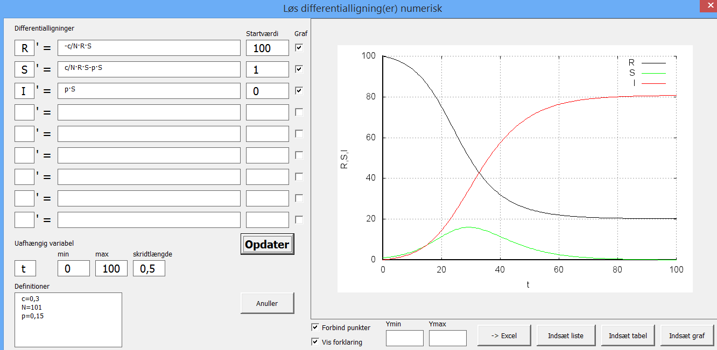

The following graph will be inserted in Word:

WordMat|1.04|c=0,3
N=101
p=0,15||t|R|0|100||||||||||||||||||||||||||||||||||||||||||||||||0;100
0,5;99,84601
1;99,68059
1,5;99,50293
2;99,31221
2,5;99,10757
3;98,88807
3,5;98,65277
4;98,40064
4,5;98,13065
5;97,84168
5,5;97,53262
6;97,20229
6,5;96,84947
7;96,47294
7,5;96,07142
8;95,64364
8,5;95,18831
9;94,70413
9,5;94,18983
10;93,64412
10,5;93,0658
11;92,45367
11,5;91,80661
12;91,12359
12,5;90,40367
13;89,64601
13,5;88,84994
14;88,01492
14,5;87,14061
15;86,22683
15,5;85,27365
16;84,28134
16,5;83,25044
17;82,18174
17,5;81,07629
18;79,93541
18,5;78,76071
19;77,55405
19,5;76,31757
20;75,05364
20,5;73,7649
21;72,45417
21,5;71,12446
22;69,77895
22,5;68,42093
23;67,0538
23,5;65,68099
24;64,30595
24,5;62,93211
25;61,56285
25,5;60,20144
26;58,85103
26,5;57,51463
27;56,19506
27,5;54,89494
28;53,61668
28,5;52,36245
29;51,13421
29,5;49,93366
30;48,76227
30,5;47,62126
31;46,51165
31,5;45,43421
32;44,38952
32,5;43,37796
33;42,39973
33,5;41,45486
34;40,54324
34,5;39,6646
35;38,81857
35,5;38,00467
36;37,22233
36,5;36,4709
37;35,74967
37,5;35,05787
38;34,39468
38,5;33,75927
39;33,15078
39,5;32,56831
40;32,01098
40,5;31,4779
41;30,96818
41,5;30,48094
42;30,0153
42,5;29,57041
43;29,14542
43,5;28,73953
44;28,35193
44,5;27,98185
45;27,62854
45,5;27,29126
46;26,96933
46,5;26,66205
47;26,36878
47,5;26,08889
48;25,82178
48,5;25,56687
49;25,32361
49,5;25,09147
50;24,86993
50,5;24,65851
51;24,45675
51,5;24,26421
52;24,08045
52,5;23,90507
53;23,7377
53,5;23,57794
54;23,42546
54,5;23,27992
55;23,141
55,5;23,00838
56;22,88179
56,5;22,76094
57;22,64557
57,5;22,53542
58;22,43026
58,5;22,32985
59;22,23398
59,5;22,14244
60;22,05502
60,5;21,97155
61;21,89183
61,5;21,8157
62;21,743
62,5;21,67356
63;21,60724
63,5;21,54389
64;21,48339
64,5;21,4256
65;21,37039
65,5;21,31766
66;21,26729
66,5;21,21916
67;21,17319
67,5;21,12927
68;21,08731
68,5;21,04722
69;21,00892
69,5;20,97232
70;20,93735
70,5;20,90395
71;20,87202
71,5;20,84152
72;20,81237
72,5;20,78452
73;20,75791
73,5;20,73248
74;20,70817
74,5;20,68495
75;20,66276
75,5;20,64155
76;20,62128
76,5;20,6019
77;20,58339
77,5;20,5657
78;20,54879
78,5;20,53263
79;20,51718
79,5;20,50242
80;20,48831
80,5;20,47483
81;20,46194
81,5;20,44962
82;20,43785
82,5;20,4266
83;20,41584
83,5;20,40556
84;20,39573
84,5;20,38634
85;20,37737
85,5;20,36878
86;20,36058
86,5;20,35274
87;20,34525
87,5;20,33809
88;20,33124
88,5;20,32469
89;20,31844
89,5;20,31246
90;20,30674
90,5;20,30128
91;20,29606
91,5;20,29106
92;20,28629
92,5;20,28173
93;20,27737
93,5;20,2732
94;20,26922
94,5;20,26541
95;20,26177
95,5;20,25829
96;20,25496
96,5;20,25178
97;20,24874
97,5;20,24583
98;20,24305
98,5;20,2404
99;20,23786
99,5;20,23543
100;20,23311
|0;1
0,5;1,076163
1;1,157852
1,5;1,245425
2;1,339255
2,5;1,439731
3;1,547259
3,5;1,662256
4;1,785154
4,5;1,916395
5;2,056432
5,5;2,205722
6;2,364727
6,5;2,533909
7;2,713726
7,5;2,904625
8;3,107039
8,5;3,321381
9;3,548033
9,5;3,787344
10;4,039616
10,5;4,305097
11;4,583973
11,5;4,876352
12;5,182259
12,5;5,501623
13;5,834264
13,5;6,179884
14;6,538054
14,5;6,908209
15;7,289635
15,5;7,681464
16;8,082669
16,5;8,492061
17;8,908287
17,5;9,329839
18;9,75505
18,5;10,18212
19;10,6091
19,5;11,03395
20;11,45452
20,5;11,8686
21;12,27392
21,5;12,66823
22;13,04924
22,5;13,41475
23;13,76262
23,5;14,0908
24;14,39739
24,5;14,68065
25;14,93902
25,5;15,17113
26;15,37585
26,5;15,55226
27;15,6997
27,5;15,81773
28;15,90617
28,5;15,96504
29;15,99461
29,5;15,99536
30;15,96796
30,5;15,91325
31;15,83225
31,5;15,7261
32;15,59606
32,5;15,4435
33;15,26985
33,5;15,07661
34;14,8653
34,5;14,63749
35;14,39472
35,5;14,13854
36;13,87047
36,5;13,592
37;13,30456
37,5;13,00954
38;12,70827
38,5;12,40202
39;12,09197
39,5;11,77925
40;11,46492
40,5;11,14994
41;10,83522
41,5;10,52159
42;10,20982
42,5;9,900589
43;9,594526
43,5;9,29219
44;8,994081
44,5;8,70064
45;8,412254
45,5;8,129257
46;7,851937
46,5;7,580534
47;7,315251
47,5;7,056248
48;6,803651
48,5;6,557555
49;6,318023
49,5;6,085093
50;5,858776
50,5;5,639064
51;5,425926
51,5;5,219317
52;5,019172
52,5;4,825415
53;4,637957
53,5;4,4567
54;4,281533
54,5;4,112341
55;3,949001
55,5;3,791385
56;3,639358
56,5;3,492786
57;3,35153
57,5;3,215447
58;3,084397
58,5;2,958237
59;2,836823
59,5;2,720014
60;2,607668
60,5;2,499646
61;2,395807
61,5;2,296017
62;2,20014
62,5;2,108045
63;2,0196
63,5;1,93468
64;1,853161
64,5;1,77492
65;1,699841
65,5;1,627806
66;1,558705
66,5;1,492428
67;1,42887
67,5;1,367927
68;1,309499
68,5;1,253491
69;1,199809
69,5;1,148362
70;1,099062
70,5;1,051825
71;1,00657
71,5;0,9632175
72;0,9216911
72,5;0,8819177
73;0,8438266
73,5;0,8073494
74;0,7724206
74,5;0,7389768
75;0,7069572
75,5;0,6763032
76;0,6469585
76,5;0,6188688
77;0,5919821
77,5;0,5662482
78;0,5416191
78,5;0,5180485
79;0,495492
79,5;0,4739071
80;0,4532527
80,5;0,4334897
81;0,4145802
81,5;0,3964882
82;0,379179
82,5;0,3626191
83;0,3467769
83,5;0,3316216
84;0,3171238
84,5;0,3032556
85;0,2899899
85,5;0,2773009
86;0,2651638
86,5;0,2535549
87;0,2424514
87,5;0,2318317
88;0,2216749
88,5;0,2119609
89;0,2026707
89,5;0,1937859
90;0,1852889
90,5;0,1771631
91;0,1693923
91,5;0,1619611
92;0,1548548
92,5;0,1480593
93;0,141561
93,5;0,1353471
94;0,1294052
94,5;0,1237234
95;0,1182904
95,5;0,1130954
96;0,108128
96,5;0,1033783
97;0,09883679
97,5;0,09449435
98;0,09034233
98,5;0,08637239
99;0,08257658
99,5;0,0789473
100;0,07547726
||True|True|2|2|||true|false|false|false|

Note that you can also download the calculated points into Excel if you want to continue working with them. If necessary, plot them using Excel or another graphing program.

## System of differential equations with Excel and Euler method

Excel can be used quite easily for this purpose and provides an ideal opportunity to gain insight into how Excel works and how to make numerical calculations.Here is an example made with embedded Excel sheets.



Enter in the sheet the constants to be used in the calculations (if there are any in your equations). Create a column for the independent variable (here t) and one for each of the dependent variables and their derivatives.

Insert a suitable number of values for the independent variable. (here t varies from 0 to 100, with an increment of 1)

Insert starting values for the dependent variable (here R = 100, S = 1, I = 0)  
The derivative is calculated using the differential equations, the initial values and the constants (if any).

In the next series, the new values of the independent variables are calculated using linear projection. For example,

This projection is made for al series, and the formulae are copied down to every row .A graph of the points can then be constructed. Afterwards, you can try to change the constants and the step to see how the graph changes.

# Graphing

## Graphing applications

There are 4 different programs that can be used to draw graphs. They each have their advantages, and which you choose to use will probably depend on the level of mastery you have achieved for each of them.

Under Settings/Graph, you can choose which of the four graph programs will be called by default. This program is activated when you click "Show graph" or press Alt + P.

Anyway, clicking the down arrow at the right of the button "Show graph" allow you to choose between all four graphing applications. The default program is all just a little quicker to reach.

The principle is to select at first the object to plot in Word.(For example, a function expression and / or the points from a table). Then WordMat takes care of transferring the selected object(s) to the graphing program and activates that program. However, there are elements that can not be displayed by all the graph applications.

### Gnuplot

The standard graphing program. It is the fastest and the only one that is 100% compatible with Maxima. With Gnuplot, the function expressions can take advantage of existing definitions, and derivative or integrals can be included in the expressions.

Selecting an expression and clicking the graphing command will automatically display the graph for that expression.

Regular functions, equations, parametric equations, points, vectors etc. can all be plotted with Gnuplot.  
The graph can be zoomed by dragging a rectangle around the area to be zoomed in. Double click to center and zoom.

The graph can be easily inserted as a picture in Word, and all settings are stored in the image so it can be edited by double clicking on it again. The size of the image can easily be changed, and all Words image editing features can be applied to the image of the graph. Elements can be added using AutoShapes.

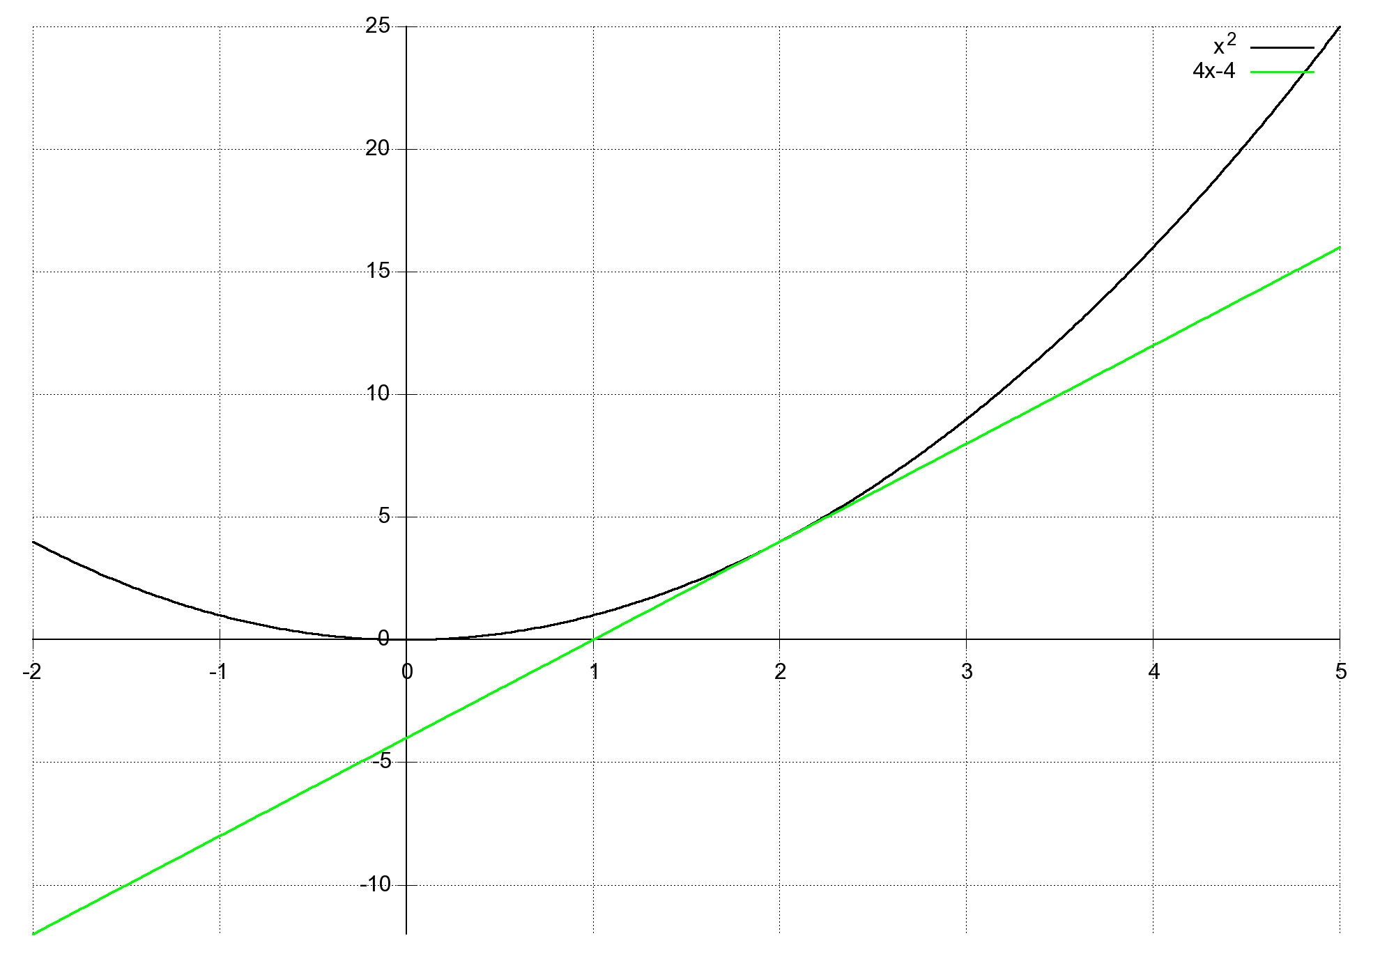

The limitations of Gnuplot are that many calculations (such as finding a tangent) cannot be performed directly in the graph. Zooming in / out commands are not sliders.  
You can also open the graph window in gnuplot directly. It provides the following options:

* Below the graph, the mouse coordinates in the coordinate system are continuously displayed.
* Zooming can be done by pressing the right mouse button, moving the mouse so that a squareis selected, and press the right mouse button again.
* Press a or u to get back to basics.
* To copy the image to the Word: Right-click the menu bar, select Options and then 'copy to clipboard'. Now close the graph window and paste in Word.
* Press r (ruler) so you can measure distances in the coordinate system
* Press g (grid) to turn on / off diced

### Graph

Graph is very user-friendly, fast and has many features, (but not as many as GeoGebra). You can solve inequalities, differentiate, insert functions, points, tangents, areas, etc.  
Note: If you double-click on the graph in the document, it is is opened in Graph again and you can edit it.



Note that Graph takes longer to open if there are definitions active, or if something is selected, because the transfer to Graph takes a little time. Custom functions are not automatically plotted, but will be listed on the left. Check the checkbox beside the definition to display the graph. Defined constants and functions can be edited in Graph by pressing the small icon with f (t) in the middle of the toolbar.

### GeoGebra:

Geogebra is a very powerful program for both geometry and graphing. Clearly it is the most versatile of the four graphing programs. The downside is that the program has a slightly steeper learning curve, and that the outcome cannot be readily inserted so you can later edit it again. The result can be copied into Word as a picture, using the command "copy drawing" in GeoGebra.

It can also partially be done using "insert GeoGebra object" but the GeoGebra file is then represented as a small icon in Word and not a graph.

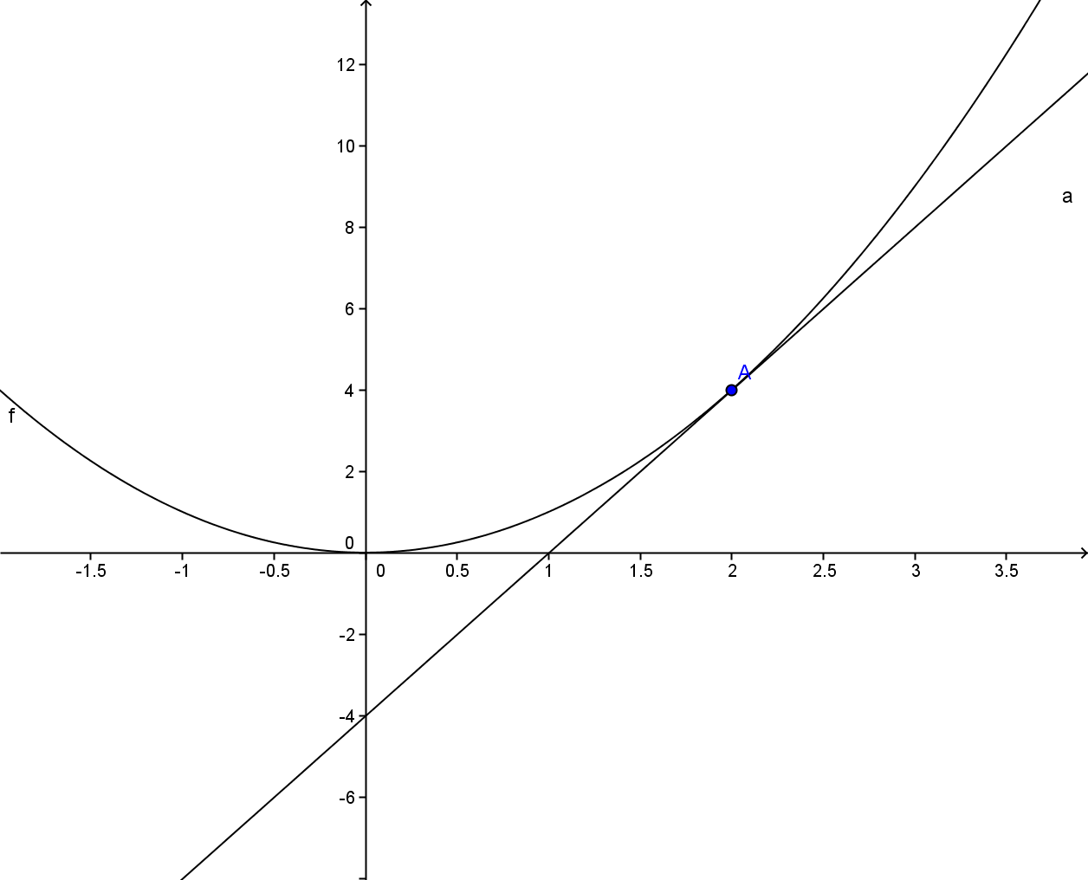

Note that x must be the independent variable. If x isn’t part of the expression to plot, you will be prompted for the independent variable. Alternatively, enter a function definition where the independent variable is specified: Example:

|  |  |
| --- | --- |
|  | Constants that are part of the expression are automatically inserted as sliders.  If the initial values for these constants are undefined, a dialog bos asking for an initial value will be displayed |

### Excel:

Excel makes nice graphs that can be inserted embedded in Word so that they can later be opened and edited again. A graph can be customized in many ways. But it works a little slowly.  
There is a tick box in the settings (under Settings / Graph) is that determines whether the graph is inserted embedded in the Word document or opened in Excel externally.



The graphing spreadsheet has a custom function to easily select a point on a graph with a red dotted line, as well as to determine a tangent. It's easy to enter up to 3 different series of points, and constants in the function expression are edited using worksheet cells reserved for this.

### Microsoft Mathematics:

This program is not part of WordMat, but if it is installed, it can also be used to plot graphs. It creates small embedded graph directly in Word, excellent for reading points using the Trace function, but the axis subdivisions are often very skewed and cannot be set manually.  
It will graph both functions and equations, and can make use of 3D coordinate systems. Note that the graph window can be enlarged by double clicking on the menu.

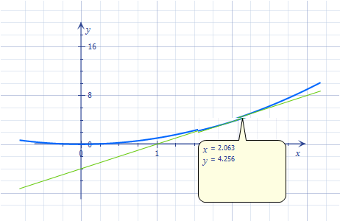

## 3D Graphs

Select the menu item. You can plott regular functions, equations, vectors, parametric equations and points.You can enter regular functions, equations or vectors in a Word maths field and click “3D plot” in the menu. The Graph will automatically be inserted. There are settings that can affect how the chart will look like, and quality level controls as well. The higher the quality the longer it takes to draw the figure. If there are a lot of entities to graph, and if a very high quality is selected, the graph may take longer than 1 minute to display.

example:

|  |  |
| --- | --- |
|  | The figure shows:  - The Unit sphere  - The parametric straight line:  - The tangent Plan at the point where the line and the sphere Intersect:  - The Normal vector to the plan: |



When the 3D plot window is open, you can rotate the figure by dragging it around with the left mouse button pressed. To copy the image to Word, right-click menu and select Options and then 'copy to clipboard'. Now 3Dplot window closes and the image is deployed.

The following command can also be used to create 3D graphs. However, only regular functions can be plotted that way..

Volume of Revolution

|  |  |
| --- | --- |
|  | If you click the ”Volume of Revolution” button under "3D plot", you get this dialog box.  If the cursor was in an expression, that expression will be inserted. The input function graph is rotated 360 degrees on the x-axis, so as to obtain the 3D shape. You can enter two functions, the graphs of which will both be rotated providing a mean to define a more complex figure. |
|  | When the 3D plot window is open, you can rotate the figure by dragging around with the left mouse button pressed. To copy the image to Word, right-click menu and select Options and then 'copy to clipboard'. Now 3Dplot window closes and the image is deployed |

**Microsoft Mathematics** can make 3D graphs that can be rotated. Enter Expression or equation, right click and select "plot in 3D"  
Examples: plane and sphere. Hilight both equations, right click and choose "Graph Plot in 3D"

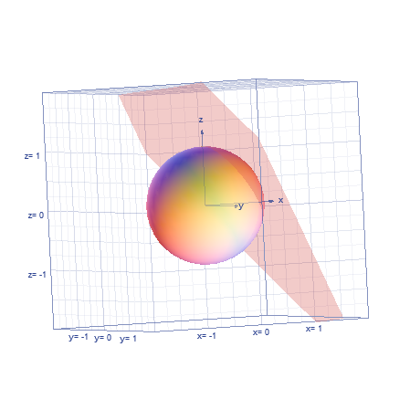

The object can be rotated by holding the left mouse button down and dragging around.

## Direction Field

You can visualize the direction field and associated integral curves of a 1st-order equation of the form

Example:

|  |  |
| --- | --- |
| WordMat|0.999|||||-5|5||||x|||-1||x|||-1||x|||-1||x|||-1||x|||-1||x|||-1|||||||||||||||||||False|False|1,2|1,2|||True|False|False|True| | Highlight The equation and press the ”direction field” item in the menu under "View graph".  Now the direction field is shown, and it is possible to enter up to 5 points which must be part of integral curves.  It is also possible to plot all sorts of other objects in the same coordinate system.  It is also possible to open an interactive window where you can click the graph to enter points wich must be part of an integral curve. You can also insert sliders which can dynamically change the constants in the equation |

## Statistical Diagrams

WordMat can generate all the statistical charts typically used in the Danish Gymnasium. This is done using. Excel documents. They can either be opened externally in Excel or embedded in Word, it depends on the setting (under Settings / graph).

Embedding documents has the advantage that you can always edit them by double clicking on them, but unfortunately it takes some time to insert the Excel worksheet, if you have a slow computer.

When you are finished editing an emedded sheet, it is stored in the Word document. If you later want to edit the sheet again, just double click on the sheet. Alternatively, you can right-click it and choose 'Spreadsheet macro-enabled' / 'open'. Then the sheet will be opened in Excel. When it closed the changes are saved in Word. It might be nicer to edit Excel document in Excel instead of embedded, as it is a little faster. You should then be aware that the window size is set in Excel indicates how much the of the embedded sheet will be visible in Word.

Note that the embedded Excel sheets can not be copied, either within the current Word document or to other Word documents. Word locks if you try. However, you can convert the Excel sheet to an image that can be copied, or open the sheet and save it in a file.

Please also note that there is a difference between changing the size of the embedded Excel sheets when it is open or closed. When it is closed, the effect is only zooming in or out. When it is open, you can change how much of the spreadsheet you can see.

Wordmat uses a spreadsheet which combines most charts. It is opened by pressing the stats button during graphing. In this spreadsheet is a series of tabs at the bottom that can be selected.  
The first tab is "data". Here you can enter raw data, have them counted and possibly group them. Then data can be copied to the other tabs for further analysis.

The next two tabs make a complete calculation of all the results you might need, and all relevant charts, depending on whether you have a grouped or ungrouped dataset. The two tabs deal with only one set of data, and often would you need for only a chart or compare data sets. In addition, they make use of more specific spreadsheets that can be selected by pressing the lower part of the statistics button in WordMat menu.

You can enter observations and frequencies, and frequency and cumulative frequency are calculated automatically. Also calculated are the following statistical descriptors: Median, first and third quartile, mean and standard deviation. You can also calculate any percentile.

If you only have raw data that must first be grouped and/or counted, you can use the sheets in the same spreadsheet called 'Groups' and 'Count Frequencies'

Box Plot, bar chart (or Stick chart) and step-wise cumulative frequency curve are generated automatically for ungrouped observations.

Box Plot, Histogram and cumulative frequency curve are generated automatically for grouped observations.

If there is data you do not want, you can hide columns by changing the column width. Charts you do not want to can be deleted. The diagrams can be moved and resized at will.

Example: ungrouped data set (double click to edit)



Example: Grouped data set (double-click to edit)



### Specific charts

Sometimes you may need a certain type of diagram and have all necessary data, so you may use the sheet specifically designed for a particulardiagram. There are sheets for:

Stick chart ( Bar chart), Histogram, Step-wise cumulative frequency, cumulative frequency and box plot

Another advantage of the specific sheet to Step-wise cumulative frequency, cumulative frequency and box plot is that they can be used for comparison of data sets. The two excelsheet for ungrouped and grouped observations treat only one dataset at a time.

In the specific excel sheet, you can select the sheet in which only the graph is displayed.



# Regression

## Linear, exponential, power or polynomial regression models

WordMat can use 4 different regression models: linear, exponential, power and polynomial (arbitrary order), as well as a user-defined regression equation type. Calculations are performed by WordMat itself. The input is a table of data points, or a list of points in a mathematics field.

Regression can also be made from 'plot graphs' menu, or via Excel. Since a table of items can be horizontal or vertical, WordMat tries to determine the direction of the table, but it may be ambiguous. For example, if there are only two points.

For example, the following table is understood as the points (1,2) and (3,4) is not (1,3) and (2,4).

|  |  |
| --- | --- |
| 1 | 2 |
| 3 | 4 |

Both comma and period can be used as the decimal separator. Mathematical expressions cannot be used in this context. However, scientific notation can be used. For example, 2.1 * 10^ 6 or 2,1E6.

One can select a part of a table. If the cursor just stand somewhere in the table, the entire table is used for the regression. Letters in the table are ignored, but do not cause errors.

The results returned by WordMat are the regression equation (i.e. the function that best fits the points), and the coefficient of determination(R²).

Example of a list of points which can be used as input for a regression:

Here with; as the list separator. The list separator is identified from the context.

Regression can also be performed via the "Show Graph" menu. Here are the items entered in the text box and the desired regression is computed and plotted in the same coordinate system. Data is not entered in the same way as in the Word document

## User-defined regression

In order to compute the parameters of a user defined regression, you must input, in addition to a table, a regression function type. The function can be entered just below the table and selected with the table before clicking ”regression”. It may also be entered subsequently, in the dialog box.

Example:

|  |  |
| --- | --- |
| X | Y |
| 1 | 4,5 |
| 2 | 8 |
| 3 | 7 |
| 4 | 10 |

WordMat returns the values which, attributed to the three constants (a, b, c) will cause the function to be the closest possible approximation of the points. You decide what are the constants to be evaluated.

It is possible to state the desired precision for the constants. Note however that this may affect the calculation time, especially when many constants are to be determined.

It is possible to enter an initial guess for the individual constants. Good initial guess can be important.

It is important to note that in the case of a numerical method, there is no guarantee that the solution found is the better. It can largely depend on the initial guess, especially if there are many constants in the expression.

# Summation and products

Example:

To get this expression, enter: ∑_(n=1)^5 (n^2-n) or use the template from the menu.

You can also use the product symbol:

# Calculus

Remember that, if trigonometric functions are differentiated or integrated, in most cases the angle units should be set to radians.

## Limits

Example: Derivative of f(x)= x² at point x

To get this expression, enter: lim_(h->0) ((x+h)^2-x^2)/h.

If there are no other elements in the maths field, it is not necessary to enter brackets around the term you take the limit of.

One can also determine right-hand and left-hand limits

Example:

|  |  |
| --- | --- |
| f(x)  WordMat|0.999|f(x)=2+x+√(4x^4-8x^2+4)||||-5|5|||2+x+√(4x^4-8x^2+4)|x|||-1||x|||-1||x|||-1||x|||-1||x|||-1||x|||-1|||||||||||||||||||False|False|1,2|1,2|||True|False|False|True| | f’(x)  WordMat|0.999|f(x)=2+x+√(4x^4-8x^2+4)||||-5|5|||f'(x)|x|||-1||x|||-1||x|||-1||x|||-1||x|||-1||x|||-1|||||||||||||||||||False|False|1,2|1,2|||True|False|False|True| |

The function is not differentiable at x = -1 and x = 1

But we can find the right / left limit

Note that the small + and - must be exponents.

## Differential calculus

Derivatives can be entered in several different ways

or are valid notations.

,

Other notations:

Or with no variable specified (the variable will be assumed to be x)

The expression to be differentiated need not have a functional form (as f(x)), but then the independent variable must be x.

The value of the derivative (for example, ) can also be calculated without first calculating .

The differential notation ( ) is also supported

In this context, a differential d is used. It is entered as \dd (There is an option to use ordinary d, but it can be dangerous as other expressions in which both the denominator and the counter starts with d might be misunderstood as differentials). Enter differentials as: \dd / \dd x (x^2+2x)

Examples:

, , , ,

Similarly, the standard notation for partial derivatives is used (entered as \ partial → ∂)

## Integral calculations

WordMat can evaluate both definite and indefinite integrals, exactly and numerically. Enter the integral in a math field and click calculate.

The shortcut to an integral character is \ int

Note, however, that there are two integral signs of different size. Two space after \ int gives the nicest characters.

For definite integrals, enter the following: \int_0^3 , which becomes:

Examples:

Remember to set the correct radians / degrees setting when using trigonometric functions.

Basically WordMat attempts to solve definite integrals exactly. If the attempt fails, numerical methods are tried. However, for some integrals, WordMat will take a very long time trying to comptute the integral exactly, so if the output is set to be numerical, try first with numerical methods. Another way to impose numerical integration is by using the form:

(note the capital N and I. You may use semicolon as separator)

GeoGebra can also perform numerical integration by finding the area under a function’s curve.

GeoGebra notation is

Integrale(f(x),a,b) The area between the x-axis and f(x), from a to b

Integrale(f(x),g(x),a,b) Area between g(x) and f(x), from a to b

Likewise, Graph also be used to find areas under function curves. It is very intuitive.

Note that a constant is added to the indefinite integrals.

It is possible to use an infinity sign for the limit of the integration interval:

The shortcut to ∞ is \infty

Double and triple integrals are supported .For example:

Note that there must be continuity[3] between dx and dy

It is also possible to use double and triple integral sign for indefinite integrals.

# Matrix and vector calculations

A vector can easily be entered in the following way:

Enter the brackets and then enter a space

Press then the back arrow and press enter repetitively

Each time you press enter, a new row will be added. Of course there are also shortcuts in design menu, but it is quicker to enter a vector that way.

It does not matter whether you use parentheses or brackets. Whether there are common or brackets at the output depends on the input and definitions. If brackets are used in the input, brackets will also be used in the output.

Vector addition and multiplication by a constant can easily be carried out

The dot product is naturally written with a multiplication sign.

The determinant is:

It is recommended that the definition of vectors is done using the arrow above the variable, but it is not required.

In order to enter the vector arrow, enter a\vec followed by two spaces.There is also another vector arrow that can be used: \rhvec .

If there are unknown vectors in an expression, it is necessary to specify them with arrow above, otherwise they are assumed to be constants.

The cross product (vector product) is defined for two vectors in space. \times ->

Tværvektor[4]: a\vec\hat

A tværvector is the rotation of a 2D vector 90 degrees counter-clockwise. The tværvector T of A is calculated as follows[5]:

The Tværvektor symbol is an operator. That is, it can not be defined, but only calculated.

Length (modulus) of a vector

Examples:

Angle between the vectors:

*The equation is solved for v by WordMat.*

Projection

Equations systems using Vectors

Intersection between line and plane.

*The system of equations is solved for x,y by WordMat's 'solve equation' function,*

You can refer to the elements of a Vector / Matrix with the following notation

Or:

Or, if the Settings / notation/ subscript is set to index (see the section on settings), you can write

where r is the row index and k is the column index.

Examples:

## Matrices

Matrices are entered by first entering the brackets and then spaces

Position then the cursor inside the new matrix and select from the Design menu “matrix” what best describes what you need.

The matrix can now be extended by right-clicking inside the matrix and using the context menu item “insert”. That way, one may insert an additional column

The hardcore Word users can also enter matrices using shortcuts: [\matrix (1 & 2 @ 2 & 3)] and space.

One can also use some Maxima functions which are especially good, to produce very large matrices.

To generate the (n x m) matrix such that all coefficients are zeros except coefficient Ci, j Which has the value x:

The very advanced reader can use the following command to insert values based on a function that takes column and the column number as parameters ..

Matrix addition and multiplication can be performed, as well as exponentiation.

The inverse matrix can also be calculated.

The determinant is written:

In the definition of matrices, it can be advantageously to use a bar above the variable. Shortcut \overbar

There are also a number of features built into Maxima, which may be relevant. Some of these are listed here:

Gauss-elimination, Reduced Row Echelon Form.

Finds eigenvalues

Finds eigenvectors,in list form

Transposes matrix M

Returns matrix with 1's in the diagonal and 0s under it

Examples

# Triangle Solver

From the input of known sides and angles, the triangle solver can calculate the remaining sides and angles in arbitrary triangles and draw the triangle with the correct dimensions and show intermediate calculations underlying the result.

example:

WordMat's triangle solver using input: A = 67 ° C = 34 °, b = 5 🡺 output follows

|  |  |
| --- | --- |
| A  B  C  a  b  c | A = 67°  B = 79°  C = 34°  a = 4,688668  b = 5  c = 2,848296 |

Vinkel B findes vha. vinkelsum = 180° i en trekant

Siderne a og c findes vha. sinusrelationerne

Note that the calculated results highlighted in bold.[6]

WordMat's triangle solver can be used for an experimental approach to triangles.

- What to know in order to calculate all sides / angles? (the existence of a solution is indicated immediately below the OK button).

- Under what circumstances can there be two solutions? (It is also indicated below the OK button).

Likewise, triangle solver can be used to compare one's own solution method with Word Mats and visualize the triangle.

WordMat's triangle solver can also be used for examination purposes during a course. Here one should not insert the values. It is also important that the names of the angles and sides are correctly entered.

# Units

One can immediately write units on any number in a calculation. But if you set the ”units” option (in the settings), these units are assembled after the figure and reduced to the shortest unit. The common prefix are supported. Units can be easily turned on / off using the shortcut Alt + E.

The disadvantage of setting ”units” on is that it can affect the speed of the calculations and that one must be careful what one calls its variables. m, g, V, K, etc. can not then be used as ordinary variables. Especially in physics formulas, it can cause problems when m often stands for mass. You can then use big M or m¬1 with subscript. Also, g denotes both acceleration due to gravity at the Earth's surface and grams. Use for example gjord instead of g. One should also be careful with variable names two to three alphabetic characters long as it can be confused with a unity with prefix. For example aM, etc., ...

In addition to WordMat gets a little worse for solving equations. Try then to turn units off and solve equation with all variables unknown. Next, turn the units on and calculate the values defined or inserted.

A distinction is made between uppercase and lowercase letters. The units must be written correctly. For example, the Joule is written with J and not small j. Prefix kg should be written with a small k.

Note that you should use a multiplication sign between numbers and the units. In the output, Units are always indicated without prefix.

It may be advantageous to switch to numeric results when using the units and possibly turn scientific notation on. The exact results are then often interesting.

|  |  |  |  |  |  |  |
| --- | --- | --- | --- | --- | --- | --- |
| **Prefix** | **name** | **value** |  | **Prefix** | **name** | **value** |
| Y | Yotta | 1024 |  | y | yocto | 10-24 |
| Z | Zetta | 1021 |  | z | Zepto | 10-21 |
| E | Exa | 1018 |  | a | atto | 10-18 |
| P | Peta | 1015 |  | f | femto | 10-15 |
| T | Tera | 1012 |  | p | pico | 10-12 |
| G | Giga | 109 |  | n | nano | 10-9 |
| M | Mega | 106 |  | μ | micro | 10-6 |
| K | kilo | 103 |  | m | milli | 10-3 |
| h | hecto | 102 |  | c | centi | 10-2 |
| da | deka | 101 |  | d | deci | 10-1 |

SI-Fundamental units

|  |  |  |
| --- | --- | --- |
| **Measurement** | **unit** | **name** |
| Length | m | meter |
| Mass | kg | kilogram |
| Time | s | sekund |
| Temperature | K | Kelvin |
| Electrical current | A | Ampere |
| number of chemical entities | mol | mol |
| Light intensity | cd | candela |

**SI derived units**

N, J, W, Pa, C, V, F, Ω (eller Ohm), T, H

**Other units that can be used**

Length AU, ly, pc

Volume: L,liter

Time seconds, minutes, days,....

Mass u,ton

Frequency Hz, Bq

Energy eV, kWh, cal, kcal

Pressure bar, torr, mmHg, atm

Temperature Temperatur: (specielt tegn \degc) men virker som Kelvin

Many units also have a longer version For example, meters. Then a prefix may be added to the long version, for example kilometers

Output Units

By default, the output uses one of the SI units listed above, without prefix. However, you can force WordMat to use a particular unit in the output, in the settings. Just enter the units you want to use , separated by commas. It is not allowed to enter two units of the same physical quantity (eg both eV and aJ as both are units of energy)

You can not set the output in combined units. cm ^ 3 or km / h is for example not allowed. You have to respectively set the output to cm and km, hours

You can also set output units using the following command:

After this command energy will be expressed in eV and lengths in nm.

Examples:

Calculation of the thermal energy required for heating the water 500g 15 degrees

Calculation of the length of time a bike takes to cover a distance of 50km The speed is 10 m / s

The equation solved for t 🡺

Electrical example: (units turned on) 🡺definition+ calculation

Calculating the angle of diffraction:

Ligningen løses for θ vha. CAS-værktøjet WordMat.

# Special functions

## Maxima

Via WordMat you get access to all of Maxima's library of functions and programming languages. This possibility, However, is only for the most ambitious user.

An overview and explanation of all the features of Maxima can be found here:

<http://maxima.sourceforge.net/docs/manual/en/maxima.html>

The functions can be included in expressions as the other functions you define yourself. The result is found by clicking the button "Maxima command" in the menu ”calculate”; in order to send an expression directly to Maxima. It can be used if you want to make sure that WordMat not interfering. WordMat’s ”calculate” is merely a simplification and converts from radians to degrees.

Below are listed some examples of useful features

examples:

5 mod 4

greatest common divisor

tests if an integer is a prime

random(25) returns an integer randomly chosen between 0 and 24

random(25,5) returns an rational number randomly chosen between 0 and 25.5

Taylor polynomial of f(x), around x=0 , order 3

## Lambert W function

The Lambert W function is the inverse function of

It can be used to solve equations, such as:

The function f is not injective and therefore W comes in two versions: or

These two functions are defined in WordMat. They will only appear if WordMat is set to calculate exactly, otherwise the solution is computed numerically.

## Programming

One can define functions using programming. Here is an example showing the possibilities.

It is recommended to work with linear mathematics fields if you want to program.

# Tips

Here are some basic useful tips for WordMat and math fields in Word

* When you type an equation into it is much faster to use shortcuts than the menu. You should at least know the most common shortcuts

/ followed by a space gives

x^2 followed by a space gives

x_2 followed by a space gives

* Use the keyboard shortcuts to the features of WordMat The most commonly used are

AltGr + Enter to activate calculate  
Alt + L solves equation

* Learn to make use of definitions. This makes it easier to avoid mistakes.
* Use draft view to increase the speed of Word

# Mac

There is a version of WordMat for Mac 2011, but it still not quite as stable as the windows version and lacks some functionality.

# Microsoft Mathematics commands

* Right-click the expressions to see the possibilities. Spaces can be used as implicit multiplication sign
* You can evaluate parts of an expression: select the part and right-click
* Only dot can be used as decimal separator Comma used in lists.

## Expression manipulation

|  |  |  |  |
| --- | --- | --- | --- |
|  | Reducing: To Reduce a term, right-click it and choose Simplify |  | The 4th root of 3 |
|  | Factor ing:  To factor an expression, use Simplify. You can also right-click the expression and select 'Factor' |  | Converts decimal to fraction. |
|  | Expand  Right click and select expand | = | Note that log¬10 is not returned as standard by equation solution. |
|  | e and pi constants are known |  | Absolute value |
|  | Inverse trigonometric functions |  | Rounds to integer |

## Equation Solving

|  |  |  |  |
| --- | --- | --- | --- |
|  | You can also simply right-click on an equation and choose ”solve ...”  Inequalities can also be solved  If no exact solution can be found, the solution is returned numerically. |  | Numerical solution of equations. Can also convert a real value to decimal All solutions are not necessarily returned. |
|  | Solve multiple equations with several unknowns: Hilight equations, right click and choose ”solve for ...” | nsolve(et+1=t+3, {t,-5,5}) | Solves numerically for specific variable within certain Domain. All solutions are not necessarily returned. |
|  | Grafisk løsning:  Højreklik og vælg ’Plot both sides in 2D’  Graphical solution:  Right-click and choose ”Plot both sides in 2D” | nsolve({x+y=0.3, x=sin(y)},{{x},{y,-1,1}}) | Numerisk løsning af flere ligninger |

## Differential and integral calculus

|  |  |  |  |
| --- | --- | --- | --- |
|  | Differentiation:  Enter the expression, right click and choose ”Differentiate on x ”  In differenital notation, a special d will be used, which is obtained by \ dd  Derivn differentiates several times. |  | Indefinite integral  Right click and select 'integrate on x'  Simplify also works in the last two cases, |
|  | Find the limit of a function:  limit((x^2-1)/(x-1),x,1) |  | Definite integral Right click and select 'Simplify' Can only be solved analytically. There is no built-in method for numerical integration. |
|  |  |  | Returns the slope of the function at the chosen point |

## Statistics

|  |  |  |  |
| --- | --- | --- | --- |
|  | **Statistics** Right-click 'Calculate Statistic' provides, inter alia,  Median, Variance, Mean, sort |  | Returns the number of possible different ways to choose k elements among n |
|  | Returns random number between 0 and n |  | Returns the number of permutations that can be made with k elements out of n |
|  | n factorial |  | Counts the number of 2's in the list |

## Vectors and Matrices

|  |  |  |  |
| --- | --- | --- | --- |
|  | Vector addition, multiplication by a constant Also works in higher dimension. |  | Reduces the matrix to its reduced echelon form |
|  | The length of the vector  Also works with -notation |  | Inverse matrix You can also enter the matrix, right click and select 'Invert' |
|  | Matrix multiplication |  | Solves Matrix equation for vector |
|  | Dotproduct.  Also works with -notation |  | Trace of a matrix  You can also right-click on the matrix and select the 'Calculate trace' |
|  | Crossproduct. Also works with -notation |  | Transpose You can also right-click on the matrix and select 'Transpose Matrix' |
|  | Determinant  You can also right-click on the matrix and select the 'Calculate Determinant' |  | Returns the identity matrix of dimension n |
|  | Right-click on a vector / matrix for inserting additional column, etc. |  | List Syntax for matrix notation |

# Troubleshooting

## WordMat-related errors

* **Fejl: - compile error …**  
  Try reinstalling
* **My Antivirus program says that WordMat is a Trojan horse**Antivirus programs may falsely identify harmless programs as being dangerous. AVG antivirus does / has done this
* **WordMat reports "Error in calculation" (”Fejl ved beregning”) at all attempts to calculate. Or there is just nothing happening.**
* Try disabling Antivirus. If it helps, you can try to find, in the settings in your antivirus program, the feature in the antivirus program that is causing the problem You can also try reinstalling WordMat with Antivirus disabled. It may also be necessary to completely uninstall AntiVirus program.
* - It may be that Word uses a standard template from Word 2003. It can be seen by standing (kompabilitetstilstand) at the top when creating a blank document   
  Locate the file normal.dot (typically stored in %appdata%\microsoft\templates . Otherwise, search forthe normal.dot template on the whole computer).Delete, rename, or open it and convert it for up to 2007 or 2010 format.
* - Perhaps Word is set to start in 2003 format by default. WordMat should fix this problem during installation, but check if necessary. Run regedit and see if you find the following settings:
  + For Word 2010:   
    HKEY_CURRENT_USER \ Software \ Microsoft \ Office \ 14.0 \ Word \ Options \ DefaultFormat . If set to Doc, it must just be deleted.
  + For Word 2007:   
    HKEY_CURRENT_USER \ Software \ Microsoft \ Office \ 12.0 \ Word \ Options \ CompatMode . If set to 1 then delete it.
* **WordMat locks on startup. There is just "WordMat start up", but there is nothing else.**
* See also previous error regarding antivirus.
* ZoneAlarm can cause this error, because it blocks Maxima. ZoneAlarm must be completely removed.
* WordMat does not work if the document is located on a network drive Save the file locally on your computer.
* Especially for Parallels and VMware for Mac, "shared folders" must be disabled.
* Some schools may have the network drive set as the default drive. Check in Word / Settings / Save if there is a network drive under the Default When the error may be recurrent, a possible solution to this problem may be the following:
  + In Word/Security Center, the following sub-locations must be set to “trusted”
  + C: \ Program Files \ WordMat \
  + C: \ Program Files \ Microsoft Office \ Office14 \
  + \\ File Server \ Share \ (this is where the users personal folder is included briefcase therefore P: \ Documents)

All 3 with notch in "all subfolders"

* - There may be problems with certain symbols in user name. If you have an apostrophe in your user name, it may be a problem for Maxima.
* **The WordMat ribbon/menu has suddenly disappeared from Word**  
  It may be that the Word program, for some reason, has disabled the WordMat add-on.

With WordMat, you installed a small program that can enable WordMat again. In the start menu, find the folder WordMat and click 'Reactivate WordMat'

Alternatively, you can manually activate WordMat again from within Word, as follows:

File / Settings / Add-ons / select the bottom 'Word add-ins' and click perform Make sure there is a checkmark next to WordMat.dotm Press OK.

Alternatively, try: File / Settings / Add-ons / select the bottom 'disabled elements' and click perform Mark and assets WordMat.dotm. The above may require that Word is started with 'Run as administrator' (Find winword.exe file typically c: \ program files \ Microsoft Office \ Office 14 \)

* **Word crashes with errors in maxima.exe**

Check if Wxmaxima works.It may be a problem with DEP (data execution prevention) See the documentation for Maxima

* **Fejlen Can’t create ActiveX component.** (**Error-Cannot create ActiveX component)**Error in the calculation processes. It is probably due to an error during installation. Try installing again. Antivirus programs can interfere with the installation, try to disable antivirus during installation. Otherwise, it may be due to rights issues or problems with the .Net installation on the machine.
* **Suddenly WordMat does not calculate anything. It worked, but doesn’t anymore.**
  + An unexpected error in Maxima may have been encountered. Go to WordMat / Settings / Advanced🡺you can restart WordMat. Alternatively, you can save the document and restart Word. You might also the need to reboot.
  + You may have an error in a definition. Press the definitions in the menu to see if the definitions are valid If something looks wrong, you must track down the problem in the document, or insert a "delete def:" command.
* **Excel sheets (as the statistics sheets) do not work.**It is probably because you have saved the Excel sheet

The file Excelarkene contains a program (macros). When the spreadsheet is saved, Excel will try to save the sheet without the program section You get a warning that the macros are not saved, but this warning is overlooked most of the time. You can, however, save the spreadsheet, but then you have to actively *save the spreadsheet as* an 'Excel sheet with macros-enabled' (.xlsm) with the command 'Save As'

* **Problem with embedded Excel Files**

The error "The server application, source file or object ..." appears when double-clicking on the embedded Excel sheets. The error can be caused by an add-in for Excel For example, Google Cloud Connect. Disable the Add-in for Excel.

## Word-related Errors

* **Word will not open the document**

Word Files can under certain circumstances be corrupted. Word can try to repair the file. When you open the document from within Word, you can select 'Open and Repair' on the bottom.

LibreOffice is strangely better at reading the faulty Word files, and if you are using version 4+, it supports the Word equation format. Always make backups in several versions, in several places.

* **Word locks completely when pressing backspace in an equation**

The error comes only if you have switched to WordMat tab after going into a mathematics field The error does not happen if you are in draft view

|  |  |
| --- | --- |
|  | This is due to some error between Word and the Tablet PC features in Windows.  The error can be removed by disabling the Tablet PC features that you mostly do not need. (This option is not available for Windows 8 as the Tablet features are integrated).  Go into the Control Panel / Programs / Applications & Tools / Turn Windows features on or off  Here, remove the tick by the Tablet PC components. |

* **Word is sluggish**

If you have many equations in the document or a slow computer, it can affect speed. There are four things you can do

* + Remember to insert ”delete definitions” commands in the document. This limits the portion to be searched through to find definitions.
  + Disable Tablet PC components. The function affects the overall rate negatively in mathematics fields. See previous errors to see how it is deactivated.
  + The speed can be significantly improved if you change to draft view. Find the tab "View" and under document views are selected Draft. There is also a shortcut to the bottom right of the screen. Under Settings / Advanced can make it possible to start up in draft view
  + You can also turn off the display of images from It. It will also make Word faster. Tables also make the document slower to edit.
* **Equations are not printed**

It is a problem with the Office suite and Windows XP that can be resolved as follows:

* + In the Control Panel, select "Regional and Language Options" and including the tab "Language"
  + Check "Install files for complex script ....."
  + Click OK.

This may require access to an XP disc and subsequent reboot

### Errors related to Word 2007

There are some errors in Word 2007 that are worth paying attention to. Most are apparently corrected in Office 2010.

* **Word cannot save the document**Shift-Enter twice followed by an equation will make it impossible to save the current document. The problem may also arise in different combinations of equations and shift-enter.  
  It can readily be solved by removing the equations caused the problem, or saving as a Word 2003 document. Equations become then images, but can be converted back to the equations again. Be careful with bullets and equations( as used here with shift-enter)
* **Shift-enter after an equation** automatically creates a new equation on the next line, but if this shift-enter is deleted with the backspace, the equation is "strange". Sometimes it can be solved by converting to linear and then back to professional, but often the equation must be deleted.  
  Use enter instead[7].
* **Suddenly, all the characters in maths fields are shown as small squares.**It is a problem with the format. Typically caused by heading style just before an equation. Go back to the document and see where you can write properly. Cut out the portion that is 'infected'
* **An equation that builds up can eat some of the text placed immediately after it[8].**
* **Microsoft Math graphs in Word.** If you enter characters, eg tabs or spaces inside the graph box, Word reports a document error when opened. However, the document can be restored, but it is annoying.
* **It may happen** that, for example, 22^2 is built up to as 2(2) ^ 2, with invisible parenthesis. It happens with bold-formatted equations .

## Microsoft Mathematics

Be sure to install the new Microsoft Mathematics and not the older Microsoft Math

* You may find that Microsoft Mathematics suddenly no longer appears in Word any more.One can not directly activate Microsoft Math again.   
  In the WordMat menu there is a button labeled "Reactivate WordMat" It will also reactivate Microsoft Mathematics. If you create a new user on the computer it will also work for this user

# Tips for Technicians

WordMat.exe can be run with the following parameters:

/silent Installs WordMat quiet. Required for installation on many computer. it may be necessary to use the switches /very silent and /SUPPRESSMSGBOXES and /nocancel

/TASKS=”installeralle” Installs for alle users. WordMat.dotm placed in  
C:\Program Files\Microsoft Office\root\Office16\STARTUP

/TASKS=”installerbruger” Only for current user. WordMat.dotm placed in  
%appdata%/Microsoft/Word/STARTUP eller %appdata%/Microsoft/Word/START  
This is default

/COMPONENTS="!Graph,!GeoGebra"

Graph and Geogebra are not installed. Can be used if Graph and GeoGebra will be installed by other means Note, however, that there may be version problems if you use other versions of GeoGebra. Of course you can also change the parameter as either Graph or GeoGebra will be installed.

WordMat uses the registry to store a few options under:

HKEY_CURRENT_USER\Software\WordMat

WordMat is installed in Word as a Global template by placing WordMat.dotm in a folder from which templates are automatically loaded

If WordMat installed for all users then place WordMat.dotm in folder  
*C:\Program Files (x86)\Microsoft Office\Office15\STARTUP*  
(depending on the Word version)

If WordMat installed 'only for that user' then place the template in the profile folder: %appdata%\Microsoft\Word\Start (This is also always the case if installing on a click-and-run version).

There is also a dll file (MathMenu.dll) installed, which program the template. This dll file requires .Net framework 4.0.

1. Not understood: Ved ligningsløsning angives som udgangspunkt det eksakte resultat, men toleransen for hvor stort et udtryk der accepteres, inden der reduceres til decimaltal er lavere end for indstillingen - eksakt.
2. (??? Where ? )
3. Not sure; Bemærk at der skal være mellemrum mellem dx og dy 🡺 space?
4. Not sure of the name in English.
5. Added BFC: taken from <http://gamedev.stackexchange.com/questions/15920/vector-problem-which-one-is-the-left-centre-right-one>
6. Does not work on my system. NDT.
7. Not understood : Hav altid mellemrum foran cursoren, så kommer der også ny ligning på næste linje
8. Not sure : En ligning der bygges op kan æde noget at teksten efter ligningen hvis funktionsudtrykket ikke er genkendt ved mellemrum først.