- Search for and run
direct assignments
- Consistency check
- Search for and solve
linear equations
- Consistency check
- Apply evaluation strategy
- Solve nonlinear equations
- Consistency check
- Recursively track multiple solutions
- Back substitution
- Processing and output results
- Command syntax check
- Result preprocessing
- Consistency check
Check syntax and semantics
of commands
Construct internal lists of
equations, variables and parameters
Consistency check
Search system for multiples of powers and substitute variables if needed
yes
no

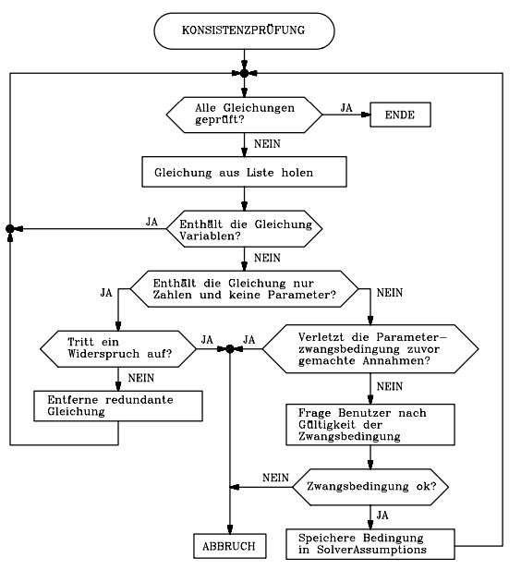
Consistency check
All equations checked?
No
No
No
No
ABORT
No
Yes
Yes
yes
yes
Yes

Yes
Get equation from list
Equation contains var’s?
Equation contains only numbers,
but no parameters?
Observe contradiction?
Parameter force condition invalidate previously made assumptions?
Delete redundant equation
Ask user to validate
force condition
Force condition ok?
Save condition in
SolverAssumptions
No
Take equation from list
All equations
searched?
Yes
Yes
Yes
No
No
No
Does the equation has shape
var=const or const=var ?
is var already contained in the solutions list?
Append var=const to solution list
Delete equation from list
Update variable list
Substitute solutions
Consistency check

Set up complete coefficient matrix
Set up evaluation matrix
Yes
Yes
Yes
No
No
No
Apply heuristic: delete row or
column of evaluation matrix
Update ΣΧ and ΣΡ
ΣΧ = ΣΡ =
Set up list of unused equations and variables
Solve linear eqs with LINSOLVE
Equation system
Inconsistent?
Check consistency of RHS of the augmented coefficient matrix
Real contradiction found?
found real contradiction?
Substitute solutions in remaining equations
Update variable list
ABORT

Delete "inconsistent" equations
Any equations left
All variables solved for?
Set up evaluation matrix
Apply evaluation strategy,
Generate order of solution

Suggestion for solutions left
Get equation from list
Try to solve equation
Succeeded in solving equation?
Check consistency of all solutions
Append unsolved equations to list
No
No
No
=No
Yes
Apply transformation
Transform equation
Delete inconsistent solutions
More than one solution ?
No
No
Yes
Yes
Yes
Yes
Yes
Update hierarchical solution list
Update variable list
Call valuation solver recursivly
All solution paths checked?
No solutions left?
Update solution list
Substitute solution
Update variable list

Yes
YesesYeses
No
No
Substitute individual solution
ABORTesYeses
Evaluate dependent variables and
expressions using the solutions
Do back substitution
Want back
substitution ?
Filter unsolved equations
Expand hierarchical solution list

Yes
No
Do partial back substitution
Append unsolved equations

