Hand in 2

***Topic:***

ETL process design and implementation for the AdventureWorks case. (Inspiration, reference case – NorthWind)

***Given case:***

***Sales reporting****. Senior management would like to be able to track sales by customer and product, with the goal of establishing which products are the top sellers, which customers are the top buyers, and sales per month for top 3 selling products.*

***Tasks:***

* *Design the ETL process*
* *Perform ETL in 2 phases:*
* *Dimension tables initial load*
* *Stage table initial load*
* *Revise (Update the ERD) the design of the DW (AdventureWorks2017_DataWarehouse)*
* *Create an ERD for the AdventureWorks2017_StagingArea database (database used for the data stores where the ETL process occurs)*
* *Document any relevant findings*
* *Create PowerBI dashboards (BI application) with the data (from the presentation server) prepared from performing the previously designed and implemented ETL process*

1. ETL Process design
   1. 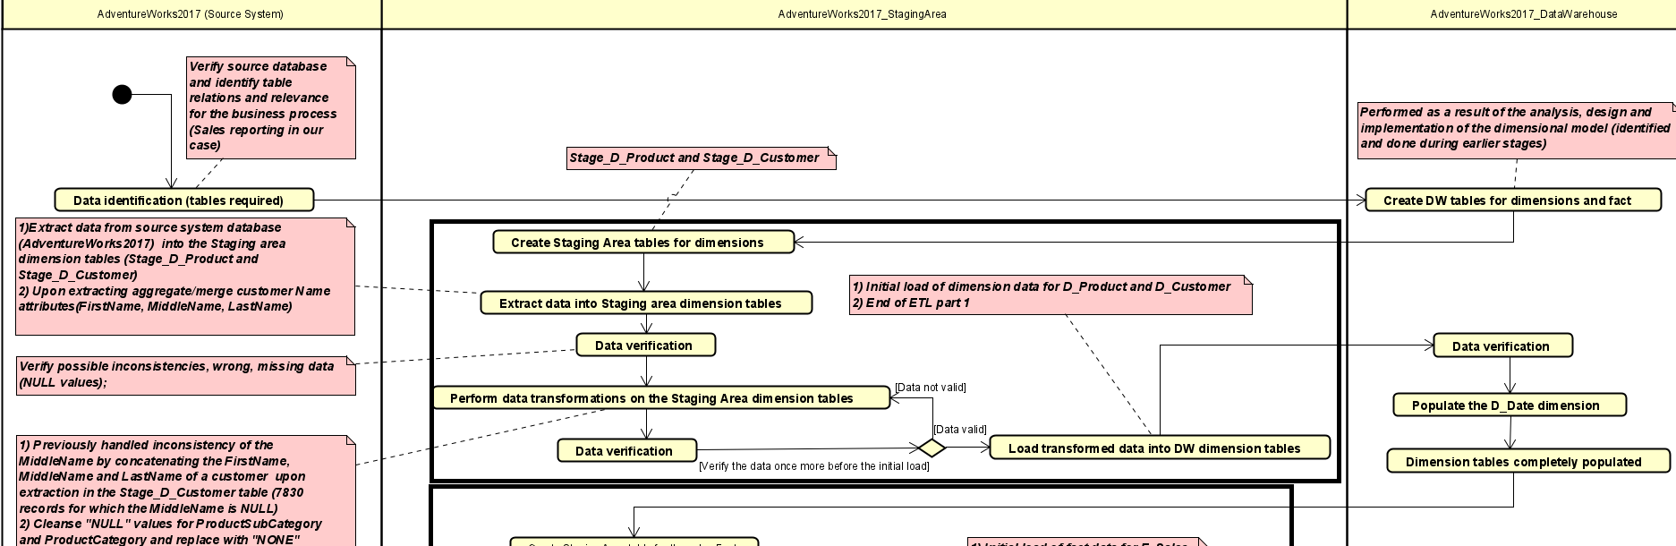ETL for dimensional data
   2. Creation of the D_Date dimension table

The table creation occurs in the dimension table creation phase (see XXX ).

AdventureWorks2017_DataWarehouse

* 1. 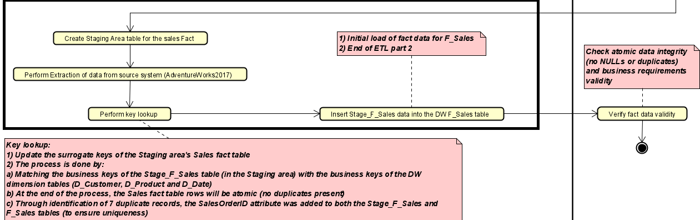ETL of the facts

AdventureWorks2017_StagingArea

1. ETL Process design and implementation
2. *Creation of the Staging Area (AdventureWorks2017_StagingArea database) tables*

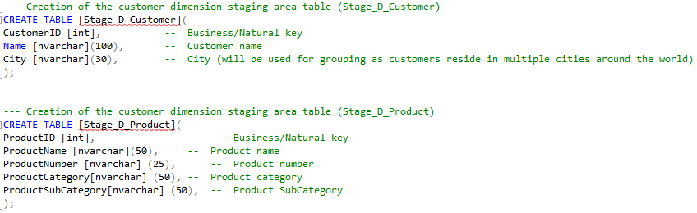

1. *Creation of the Staging Area (AdventureWorks2017_StagingArea database) tables*
2. *Populating the Stage_D_Customer table*

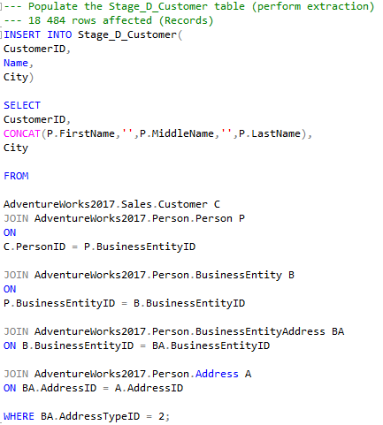

1. Verification of the Stage_D_Customer table contents

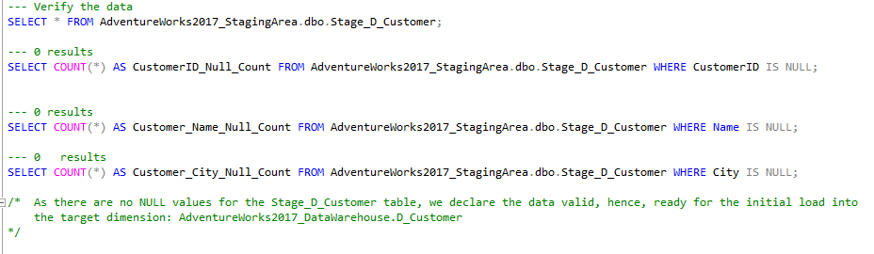

1. *Populating the Stage_D_Product table*

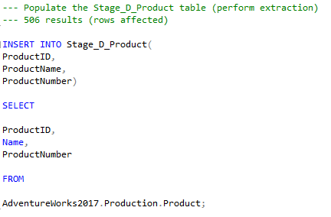

1. *Verification of the Stage_D_Product table contents*

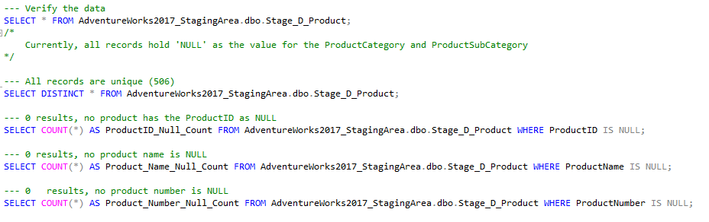

1. *Perform transformations on the Stage_D_Product table contents*

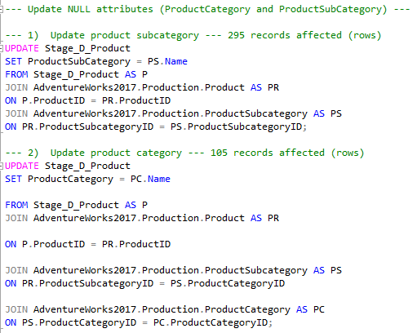

1. *Perform verifications on Stage_D_Product and set default values where Category or SubCategory attributes are NULL for a product.*

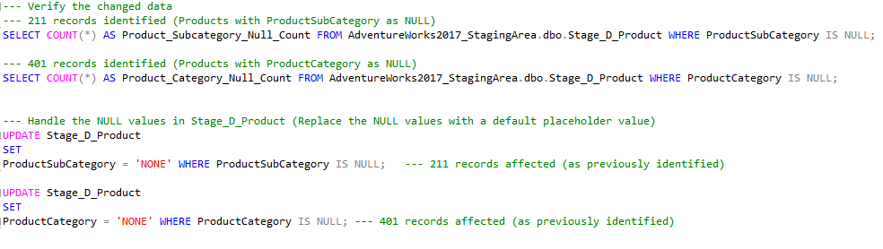

1. *Perform initial load of dimension data*

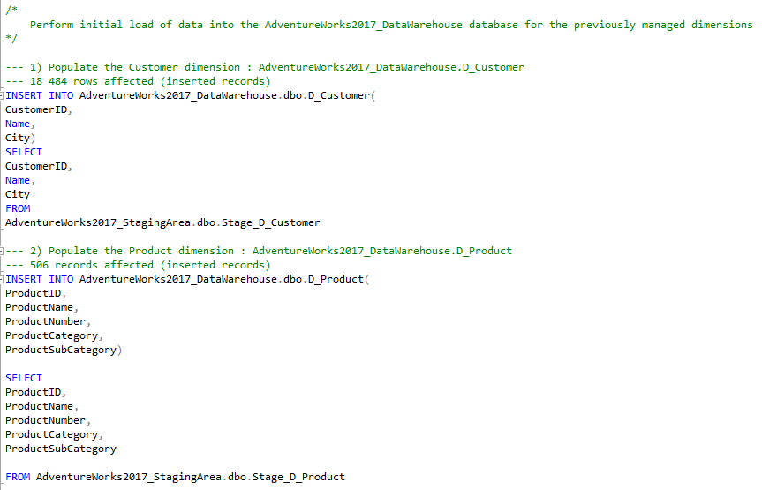

1. *Verify the dimension data once the ET-“L” (initial load) is finished*

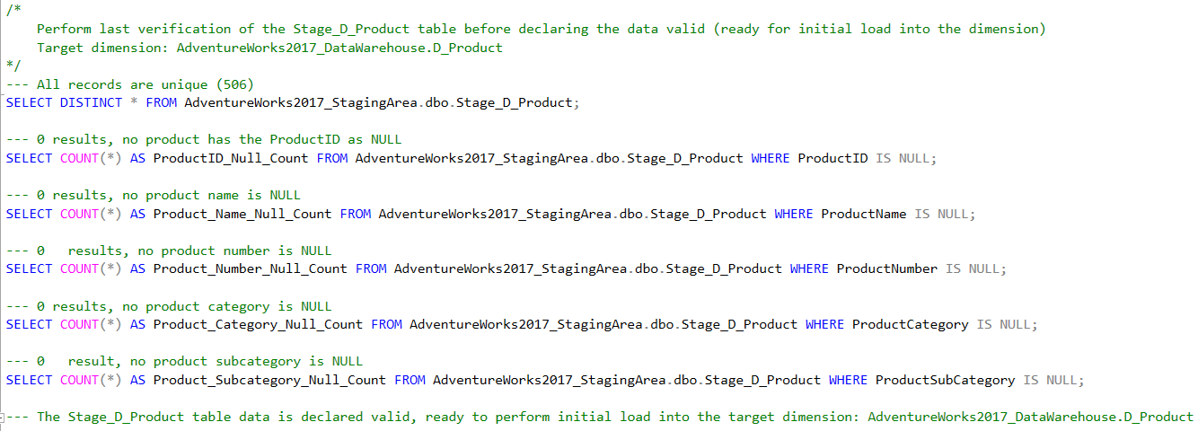

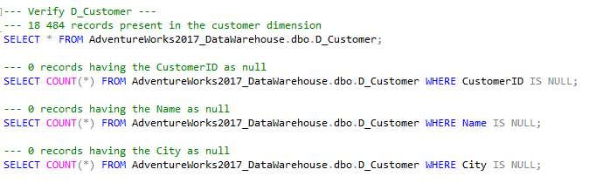

1. *Populate the Date dimension*

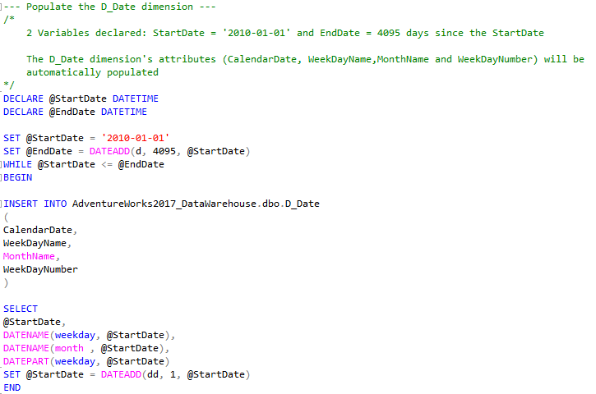

1. *Beginning of ETL part 2 (ETL of the Sales fact table) – create the Staging area fact table*

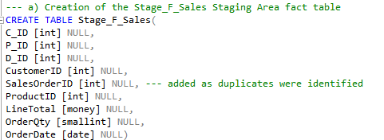

1. *Populate the Stage_F_Sales table (Extract data from source)*

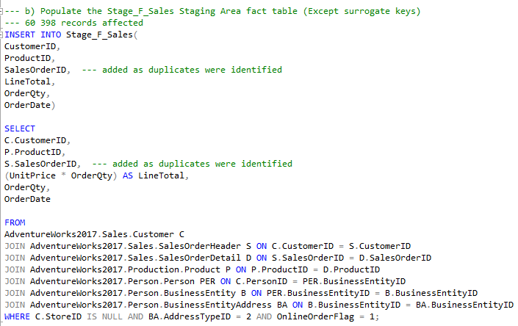

1. *Perform the key lookup*

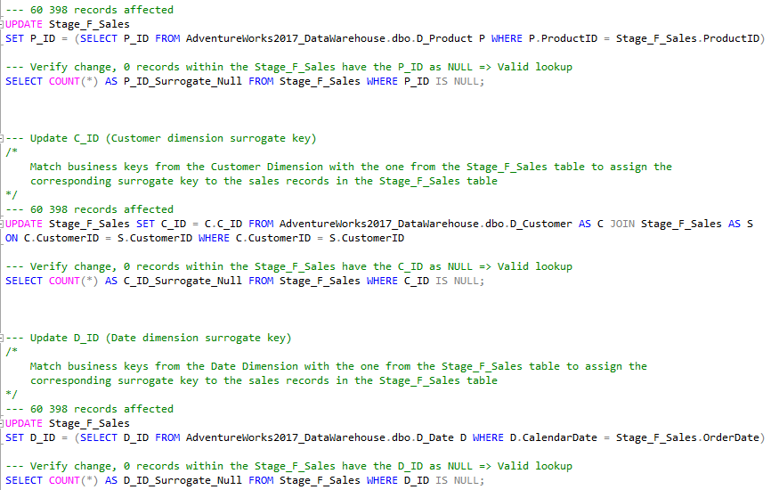

1. *Perform data verifications on the new contents of Stage_F_Sales*

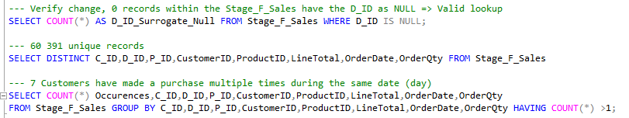

1. *Perform the initial load of Fact data into the DW F_Sales table*

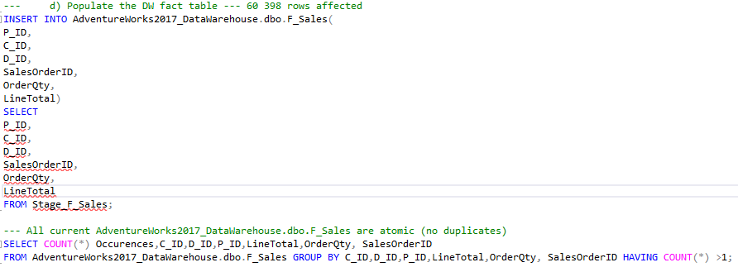

1. *Initial load completed (data ready for exposure to the BI application from the presentation server)*
2. ERD for the Staging Area Database (AdventureWorks_2017_StagingArea)

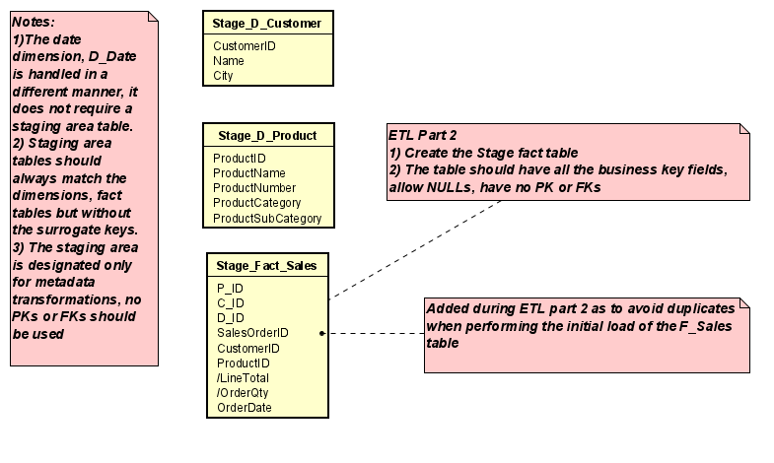

1. ERD for the Data Warehouse Database (AdventureWorks_2017_DataWarehouse)

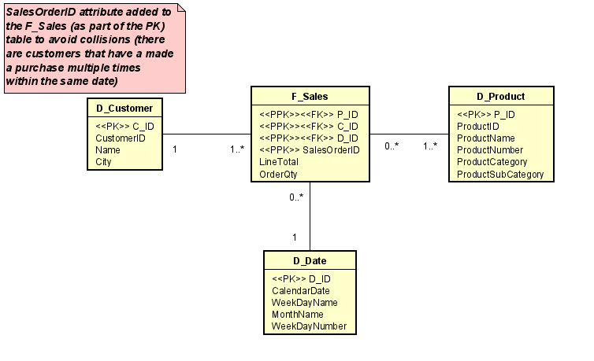

1. PowerBI dashboards (decision-making support based on the presentation server data)
   1. Page 1

Contents:

* Bar chart showing sales by category (green – highest, dark yellow – median, red – lowest, red line – median sales line). Each category has a different colour variation.
* Bar chart with individual products sold.

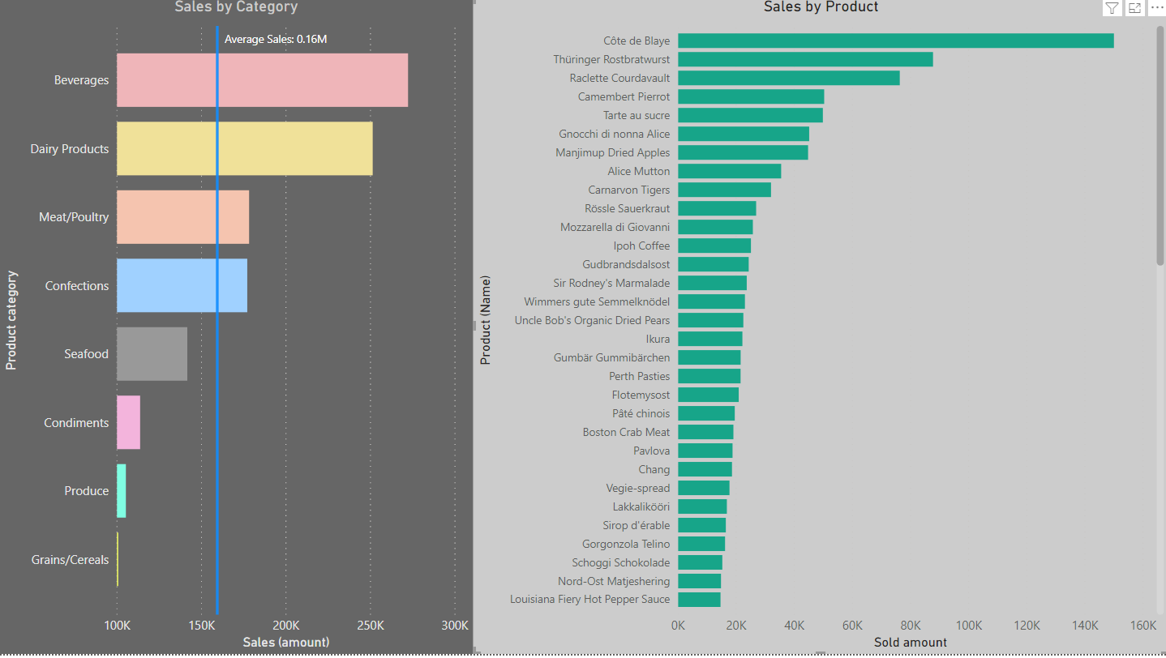

Chart collaboration, upon selecting a product from the right-hand side chart, its corresponding category is highlighted, and the amount (sales) is getting a strong coloration (representation of how much of the sales within that specific category is represented by the selected product).

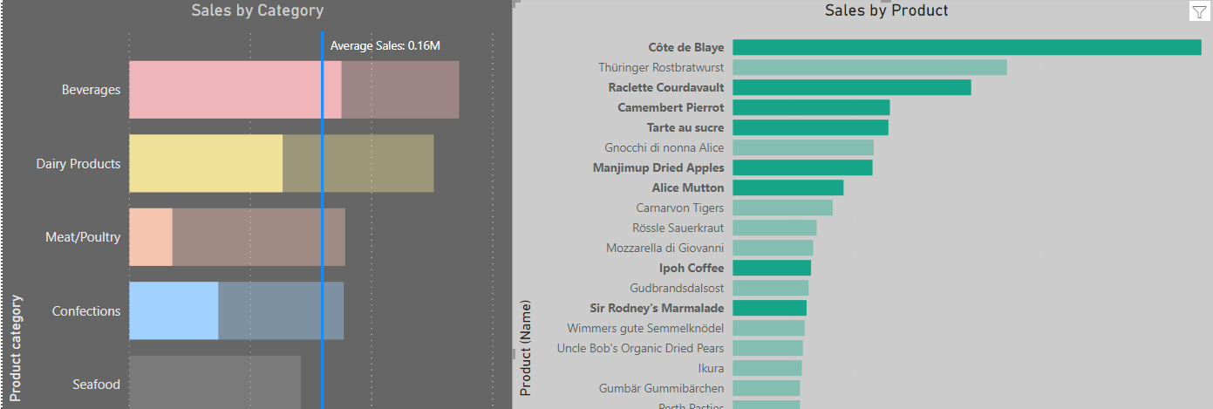

* 1. Page 2

Contents:

* All LineCharts use a calendar hierarchy
* Drill down used for month and day

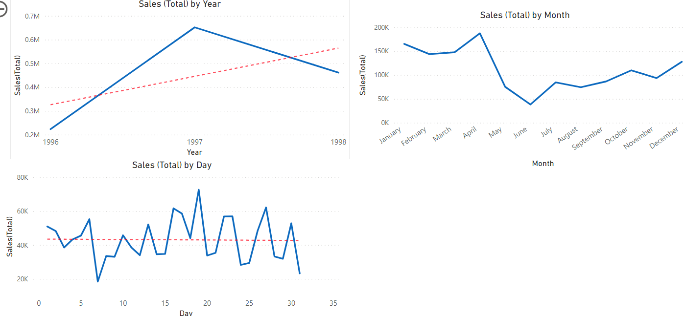

* 1. Page 3

Contents:

* Map visualization of sales (quantity) by country (upper right corner, green – highest, yellow – median, red – lowest).
* Map visualization (filled map/choropleth showing sales – quantity by country).
* Slicer (drop-down) for selection of a country.

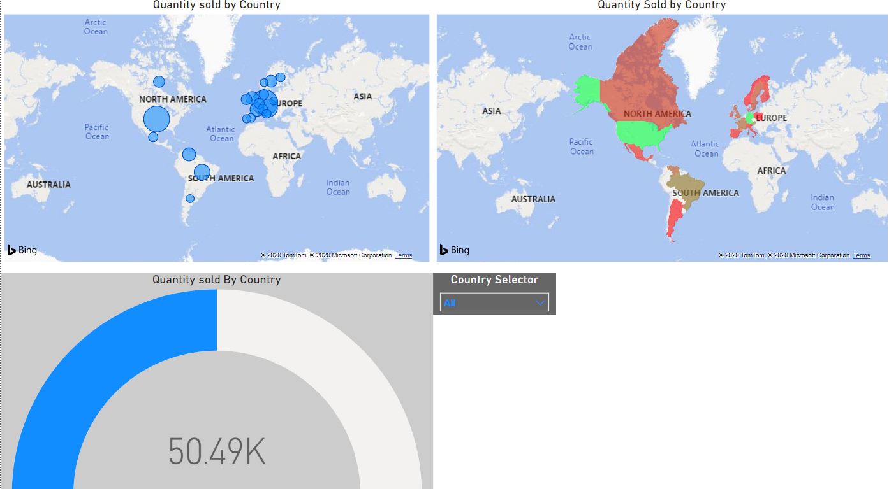

* 1. AdvetureWorks2017_DataWarehouse data analysis reporting

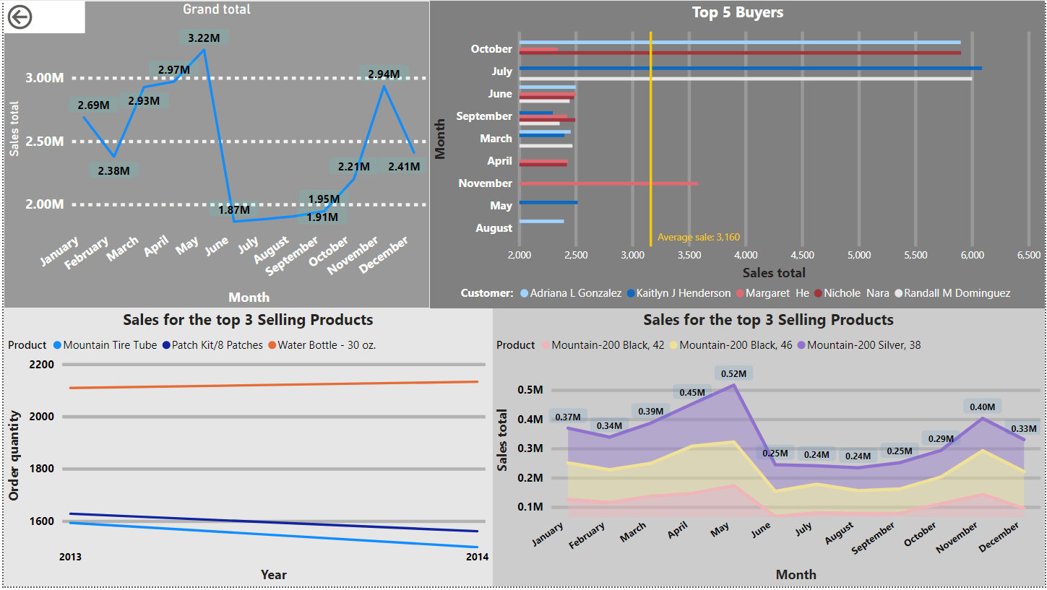

Chart collaboration