**KPSEA- CREATIVE ARTS & SOCIAL STUDIES - GRADE 6 EXAMS TERM 1 2023**

**QUESTIONS**

1. Which of the following is an upper case letter?
   1. a
   2. b
   3. H
   4. g
2. A person who manipulates and control puppet is called:-
   1. marionette
   2. puppeteer
   3. magician
   4. acrobat
3. Which of the following is **not** a principal of art?
   1. Balance
   2. Tonal value
   3. Proportion
   4. Overlapping
4. The following materials are used in painting **except**:-
   1. Pencil
   2. Crayon
   3. Thread
   4. Brush
5. The process of joining these two pieces of leather is called:  
   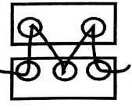
   1. beading
   2. etching
   3. thonging
   4. hemming
6. Three of the following are benefits of songs **except**. Songs ________________________ people.
   1. educate
   2. entertain
   3. console
   4. accuse
7. Erick used the printed fabric shown below to decorate a book cover. How many motif have been used?  
   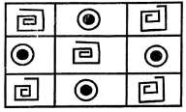
   1. Three
   2. Two
   3. Nine
   4. Six
8. Sarah, a grade five leamer drew a hut on a hard carton. She then applied glue and mounted rice on the drawing. Sarah was making a
   1. mosaic
   2. motif
   3. collage
   4. montage
9. Which colour do you get when you mix red and yellow?
   1. Green
   2. Violet
   3. Orange
   4. White
10. The pattern below is used in weaving. It is called:-  
    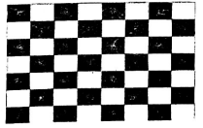
    1. twinning
    2. splitting
    3. plaiting
    4. plain weaving
11. The pattern above can be used to decorate a
    1. mat
    2. pot
    3. sufuria
    4. T.V
12. Wind instruments are played by:-
    1. plucking
    2. blowing
    3. hitting
    4. shaking
13. Special clothes that are worn when performing folk songs are called:-
    1. uniform
    2. costumes
    3. adornment
    4. decoration
14. Which community uses the instrument below?  
    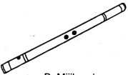
    1. Kalenjin
    2. Mijikenda
    3. Akamba
    4. Teso
15. Which of the following types of song is correctly matched with the community it comes from?
    1. Ramogi - Akamba
    2. Isikuti - Luo
    3. Mwomboko - Agikuyu
    4. Kilumi - Luhya
16. Which of the following materials can be used to make a dancing skirt?
    1. Clay soil
    2. Tree leaves
    3. Manilla paper
    4. Sisal fibres
17. What is the use of adhesives when mounting an artwork?
    1. Decoration.
    2. Exhibition.
    3. Sticking.
    4. Cutting.
18. The speed of a song is called:-
    1. tempo
    2. pitch
    3. rhythm
    4. volume
19. "Natujenge taifa letu". This statement is found in the:-
    1. East Africa Anthem
    2. Sacred song
    3. Topical song
    4. Kenya National Anthem
20. A piece of song performed by two people is called:-
    1. duet
    2. solo
    3. choral
    4. trio

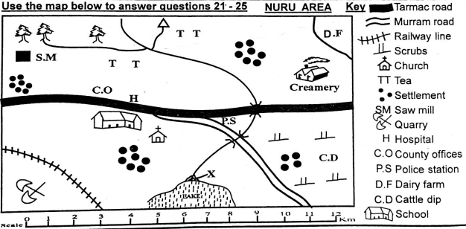

1. Which pattern is formed by the population | 25 distribution in Nuru Area?
   1. nucleated
   2. sparse
   3. dense
   4. linear
2. Nuru area is headed by:-
   1. Assistant County Commissioner
   2. Deputy County Commissioner
   3. Governor
   4. Chief
3. The climate experienced in the Northern part of Nuru area is :-
   1. cool and wet
   2. hot and wet
   3. cool and dry
   4. hot and dry
4. The feature marked x is called:-
   1. estuary
   2. delta
   3. confluence
   4. tributary
5. Which economic activity is **not** carried out in Nuru Area?
   1. Lumbering
   2. Farming
   3. Tourism
   4. Mining
6. Which of the following groups consists of the plain nilotes in Kenya?
   1. Agikuyu, Dawida, Abakuria
   2. Maasai, Samburu, Turkana
   3. Somali, Boran, Rendille
   4. Arabs, Nubians, Indians
7. A school routine is normally shown on
   1. a timetable.
   2. an exercise book cover.
   3. the school uniform.
   4. the school gate.
8. Equatorial climate is always:-
   1. hot and wet
   2. hot and dry
   3. cool and wet
   4. cool and dry
9. On 12th December, Kenyans celebrate:-
   1. Madaraka day
   2. Labour day
   3. Jamhuri day
   4. Mashujaa day
10. Which of the following minerals is **correctly** matched with the place it is found?
    1. Soda ash - Magadi
    2. Diatomite - Malindi
    3. Salt - Kariandusi
    4. Oil - Nakuru
11. One of the crops below is grown in the subsistence farms. Which is it?
    1. Tea
    2. Flowers
    3. Kales
    4. Coffee
12. Which of the following is a quality of a good leader?
    1. Dishonest
    2. Caring
    3. Cruel
    4. Unjust
13. Chege a grade five pupil has been employed in a hotel. The hotel owner is practising:-
    1. Child labour
    2. Early marriage
    3. Good citizenship
    4. Child right
14. Who among the following traditional leaders practised long distance trade?
    1. Mekatilili wa menza
    2. Njuri Ncheke
    3. Oloibon Lenana
    4. Chief Kivoi Mwendwa
15. Which of the following economic activities is **correctly** matched with the symbol it represents?
    1. Saw mill-fishing
    2. Tea- transport
    3. Quarry - mining
    4. Road - farming
16. Identify a historic built environment in Kenya.
    1. Wilson airport
    2. River Tana
    3. Mount Kenya
    4. Fort Jesus
17. Which is the largest country in Eastern Africa?
    1. Tanzania
    2. Sudan
    3. Somalia
    4. Djibouti

**Use the diagram below to answer questions 38 and 39**

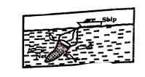

1. The fishing method illustrated above is
   1. trawling.
   2. net drifting.
   3. harpooning.
   4. purse-seining.
2. The fishing method above is used where
   1. water is flowing fast.
   2. there are few fish.
   3. a river is shallow.
   4. the sea is deep.
3. How many basketfuls of food were left after Jesus fed the multitude?
   1. 24
   2. 10
   3. 3
   4. 12
4. Which is the **correct** way of using social media?
   1. Accusing others
   2. Watching nakedness
   3. Sending greetings to friends
   4. posting immoral pictures
5. Otieno wakes up very early every Sunday to arrange chairs in their church. Otieno demonstrates:-
   1. responsibility
   2. courage
   3. holiness
   4. loneliness
6. Who raised the Jairus daughter from death?
   1. Peter
   2. Jesus
   3. Elisha
   4. Paul
7. Which of the following is **not** one of the books in the Bible?
   1. Genesis
   2. Exodus
   3. Gideon
   4. Samuel
8. Who among the following grade six learners used his/her free time well during the December holiday?
   1. Ken- went to steal fruits from a nearby farm
   2. Eliud - went to fetch water for an old lady
   3. Tom was given a ride by a stranger
   4. Betty-talking with her friends about others
9. One of the Ten commandments tells us to honour our parents because:-
   1. they give us food
   2. we can live long on earth
   3. we can avoid being cursed
   4. they may refuse to pay our school fees
10. "Do not accuse anyone falsely". Which lesson do Christians learn from this statement?The importance of being:-
    1. obedient
    2. kind
    3. loving
    4. truthful
11. Eve was created by God as a ___________________________ of  Adam.
    1. servant
    2. caretaker
    3. helper
    4. enemy
12. Which of the following prophets challenged the prophet of Baal at Mt. Carmel by bringing fire from heaven?
    1. Jeremiah
    2. Daniel
    3. Elijah
    4. Isaiah
13. Which of the following prophets challenged the prophet of Baal at Mt. Carmel by bringing fire from heaven?
    1. Jeremiah
    2. Daniel
    3. Elijah
    4. Isaiah

**MARKING SCHEME**

1. C
2. B
3. D
4. C
5. C
6. D
7. B
8. A
9. C
10. D
11. A
12. B
13. C
14. B
15. C
16. D
17. B
18. A
19. D
20. A
21. A
22. C
23. A
24. B
25. C
26. B
27. A
28. A
29. C
30. A
31. C
32. B
33. A
34. D
35. C
36. D
37. B
38. D
39. B
40. A
41. A
42. C
43. A
44. B
45. C
46. B
47. B
48. D
49. C
50. C