**Financial Stress Indicators and Systemic Risk**

Name

Course

School

Date

Table of Contents

**Toulmin-Style Outline** 4

**1. Introduction** 6

**1.1. Primary Research Objective** 6

**1.2. The importance of Behavioral Models** 6

**1.3. Implications for Stakeholders and Policy Development** 6

**1.4. Scope of the Study** 7

**2. Conceptual Framework** 7

**2.1. Key Concepts** 7

**2.1.1. Systemic Risk** 7

**2.1.2. Financial Stress Indicators (FSIs)** 7

**2.1.3. Agent-Based Modeling (ABM)** 7

**2.1.4. Financial Contagion** 8

**2.1.5. Network Effects** 8

**2.2. Behavioral considerations in agent based models** 8

**2.2.1. Heuristics** 8

**2.2.2. Biases** 8

**2.2.3. Emotional Triggers** 9

**2.3. Prior Models and Literature** 9

**2.3.1. Literature on Behavioral Economics** 9

**2.3.2. Network Theory** 9

**2.3.3. Agent-Based Models** 9

**2.4. Causal Loop Diagrams (CLDs) and Theoretical Foundations** 9

**2.4.1. Positive Feedback Loops** 9

**2.4.2. Negative Feedback Loops** 10

**2.4.3. Network Theory** 10

**2.4.4. Behavioral Economics** 10

**3. Methodology** 10

**3.1 Overview** 10

**2. Design Concepts** 11

**3. Details** 12

**3.1. Data Preprocessing and Analysis** 13

**4. Results** 14

**4.2. Static and dynamic spillover tables and heat maps** 15

**5. Discussion** 19

**5.1. Key Findings and Their Relevance to Stakeholders** 20

**5.2.1. Role of Heuristics and Biases** 20

**5.2.2. Emotional Triggers and Herding Behavior** 21

**5.2.3. Network Effects and Financial Contagion** 21

**5.3. Limitations of the Study** 21

**5.4. Future Research Directions** 22

**6. Policy recommendations** 22

**7. Conclusion** 27

**References** 29

**Appendices** 31

# **Abstract**

**Claim(s):** For key stakeholders in a financial system, the ability to predict and manage systematic risk is a critical determinant of the overall stability of the system. The linkages in place among stakeholders in the system often mean that all stakeholders are exposed to contagion effects, where shocks affecting one agent are transmitted to other nodes within the network. Agent-Based Modeling (ABM) is a valuable theoretical approach to modeling the sum of individualistic financial decisions during macroeconomic uncertainty to estimate the level of systemic risk. This method enables analysis of the interaction of the micro patterns of behaviors arising from psychological factors and general in nature, leading to macro financial crises patterns. Moreover, the integration of composite financial stress index (FSIs) and behavioral variables offers a holistic solution to tracking the conduits through which economic shocks spread across the financial systems so that precise interventions can be made.

**Grounds:** Research data on the United States, China, Austria, Thailand, and Israel are used to support the arguments presented in this paper as a result, and this provides the theoretical framework for the comparative discussion of the financial systems and their contexts in terms of the specific economic conditions and developments of each country. It compiles forty developed and developing countries, which can help provide insights on how different structures deal with macroeconomic shocks. The information obtained from wavelet coherence shows coexisting temporal associations between stress indicators and economic variables, while spillover tables show the sectorial and geographical transmission of shocks. Exploratory analyses reveal relevant patterns and trends regarding the nature and distribution of systematic risk drivers.

**Warrants:** The translation of micro-level behaviors and macro-level outcomes is done using ABM simulations. These simulations illustrate how heuristics and biases at the individual level lead to system failures in interconnected financial networks. The integration of the FSIs in the ABM modeling preserves some essential characteristics of the real economy, including the appearance of the network effects and spreading of distressed sectors across the economy. In support of the relationships between individual and systemic levels, theory frameworks from behavioral economics and network theory are employed.

**Backing:** To approach ABMs more systematically and to prevent methodological chaos, the ODD (Overview, Design concepts, Details) protocol was developed. This makes it possible to describe agent behaviors, interactions, and environments in detail so that simulation exercises are credible and repeatable. Furthermore, behavioral public policy highlights the cognitive and emotive aspects influencing financial behaviors, thereby supporting the understanding encapsulated in the paper that psychological factors should constitute part of the modeling process. The analysis is applicable to stakeholders through the utilization of this multidimensional approach, which links the theory with the practice.

**Qualifiers:** The results derived from the analysis depend on several assumptions, such as the agents’ heterogeneity, the structure of financial networks, and the stability of basic economic conditions. Validity of the results is directly proportional to input quality and specificity because the quality of results may be distorted by the quality and specificity of input information. Additionally, the generalizability of findings is constrained by the conditions and jurisdiction in other economic environments and market settings.

**Rebuttals:** A number of challenges have been raised concerning the application of ABM for the simulation of large systems where there are many interacting entities. These requirements make it necessary to employ high-performance input-output computing resources and might limit the model’s applicability. Further, it means that models may be fitted with specific scenarios or datasets and fail to generalize in other conditions. Solving these issues requires striking a proper complexity of the model along with having the proper computational resources and replicating the obtained results across datasets and cases.

# **1. Introduction**

## **1.1. Primary Research Objective**

The goal of this study is to analyze the use of FSIs and ABM to forecast and manage systemic risk during macroeconomic instability. As structures, financial systems are susceptible to functional interactions among their different agents, including those who borrow, lend, invest, and make policies. These links expose financial systems to contagion effects, with shocks in one point spreading to other points of the system (Cheng et al., 2017). This research aims at incorporating FSIs into ABM to formulate a strong analytical tool for tracking, modeling, and handling systemic risks. The ability to effectively forecast systematic risk within a financial system can enable stakeholders to contain contagion and, as a result, maintain the stability of the system. The study also utilizes cognitive theories of behavior and heuristics to analyze the impact that financial decisions made by individuals can have on macro-level outcomes under stress conditions, the stressors and their influence, as well as aspects of network interconnectedness and financial contagion (Chavleishvili, 2023).

## **1.2. The importance of Behavioral Models**

Behavioral factors can be a major influence on the outcomes of the financial system, in addition to economic variables. It is therefore important to analyze how behavioral economics factors can enrich standard finance theory with details about psychological biases such as overconfidence, herding, and loss aversion, and how they can in fact exaggerate economic vulnerability. For example, when investors are faced with unpredictable market conditions that are characterized by high volatility, overreactions by individual investors can encourage others to take similar actions at different phases in the economic cycle. This crowds most investors in a specific direction and consequently increases the volatility of assets. When behavioral variables can be clearly defined and measured, they can be effectively used in models to analyze financial decision-making (Sorropago, 2014). According to Grimm et al. (2020), when these ideas are applied to ABM, they provide the basis for constructing more realistic models that reflect actual agent behaviors along with their overall consequences on financial stability.

The analysis of behavioral models bridges the gap between financial theory and the use of models in solving practical problems since it offers clear guidelines on stakeholder behaviors to the policymakers and other stakeholders. It is easier as a result to comprehensively assess different economic conditions and to identify weaknesses and the potential effectiveness of a variety of actions. For example, policymakers can apply these simulations in crafting appropriate measures that hedge on borrowers’ credit risk, high leverage, and cross-market risks. While behavioral variables are numerous and can be difficult to objectively map, focusing on variables that are most likely to impact financial decisions can increase the accuracy of models created.

## **1.3. Implications for Stakeholders and Policy Development**

The research has considerable implications for central banks, regulatory authorities, financial institutions, and policymakers. For central banks it is important to have early indications of unstable conditions so that monetary or fiscal measures can be put in place early to address the problems identified. Using ABM, regulatory agencies can also evaluate the potential linkages within the financial system that have the potential to increase or reduce systematic risk on interconnected financial institutions and design policies that address such linkages (Chavleishvili, 2021). Financial institutions can therefore benefit from this research by identifying more effective risk management strategies meant to address negative macroeconomic shocks.

Economic policies are generally designed to ignore behavioral aspects of key stakeholders since they are often difficult to control or predict. Policies therefore often have to consider the fact that not all stakeholders will act rationally. While traditional models often assume that all actors will be rational, this is not always the case, meaning policies need to be designed in ways that can accommodate irrational decision-makers (Sorropago, 2014). For instance, knowledge of why panic-driven behaviors are most significant in economic difficulties helps policymakers to put in measures that prevent behaviors beyond structural flaws.

## **1.4. Scope of the Study**

Data used in the study is collected from five countries; the United States, China, Austria, Thailand, and Israel, that have different economic characteristics and regulatory settings. The study as a result analyzes financial systems that differ significantly in terms of regulatory composition and their associated macroeconomic environment. The provided case studies also help to understand how different systems address the challenges they face, with findings that can be generalized to other financial systems. Moreover, the research has general correlation with the course learning outcomes.

This study is organized to offer a proper conceptualization and construction of the composite FSIs firstly and then integrating these indicators into ABM secondarily. Empirical techniques used include the use of wavelet coherence to capture stress transmission; the use of spillover tables to gauge effects of contagion; and lastly descriptive statistics to reveal important characteristics. This feeds into policy briefs that looks into policy issues relative to multiple stake holders making sure that the research finding has an application to the practical world.

# **2. Conceptual Framework**

## **2.1 Hypothesis and Research Questions**

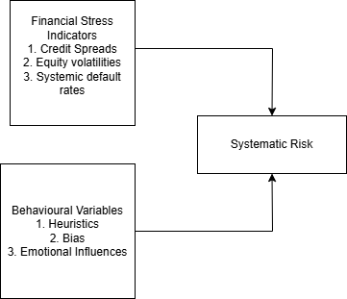

The study intends to evaluate the extent to which FSIs can be used to forecast systemic risks during macroeconomic instability using ABM. The main research hypothesis for the study can therefore be identified as:

H1: FSI variables such as credit spreads, equity volatilities, and systemic default rates, as well as behavioral variables that impact financial decision-making, can be used in agent-based models to predict systemic risk during macroeconomic instability.

H0: FSI variables such as credit spreads, equity volatilities, and systemic default risks and behavioral variables that impact financial decision-making cannot be reliably used in agent-based models to predict systemic risk during macroeconomic instability.

The research questions of the study therefore include:

1. Can key financial stress indicators be used in ABM models to forecast systemic risk?

2. Can behavioral variables be used in ABM models to forecast systemic risk?

## **2.2. Key Concepts**

### **2.2.1. Systemic Risk**

Systemic risk refers to the vulnerability the financial systems faces due to the possible failure of one or more of its key components. Unlike idiosyncratic risk which is firm specific risk, systemic risk arises from the complexity, interdependence and integration of the financial system as a whole. Situations like the 2008 global financial crisis show the disruptive nature of systemic risk (Alexandridis & Hasan, 2020). For example when Lehman Brothers went into liquidation, the entire financial market almost collapsed, leading to a global recession. Managing and measuring systemic risk must involve a systematic approach to address sources of systemic risk; core among them are; leverage, liquidity risk and network externalities as well as the processes through which these risks enlarge themselves (Chavleishvili, 2021). Regulatory or public policy plays a critical role in managing systemic risk. Effective financial regulations can minimize excesses by one or more stakeholders in the system that can have far reaching consequences for everyone else. Regulators can also aid in crisis management when the system fails to perform as expected, which minimizes losses and allows the system to continue operating as expected.

### **2.2.2. Financial Stress Indicators (FSIs)**

Financial stress is usually measured by FSIs, which are composite indicators that are meant to capture the level of stress within various financial systems (Monin, 2019). They sum up several financial outlooks, including interest rate spread, stock market return, and credit default swap spread, and use them to describe the balance in the financial system. FSIs work as alarms that alert stakeholders about their weaknesses before they become serious issues (Chavleishvili & Kremer, 2021). For example, wavelet coherence as a transport approach can show the temporal structure of the mutual connection between FSIs and macroeconomic factors and explain how the financial stress is transmitted across economies. When combined with ABMs, FSIs can provide insights into how aggregated macroeconomic stimuli affect performance at the level of individuals and groups of agents to create system-level effects.

A key challenge associated with the use of FSIs to assess financial stability is their lack of universality. Indicators used for one country may not be as effective when applied to other countries. FSIs are also highly sensitive to model design and may oversimplify rather complex aspects of the financial system they are analyzing. By selecting variables that are closely aligned with the markets being analyzed, the impact of these limitations can be significantly minimized.

### **2.2.3. Agent-Based Modeling (ABM)**

ABM is a computational method that focuses on agents’ actions across sectors such as households, firms, and financial institutions to analyze emergent macro behaviors (Uddin et al., 2021). In financial systems, ABM mimics individual behavior decision-making processes as influenced by behavioral biases. The outputs derived often mimic the subsystems in place in a large macro system. Unlike other models that are based on an equilibrium approach, ABM is capable of capturing the complexity and chronicity of developments, including contagion effects and feedback loops. For instance, the way agents behave in response to such signals or how falling asset prices can show how panic behaviors spread. Flexibility of ABM makes it suitable for analysis of complex phenomena such as systemic risk. A key challenge associated with the use of ABM that can impact the accuracy of findings made is the assumption of limited rationality, which implies that agents have a limited set of choices (Abar et al., 2017). This may not always be the case in real-world decision-making, as some options that may not be studied may be available to decision-makers.

### **2.2.4. Financial Contagion**

Financial contagion refers to a process through which shocks are transmitted from one institution, market, or country to another either through direct or indirect links. Common contagion mechanisms include a liquidity spiral, counterparty risk exposure, and correlated exposures. For example, a relative rise in demand for an asset in one market will push institutions to sell similar assets in other markets, which depresses prices and creates more selling pressure. Due to propensity and behavioral influences, herding and adverse reaction to astringent events can be intensified in a market based on events in a different market, which means it is important to analyze the relationship between key behavioral factors and financial contagion. Since contagion entails organizing the structures and the stream of shocks, ABM and CLDs can form the model (Sabzian et al., 2018).

### **2.2.5. Network Effects**

These are effects whereby individual actions are magnified due to the fact that agents are linked in a network in a financial system. These effects may strengthen or weaken the systems, depending on the network’s base on which the effects are founded. For example, many links between banks in place in a market make it easy to share risks as well as to make the system easily susceptible to issues that affect a single entity (Demange, 2018). Through a simulation of the networks, it is possible to determine certain nodes or institutions that, if they fail, will significantly affect the performance of the network as a whole. The dynamics of these structures can be established by the application of network theory together with ABM, hence the ability to formulate targeted interventions aimed at reducing the overall risk.

## **2.3. Behavioral considerations in agent based models**

Behavioral policies are concerned with the impact of heuristics, bias, and emotional influence on decision-making as a framework through which agent behavior in financial systems can be explained (Ceschi, 2019). Key insights include:

### **2.3.1. Heuristics**

Stakeholders in the financial system often rely on rules of thumb and heuristics when faced with difficult decisions. For instance, during times of significant financial stress, classical rationality is replaced by the so-called ‘herd behavior,’ where agents take actions that replicate the actions taken by other individuals, thereby ignoring inherent rationality (Ceschi, 2019). This can result in asset bubbles or crashes, as the global 2008 housing crisis demonstrated. Integrating heuristics into ABM addresses such behavioral assumptions, showing that they bring about systemic vulnerability.

### **2.3.2. Biases**

Overconfidence and loss aversion can create psychological biases that tend to affect financial decision-making. Overconfidence can make investors not consider risks in their decision-making, while on the other hand, investors in fear of losses may make hasty decisions meant to protect their investments. In this manner, ABM offers an accurate portrayal of these biases and thus the behavior of each agent under stress in order to replicate the realization of systemic risk from numerous agent misperceptions.

### **2.3.3. Emotional Triggers**

Emotions can have a significant impact on the decisions that stakeholders in different areas of a financial system end up making. Fear can lead to the offloading of assets, whereas greed leads to increased speculation. Among behavioral models, those that take into consideration emotion-induced events are useful to describe sharp market micro-movements and the spreading of stress through networks. For instance, a withdrawal of funds based on the fear fueling the entire situation can worsen into a crisis of liquidity in a bank.

## **2.4. Prior Models and Literature**

This study is based on previous research works in the fields of behavioral economics and network theory. Key influences include:

### **2.4.1. Literature on Behavioral Economics**

The agent’s behavior under risk and uncertainty is presented by Kahneman and Tversky in the framework of prospect theory works that aim to find the origin of outlooks, including loss aversion. Subsequent research builds on these findings to illustrate how such dynamics manifest in financial markets by creating systemic risk.

### **2.4.2. Network Theory**

The network approach offers solutions for studying the connection between various financial structures. Such models as the “core-periphery” models demonstrate clearly how disturbances to central elements affect the entire system profoundly. Reviews of various studies on routinization reveal how topology affects stress in the context of financial contagion to design ABM simulations. Other aspects of network theory, such as the degree of centrality and pathway contagion, can also aid in evaluating systematic risk and can therefore be included as attributes in the model.

### **2.4.3. Agent-Based Models**

Past ABM studies have often modeled a country’s financial crises by focusing on stressed agent behaviors. For instance, Farmer’s and Foley’s models illustrate the impact of leverage on systematic risk. These approaches are best extended in this research by the inclusion of both FSIs and behavioral insights to present a picture with more accuracy. Other studies that have used ABM to evaluate financial crises have focused on feedback loops and the impact they can have on contagion and systematic risk, while others have evaluated the impact that specific regulatory measures can have on stressful financial conditions that can lead to a crisis.

## **2.5. Causal Loop Diagrams (CLDs) and Theoretical Foundations**

Causal Loop Diagrams (CLDs) are one of the principal methods to model the feedback loops that underlie systemic risk. Key loops include:

## **2.5.1. Positive Feedback Loops**

These feedback loops increase volatility, for example, when declining prices prompt margin calls, thereby fueling price declines. In network terms, high connectivity intensifies these effects, pointing out that network topology plays a key role in systemic risk. In countries with highly interconnected financial systems, more feedback loops are likely to be witnessed, as stakeholders exchange information rapidly on different aspects of the market.

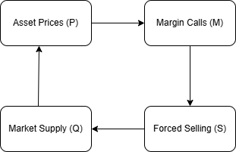

## **2.5.2. Negative Feedback Loops**

These loops stabilize systems, for example, when the central bank comes in to inject funds during a crisis. In order to model such dynamics, one has to have substantial knowledge of policy interventions as well as their behavioral consequences.

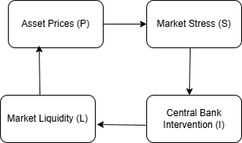

CLDs also connect directly to theoretical frameworks such as:

### **2.5.3. Network Theory**

CLDs represent the platforms of network communication and illustrate nexus of contacts and possible points of viral spread. For example, a CLD demonstrating that specific institutions are spiraling towards liquidity problems can be used to direct remedial efforts.

### **2.5.4. Behavioral Economics**

CLDs take into consideration behavioral characteristics of panic-driven withdrawals and speculative bubbles and map individual behaviors to systemic effects. These conceptual diagrams bring out the ways in which heuristics and biases affect financial behaviors and patterns.

# **3. Methodology**

This section explains the methodology used in the ABM analysis of the systemic risk with the help of the ODD protocol of the overview, design concepts, as well as the detail of the methodology. The model structure and its processes are described in more detail with the help of diagrams such as UML and pseudocode. Data preprocessing techniques have also been identified, with explanations and extended ODD being shown in Appendix 1.

## **3.1 Overview**

The model recreates the spreading of systemic risk across agents’ borrowers, lenders, and regulators under shifts within the macroeconomic environment. The purpose is to examine how financial stress indicators and the behavior of the agent coordinate to affect financial stability (Anshuka et al, 2022). Therefore, the ABM shows the important channels for the propagation of psychological biases and the spreading of network effects.

**Entities and State Variables**

**Agents**

Borrowers: Two or more households or firms with different financial statuses.

-State Variables: Receiving income, type and level of liabilities, probability of default, behavioral patterns (such as mind-following).

Lenders: Business firms who offer financial accommodation or credits.

-State Variables: Liquid, leveraged, risk, counterparty.

Regulators: Policy entities as the actors using the intervention.

-State Variables: Level for action, the available choices.

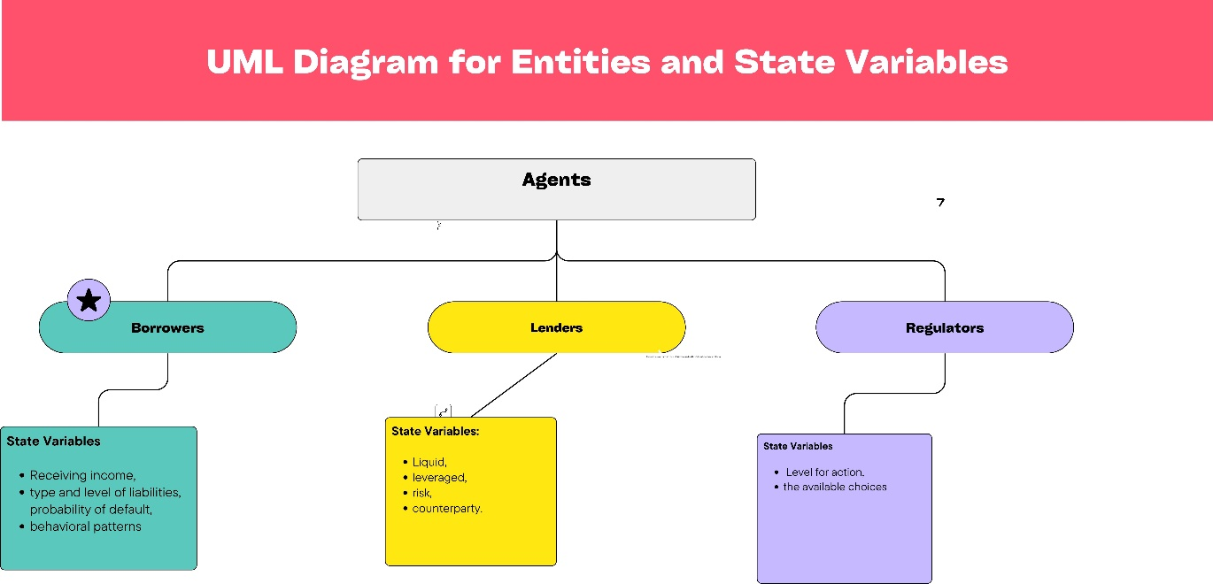

**Environment**

Business factors including gross domestic product, inflation rates and the rate of unemployment.

Financial Stress Indicators (FSIs): Credit spreads, or equity volatilities, or systemic default rates.

***UML diagram illustration for FSIs***

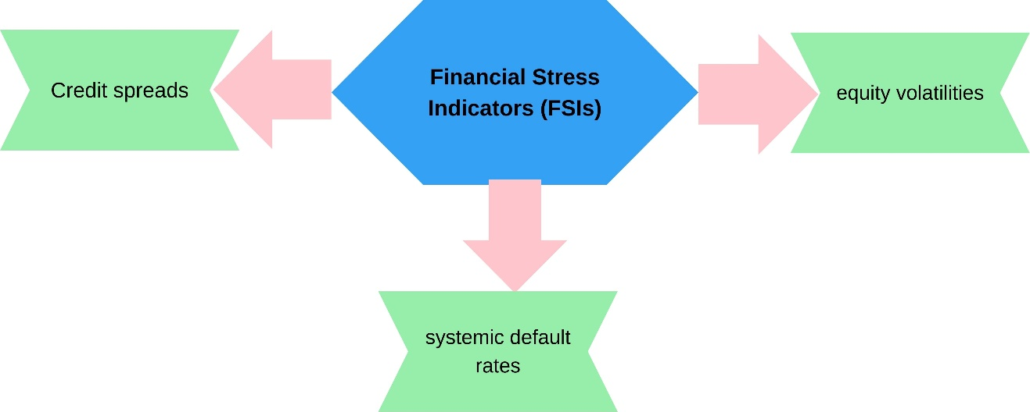

## **2. Design Concepts**

**Basic Principles**

The model also includes some perceptions of behavioral economics including heuristics and biases and network analysis to model financial diffusion.

***Emergence***

Systemic risk is brought about by the combination of cash flow interactions in the economic system.

***Adaptation***

Major shifts are made by agents and are done in response to economic circumstances and psychoneural tendencies. For instance, availability of credit is limited during stress periods.

***Stochasticity***

There are other factors such as income variation randomness, dept. levels randomness, and randomness in the macroeconomic shocks.

## **3. Details**

Process Workflow and Print Timing

The time horizon selected for operation of this model is at monthly disbursement frequency. At each step:

The macroeconomic conditions are revisited applying VAR models.

Economically, borrowers pay off debt or default depending on their status and their perceived self-bias.

The relative liquidity and lending decisions are made by lenders based on the market factors.

Supervisors analyze the activities of FSIs and intervene when required.

**Pseudocode**

Initialize global parameters (macroeconomic indicators, FSIs)

Initialize agent attributes (borrowers, lenders, regulators)

For each time step:

Update macroeconomic indicators via VAR model

Calculate FSIs using wavelet coherence analysis

For each borrower:

Update income, expenses, and debt levels

Compute default probability based on risk tolerance and heuristics

If default:

Reduce lender liquidity

Update borrower state (defaulted)

For each lender:

Evaluate liquidity and leverage ratios

Adjust lending activity based on FSIs and borrower defaults

If critical thresholds exceeded:

Trigger financial contagion

For regulators:

Monitor FSIs for systemic thresholds

Deploy interventions if necessary (e.g., capital buffers, liquidity support)

Record system-wide metrics (defaults, contagion levels, intervention impacts)

End

### **3.1. Data Preprocessing and Analysis**

**Data Sources**

Simulation is based on the empirical data of the United States, China, Austria, Thailand and Israel. Such variables correspond to factors such as a country’s GDP growth rate, credit spread estimates, equity market statistics and default levels.

**Preprocessing Techniques**

Vector Autoregression (VAR): Features active relationships between macroeconomic factors and FSIs.

Wavelet Coherence Analysis: Enables one to detect correlation between FSIs and selected economic indicators and periods of elevated correlation.

**Visualizations**

**a. HP Filter (Hodrick-Prescott Filter)**

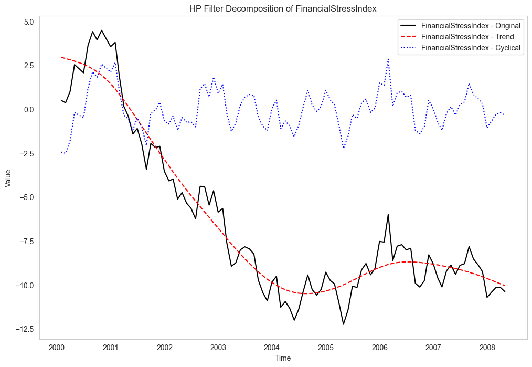

Figure 1: Filter decomposition of Financial Stress Index

The HP filter is used to filter out the trend and cyclical aspects of the financial series data. This leads to the elimination of noise in the data and simplifies subsequent analyses of macroeconomic and systemic stress indicators.

**b. VAR (Vector Autoregression Model)**

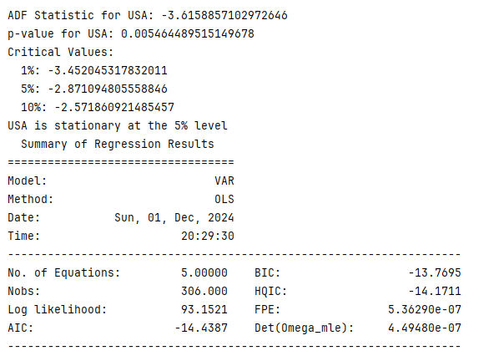

Figure 2: VAR (Vector Autoregression Model)

This diagram represents the structure of VAR model as it depicts relationships along with lagged intermediate future dependencies among financial variables. They measure active relationships that are essential for deciding the probable extent of systemic risk.

# **4. Results**

**CDF (Complementary Distribution Function of Financial Stress)**

It expresses the extent of financial stress by entities or periods; normal, moderate, or high stress levels are depicted. The tail behavior suggests extreme events that are indicative of system risks important for constructing early warning models (Shown in Fig. 4 below).

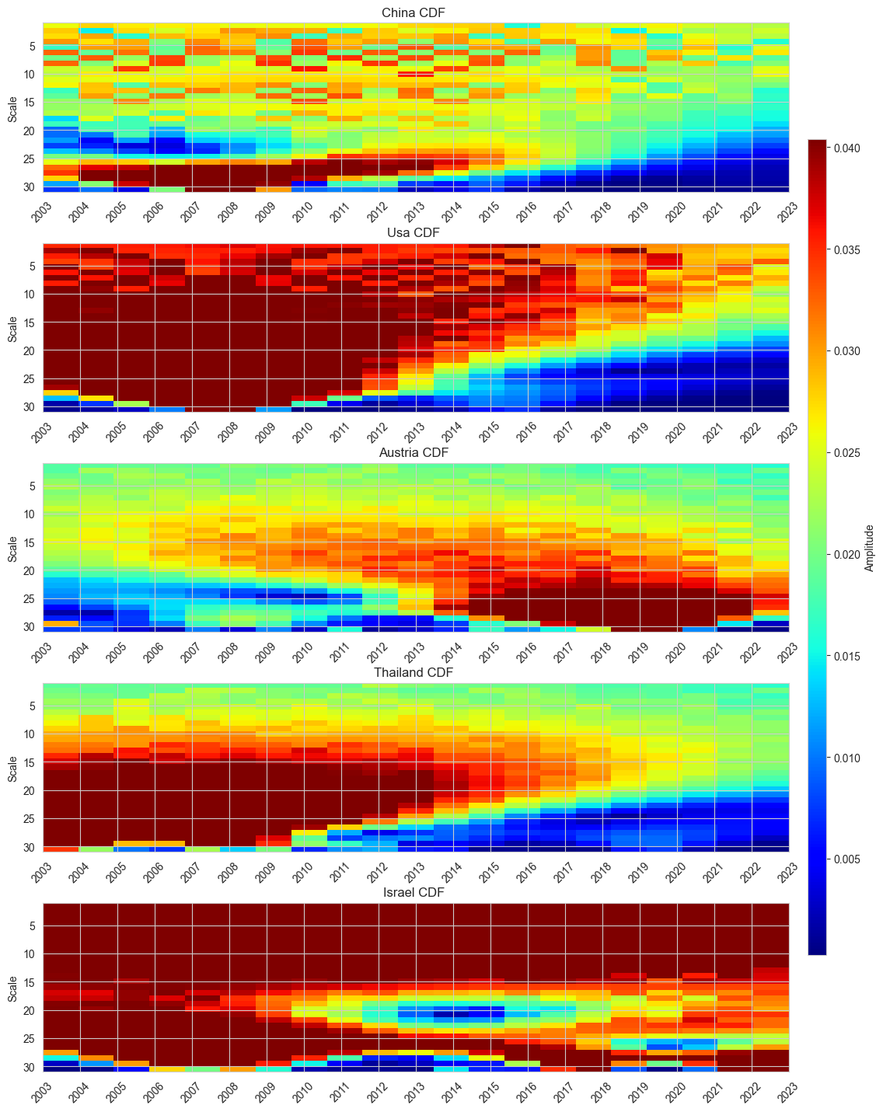

Figure 3: CDF (Complementary Distribution Function of Financial Stress)

## **4.2. Static and dynamic spillover tables and heat maps**

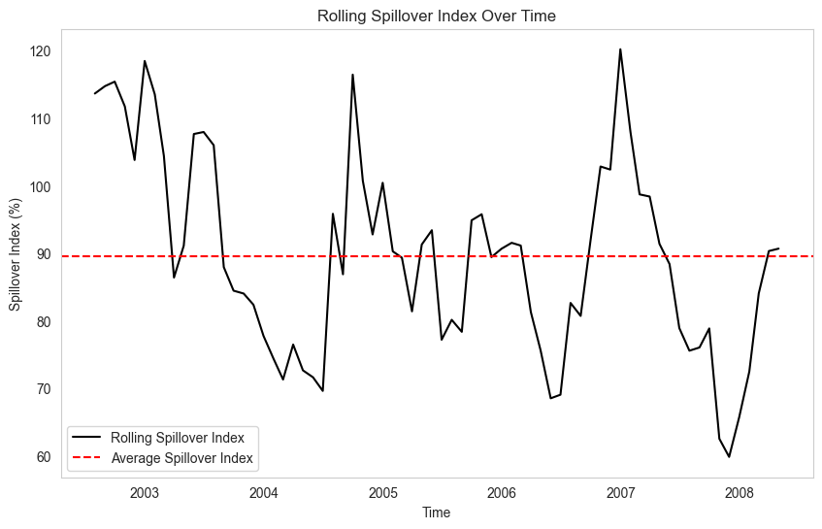

Figure 4: Rolling spillover Index over Time

This is a time-series graph that depicts changes in the spillover index and it illustrates periods of elevated systemic risk. Periods of rises are associated with large-scale events – crises in the financial sphere or shifts in the geopolitical landscape.

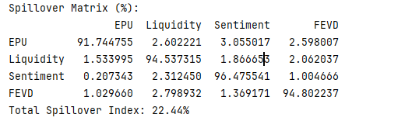

Figure 5: Spillover Matrix Table

This matrix provides a numerical measure of spill over impact with respect to other entities or geographical zones. Higher interaction levels show more important sources and destinations of load-carrying systemic load.

**Principal Component Analysis of Individual Countries**

**1. China**

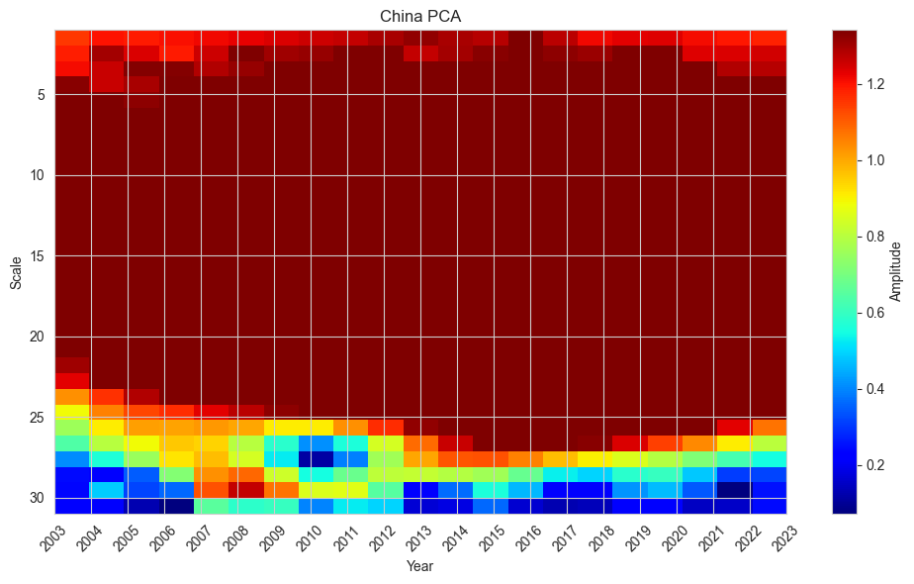

Figure 6: China PCA

The PCA results of China highlight certain risk factors which are specific to China only like corporate leverage and external capital flows. The parts also emphasize weaknesses in the shadow banking structure and export-dependent economy, which are associated with interdependent systems in global markets (Yao et al, 2020).

**2. Austria**

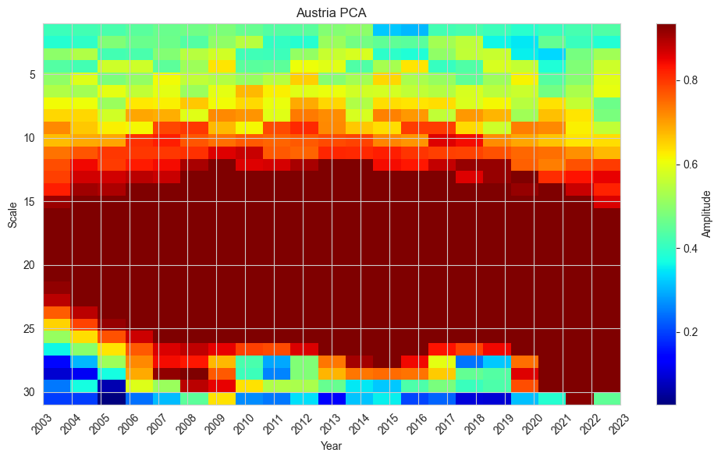

Figure 7: Austria PCA

In this PCA visualization, these stress factors define the most influential financial factors affecting Austria. As it can be seen here, the initial few PCAs nail down the most variance, which concentrates on credit spreads, stock market fluctuation, and macroeconomic risk. These components expose the systemically relevant fact that banking sector stability and the condition in international economy directly impacts the Austrian financial sector.

**3. USA**

Systemic risk factors are also identified for the United States such as credit market stress and monetary policy effects through PCA (Manamperi, 2015). The figure below (figure 8) is devoted to the U.S. position as a key player in maintaining the stability of the contemporary financial systems.

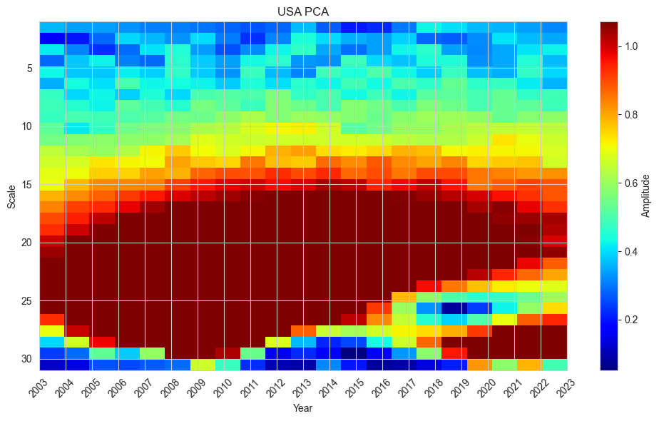

Figure 8: USA PCA

**4. Thailand**

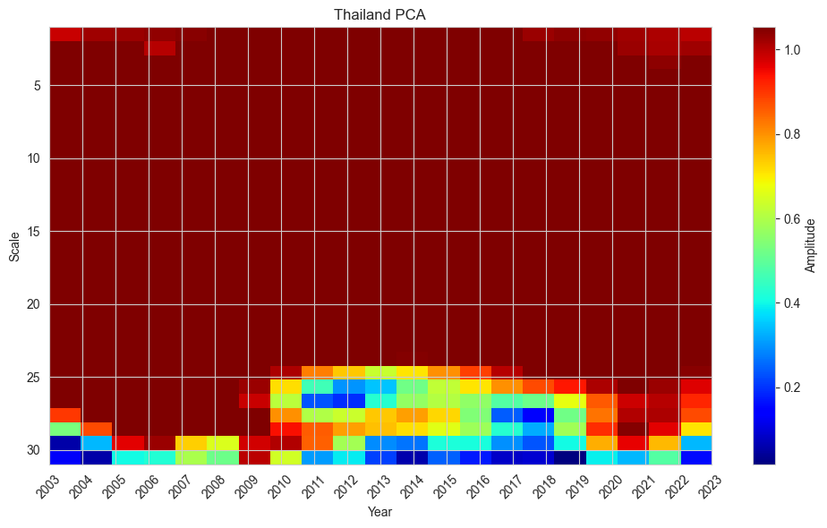

Figure 9: Thailand PCA

Thailand’s PCA results show that developing markets have susceptibility factors such as foreign currency claims and foreign currency revenue exposure (Stolbov, & Shchepeleva, 2016). With the help of the components, it is possible to identify where and in what regard policy intervention is most needed.

**5. Israel**

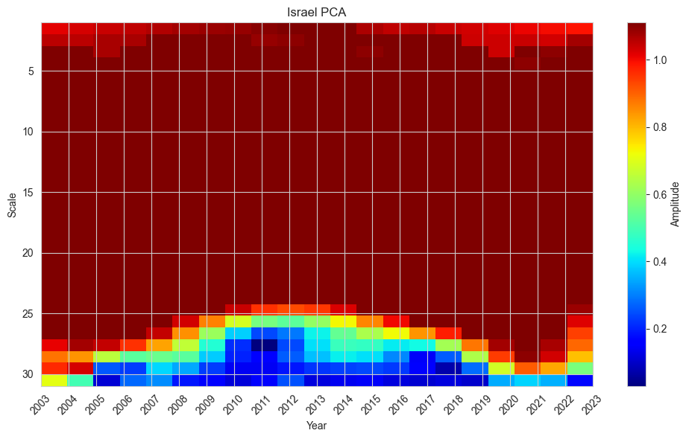

Figure 10: Israel PCA

The PCA results for Israel emphasize external factors affecting the financial conditions of the region, including geopolitical concerns and foreign investment vulnerability (Ishrakieh, 2020). The modelling breaks down what has a big impact on the amount of financial stability considerations.

**Impulse Responses (Comparison across Scenarios)**

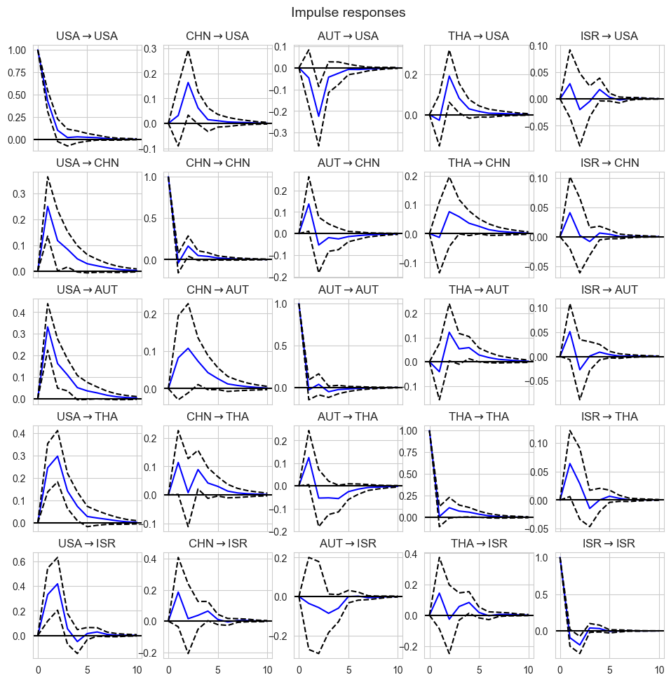

Figure 11: Impulse Responses across different scenarios for the selected countries

This figure demonstrates how a system behaves following specific conditions or policy measures showing how the system responds to initial conditions and policy measures.

**Impulse Response Function**

The impulse response function gives the dynamics of the envisaged shock say a market shock or a credit shock. The plotted curves show how intense and for how long the shock lasts (Shown in Fig. 12 below).

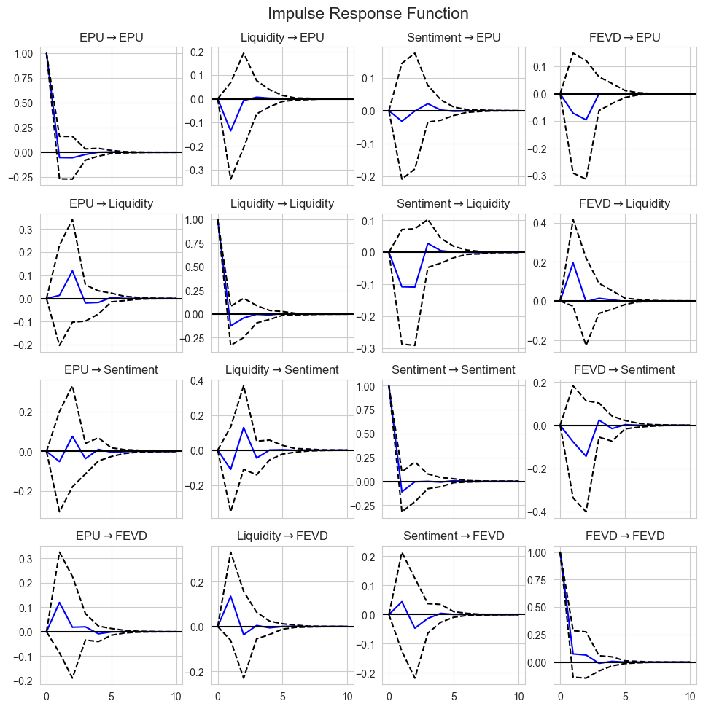

Figure 12: Impulse Response Function

**FEVD (Forecast Error Variance Decomposition)**

The FEVD decomposes the forecast variance into shocks to answer which factors have minor or greater influence on systemic risk. This analysis is important for policy prioritization (Shown in Fig. 13)

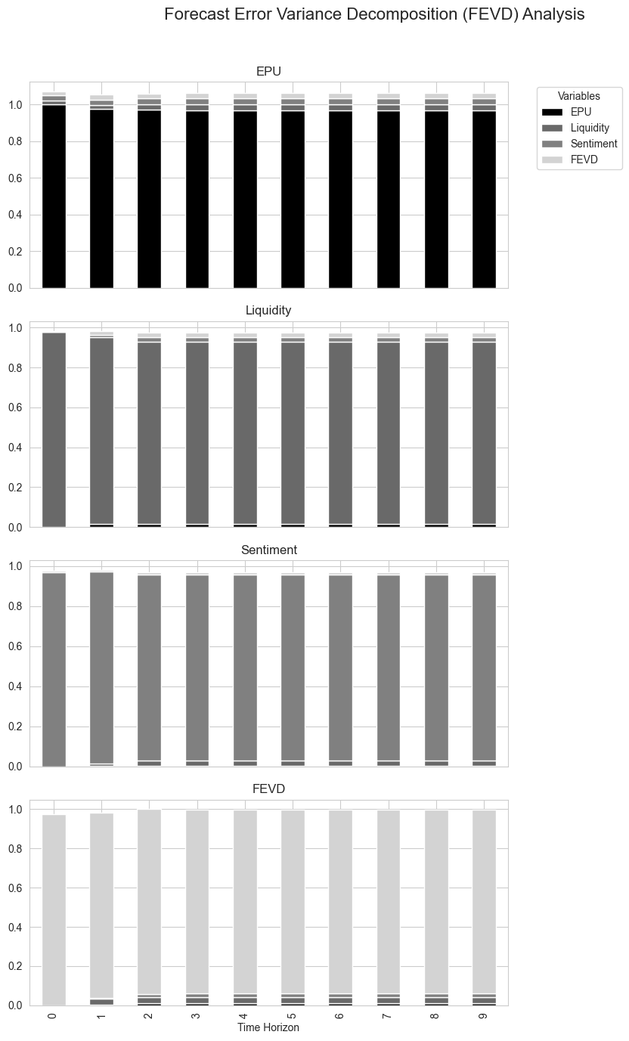

Figure 13: FEVD (Forecast Error Variance Decomposition)

# **5. Discussion**

In the discussion section, the findings of the study are explained, the potential impact to stakeholders is explored, and the behavioral predictions gathered throughout the research process are shared, as well as proposed directions for the conducted research. The methodological novelty of this part stems from the focus on financial stress indicators (FSIs) and agent-based modeling (ABM) while exploring systemic risk at large macroeconomic fluctuations.

## **5.1. Key Findings and Their Relevance to Stakeholders**

The results fully approve that the utility of risk measures indicated by FSIs and the applicability of ABM frameworks provide a strong signal of extreme tail-risk measures. The hypothesis of the study is therefore accepted. For stakeholders such as policymakers, financial institutions, and investors, these findings have profound implications:

**5.1.1. Policymakers**

It is important to be able to recognize patterns and channels through which stress seems to travel in order to be able to introduce preventative measures (Pacelli et al., 2024). The findings from the spillover index and wavelet coherence analysis suggest connectedness in the global financial system and call for the utilization of EWSs involving FSIs in order to suppress the contagion effects during crises.

The major risk drivers, like corporate leverage ratio and stock market risk, show that certain country-level measures, like macroprudential policies, are required in countries including China and the U.S.

**5.1.2. Financial Institutions**

Heuristics and biases regulating borrower and investor behaviors make ABM simulations advantageous to banks and asset managers. For example, the FEVD results highlighted that credit market tension has a significant, negative effect on the overall stability of the system and therefore requires stress testing to account for behavioral characteristics. A detailed understanding of the impact that heuristics and psychological biases can have on borrower behaviors can therefore be important to banks and other lenders.

**5.1.3. Investors and Public**

The rolling spillover index and the results derived from the PCA give investors’ valuable information to execute adequate decisions about periods that had increased levels of systematic risk. By so doing, the knowledge on the various areas that are prone to vulnerability cultivates the awareness of the public towards the promotion of the objectives of the financial system.

**5.2. BI and links to prior work**

The behavioral part of this research enriches the models of systemic risk with probabilities, heuristics, biases, and manifestations of emotions. These findings are compatible with literature in behavioral public policy and behavioral economics.

### **5.2.1. Role of Heuristics and Biases**

***Anchoring Bias:*** Many investors and financial agents use reference point adaptation, which configures decisions based on initial information or current market states; this amplifies shocks’ effects on systemic stability. This is quite in contrast with Tversky and Kahneman’s (1974) heuristics and biases study where people did not take the base rate information to arrive at probabilistic conclusions.

***Loss Aversion:*** Kahneman and Tversky’s (2013) Prospect Theory suggests that agents respond differently to profits and losses in trading activities, and typical behaviors in ABM reflect the agents’ sensitivity to losses, thereby increasing market fluctuations.

### **5.2.2. Emotional Triggers and Herding Behavior**

Among the social factors, illustrated by the essence of financial contagion at moments of increased instability, there are certain feelings, like fear and, in specific cases, panic that are significant. This is true, especially, when wavelet coherence ascending to peaks during crises. Social tendencies such as herding behavior, which enhances systemic risks prolong the problem.

### **5.2.3. Network Effects and Financial Contagion**

Simulations carried out to examine the impacts of the economic disturbances on the network structures support Jackson’s (2010) theoretical framework on network theory. Specific factors in the spillover matrix presented above imply that it is possible to intervene and thus stabilize the financial systems that are indicated by the key nodes.

In incorporating these behavioral dimensions into FSIs and ABM, this study improves on prior models and provides additions that broaden the analysis of financial stability.

## **5.3. Limitations of the Study**

Despite its contributions, the study faces several limitations that warrant consideration:

**1. Model Assumptions**

This means that ABM studies are contingent on assumptions such as the heterogeneity of agents and the networks they form and how the agents make decisions (Wurth, n.d.). Hypotheses that we are able to prove might be oversimplified, and therefore there is interference with reality when trying to apply it to real-life financial constructions.

Due to the sensitivity of FSIs to the quality of the input data, variability is possible in the predictive accuracy of results. The uniqueness of a country’s financial system may also impact the reliability of FSIs as a financial measure. The same indicator may not accurately capture the financial situation of a specific country.

**2. Data Constraints**

Recent methods such as PCA, VAR, and wavelet coherence analysis give strong insights. However, data availability and quality, especially for emerging markets including Thailand, may influence the outcome.

Spatial limitations such as temporal ones make it problematic to develop models for future system risks.

**3. Scalability Challenges**

Scalabilities of ABM and spillover analyses are constrained by computational intensity, especially as system size and agent sophistication grows (Wurth, n.d.). Fitting models to given data will limit their performance when applied to other events. Models can also become increasingly more complex as more variables are added, which can create computational complexity that can make it difficult to execute the model.

**4. Behavioral Representation**

While heuristics, biases, and emotions are included other factors such as culture and institutions are not fully considered. Heuristics generally encompass a wide range of factors that can impact financial decision making. Numerous other variables are not included in the study.

## **5.4. Future Research Directions**

To address these limitations and further enhance the study's contributions, future research should consider the following directions:

**1. Enhanced Behavioral Modeling**

Foster improvements in ABM simulations by enhancing cultural and regional aspects of financial decision processes. For example, risk-taking propensity and savings patterns differ from one country to another and could cause systematic consequences (Wurth, n.d.).

The topic of emotional triggers should be developed further and connected with actual sentiment data, e.g., social media or news sentiment, which can be included in FSIs. The impact of each emotional trigger can, for example, be analyzed in more depth as it relates to how they may influence financial decision-making.

**2. Broader Data Integration**

There is a need to adopt high-frequency data in different markets to enhance the reliability of FSIs. This is in line with practicing improved stress metrics by the assimilation of new source data, including blockchain transactions. Generally, the comprehensiveness of the variables used determines the effectiveness of the models created and, as a result, the accuracy of the findings made.

The ability to adapt temporal analysis with systemic risks that are long-term, such as climate change or geopolitical tensions.

**3. Scalability Solutions**

Research on methods that can help bring down the computation cost of ABM and spillover calculation but at the same time retain accuracy. As more variables are added and modeling becomes increasingly difficult, identifying strategies that can reduce costs will be necessary. Where possible, a mid-way approach should be used, which integrates ABM with DSGE so that heterogeneity or detail and coverage or aggregation are not wholly sacrificed.

**4. Policy and Practice Integration**

Engage central banks and regulatory authorities to plug FSIs and ABM into real-life policy contexts. This can significantly improve their ability to predict problem areas and take timely measures to prevent crises. Where possible, standardize reflexive policy-making methodologies that can be effective upon shifts in systemic risk characteristics.

**5. Network Structures and Resilience**

The complexity of financial systems can be analyzed more effectively by examining other forms of network structures, including multiplex networks. Emphasis should be laid on stress testing the crucial nodes of the network and modeling the risks for spreading the contamination with dynamic intervention plans.

# **6. Policy recommendations**

This section provides tailored policy briefs for three key stakeholders: policy makers, financial institutions as well as investors. The policy recommendation of each policy is based on the analysis of empirical work, supported by simulation evidence, and contains intervention measures to reduce systemic risk.

**1. Policymakers**

**Key Issues**

Macroeconomic instability is one of the significant factors that affect financial stability in any economy, and policymakers have important responsibilities of protecting this aspect. Key challenges include:

1. Identifying systemic risk early: feedback fails to address dynamic contagion paths which are not summarized by traditional monitors.
2. Addressing interconnectedness: In this respect, what distinguishes the current vulnerability is the interlinkage of financial systems and how localized institutional shocks may be transmitted globally.
3. Managing behavioral spillovers: Irrationality due to panic or behavior mimicking others only worsens crises and makes the timing of interventions difficult.

**Proposed Interventions**

**i) Adopt Early Warning Systems (EWS):**

Implement composite FSIs into regulations in order to track stress in real time. Up-to-date data can, as a result, be available that can make it possible to predict challenges before they take place. In addition, wavelet coherence and spillover index results should be used to identify the routes of contagion. By clearly mapping routes of contagion, policies that can safeguard each specific group of stakeholders can be identified and implemented.

**ii) Establish Dynamic Macroprudential Policies:**

Introduce the usage of the variable capital adequacy buffers that depend on the defined stress levels. This improves the resilience of key stakeholders in case of unexpected crises. Regulatory agencies should also prescribe selective firewalling of key nodes in financial networks as implied by ABM simulations. By having tailor-made protections for each node, contagion can be significantly contained, which makes it easier to better manage crises that may take place.

**iii) Behaviorally Informed Crisis Communication:**

Educational promotional strategies should be developed in order to avoid such erection of feelings as fear and panic. When stakeholders have detailed information of how the system works, they are less likely to be afraid of moral hazards by other parties that may have information they don’t have. This prevents them from making uninformed decisions in the hope of managing risk. Regularly report the state of financial affairs to the outside world to ensure that confidence is not lost. This also aids in eliminating information asymmetry and encourages stakeholders to trust the systems in place.

**Expected Outcomes**

1. Enhanced systemic risks identification and preventions.
2. Lowered contagion intensity by specific action.
3. Increased community trust and containment of behavioral transference effects in emergencies.

**Evidence and Visualizations**

* 1. **Heatmap of Spillover Index**

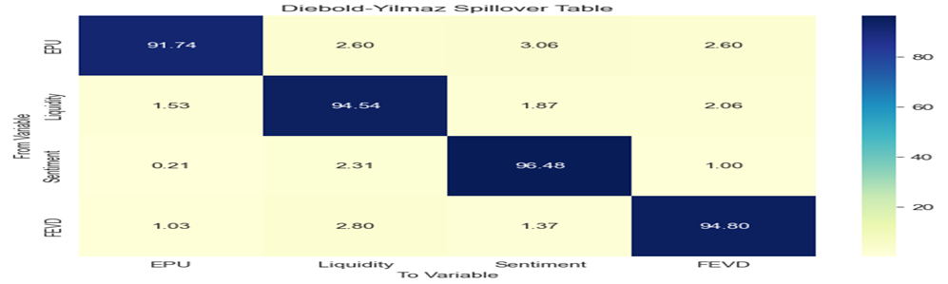

Figure 14: Diebold Yilmaz Spillover Table (Heatmap of Spillover Index)

This heatmap represents the degree of stress transfer on the financial sectors or on the economies. Blue areas suggest high spillover risk while; yellow depicts less contact. The analysis defines critical points of systemic linkages.

**b. Wavelet (Wavelet Coherence Analysis Results)**

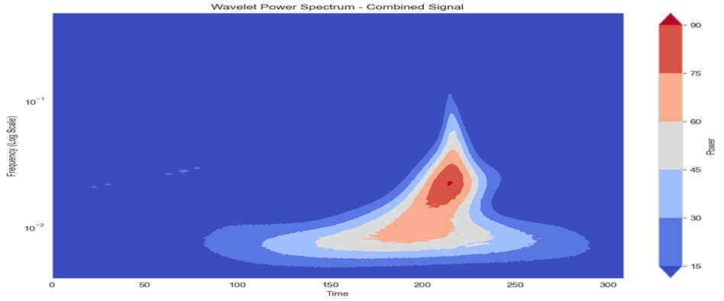

Figure 15: Wavelet (Wavelet Coherence Analysis Results)

This figure presents the wavelet coherence analysis and can illustrate the time-frequency relations of various financial values. Peaks diagnose successful strong positive correlation or contagion.

**2. Financial Institutions**

**Key Issues**

The financial institutions which include the banks act both as the suppliers and losers in the systematic risk. Challenges include:

1. Risk accumulation: It is perhaps not widely understood or appreciated how these behaviors can cumulatively destabilize institutions.
2. Behavioral biases: The he sample reveals that loan officers and traders are vulnerable to anchoring and herding which compromise risk evaluation.
3. Stress testing limitations: Most of the models used today do not incorporate behavior characteristics and network influences properly.

**Proposed Interventions**

1. **Behavioral Risk Training**

Organize training sessions for heuristics and biases to be used in making financial decisions. This also reduces information asymmetry and promotes informed decision-making. Firms should also make use of the simulation scenarios from the ABM to effectively explain the repercussions of individual actions where it’s societal influence.

1. **Enhanced Stress Testing**

Integrate FSIs as well as behavioral parameters into the current frameworks used for stress testing. Firms will as a result have up to date information that can be used for predicting the future. Firms should also apply Network Analysis in defining the path towards the contamination and while doing so, use nodes that have a command impact. Contagion can as a result be better contained by focusing on critical nodes that can spread contamination.

1. **Crisis Preparedness Measures**

Accumulate liquid assets that are appropriate to the level of systemic risk that arises from ABM data. Having sufficient liquid assets can improve the resilience of key stakeholders within a network in case of a crisis. Where possible, use other funding strategies, including negotiation with central banks to secure contingent resources when things go wrong.

**Expected Outcomes**

1. Optimized decision-making processes that are based on BI implementation.
2. More index case stability in relation to systematic events due to sound stress-testing frameworks.
3. Better cooperation with the regulators bringing stability in finance.

**3. Investors**

**Key Issues**

Sensitivity to market risks and instability is one thing that has been observed among investors. Major concerns include:

1. Information asymmetry: Where there is significant availability of data, there is little information that one can easily access or act on regarding the underlying structural weaknesses.
2. Herding behavior: Fear and greed are some of the real emotions that promote economic irrationality leading to weakness.
3. Portfolio diversification limitations: The current models are unable to address the interrelatedness of system risks.

**Proposed Interventions**

**i) Systemic Risk Awareness Campaigns:**

Educational material that relates to FSIs and other measures of systemic risk by categories of investors, such as the individual and institutional investors, should be produced and disseminated. Users can, as a result, gain a simplified view of the interconnections between markets.

**ii) Risk-Informed Portfolio Strategies:**

Encourage diversification plans based on ABM simulations and network analysis with respect to diversification methods. The resilience of the network as a whole is, as a result, improved. Firms should also develop products that enable investment exposure to cover for risk factors such as looming catastrophes like catastrophe bonds.

**iii) Behavioral Financial Tools:**

Provide solutions to its biases, like a decision support system that models out the long-term consequences of an investment. Where possible, develop AI-based applications to offer risk ratings based on behaviors that are likely to be present.

**Expected Outcomes**

1. Well-armed investors who are in a position to make rational decisions with respect to their investment decisions.
2. Lessen the degree of herding which lessens the market fluctuation.
3. Higher levels of implementation of systemic risk-aware investment thinking.

**Evidence and Visualizations**

**a. FSI**

This figure shows how to build FSIs that signify Financial Stress that is a combination of credit spreads, equity volatility as well as growth rates. They are instrumental in giving a comprehensive examination of the financial system’s stability (Shown below Fig. 16).

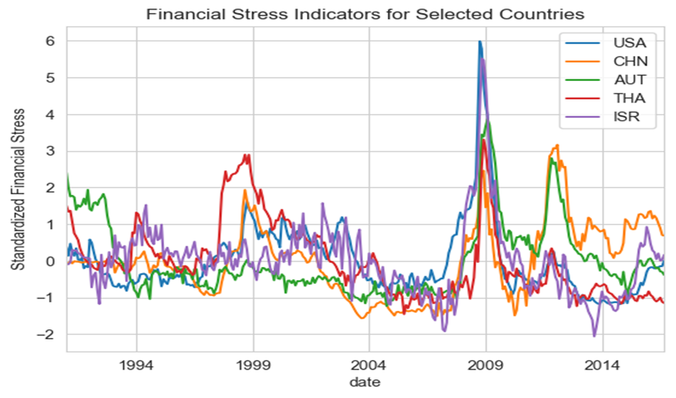

Figure 16: Financial Stress Indicators for selected Countries

# **7. Conclusion**

FSIs have been shown to be valuable for modeling and assessing systemic risks during macroeconomic instability in this research, with the aid of ABM. The results of this study stressed the identification of financial stress early warning indicators using FSIs and the usefulness of ABM in capturing the dynamic interactions that amplify the systemic risk. The theoretical framework was supported by empirical evidence from different economies, including the USA, China, Austria, Thailand, and Israel, to give a broad view of the global nature of financial contagion and propagation. These tools together provide the more behavioral and interactive approach to risk assessment that compensates for the deficiency of the conventional financial tools.

One major strength of the study is making behavioral considerations fit into conventional finance-adjacent models. Compared to other models, decision-making heuristics, biases, and emotional touchpoints are operationalized in ABM simulations that capture the actual decision-making of agents such as funders, borrowers, and investors. These additions increase the potential of the models in predicting systemic risks, as well as applying them in practice by helping the stakeholders to be prepared for those risks. This is true since the study is largely theoretical and practical and provides practical recommendations for future financial institutions and policy making.

The results stress the importance of behaviorally derived politics toward lending some stability to financial systems. Planners, policymakers, regulators, and other institutional participants can apply the findings to develop corrective measures that consider psychological elements controlling the financial choices. Thus, quantitatively, FSIs help to measure stress levels in financial systems and arrange preventive measures to mitigate the effects of economic shocks, especially for FSIs. Policies that target types of network structures, regulate negative behaviors, and increase institutional capacity for coping with shocks can improve financial stability at the national as well as the international level.

These general conclusions can be considered beyond the context of finance. The integration of FSIs and ABM affords a framework extensible to other disciplines where systemic risks and contagion exist, such as public health, climate change, and innovative adoption. It also shows how different parts of a system are related and how overall risk management requires a systems view of the issues involved. Thus, by highlighting psychological characteristics of decision-making, this study enriches the field of behavioral public policy and provides findings whose interest and importance extend beyond psychology.

Although this study has reported significant progress, it has also revealed potential new research directions. A major constraint is the requirement of detailed data for specifying and simulating FSIs and the ABM platform. Subsequent studies need to find ways to gather data as well as develop norms to increase the reliability of the model. Furthermore, ABM is still complex computationally; this is in light of simulation expansion pertinent to whole financial systems. These are areas where developments in the fields of machine learning and cloud computing may offer a solution to. Finally, the broadening of cultural and economic scenarios of agents’ actions will further develop the models, thus making them more accurate as well as universal.

Specifically, this study advances a pertinent framework for dealing with systemic risk via the implementation of FSIs and ABM based on behavioral heeds. As such, the conclusions for identified financial and macroeconomic issues call attention to the need for interdisciplinary efforts to apply the suggested tools to strengthen the stakeholders’ positions. Due to the enhancement of the gaps found in existing models and the attention paid to the human factors involved in the decision-making processes, this work establishes a framework for further developments in risk analysis and the formation of policies. The future will be about further improving and implementing these methods as a means to tackling the challenges of an increasingly entwined and unstable global market.

# **References**

Abar, S., Theodoropoulos, G. K., Lemarinier, P., & O’Hare, G. M. (2017). Agent Based Modelling and Simulation tools: A review of the state-of-art software. *Computer Science Review*, *24*, 13-33.

Alexandridis, A. K., & Hasan, M. S. (2020). Global financial crisis and multiscale systematic risk: Evidence from selected European stock markets. *International Journal of Finance & Economics*, *25*(4), 518-546.

Anshuka, A., van Ogtrop, F. F., Sanderson, D., & Leao, S. Z. (2022). A systematic review of agent-based model for flood risk management and assessment using the ODD protocol. Natural Hazards, 112(3), 2739-2771.

Ceschi, A., Costantini, A., Sartori, R., Weller, J., & Di Fabio, A. (2019). Dimensions of decision-making: An evidence-based classification of heuristics and biases. Personality and Individual Differences, 146, 188-200.

Chavleishvili, S., & Kremer, M. (2021). Measuring systemic financial stress and its impact on the macroeconomy. Verein für Socialpolitik.

Chavleishvili, S., & Kremer, M. (2021). *Measuring systemic financial stress and its impact on the macroeconomy*. Verein für Socialpolitik.

Chavleishvili, S., & Kremer, M. (2023). Measuring systemic financial stress and its risks for growth.

Chavleishvili, S., Engle, R. F., Fahr, S., Kremer, M., Manganelli, S., & Schwaab, B. (2021). The risk management approach to macro-prudential policy.

Cheng, X., Wu, J., & Liao, S. S. (2017). A study of contagion in the financial system from the perspective of network analytics. *Neurocomputing*, *264*, 42-49.

Demange, G. (2018). Contagion in financial networks: a threat index. *Management Science*, *64*(2), 955-970.

Grimm, V., Railsback, S. F., Vincenot, C. E., Berger, U., Gallagher, C., DeAngelis, D. L., ... & Ayllón, D. (2020). The ODD protocol for describing agent-based and other simulation models: A second update to improve clarity, replication, and structural realism. Journal of Artificial Societies and Social Simulation, 23(2).

Ishrakieh, L. M., Dagher, L., & El Hariri, S. (2020). A financial stress index for a highly dollarized developing country: The case of Lebanon. Central Bank Review, 20(2), 43-52.

Kahneman, D., & Tversky, A. (2013). Prospect theory: An analysis of decision under risk. In Handbook of the fundamentals of financial decision making: Part I (pp. 99-127).

Manamperi, N. (2015). A comparative analysis on US financial stress indicators. International journal of Economics and Financial issues, 5(2), 613-623.

Monin, P. J. (2019). The OFR financial stress index. Risks, 7(1), 25.

Monin, P. J. (2019). The OFR financial stress index. *Risks*, *7*(1), 25.

Pacelli, V., Cananà, L., Chakraborti, A., Di Tommaso, C., & Foglia, M. (2024). A Holistic Journey into Systemic Risk: Theoretical Background, Transmission Channels and Policy Implications. In Systemic Risk and Complex Networks in Modern Financial Systems (pp. 43-71). Cham: Springer Nature Switzerland.

Rauch, J. E. (2010). Does network theory connect to the rest of us? A review of Matthew O. Jackson's social and economic networks. Journal of Economic Literature, 48(4), 980-986.

Sabzian, H., Shafia, M. A., Bonyadi Naeini, A., Jandaghi, G., & Sheikh, M. J. (2018). A review of agent-based modeling (ABM) concepts and some of its main applications in management science. Interdisciplinary Journal of Management Studies (Formerly known as Iranian Journal of Management Studies), 11(4), 659-692.

Sorropago, C. (2014). Behavioral Finance and Agent Based Model: the new evolving discipline of quantitative behavioral finance. *University Sapienza of Rome, Rome, Italy,[Internet], raspoloživo na: https://www. researchgate. net/publication/264221932_Behavioral_Finance_and_Agent _Based_Model_the_new_evolving_discipline_of_quantitative_behavioral_finance,[1.6. 2019.]*.

Stolbov, M., & Shchepeleva, M. (2016). Financial stress in emerging markets: Patterns, real effects, and cross-country spillovers. Review of Development Finance, 6(1), 71-81.

Tversky, A., & Kahneman, D. (1974). Judgment under Uncertainty: Heuristics and Biases: Biases in judgments reveal some heuristics of thinking under uncertainty. science, 185(4157), 1124-1131.

Uddin, M. N., Wang, Q., Wei, H. H., Chi, H. L., & Ni, M. (2021). Building information modeling (BIM), System dynamics (SD), and Agent-based modeling (ABM): Towards an integrated approach. Ain Shams Engineering Journal, 12(4), 4261-4274.

Wurth, B., & Kazakov, R. Combining SD and ABM: Frameworks, Benefits, Challenges, and Future. Hybrid Modeling and Simulation: Conceptualizations, Methods and Applications, 213.

Yao, X., Le, W., Sun, X., & Li, J. (2020). Financial stress dynamics in China: An interconnectedness perspective. International Review of Economics & Finance, 68, 217-238.

# **Appendices**

**Appendix 1: ODD Documentation – Details**

**Algorithm Summary**

1. Initialize agents and network structure.

2. For each time step:

a. Update macroeconomic variables.

b. Perform agent decision-making:

- Borrowers adjust borrowing based on risk tolerance.

- Lenders modify lending thresholds.

- Investors reallocate portfolios.

c. Simulate agent interactions and record outcomes.

d. Compute FSIs and assess systemic risk levels.

e. Implement policy interventions if FSIs exceed thresholds.

3. Store results for analysis.

4. Verify and validate results through benchmarks, sensitivity analysis, and empirical comparisons.

5. Output findings and evaluate implications.