Articles Of Association
THE COMPANIES ACT
CAP 486 Laws of Kenya
COMPANY LIMITED BY SHARES.

ARTICLES OF ASSOCIATION OF TESTPREP EDUCATIONAL PUBLISHERS

PRELIMINARY
1. The regulations contained in Table "A" of part I in the First Schedule to the Companies Act (such Table being hereinafter called Table "A") shall not apply to the Company except so far as expressly incorporated herein. All references herein contained to any specific Articles of Table "A" shall be inclusive of the first and the last Articles referred to and in case of any conflict between the provisions herein contained and the incorporated clauses of Table "A" the provisions herein contained shall prevail.

INTERPRETATION
2. In these Articles unless there is something in the subject matter or context inconsistent therewith: -
(a) "The Company" means the above Company.
(b) "The Companies Act" means the Companies Act, Cap. 486, of the Laws of Kenya.
(c) "The office" means the registered office for the time being of the company.
(d) "The Seal" means the Common Seal of the Company. "Dividend" includes Bonus.

PRIVATE COMPANY
3. The Company is to be a Private Company and accordingly:-
(a) The number of members of the Company (exclusive of persons who are in the employment of the Company and of persons who having been formerly in the employment of the Company were white in such employment to be members of the Company) is limited to fifty: Provided that where two or more persons hold one or more shares in the Company jointly they shall for the purpose of this regulation be treated as a single member.
(b) Any invitation to the public to subscribe for any shares or debentures of the Company is hereby prohibited.
(c) The right to transfer shares is restricted in manner hereinafter provided.
(d) The Company shall not have power to issue share warrants to bearer.

SHARE
4. No part of the funds of the Company shall directly or indirectly employed in the purchase of or in loans upon the security of the Company's shares, but nothing in this regulation shall prohibit transactions mentioned in the proviso of Section 56 (1) of the Companies Act.
5. Subject to the provisions of the above-mentioned articles the shares shall be under the control of the Directors, who may allot or otherwise dispose of the same to such persons and on such terms and conditions as they think fit.

CERTIFICATES
6. Every person whose name is entered as a member in the register of members shall, without payment, be entitled to a Certificate under the Seal of the Company specifying the share or shares held by him and the amount paid up thereon, provided that in respect of a share or shares held jointly by several persons the Company shall not be bound to issue more than one Certificate and delivery of a Certificate for a share to one of the several joint holders shall be sufficient delivery to all.
7. Every share certificate shall specify the number, and the denoting numbers of the shares in respect of which it is issued and the amount paid upon thereon.
8. If any Certificate be worn out or defaced, then, upon production thereof to the Directors, they may order the same to be cancelled, and may issue a new Certificate in lieu thereof, and if any Certificate be lost or destroyed, then upon thereof to the satisfaction of the Directors and on such indemnity as the Directors deem adequate being given a new Certificate in lieu thereof shall be given to the party entitled to such lost or destroyed Certificate. The sum of Shillings one shall be paid to the Company for every Certificate issued under this clause.
9. The Certificate of shares registered in the names of two or more persons shall be delivered to the person first named on the register.

CALLS
10. Subject to any special condition on the allotment of shares all calls on share shall be made at the discretion of the Directors and shall be payable at such time and place and by installments or otherwise as the Directors may appoint and Articles 15 to 21 of Table "A" shall apply.
11. A call shall be deemed to have been made when the resolution of the Directors authorizing such call was passed.

FORFEITURE
12. Articles 33 to 39 of Table "A" shall apply except that:-
(a) Forfeiture of a share shall include all dividends declared in respect of the forfeited shares and not actually paid before the forfeiture; and
(b) The liability of a person whose shares have been forfeited shall continue notwithstanding that the Company may have received payment in full of the nominal amount of the shares.

LIEN
13. The Company shall have a first and paramount lien upon all the shares registered in the name of each member and Articles 11 to 14 of Table "A" shall apply, but so that lien shall apply to fully paid up share.

TRANSFER AND TRANSMISSION OF SHARE
14. The right of members to transfer their shares shall be restricted as follows:-
(a) A share may be transferred by a member or other person entitled to transfer to any member of the Company selected by the transferor; but save as aforesaid and save as provided in sub-clause (b) hereof no share shall be transferred to a person who is not a member so long as any member or any person selected by the Directors as one whom it is desirable to admit to membership is willing to purchase the same at a fair value.
(b) Member at a fair value to be paid as provided in sub-clause (e) hereof before such shares shall be transferred or sold by the executors or the administrators of the deceased to any member or non-members unless the son or sons or wife of the deceased member apply for transfer of shares to him or them in which case he or they shall have the first option to have the shares transferred to him or them jointly and the executors or the administrators of the deceased holding shares on behalf of the minor sons of the deceased shall have no voice in the management of the Company.
(c) Except where the transfer is made pursuant to sub-clause (a) and (b) hereof, the member proposing to transfer any shares shall give notice in writing to the Company that he desires to transfer the same. Such notices shall specify the sum he or she gives as the fair value and shall constitute the Company his or her agent for the sale to any member of the Company or person selected as aforesaid at the price so fixed or at the option of the purchaser, at the fair value to be fixed by the auditor in accordance with these Articles. The transfer--notice may include several shares and in such case shall operate as if it were a separate notice in respect of each share. The transfer notice shall not be revocable except with the sanction of the Directors.
(d) If the Company shall within the space of twenty-eight days after being served with such notice find a person willing to purchase the shares and shall give notice thereof to the proposing transferor he shall be bound upon payment of the full fair value to transfer the shares to the purchaser.
(e) In case any difference arises between the proposing member of other purchaser selected as above and the proposing transferor as to the fair value of the shares the auditor shall on application of either party, certify in writing the sum which is in opinion the fair value and in so certifying the auditor shall be deemed to be acting as an expert and not as an arbitrator.
(f) If in any case the proposing transferor after having become bound as aforesaid makes default in transferring the shares, the Company may receive the purchase money, and shall thereupon cause the name of the purchasing member to be entered in the. Register as the holder of the shares and shall hold the purchase money in trust for the proposing transferor.
(g) If the Company shall not within the space of twenty-eight days after being served with the transfer notice, find a member of other person selected as above willing to buy the shares and give notice in manner aforesaid, the proposing transferor shall at any time within three months afterwards be at liberty subject to sub-clause (i) hereof to sell and transfer the shares to any person whatever and at any price.
(h) The shares specified in any notice served by the Company pursuant to sub-clause (c) hereof shall be offered to all the members of the Company if there are more than one member willing to purchase in proportion to the shares held by them on that date.
(i) The Directors may refuse to register any transfer of a share:
(1) where the Company has a lien on the share; or
(2) where they are not satisfied that the proposed transferee is a responsible person; or
(3) where the Directors consider that the proposed transferee (not being a member) is not a desirable person to admit to membership, but proviso (1) and (2) shall not apply where the proposed transferee is already a member nor to a transfer made pursuant to sub-clause (b) hereof.
(j) Subject to sub-clause (b) hereof the Directors may call the executors or administrators of a deceased member or the trustees or representatives of a bankrupt member to transfer the shares held by such member to a member of the Company or to some person selected by the Directors as aforesaid and if the executors or administrators or trustees aforesaid do not comply forthwith, they shall be deemed to have served the Company with a transfer notice under sub-clause (c) hereof and to have specified therein sum equal to the value of the shares as the same shall be determined by the auditor.
(k) Save as aforesaid Articles 29 to 32 of Table "A" shall apply.

ALTERATION OF CAPITAL
15. Articles 44 to 46 of Table "A" shall apply and the Directors may also (subject to the provisions of the Companies Act) accept surrender of shares.

BORROWING POWERS
16. The Directors may from time to time, at their discretion borrow from any and secure the payment of any sum or sums of money for the purpose of the Company or for the benefit of third parties.
17. The Directors may secure the repayment of such moneys in such manner and upon such terms and conditions in all respects as they think fit and in particular subject to Article 3(b) hereof by the issue of debentures or debenture stock of the Company, charged upon or any part of the property of the Company, (both present and future) including the uncalled capital for the time being.

GENERAL MEETINGS
18. General Meetings shall be held once at least in every calendar year at such time (not being more than fifteen months after the holding of the last preceding General Meeting) and at such place as may be determined by the Directors. Such general meetings shall be called "Annual General Meetings" and all other meetings of the Company shall be called "Extraordinary General Meetings".
19. The Directors may, whenever they think fit, convene an Extraordinary General Meeting and the Director shall on the request in writing of the holders of not less than one-tenth of the issued capital of the Company upon which all calls or other sums then due have been paid forthwith proceed to convene an Extraordinary General Meeting and the provisions of Section 132 of the Companies Act shall apply.
20. If at any time there are not within East Africa sufficient Members or Directors capable of acting to form a quorum any Director or any two members of the Company may convene an Extraordinary General Meeting.

PROCEEDINGS AT GENERAL MEETINGS
21. Article 52 to 61 of Table "A" shall apply but so that:-
(a) An Extraordinary General Meeting may, with the consent in writing of all the members for the time being be convened on a shorter notice than seven days or without written notice.
(b) Notice of an adjourned meeting shall not be required in any case.
(c) Two members present personally or by proxy shall form a quorum.

VOTES OF MEMBERS
22. Articles 62 to 73 Table "A" shall apply, save that an instrument of proxy may be in the usual common form or in any other form approved or accepted by the Directors.

DIRECTORS
23. The number of Directors shall not be less than two and not more than seven.
24. The first Directors of the Company shall be the subscribers of this Memorandum and Articles of Association.
25. Each Director shall be paid remuneration at such rate as the Company in its Annual General Meeting shall direct and each Director shall be entitled to be paid his reasonable traveling expenses incurred by him whilst employed in the business of the Company.
26. If any Director being willing shall be called upon to perform extra services for the purposes of the Company, and the Company shall remunerate such Director by a fixed sum or percentage of profits or otherwise as may be determined by the Directors and such remuneration may either in addition to or in substitution for his remuneration above provided.
27. The Directors shall remain in office until removed by memorandum in writing signed by the holders of a majority in nominal value of the issued share capital for the time being of the Company, and left at the Registered Office for the time being of the Company or by a Special Resolution of the Company in General Meeting.
28. The office of a Director shall ipso facto be vacated:-
(a) if he be found lunatic or become of unsound mind; or
(b) if he shall become bankrupt or compound with his creditors; or
(c) if by notice in writing to the Company he resigns his office; or
(d) if he ceases to hold the required amount of shares to qualify him; or
(e) if he ceases to be a Director by virtue of or becomes prohibited from being a Director by reason of an order made under any of the provisions of he Act; or
(f) if he be removed from office under the provisions of these Articles.
29. No Director shall be disqualified from his office by contracting with the Company nor shall any such contract entered into by or on behalf of the Company in which any Director shall be in any way interested be avoided, nor shall any Director so contracting or being so interested be liable to account to the Company for any profit realized by any such contract by reason of such Director holding that office, or of the fiduciary relations thereby established but is declared that the nature of his interest must be disclosed by him at the meeting of Directors at which the contract is determined if his interest must be disclosed by him at the meeting of Directors at which the contract is determined if his interest then exists or in any other case at the first meeting of the Directors after the acquisition of his interest.
30. The qualification of a Director shall be the holding of one share in his own right.
31. Articles 91 to 97 of Table “A” shall apply.

ALTERNATE DIRECTORS
32. Every Director shall have power to nominate any person to act or attend as Alternate Director in his place during his absence from East Africa and on such appointment being made the Alternate Director shall be subject in all respects to the terms (except as regards share qualification) and conditions existing with reference to the other Directors and such Alternate Director while acting in the Place of such- absent Director shall exercise and discharge all the duties of the Director whom he represents.

PROCEEDINGS OF DIRECTORS
33. Articles 98 to 106 of Table "A" shall apply but so that: - (a) A Director who is at any time out of Kenya shall not during his absence have the right to vote. (b) A resolution determined without any meeting of Directors and evidenced in writing under the hands of all the Directors shall be as valid and effectual as a resolution duly passed at a meeting of the Directors. .
34. Directors and the Directors may exercise all such powers and do all such acts and things as the Company by its Memorandum of Association or otherwise authorised to exercise or do, and as are not hereby or by statute directed or required to be exercised or done by the Company in Annual General Meeting but subject nevertheless to the Companies Act and of these presents and to any regulations from time to time made by the Company in Annual General Meeting not being inconsistent with the provisions of these presents; provided that no such regulation shall invalidate any prior act of the Directors which would have been valid if such regulation had been made.
35. The Directors may from time to time appoint one or more of them as Manager for such term and at such remuneration and upon such terms and duties to be performed as they may think fit, and any Director so appointed shall not, while holding that office be subject to retirement by rotation or taken into account in determining the rotation of retirement of Directors; but his retirement shall be subject to determination ipso facto if he ceases from any causes to be Director; or if the Company in General Meeting resolves that his tenure of office of Managing Director or Manager be determined.
36. The Directors shall duly comply with the provisions of the Companies Act or any statutory modification thereof for the time being in force and in particular of mortgages affecting the property of the Company, or created by it, and keeping a register of the Directors, and to sending to the Registrar of the Companies all information as required by the Companies Act.
37. The Directors shall cause minutes to be made in books provided for the purpose:-
(a) Of all appointments of officers made by the Directors;
(b) Of the names of the Directors present at each meeting of the Directors and of any committee of the Directors;
(c) Of all resolutions and proceedings at all meetings of the Company, and of the Directors, and of the Committee of Directors; and every Director present at any meeting of the Directors or Committee of Directors shall sign his name in the book to be kept for that purpose.

SECRETARY
38. The Directors shall from time to time by resolution appoint a Secretary or a temporary substitute for such Secretary and such substitute shall for all the purposes of these Articles be deemed to be the Secretary during the period for which he is appointed. A Director may hold the office of Secretary of the Company subject to Section 179 of the Companies Act.
39. The Seal of the Company shall not be affixed on any instruments except by the authority of a resolution of the Board of Directors, and in the presence of at least one Director and of the Secretary or such other person as the Directors may appoint for the purpose. Such Director and Secretary or other person aforesaid shall sign every instrument to which the Seal of the Company is so affixed in their presence.

DIVIDEND AND RESERVE
40. Articles 114 to 122 of Table "A" shall apply and in addition to the provisions therein contained any General Meeting declaring a dividend may resolve that such dividend be paid wholly or in part by the distribution of specific assets, and in particular or paid up shares, debentures or debenture stock of any one or more of such ways.

ACCOUNTS
41. Articles 123 to 127 of Table "A" shall apply.

AUDIT
42. Once at least in every year the accounts of the Company shall be examined and the correctness of the profit and loss account and balance sheet ascertained by an auditor. The Company at each Annual General Meeting shall appoint an auditor to hold office until the next Annual General Meeting and his appointment, remuneration, rights and duties shall be regulated by Sections 159 to 162 of the Companies Act.

NOTICES
43. A notice may be served by the Company upon any member either personally or by sending it through the post in a prepaid letter, envelope or wrapper addressed to each member at his registered place of address.
44. Each holder of registered share whose place of address is not in Kenya may from time to time notify in writing to the Company an address in Kenya, which shall be deemed to be his registered place of address within the meaning of the preceding clause. If he shall not have named such an address he shall not be entitled to any notice.
45. All notices shall with respect of any registered shares of which persons are jointly entitled to be given to whichever of such persons is named first in the register and notice so given shall be sufficient notice to all the holders of such shares.
46. Any notice or document sent by post shall be deemed to have been served on the day (following that) on which the letter, envelope or office.
47. In case of special resolution twenty-one days' notice shall be given. In any other case where a given number of days' notice or notice extending over any other period is required to be given the day of service shall, but the day upon which such notice shall expire shall not be counted in such number of days or other period.
48. Save as hereinbefore provided notice of every General Meeting shall be given to every member of the Company.

WINDING UP
49. If the Company shall be wound up, whether voluntarily or otherwise the liquidators may, with the sanction of Special Resolution divide among the contributors in specie, any part of the assets of the Company and such division may, if so decided by special resolution, be otherwise than in accordance with the rights of the members.

INDEMNITY
50. Subject to the requirements of Section 402 of the Companies Act every Director or other Officer of the Company shall be entitled to be indemnified out of the assets of the Company against all losses or liabilities which he may sustain or incur in or about the execution of his duty, and no Director or other officer shall be liable for any loss which may be incurred by the Company in the execution of his office or in relation thereto. We, the several persons whose names and addresses are subscribed below are desirous of being formed into a company, in pursuance of this memorandum of Association and we respectively agree to take the number of shares in the capital of the company set opposite our respective names. Names, Postal Addresses and Descriptions of Subscribers
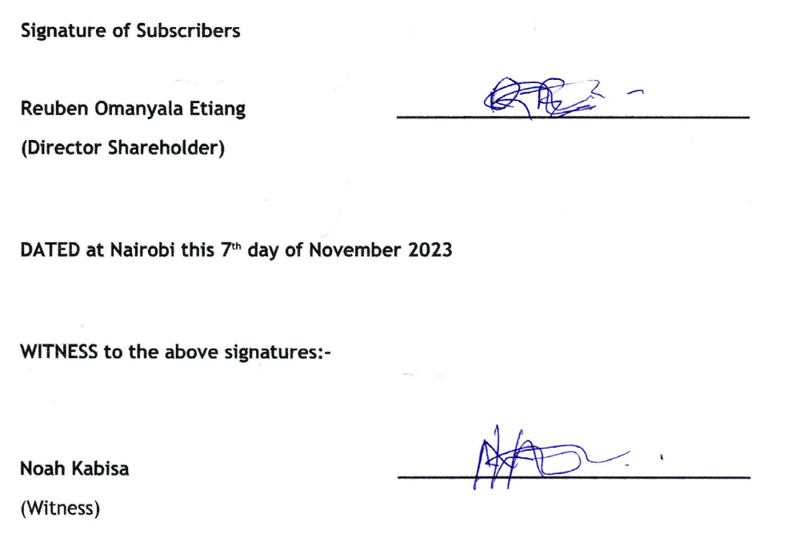
CERTIFICATE UNDER THE COMPANIES REGULATION Certified that the above Articles of Association of Testprep Educational Publishers have been produced by.

