1. Objective of the project

The current pandemic has shown that online tools are important for educating, working remotely or socializing. Music conservatories are one of the institutions that have suffered more the consequences of not being able to make presential lessons. Trying to do instrument online classes can be difficult due to quality of the sound, connexion problems and not being able to receive a proper feedback of the professor, whose decisions and observations are being affected for all the above mentioned. Furthermore, music is a pretty common modality of art practiced by many people around the world and in many different knowledge levels.

Music is an important market and the technology must provide solutions to it. In this context arises MTG (Music Technology Group), a research group installed on UPF and in which I will do my internship. Taking into profit the work that I will do there, I decided to do my final project about:

Assessment of guitar music performances for online education.

The aim of this work is to implement in local host a script that can assess how a student plays a specific musical exercise. I am going to use some python libraries which are private from the MTG, hence it wouldn’t be possible to run the code without having access to that libraries. This work can be classified in the field of MIR (Music Information Retrieval) and MPA (Music Performance Assessment).

1. Methodology and work done

Here I am going to describe my contributions to the project and the methodology I followed.

2.1. How the system works

MUSIC EXERCISE TEMPLATE

*(.ly & .json)*

MUSIC EXERCISE

2.1. Contributions I want to make

1. Create a new exercise template.
2. Improve visualization of the assessment.
3. Improve visualization of the scores.

2.2. Methodology

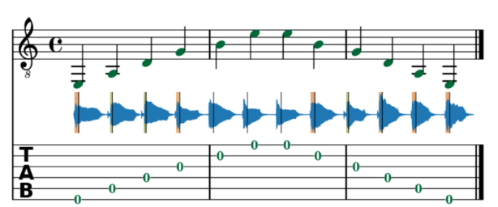The first step was to install all the dependencies needed for executing the code of the MTG libraries. The code works only in python 3.6.8 and requires, between others, *Essentia* (MIR python library implemented by MTG and publicly available) and *lilypond* (Music annotation software).

After the installation, I had to navigate through different MTG GitHub repositories and put together a code which was able to take a music exercise template and a student recording generating a visualization of the performance assessment like *Image1*.

*Image 1*

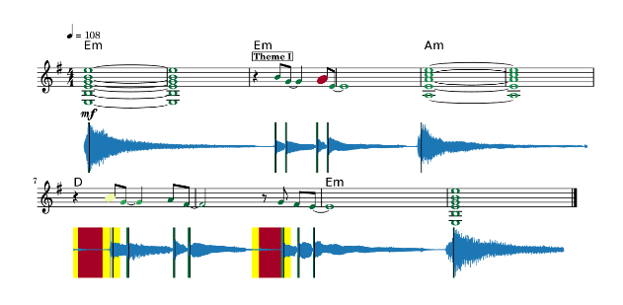When I was able to run this process locally, my next step was to create an exercise template. For this I take in to account the two first lines of the song Lily Was Here ~ [David A. Stewart](https://en.wikipedia.org/wiki/David_A._Stewart) and [Candy Dulfer](https://en.wikipedia.org/wiki/Candy_Dulfer). You can find the music score attached in the data/ repository of this project. The template consists of to files a *.ly (lilypond)* file plus a *.json* file.

My next step was to improve the visualization of the results. For this purpose, I created a macro in the lilypond file which augments the size of the notes that are being played badly and also I add code to highlight the regions where the rhythm from the student deviates much from the original beats (example in Image2).

*Image 2*

The aim for this was to make more intuitive and dinamic the visualization of the final result. Now it is easier to detec the points where the student has miss-played.

Finally, I create a better visualization of the results by adding a radar chart that

1. Results and Conclusions
2. Annexes

MTG: <https://mail.google.com/mail/u/1/#inbox/FMfcgxwKjngTcFVKdlrtKmfPgspCPwQb>

ESSENTIA: https://essentia.upf.edu/index.html

Lilypond: <http://lilypond.org/>

Music Critic Framework: <https://repositori.upf.edu/handle/10230/44130?locale-attribute=en>

Music Critic Demo: <https://musiccritic.upf.edu/#demo>