Self-Hosted Deployment Guide

Overview
This project consists of a single shared dist and one assets folder per floor. The dist does not need to be re-exported when floors change — only the assets folders do.

Folder Structure on Your Server / S3 Bucket
your-bucket/
dist/ ← single dist, shared by all floors
index.html
player.js
app.js
floor-navigator.js
floor-navigator.css
patch-app.js
[fonts, icons, etc.]
SAP0/ ← GF assets
Ia9teGNuMXei6WqP1rKIgw/ ← GF ID tour folder
tourData.json
userData.json
mesh/
pano/
auto_floorplans/
user_floorplans/
SAP1/ ← 1F assets
u16wb_b4P-S3qKWzk0agug/ ← 1F ID tour folder
tourData.json ...
SAP2/ SAP3/ SAP4/ SAP5/ SAP6/ ← one folder per floor
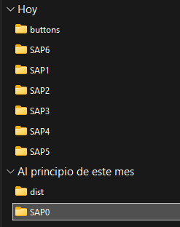
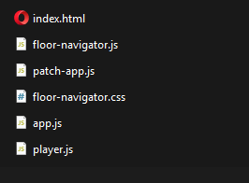
BUCKET / Server DIST/
← floor-navigator.js: UI logic and design

← floor-navigator.css: Block UI interferences

The wrapper folder name (e.g. SAP0, SAP1) can be anything. What matters is that each one contains exactly one subfolder named after the tour ID.

What to Change in floor-navigator.js
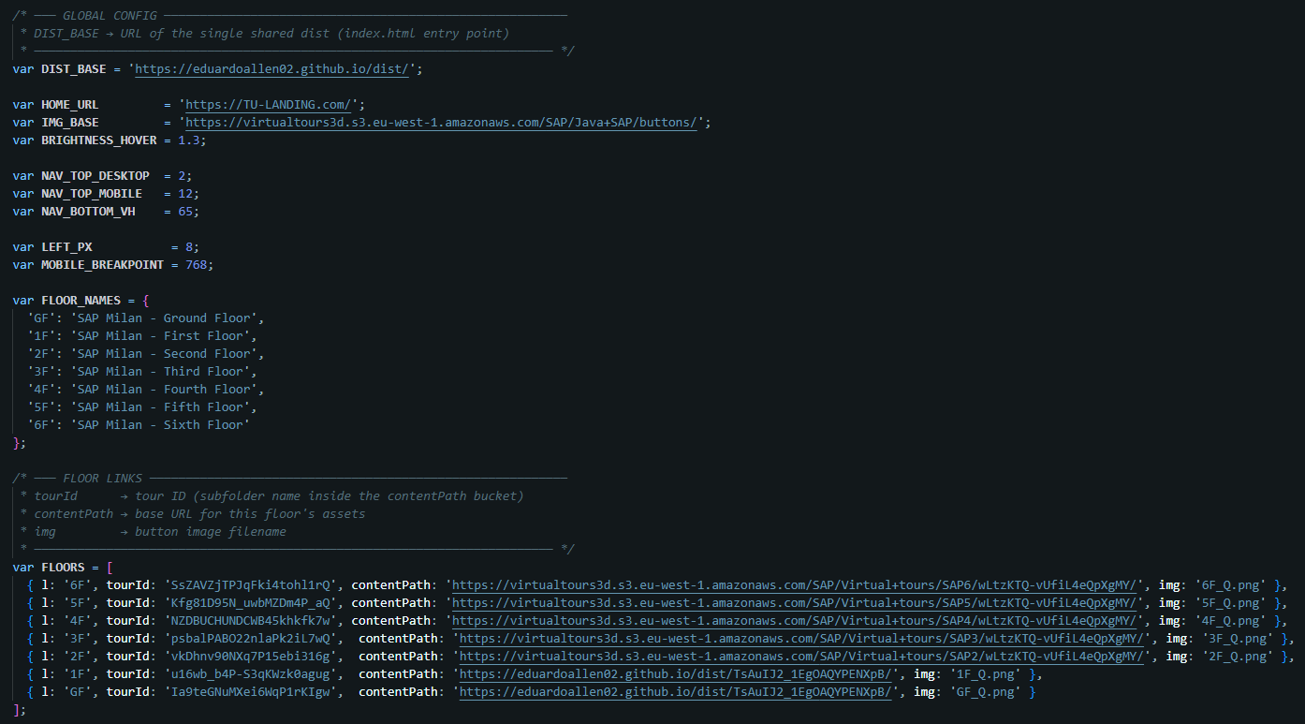
Open floor-navigator.js and update the values at the top of the file:
← DIST_BASE: URL to single shared dist, eg: https://virtualtours3d.s3.eu-west-1.amazonaws.com/dist/

Landing page URL and Imagen/buttons folder url, eg: https://virtualtours3d.s3.eu-west-1.amazonaws.com/buttons/

ContentPath:
URL floor assets folder per floor, eg: MyBucketS3/SAP0/
Tour ID

Rules for contentPath
- Must end with a trailing slash /
- Must point to the folder that contains the tour ID subfolder, not to the tour ID folder itself
- Each floor must have its own contentPath pointing to its own assets folder

How the URL Is Built
When a user clicks a floor button, the navigator builds:
{DIST_BASE}?tour={tourId}&content-path={contentPath}
Example for GF:
https://your-domain.com/dist/?tour=Ia9teGNuMXei6WqP1rKIgw&content-path=https%3A%2F%2Fyour-domain.com%2FSAP0%2F
The player (app.js) then:
- Fetches tourData.json from {contentPath}{tourId}/tourData.json
- Replaces all Rowi S3 URLs inside it with the correct self-hosted paths automatically
- Loads mesh, pano tiles, and floorplans from your server — no calls to Rowi

Running patch-app.js
Run this once before deploying to patch app.js so it accepts both old and domain formats:
node patch-app.js
This only needs to be done once per app.js version. (Done)

Entry URL
Share this URL with users, or use it in Virtual tour button in your landing page for example (replace values accordingly):
https://your-domain.com/dist/?tour={tourId}&content-path={contentPath}
For the Ground Floor:
https://your-domain.com/dist/?tour=Ia9teGNuMXei6WqP1rKIgw&content-path=https%3A%2F%2Fyour-domain.com%2FSAP0%2F

