Document Revision History
PN | // |  | Model | XXX | Name | XXX assembly level number write | Issued/date |  | Approve/Date
NO. | Modify Date | Version | Revised and updated content |  |  |  | Issued By | Project audit | Quality audit | Production audit
1 |  | V1.0 | First Edition |  |  |  | WW PE | // | // | //
Note: the red font is revised; the blue font is noted.

File Directory
Model Name | XXX |  | Machine number | // | First page / total 1 Pages
Station | Station Name | Version | Revision date | Operator | Page | Remark

XXX Number Write Manual
Model | XXX |  | Document | XXX assembly level number write |  |  |  | Name |  | USB driver install |  |  |  |  | Work Hour |  |  |  |  | Station |  | A01
Process: USB driver install
Task content: |  |  |  |  |  |  |  |  |  |  |  |  |  | Notice:
1 | Open Qualcomm Driverthen 64bitfolder accordingly |  |  |  |  |  |  |  |  |  |  |  |  | 1 |  |  | 32bit/64bit use each folder accordingly
2 | Click the Android Driver All-in-One 64bit V1.00 icon |  |  |  |  |  |  |  |  |  |  |  |  | 2
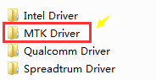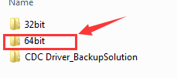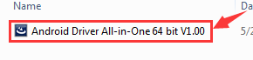

NO. | Part description |  |  |  | PN |  | Consumption |  |  |  | Equipment / tools / accessories |  |  |  |  |  |  |  |  |  |  |  | ESD Protection
 |  |  |  |  |  |  |  |  |  |  | NO. | Name/Model |  |  |  |  |  |  |  |  | Consumption
1 |  |  |  |  |  |  |  |  |  |  | 1 | MTKUSB Driver |  |  |  |  |  |  |  |  | 1 |  | 
2 |  |  |  |  |  |  |  |  |  |  | 2 | PC/Windows 64bit |  |  |  |  |  |  |  |  | 1
3 |  |  |  |  |  |  |  |  |  |  | 3
4 |  |  |  |  |  |  |  |  |  |  | 4
Version |  | C0 | Issued By | WW PE |  | Production audit |  | // | Quality audit |  |  |  | // |  |  | Project audit |  |  | // | Revision date |  |  | 2016/8/31

XXX Number Write Manual
Model | XXX |  | Document | XXX assembly level number write |  |  |  | Name |  | USB driver install |  |  |  |  | Work Hour |  |  |  |  | Station |  | A01
Process: USB driver install
Task content: |  |  |  |  |  |  |  |  |  |  |  |  |  | Notice:
1 | Click Next icon |  |  |  |  |  |  |  |  |  |  |  |  | 1
2 | Click Install for next step |  |  |  |  |  |  |  |  |  |  |  |  | 2
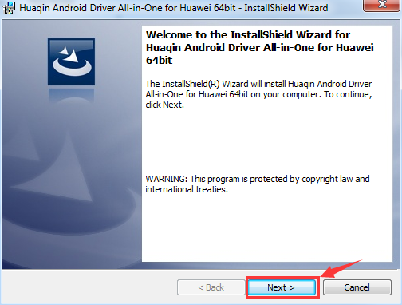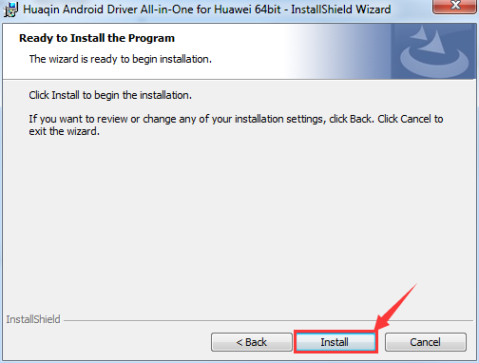
NO. | Part description |  |  |  | PN |  | Consumption |  |  |  | Equipment / tools / accessories |  |  |  |  |  |  |  |  |  |  |  | ESD Protection
 |  |  |  |  |  |  |  |  |  |  | NO. | Name/Model |  |  |  |  |  |  |  |  | Consumption
1 |  |  |  |  |  |  |  |  |  |  | 1 |  |  |  |  |  |  |  |  |  |  |  | 
2 |  |  |  |  |  |  |  |  |  |  | 2
3 |  |  |  |  |  |  |  |  |  |  | 3
4 |  |  |  |  |  |  |  |  |  |  | 4
Version |  | C0 | Issued By | WW PE |  | Production audit |  | // | Quality audit |  |  |  | // |  |  | Project audit |  |  | // | Revision date |  |  | 2016/8/31

XXX Number Write Manual
Model | XXX |  | Document | XXX assembly level number write |  |  |  | Name |  | USB driver install |  |  |  |  | Work Hour |  |  |  |  | Station |  | A01
Process: USB driver install
Task content: |  |  |  |  |  |  |  |  |  |  |  |  |  | Notice:
1 | Always choose the Install this driver software anyway, shown as below. |  |  |  |  |  |  |  |  |  |  |  |  | 1
2 | Click the Finish button complete the process |  |  |  |  |  |  |  |  |  |  |  |  | 2
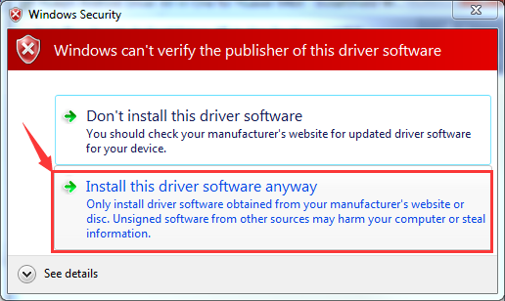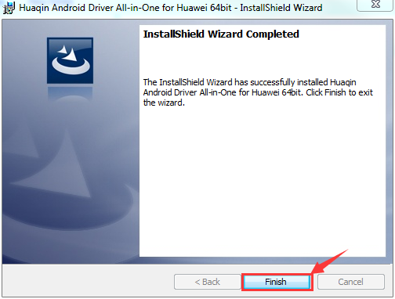
NO. | Part description |  |  |  | PN |  | Consumption |  |  |  | Equipment / tools / accessories |  |  |  |  |  |  |  |  |  |  |  | ESD Protection
 |  |  |  |  |  |  |  |  |  |  | NO. | Name/Model |  |  |  |  |  |  |  |  | Consumption
1 |  |  |  |  |  |  |  |  |  |  | 1 |  |  |  |  |  |  |  |  |  |  |  | 
2 |  |  |  |  |  |  |  |  |  |  | 2
3 |  |  |  |  |  |  |  |  |  |  | 3
4 |  |  |  |  |  |  |  |  |  |  | 4
Version |  | C0 | Issued By | WW PE |  | Production audit |  | // | Quality audit |  |  |  | // |  |  | Project audit |  |  | // | Revision date |  |  | 2016/8/31

XXX Number Write Manual
Model | XXX |  | Document | XXX assembly level number write |  |  |  | Name |  | USB driver install |  |  |  |  | Work Hour |  |  |  |  | Station |  | A01
Process: USB driver install(Backup solution)
Task content: |  |  |  |  |  |  |  |  |  |  |  |  |  | Notice:
1 | In normal number write status, if we found device display CDC Serial in Device manager, another driver install solution will be used. |  |  |  |  |  |  |  |  |  |  |  |  | 1 |  |  | This issue only occur in Normal driver install unsuccessful conditions!!!
2 | Right click the CDC Serial device(in number write status) and choose Update Driver Software |  |  |  |  |  |  |  |  |  |  |  |  | 2
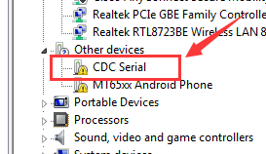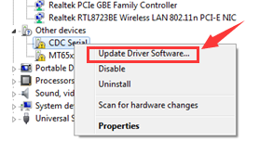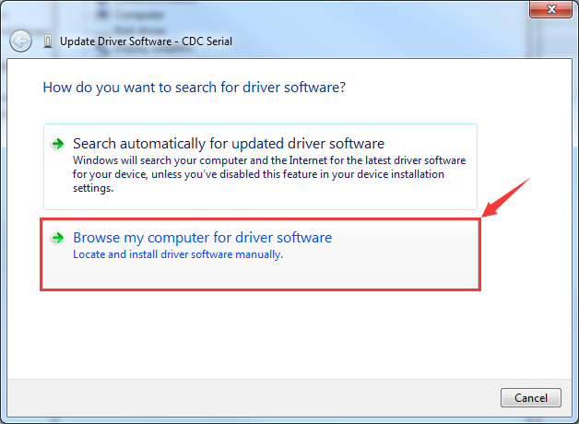
NO. | Part description |  |  |  | PN |  | Consumption |  |  |  | Equipment / tools / accessories |  |  |  |  |  |  |  |  |  |  |  | ESD Protection
 |  |  |  |  |  |  |  |  |  |  | NO. | Name/Model |  |  |  |  |  |  |  |  | Consumption
1 |  |  |  |  |  |  |  |  |  |  | 1 |  |  |  |  |  |  |  |  |  |  |  | 
2 |  |  |  |  |  |  |  |  |  |  | 2
3 |  |  |  |  |  |  |  |  |  |  | 3
4 |  |  |  |  |  |  |  |  |  |  | 4
Version |  | C0 | Issued By | WW PE |  | Production audit |  | // | Quality audit |  |  |  | // |  |  | Project audit |  |  | // | Revision date |  |  | 2016/8/31

XXX Number Write Manual
Model | XXX |  | Document | XXX assembly level number write |  |  |  | Name |  | USB driver install |  |  |  |  | Work Hour |  |  |  |  | Station |  | A01
Process: USB driver install(Backup solution)
Task content: |  |  |  |  |  |  |  |  |  |  |  |  |  | Notice:
1 | Choose Let me pick from…; Select the Ports(COM&LPT), the click Next button |  |  |  |  |  |  |  |  |  |  |  |  | 1
2 | Click Have Disk… , means driver from certain file folder |  |  |  |  |  |  |  |  |  |  |  |  | 2
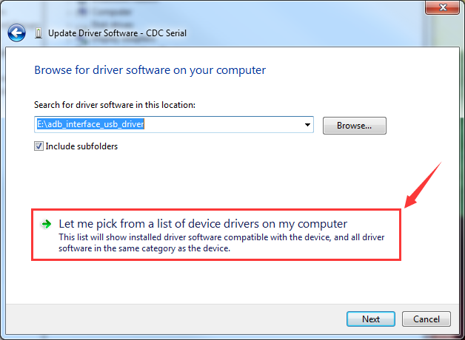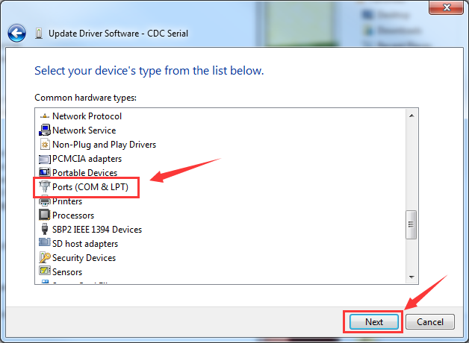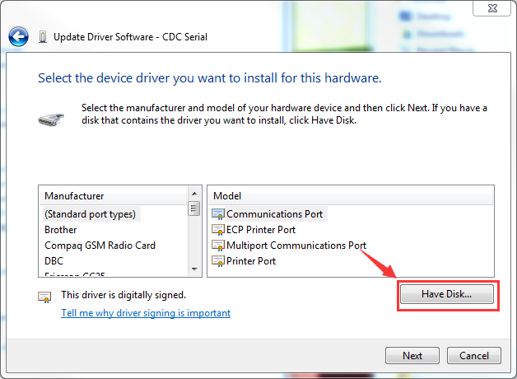
NO. | Part description |  |  |  | PN |  | Consumption |  |  |  | Equipment / tools / accessories |  |  |  |  |  |  |  |  |  |  |  | ESD Protection
 |  |  |  |  |  |  |  |  |  |  | NO. | Name/Model |  |  |  |  |  |  |  |  | Consumption
1 |  |  |  |  |  |  |  |  |  |  | 1 |  |  |  |  |  |  |  |  |  |  |  | 
2 |  |  |  |  |  |  |  |  |  |  | 2
3 |  |  |  |  |  |  |  |  |  |  | 3
4 |  |  |  |  |  |  |  |  |  |  | 4
Version |  | C0 | Issued By | WW PE |  | Production audit |  | // | Quality audit |  |  |  | // |  |  | Project audit |  |  | // | Revision date |  |  | 2016/8/31

XXX Number Write Manual
Model | XXX |  | Document | XXX assembly level number write |  |  |  | Name |  | USB driver install |  |  |  |  | Work Hour |  |  |  |  | Station |  | A01
Process: USB driver install(Backup solution)
Task content: |  |  |  |  |  |  |  |  |  |  |  |  |  | Notice:
1 | Click Browse button, then open the folder CDC Driver_BackupSolution |  |  |  |  |  |  |  |  |  |  |  |  | 1 |  |  | 32bit/64bit use each folder accordingly
2 | Choose 64bit file folder |  |  |  |  |  |  |  |  |  |  |  |  | 2
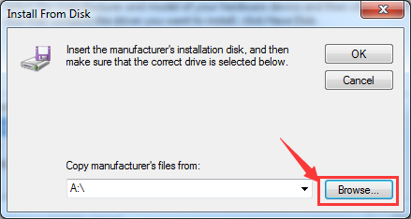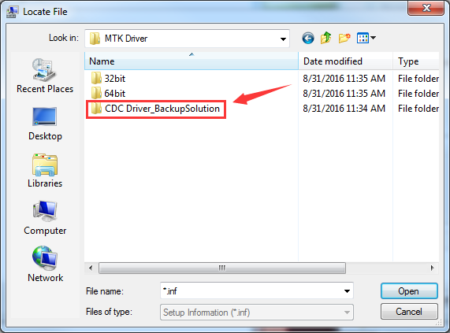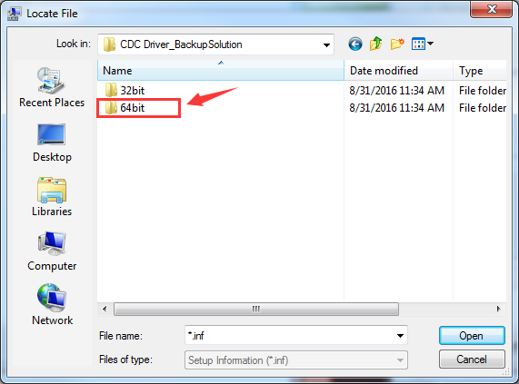
NO. | Part description |  |  |  | PN |  | Consumption |  |  |  | Equipment / tools / accessories |  |  |  |  |  |  |  |  |  |  |  | ESD Protection
 |  |  |  |  |  |  |  |  |  |  | NO. | Name/Model |  |  |  |  |  |  |  |  | Consumption
1 |  |  |  |  |  |  |  |  |  |  | 1 |  |  |  |  |  |  |  |  |  |  |  | 
2 |  |  |  |  |  |  |  |  |  |  | 2
3 |  |  |  |  |  |  |  |  |  |  | 3
4 |  |  |  |  |  |  |  |  |  |  | 4
Version |  | C0 | Issued By | WW PE |  | Production audit |  | // | Quality audit |  |  |  | // |  |  | Project audit |  |  | // | Revision date |  |  | 2016/8/31

XXX Number Write Manual
Model | XXX |  | Document | XXX assembly level number write |  |  |  | Name |  | USB driver install |  |  |  |  | Work Hour |  |  |  |  | Station |  | A01
Process: USB driver install(Backup solution)
Task content: |  |  |  |  |  |  |  |  |  |  |  |  |  | Notice:
1 | Open the Unsigned infs folder; choose cdc-acm file then click Open button |  |  |  |  |  |  |  |  |  |  |  |  | 1
2 | Click OK button |  |  |  |  |  |  |  |  |  |  |  |  | 2
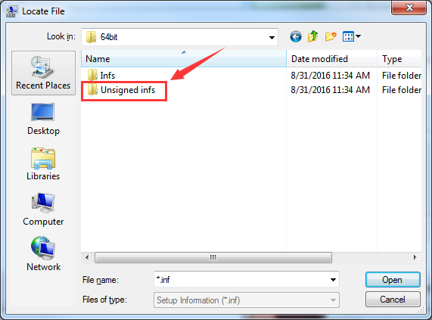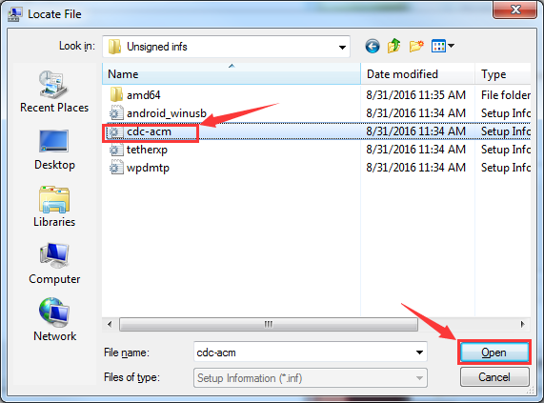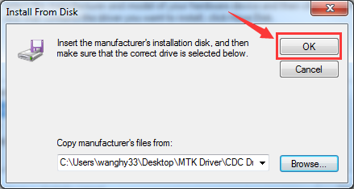
NO. | Part description |  |  |  | PN |  | Consumption |  |  |  | Equipment / tools / accessories |  |  |  |  |  |  |  |  |  |  |  | ESD Protection
 |  |  |  |  |  |  |  |  |  |  | NO. | Name/Model |  |  |  |  |  |  |  |  | Consumption
1 |  |  |  |  |  |  |  |  |  |  | 1 |  |  |  |  |  |  |  |  |  |  |  | 
2 |  |  |  |  |  |  |  |  |  |  | 2
3 |  |  |  |  |  |  |  |  |  |  | 3
4 |  |  |  |  |  |  |  |  |  |  | 4
Version |  | C0 | Issued By | WW PE |  | Production audit |  | // | Quality audit |  |  |  | // |  |  | Project audit |  |  | // | Revision date |  |  | 2016/8/31

XXX Number Write Manual
Model | XXX |  | Document | XXX assembly level number write |  |  |  | Name |  | USB driver install |  |  |  |  | Work Hour |  |  |  |  | Station |  | A01
Process: USB driver install(Backup solution)
Task content: |  |  |  |  |  |  |  |  |  |  |  |  |  | Notice:
1 | Choose MediaTek USB VCOM(Android) and then click Next button |  |  |  |  |  |  |  |  |  |  |  |  | 1
2 | Click Yes for the warning window. Then choose Install this driver software anyway |  |  |  |  |  |  |  |  |  |  |  |  | 2
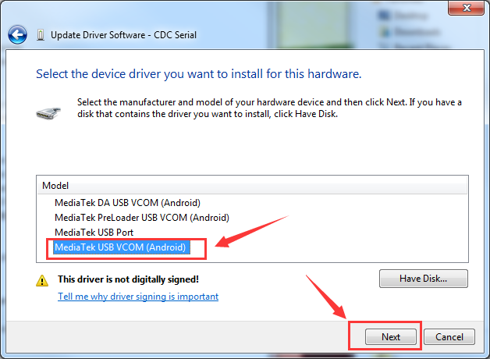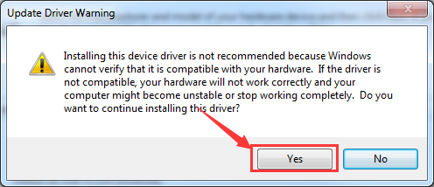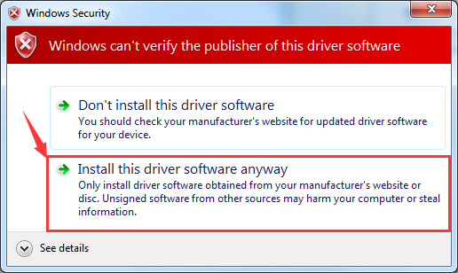
NO. | Part description |  |  |  | PN |  | Consumption |  |  |  | Equipment / tools / accessories |  |  |  |  |  |  |  |  |  |  |  | ESD Protection
 |  |  |  |  |  |  |  |  |  |  | NO. | Name/Model |  |  |  |  |  |  |  |  | Consumption
1 |  |  |  |  |  |  |  |  |  |  | 1 |  |  |  |  |  |  |  |  |  |  |  | 
2 |  |  |  |  |  |  |  |  |  |  | 2
3 |  |  |  |  |  |  |  |  |  |  | 3
4 |  |  |  |  |  |  |  |  |  |  | 4
Version |  | C0 | Issued By | WW PE |  | Production audit |  | // | Quality audit |  |  |  | // |  |  | Project audit |  |  | // | Revision date |  |  | 2016/8/31

XXX number write Manual
Model | XXX |  | Document | XXXassembly level number write |  |  |  | Name |  | Tool configure |  |  |  |  | Work Hour |  |  |  |  | Station |  | A01
Process:Tool configure
Task content: |  |  |  |  |  |  |  |  |  |  |  |  |  | Notice:
1 | Run RW_Tool tool |  |  |  |  |  |  |  |  |  |  |  |  | 1 |  |  | More than 30% battery power volume recommended.
2 | System config run Tool setting |  |  |  |  |  |  |  |  |  |  |  |  | 2
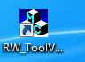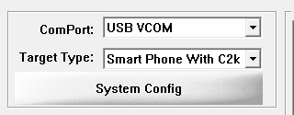

NO. | Part description |  |  |  | PN |  | Consumption |  |  |  | Equipment / tools / accessories |  |  |  |  |  |  |  |  |  |  |  | ESD Protection
 |  |  |  |  |  |  |  |  |  |  | NO. | Name/Model |  |  |  |  |  |  |  |  | Consumption
1 |  |  |  |  | // |  |  |  |  |  | 1 | RW_Tool.exe |  |  |  |  |  |  |  |  | 1 |  | 
2 |  |  |  |  |  |  |  |  |  |  | 2 | PC/Windows 7 32/64bit |  |  |  |  |  |  |  |  | 1
3 |  |  |  |  |  |  |  |  |  |  | 3 | USB cable |  |  |  |  |  |  |  |  | 1
4 |  |  |  |  |  |  |  |  |  |  | 4
Version |  | C0 | Issued By | WW PE |  | Production audit |  | // | Quality audit |  |  |  | // |  |  | Project audit |  |  | // | Revision date |  |  | 2016/8/31

XXX number write Manual
Model | XXX |  | Document | XXX assembly level number write |  |  |  | Name |  | Tool configure |  |  |  |  | Work Hour |  |  |  |  | Station |  | A01
Process: Tool configure
Task content: |  |  |  |  |  |  |  |  |  |  |  |  |  | Notice:
1 | On the setting page, choose MTK platform first |  |  |  |  |  |  |  |  |  |  |  |  | 1
2 | Select SN/APSN/IMEI1/IMEI2/BLT/WIFInumber accordingly |  |  |  |  |  |  |  |  |  |  |  |  | 2 |  |  | SN: 23bit PCBA 8Sxxx code ; APSN: 8bit group SN
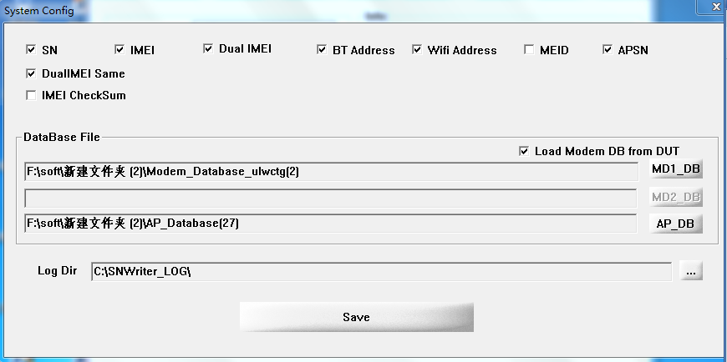
NO. | Part description |  |  |  | PN |  | Consumption |  |  |  | Equipment / tools / accessories |  |  |  |  |  |  |  |  |  |  |  | ESD Protection
 |  |  |  |  |  |  |  |  |  |  | NO. | Name/Model |  |  |  |  |  |  |  |  | Consumption
1 |  |  |  |  |  |  |  |  |  |  | 1 |  |  |  |  |  |  |  |  |  |  |  | 
2 |  |  |  |  |  |  |  |  |  |  | 2
3 |  |  |  |  |  |  |  |  |  |  | 3
4 |  |  |  |  |  |  |  |  |  |  | 4
Version |  | C0 | Issued By | WW PE |  | Production audit |  | // | Quality audit |  |  |  | // |  |  | Project audit |  |  | // | Revision date |  |  | 2016/8/31

XXX number write Manual
Model | XXX |  | Document | XXXassembly level number write |  |  |  | Name |  | Tool configure |  |  |  |  | Work Hour |  |  |  |  | Station |  | A02
Process: Tool configure
Task content: |  |  |  |  |  |  |  |  |  |  |  |  |  | Notice:
1 | Select the K10a40image file folder BP/AP modem file accordingly; |  |  |  |  |  |  |  |  |  |  |  |  | 1 |  |  | Here use K10a40_USR_S216_160709…for example
2 | Click OK button to completed tool setting |  |  |  |  |  |  |  |  |  |  |  |  | 2
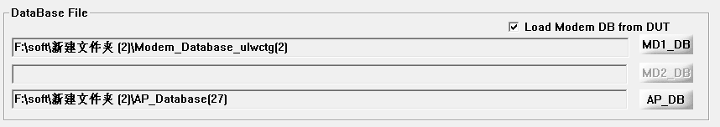
NO. | Part description |  |  |  | PN |  | Consumption |  |  |  | Equipment / tools / accessories |  |  |  |  |  |  |  |  |  |  |  | ESD Protection
 |  |  |  |  |  |  |  |  |  |  | NO. | Name/Model |  |  |  |  |  |  |  |  | Consumption
1 |  |  |  |  |  |  |  |  |  |  | 1 |  |  |  |  |  |  |  |  |  |  |  | 
2 |  |  |  |  |  |  |  |  |  |  | 2
3 |  |  |  |  |  |  |  |  |  |  | 3
4 |  |  |  |  |  |  |  |  |  |  | 4
Version |  | C0 | Issued By | WW PE |  | Production audit |  | // | Quality audit |  |  |  | // |  |  | Project audit |  |  | // | Revision date |  |  | 2016/8/31

XXX number write Manual
Model | XXX |  | Document | XXXassembly level number write |  |  |  | Name |  | Number write |  |  |  |  | Work Hour |  |  |  |  | Station |  | A03
Process: Number write
Task content: |  |  |  |  |  |  |  |  |  |  |  |  |  | Notice:
1 | Click Start button and Read shows Please power on your mobile ….. |  |  |  |  |  |  |  |  |  |  |  |  | 1
2 | On power off status connect sample to PC; Input APSN/IMEI1/IMEI2/BLT/WIFI/SN number |  |  |  |  |  |  |  |  |  |  |  |  | 2 |  |  | Make sure device display:MediaTek USB VCOM…
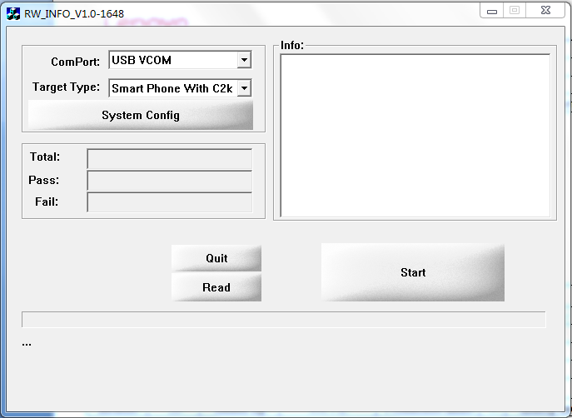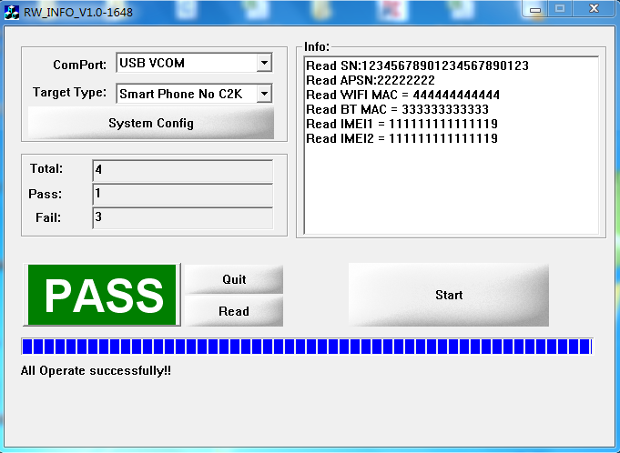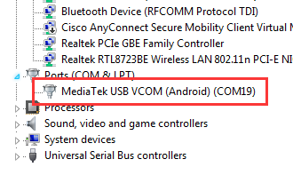
NO. | Part description |  |  |  | PN |  | Consumption |  |  |  | Equipment / tools / accessories |  |  |  |  |  |  |  |  |  |  |  | ESD Protection
 |  |  |  |  |  |  |  |  |  |  | NO. | Name/Model |  |  |  |  |  |  |  |  | Consumption
1 |  |  |  |  |  |  |  |  |  |  | 1 |  |  |  |  |  |  |  |  |  |  |  | 
2 |  |  |  |  |  |  |  |  |  |  | 2
3 |  |  |  |  |  |  |  |  |  |  | 3
4 |  |  |  |  |  |  |  |  |  |  | 4
Version |  | C0 | Issued By | WW PE |  | Production audit |  | // | Quality audit |  |  |  | // |  |  | Project audit |  |  | // | Revision date |  |  | 2016/8/31

XXX number write Manual
Model | XXX |  | Document | XXX assembly level number write |  |  |  | Name |  | Number Check |  |  |  |  | Work Hour |  |  |  |  | Station |  | A04
Process: Number Check
Task content: |  |  |  |  |  |  |  |  |  |  |  |  |  | Notice:
1 | Click Settings->Status icon for example |  |  |  |  |  |  |  |  |  |  |  |  | 1 |  |  | Different models may with different number check method
2 | Check APSN/IMEI1/IMEI2/BLT/WIFI/SN information |  |  |  |  |  |  |  |  |  |  |  |  | 2
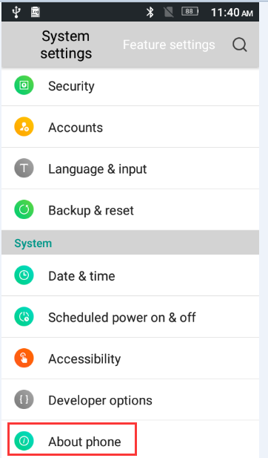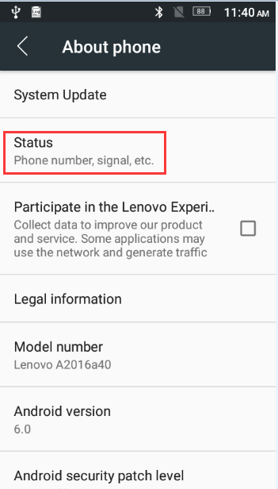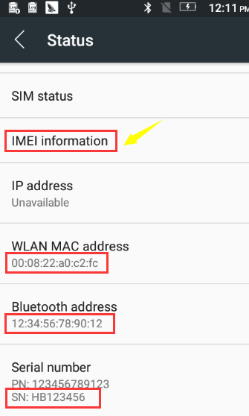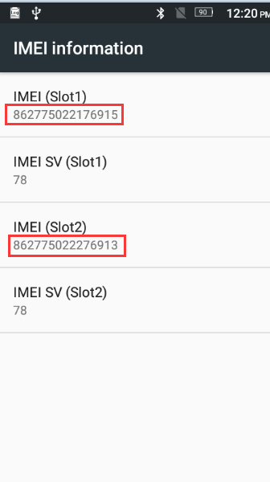
NO. | Part description |  |  |  | PN |  | Consumption |  |  |  | Equipment / tools / accessories |  |  |  |  |  |  |  |  |  |  |  | ESD Protection
 |  |  |  |  |  |  |  |  |  |  | NO. | Name/Model |  |  |  |  |  |  |  |  | Consumption
1 |  |  |  |  |  |  |  |  |  |  | 1 |  |  |  |  |  |  |  |  |  |  |  | 
2 |  |  |  |  |  |  |  |  |  |  | 2
3 |  |  |  |  |  |  |  |  |  |  | 3
4 |  |  |  |  |  |  |  |  |  |  | 4
Version |  | C0 | Issued By | WW PE |  | Production audit |  | // | Quality audit |  |  |  | // |  |  | Project audit |  |  | // | Revision date |  |  | 2016/8/31

