Elasticidad Demanda y Oferta

|  |  |  |  |
| --- | --- | --- | --- |
| Punto | Qd (Cantidad Demanda) | Precio | Ed (Elasticidad) |
| A | 2,600 | 128.086 | 0.9909607378 |
| B | 2,559.5 | 126.0925 |
| C | 2,519 | 124.099 | 0.5004364124 |
| D | 2,478.5 | 120.112 |
| E | 2,438 | 112.1055 |  |

|  |  |  |  |
| --- | --- | --- | --- |
| Punto | Qd (Cantidad Ofertada) | Precio | Es (Elasticidad) |
| A | 2,600 | 128.086 |  |
| B | 2,559.5 | 126.0925 | 1.000859014 |
| C | 2,519 | 124.099 |
| D | 2,478.5 | 120.112 | 0.2451375213 |
| E | 2,438 | 112.1055 |

$$E_{s}=\frac{\% Variación porcentual en la cantidad demandada}{\% Variación porcentual en el precio}=\frac{{ΔQ_{s}}/{Q_{s}}}{{ΔP}/P}=\frac{\frac{Q_{1}-Q_{2}}{Q_{1}}}{\frac{P_{1}-P_{2}}{P_{1}}}$$

$$E_{s1}=\frac{{ΔQ_{s}}/{Q_{s}}}{{ΔP}/P}=\frac{\frac{Q_{1}-Q_{2}}{Q_{1}}}{\frac{P_{1}-P_{2}}{P_{1}}}=\frac{\frac{2559.5-2519}{2559.5}}{\frac{126.0925-124.099}{126.0925}}=1.000859014, Aproximadamente unitaria$$

$$E_{s2}=\frac{{ΔQ_{s}}/{Q_{s}}}{{ΔP}/P}=\frac{\frac{Q_{1}-Q_{2}}{Q_{1}}}{\frac{P_{1}-P_{2}}{P_{1}}}=\frac{\frac{2478.5-2438}{2478.5}}{\frac{120.112-112.1055}{120.112}}=0.2451375213, Inelástica$$

Elasticidad cruzada

|  |  |
| --- | --- |
| $$Q_{dA}$$ | $$\$_{B}$$ |
| $$128.086$$ | 55 |
| $$128.086$$ | 78 |
| $$128.086$$ | 125 |

$$E_{A,B}=\frac{\% Variación porcentual en la cantidad demandada A}{\% Variación porcentual en el precio B}=\frac{{ΔQ_{dA}}/{Q_{dA}}}{{ΔP_{B}}/{P_{B}}}=\frac{\frac{Q_{1}-Q_{2}}{Q_{1}}}{\frac{P_{1}-P_{2}}{P_{1}}}$$

$$E_{{A,B}_{1}}=\frac{{ΔQ_{dA}}/{Q_{dA}}}{{ΔP_{B}}/{P_{B}}}=\frac{\frac{Q_{1}-Q_{2}}{Q_{1}}}{\frac{P_{1}-P_{2}}{P_{1}}}=\frac{\frac{2600-2559.5}{2600}}{\frac{55-54}{55}}=0.8567307692$$

$$E_{{A,B}_{2}}=\frac{{ΔQ_{dA}}/{Q_{dA}}}{{ΔP_{B}}/{P_{B}}}=\frac{\frac{Q_{1}-Q_{2}}{Q_{1}}}{\frac{P_{1}-P_{2}}{P_{1}}}=\frac{\frac{2600-2559.5}{2600}}{\frac{78-77}{78}}=1.215$$

$$E_{{A,B}_{3}}=\frac{{ΔQ_{dA}}/{Q_{dA}}}{{ΔP_{B}}/{P_{B}}}=\frac{\frac{Q_{1}-Q_{2}}{Q_{1}}}{\frac{P_{1}-P_{2}}{P_{1}}}=\frac{\frac{2600-2559.5}{2600}}{\frac{125-124}{125}}=1.947115385$$

Conclusión:

Ya que todas las elasticidades son positivas tenemos que el producto B (Competencia) es sustituto del producto A (Nuestro producto). De esta forma, ate un aumento del precio en B, la cantidad demandada de A aumenta. Lo anterior quiere decir que los consumidores consideran que A puede ser un buen sustituto de modo que cuando el precio de B aumenta, reducen sus compras de B para reemplazarlas por una mayor cantidad de compra de A.

Elasticidad ingreso

|  |  |
| --- | --- |
| $Q_{d}$ (Cantidad Demandada) | $I$ (Ingreso) |
| $$2600$$ | 1000 |
| $$2600$$ | 1500 |
| $$2600$$ | 2000 |

$$E_{Ingreso de la demanda}=\frac{\% Variación porcentual en la cantidad demandada}{\% Variación porcentual en el ingreso}=\frac{{ΔQ_{d}}/{Q_{d}}}{{ΔI}/I}=\frac{\frac{Q_{1}-Q_{2}}{Q_{1}}}{\frac{I_{1}-I_{2}}{I_{1}}}$$

$$E_{{Ingreso de la demanda}_{1}}=\frac{{ΔQ_{d}}/{Q_{d}}}{{ΔI}/I}=\frac{\frac{Q_{1}-Q_{2}}{Q_{1}}}{\frac{I_{1}-I_{2}}{I_{1}}}=\frac{\frac{2600-2559.5}{2600}}{\frac{1000-1500}{1000}}=-0.03115384615$$

$$E_{{Ingreso de la demanda}_{2}}=\frac{{ΔQ_{d}}/{Q_{d}}}{{ΔI}/I}=\frac{\frac{Q_{1}-Q_{2}}{Q_{1}}}{\frac{I_{1}-I_{2}}{I_{1}}}=\frac{\frac{2600-2559.5}{2600}}{\frac{1500-2000}{1500}}=-0.04673076923$$

Conclusiones:

Debido a que las elasticidades son negativas en ambos casos tenemos que nuestro producto es un bien inferior, porque, cuando aumenta el ingreso los consumidores se desplazan hacia bienes sustitutos.

Investigación

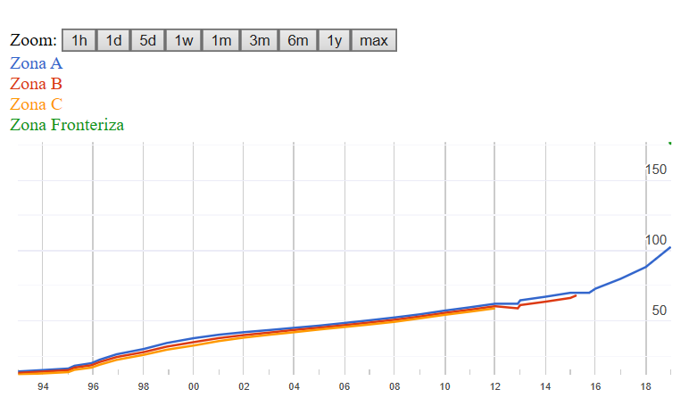**¿Cuánto está el salario mínimo?**

|  |  |  |  |  |
| --- | --- | --- | --- | --- |
| Vigencia | Zona A | Zona B | Zona C | Zona Fronteriza |
| 01/01/2019 | $102.68 | Eliminada | Eliminada | $176.72 |
| 01/01/2018 | $88.36 | Eliminada | Eliminada |  |
| 01/01/2017 | $80.04 | Eliminada | Eliminada |  |
| 01/01/2016 | $73.04 | Eliminada | Eliminada |  |
| 01/10/2015 | $70.10 | Eliminada | Eliminada |  |
| 01/04/2015 | $70.10 | $68.28 | Eliminada |  |
| 01/01/2015 | $70.10 | $66.45 | Eliminada |  |
| 01/01/2014 | $67.29 | $63.77 | Eliminada |  |
| 01/01/2013 | $64.76 | $61.38 | Eliminada |  |
| 27/11/2012 | $62.33 | $59.08 | Eliminada |  |
| 01/01/2012 | $62.33 | $60.57 | $59.08 |  |
| 01/01/2011 | $59.82 | $58.13 | $56.70 |  |
| 01/01/2010 | $57.46 | $55.84 | $54.47 |  |
| 01/01/2009 | $54.80 | $53.26 | $51.95 |  |
| 01/01/2008 | $52.59 | $50.96 | $49.50 |  |
| 01/01/2007 | $50.57 | $49.00 | $47.60 |  |
| 01/01/2006 | $48.67 | $47.16 | $45.81 |  |
| 01/01/2005 | $46.80 | $45.35 | $44.05 |  |
| 01/01/2004 | $45.24 | $43.73 | $42.11 |  |
| 01/01/2003 | $43.65 | $41.85 | $40.30 |  |
| 01/01/2002 | $42.15 | $40.10 | $38.30 |  |
| 01/01/2001 | $40.35 | $37.95 | $35.85 |  |
| 01/01/2000 | $37.90 | $35.10 | $32.70 |  |
| 03/12/1998 | $34.45 | $31.90 | $29.70 |  |
| 01/01/1998 | $30.20 | $28.00 | $26.05 |  |
| 03/12/1996 | $26.45 | $24.50 | $22.50 |  |
| 01/04/1996 | $22.60 | $20.95 | $19.05 |  |
| 04/12/1995 | $20.15 | $18.70 | $17.00 |  |
| 01/04/1995 | $18.30 | $17.00 | $15.44 |  |
| 01/01/1995 | $16.34 | $15.18 | $13.79 |  |
| 01/01/1994 | $15.27 | $14.19 | $12.89 |  |
| 01/01/1993 | $14.27 | $13.26 | $12.05 |  |
| 11/11/1991 | $13,330.00 | $12,320.00 | $11,115.00 |  |
| 16/11/1990 | $11,900.00 | $11,000.00 | $9,920.00 |  |
| 04/12/1989 | $10,080.00 | $9,325.00 | $8,405.00 |  |
| 01/07/1989 | $9,160.00 | $8,475.00 | $7,640.00 |  |
| 01/01/1989 | $8,640.00 | $7,995.00 | $7,205.00 |  |
| 01/03/1988 | $8,000.00 | $7,405.00 | $6,670.00 |  |
| 01/01/1988 | $7,765.00 | $7,190.00 | $6,475.00 |  |
| 16/12/1987 | $6,470.00 | $5,990.00 | $5,395.00 |  |
| 01/10/1987 | $5,625.00 | $5,210.00 | $4,690.00 |  |
| 01/07/1987 | $4,500.00 | $4,165.00 | $3,750.00 |  |
| 01/04/1987 | $3,660.00 | $3,385.00 | $3,045.00 |  |
| 01/01/1987 | $3,050.00 | $2,820.00 | $2,535.00 |  |
| 22/10/1986 | $2,480.00 | $2,290.00 | $2,060.00 |  |
| 01/06/1986 | $2,065.00 | $1,900.00 | $1,675.00 |  |
| 01/01/1986 | $1,650.00 | $1,520.00 | $1,340.00 |  |
| 04/06/1985 | $1,250.00 | $1,150.00 | $1,015.00 |  |
| 01/01/1985 | $1,060.00 | $975.00 | $860.00 |  |
| 11/06/1984 | $816.00 | $750.00 | $660.00 |  |
| 01/01/1984 | $680.00 | $625.00 | $550.00 |  |
| 14/06/1983 | $523.00 | $478.00 | $421.00 |  |
| 01/01/1983 | $455.00 | $415.00 | $365.00 |  |
| 01/11/1982 | $364.00 | $358.00 | $332.00 |  |
| 01/01/1982 | $280.00 | $275.00 | $255.00 |  |

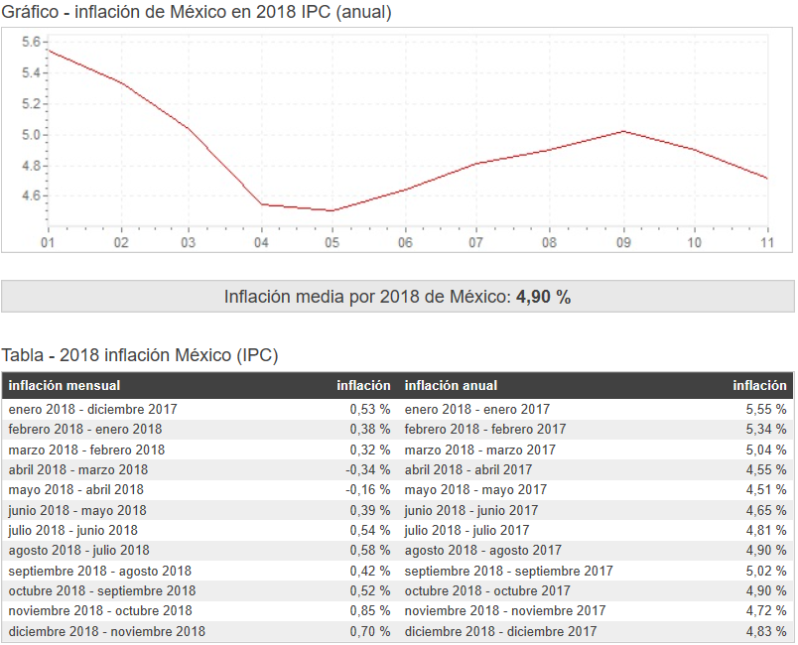**Inflación:**

