Working document

SEAL_directed with node attributes
Initial train-ratio 90 comparison with original SEAL

Purpose. Review the current SEAL_directed implementation and its node attributes, interpret the first target train-ratio 90 results, and agree the controlled experiments.

Decisions
☐ Confirm whether the current 44-feature biological attribute set should be retained.
☐ Agree which outcomes should be reported in the manuscript and which belong in supplementary material.

1. Summary
• The repository contains results for 290 food webs in both pipelines.
• The pooled run-level medians are higher for SEAL_directed for all five predictive metrics examined.
• The largest median increases are precision (+0.124), PR-AUC (+0.081) and F1 (+0.073); recall changes much less (+0.011).
• The pattern is consistent with fewer false positives while retaining similar sensitivity, but no causal or significance claim should yet be made.
• The current comparison changes direction handling, biological attributes and negative-link sampling; it is therefore not a clean test of any one component.

2. Current implementation

Direction-aware SEAL pipeline
• Positive trophic links are treated as ordered resource-to-consumer pairs.
• Test-positive links are masked before enclosing-subgraph extraction, avoiding direct target-link leakage.
• The two target endpoints receive distinct labels, preserving source/target order.
• Neighbourhoods use incoming and outgoing neighbours, but the present DGCNN receives the weak undirected projection of each subgraph. Direction is therefore represented through endpoint order/labels rather than directed message passing.
• By default, negative candidates are filtered to ecologically admissible resource-to-consumer role combinations. If that constrained pool is too small, the implementation falls back to all directed unknown pairs.

Node attributes
A 44-column group matrix is stored in each attributed .mat file and concatenated with the structural SEAL labels before the DGCNN model. The build summary contains 290 food webs and 18,721 nodes.
Attribute family | Encoding | Features | Mean raw coverage | Missing-data treatment
Body mass | log10_mass_z + missingness flag | 2 | 95.4% | Global-median imputation when unavailable; missingness retained explicitly
Taxonomic resolution | One-hot taxonomy level | 6 | 91.5% | Unknown category retained
Metabolic type | One-hot category | 10 | 100.0% | Unknown category retained
Movement type | One-hot category | 7 | 99.7% | Unknown category retained
Life stage | One-hot category + missingness flag | 19 | 55.5% | Missingness retained; interpretation requires caution

Mass was imputed for 1,369 of 18,721 nodes (7.31%). Length variables are excluded because raw coverage is much lower. Degree, trophic level, generality, vulnerability and clustering are also excluded because calculating them on the full network could leak held-out structural information.
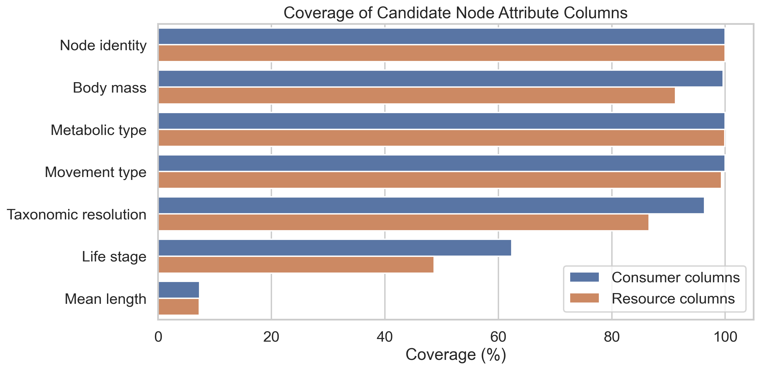
Figure 1. Candidate attribute coverage in the source data. Length variables were excluded because their mean coverage is only about 7.3%.
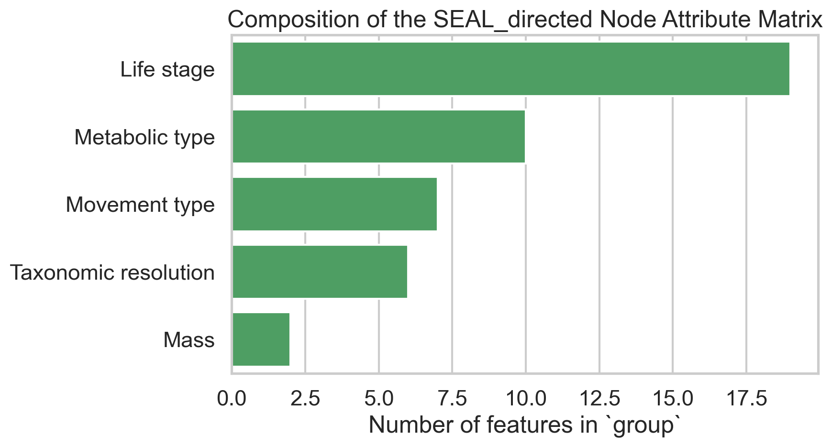
Figure 2. Composition of the 44-dimensional node-attribute matrix currently supplied to SEAL_directed.

3. Initial target train-ratio 90 results
The table below reproduces the medians in the original update and verifies them against the current CSV files. These are pooled medians over run-level rows, so they describe the current result folders but are not yet a matched inferential analysis.
Metric | Original SEAL | SEAL_directed | Median change
ROC-AUC | 0.863 | 0.929 | +0.066
PR-AUC | 0.849 | 0.930 | +0.081
F1 | 0.778 | 0.851 | +0.073
Precision | 0.715 | 0.839 | +0.124
Recall | 0.878 | 0.889 | +0.011

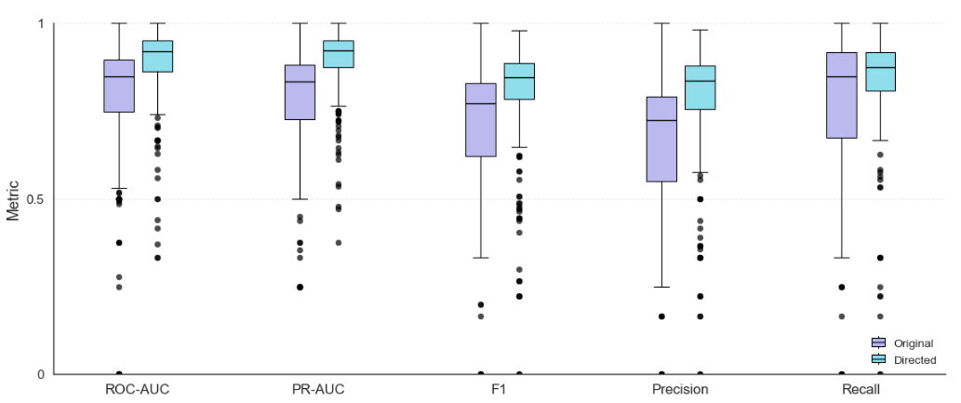
Figure 3. Existing distributional comparison across food webs.

