**The Generalized Beta Distribution**

**Carla Johnston**

**James B. McDonald**

**Brigham Young University**

**9 October 2013**

The generalized beta (GB) distribution is a five parameter distribution which nests many important distributions as special or limiting cases. Some of these limiting and special cases include the generalized beta of the second kind (GB2) and generalized beta of the first kind (GB1)which have four parameters. The generalized gamma (GG), the beta of the first kind (B1), beta of the second kind (B2), Burr 3 and Burr 12 distributions are three parameter special cases while the Pareto, lognormal, gamma(GA), F, Weibull (W), Lomax (W), and Fisk are two parameter special cases. The uniform, chi-square, exponential (EXP), Pareto, Rayleigh (R), and loglogistic distributions are also special cases, involving one parameter.

The more general distributions, having more parameters, allow for more flexibility in modeling data characteristics such as skewness and kurtosis. These distributions have been applied in diverse settings, including modeling the distribution of income, stock returns, option pricing, and in hydrology.

We report Python code for the probability density function , cumulative distribution function , and corresponding theoretical moments (mean, variance, skewness, and kurtosis) which can be used in a variety of settings where *y* denotes the random variable and  is a vector of unknown parameters . For example, to obtain maximum likelihood estimators of the unknown parameters from a random sample of *n* individual observations the code for the probability density functions could be used to form the loglikelihood function,  , which is then maximized over  . If some of the observations are top-coded where you are only given that the actual observation  is greater than or equal to some lower bound , then the corresponding term in the log-likelihood function is replaced by .

To facilitate an application of the code to problems of interest we replicate the distribution tree from McDonald and Xu (1995) based on a generalized beta distribution defined by

 .

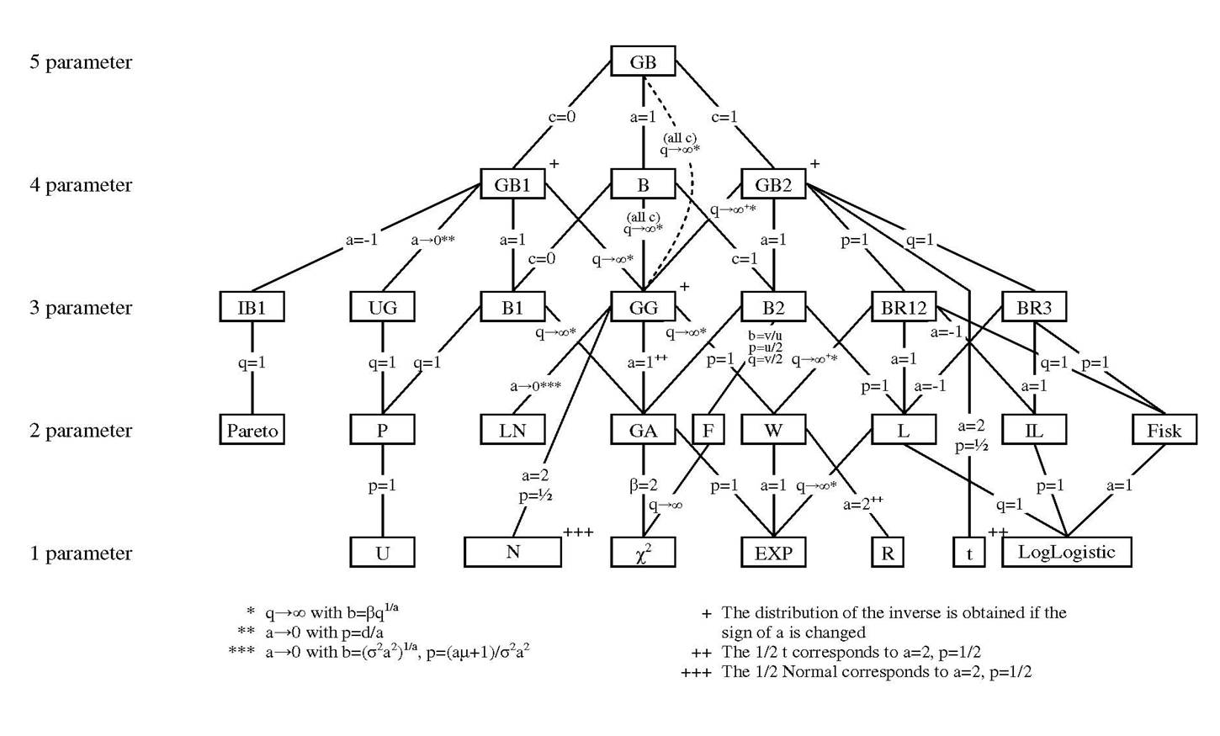

The special and limiting cases of the GB are shown in the footnotes and on the lines linking different nested distributions. Since the form for the generalized gamma may not be obvious, it is reported here

 .

Another example, the Weibull distribution is obtained if we if we let the parameters *a=1* and *p=1*  in the generalized gamma distribution. Other distributions in the tree which have not been discussed here, but appear in the previous figure include the unit gamma (UG), inverse beta of the first kind (IB1), power (P), and inverse Lomax (IL). There are other distributions not included in the distribution tree, for example the reciprocal gamma is a generalized gamma with *a*=-1 and the Kumaraswamy and inverse Kumaraswamy distributions can be expressed as a GB1 with (a,b,p,q) equal to (a,1,1,b) and (a, 1, b,1), respectively.

**References**

Kumaraswamy, P. (1980). “A generalized probability density function for double-bounded random processes,” *Journal of Hydrology*, 46, 79-88.

McDonald, J. B. and Y. J. Xu, 1995. “A generalization of the beta distribution with applications,” *Journal of Econometrics*, 66, 133-152.

McDonald, J. B. , Sorenson, J. and Turley, P., 2012. “Skewness and Kurtosis Properties of Income Distribution Models,” *The Review of Income and Wealth*, 59(2), 360-374.