**Python Notebook for using WA-Testing-Tool**

**Getting Started**

This Notebook is a 'wrapper' that enables you to the run the [WA-Testing Tool](https://github.com/cognitive-catalyst/WA-Testing-Tool)on IBM Watson Studio.

1. Once you are logged into your Watson Studio project import this Notebook by clicking New Notebook



1. Select “From URL”, enter the Notebook file URL from the github repository

**Master**: (<https://github.com/cognitive-catalyst/WA-Testing-Tool/blob/master/notebook_ws/WA-Testing-Tool-WS-Python-Notebook.ipynb>)

**Dev**: (<https://github.com/cognitive-catalyst/WA-Testing-Tool/blob/87_notebook_ws/notebook_ws/WA-Testing-Tool-WS-Python-Notebook.ipynb>)

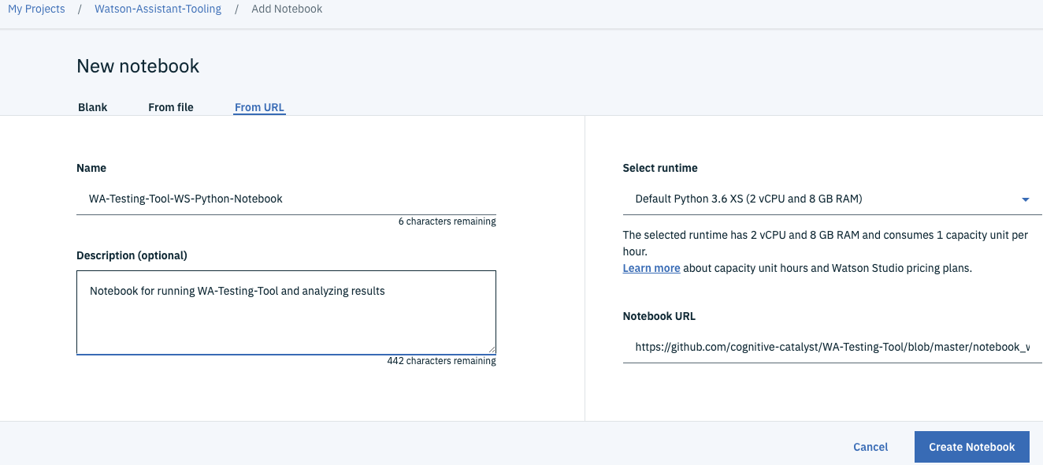

(If you have *WA-Testing-Tool-WS-Python-Notebook.*ipynb file you can also create using the From file option)

1. Launch the Notebook from the project >> Assets > Notebooks in Edit mode. 
2. Once launched, the first step is to add the project token to the Notebook to enable the files to be shared with the project environment securely.

Add the project token to this Notebook:

1. Click on the three vertical dots in the top menu bar and then "Insert project Token". (Read below if you don't have a project token setup yet.)

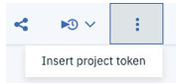

1. A new project token for your project should appear in the first cell.
2. Delete the example project token cell by selecting/highlighting it, then Edit > Delete Cells
3. The project token is an authorization token that is used to access project resources like data sources, connections, and used by platform APIs.
4. Make sure to "Run' the cell with your token to initialize the project token into variables.

Example of the first cell (project token cell)

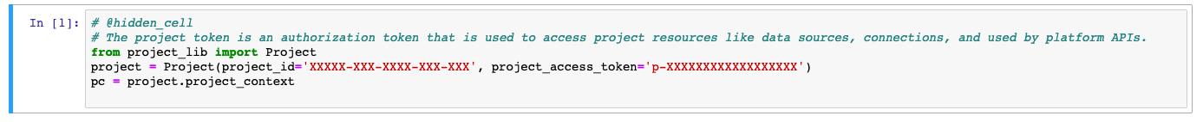

|  |
| --- |
| If your Watson Studio project does not already have project token setup, make sure to set that up first. The steps are: Create an access token on the Settings page of your project. Only project admins can create access tokens. The access token can have viewer or editor access permissions. Only editors can inject the token into a notebook.  (Complete instructions <https://dataplatform.cloud.ibm.com/docs/content/wsj/analyze-data/token.html>)  /var/folders/b7/8zv0z6ps6_d_rwhnv39wpdwm0000gp/T/com.microsoft.Word/Content.MSO/1F30E148.tmp |

Once the project token cell is added make sure to ‘run’ it to initialize the variables.

1. Follow the instructions provided in the Notebook. The cells in Section 1 are for setting up the environment and initializing the variables and needed only the first time. Once you get to Section 2 you can start configuring the test parameters and running the test.
2. In Section 2 to add an input file (for example input for blind and standard tests.) simply drag-drop on the Data Files from the Notebook page, or you can add the file to the directly to the project Assets.

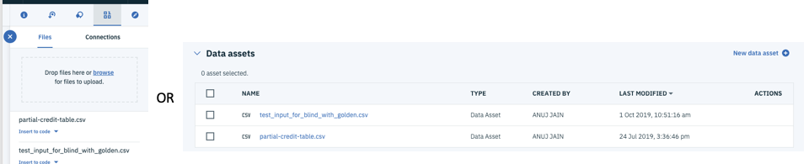

1. Section 3 is for analyzing the results of your tests. Feel free to extend the analysis based on your needs and using the output files generated from the tests.

Thank you!