# Part 2

# Deliverable 2

## Assumptions

<In this section write down the assumptions you made about the data, if any. Write a sentence for each assumption you made>

The DATA is somehow clean (no duplicate…)

## DDL

<In this section write down the DDL you wrote for implementing the provided ER model>

## Query Implementation

<For each query>

**Query a:**

***Description of logic:***

<What does the query do and how do I decide to solve it>

***SQL statement***

<The SQL statement>

***Query result (if the result is big, just a snippet)***

<The SQL statement result>

Initial Insights

QUERY 1:

Description of logic:

SQL statement:

QUERY 2:

Description of logic:

SQL statement:

QUERY 3:

Description of logic:

SQL statement:

QUERY 4:

Description of logic:

SQL statement:

QUERY 5:

Description of logic:

SQL statement:

QUERY 6:

Description of logic:

We first need to count, for each user, the number of businesses they reviewed. Then we simply compute the max of these counts.

More precisely, we have an sub query on the table REVIEWS that counts for each user, the number of distinct businesses they reviewed. Then we simply select the maximum of these counts.

SQL statement:

QUERY 7:

Description of logic:

We first find the DIETARY_REST_ID corresponding to. ‘vegetarian’, then we find all the businesses with this DIETARY_REST_ID, we count, by states, these businesses and adding the states which do not have such restaurant (setting the count to 0).

In details :

* A sub query simply select from BUSINESS_DIETARY_RESTRICTION the DIETARY_REST_ID of the tuple having DIETARY_REST_DESCRIPTION ‘vegetarian’
* Another subquery on BUSINESS selects only the BUSINESS_ID of tuples having the found DIETARY_REST_ID
* Then we perform a join of these BUSINESS_ID with BUSINESS_LOCATION (ON BUSINESS_ID) so that we have the location of all BUSINESS VEGETARIAN
* Then we count the distinct BUSINESS_ID by state
* We finally join with all states in STATES (on STATE_NAME) so that states that do not have BUSINESS with ‘vegetarian’ tag still appear with count 0

SQL statement:

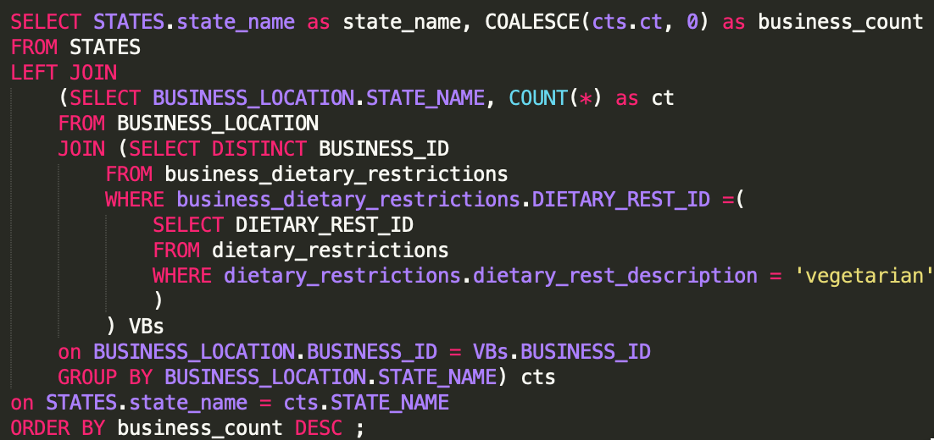

QUERY 8:

Description of logic:

We first count by BUSINESS_ID in BUSINESS_HAS_CATEGORIES. Then we join with all BUSINESS (on BUSINESS_ID) so that businesses with no category still appear and with count 0. Then we simply apply the min, max, avg, and median functions.

SQL statement:

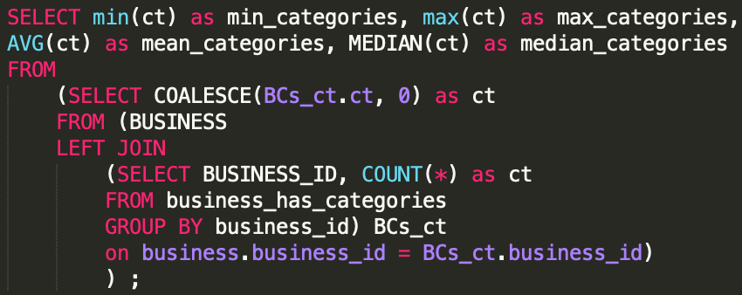

QUERY 9:

Description of logic:

SQL statement:

QUERY 10:

Description of logic:

SQL statement:

## General Comments

<In this section write general comments about your deliverable (comments and work allocation between team members>