HOME PAGE:
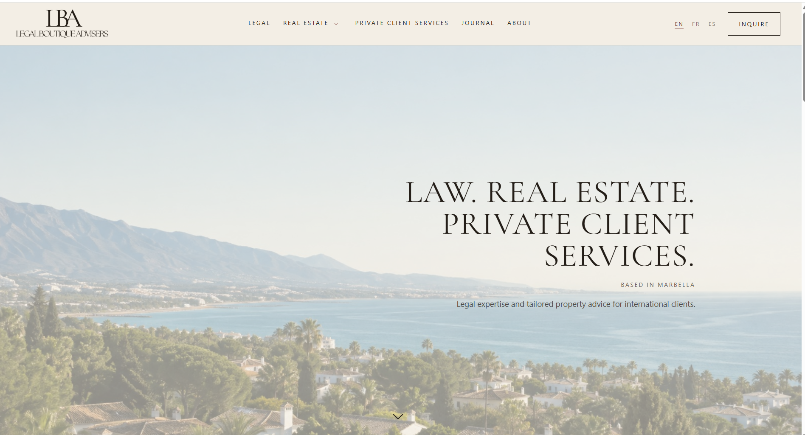
EL icono de LBA en negro no tiene que ser como marron, para que pegue con el beige.
Nuevos Cambios al titulo centrado así:
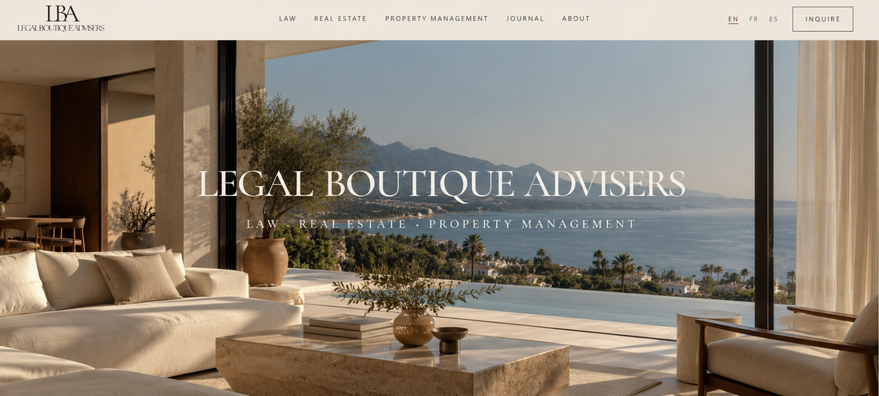
LEGAL BOUTIQUE ADVISERS (utiliza ese font es Cormorant Garamond)
LAW . REAL ESTATE . PROPERTY MANAGEMENT (pon ese punto en medio)
Y la nueva imagen te la voy a pasar como IMAGENNUEVA1
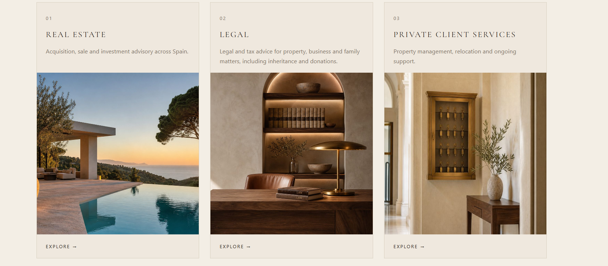
Cambia el orden 1 legal,2 real estate
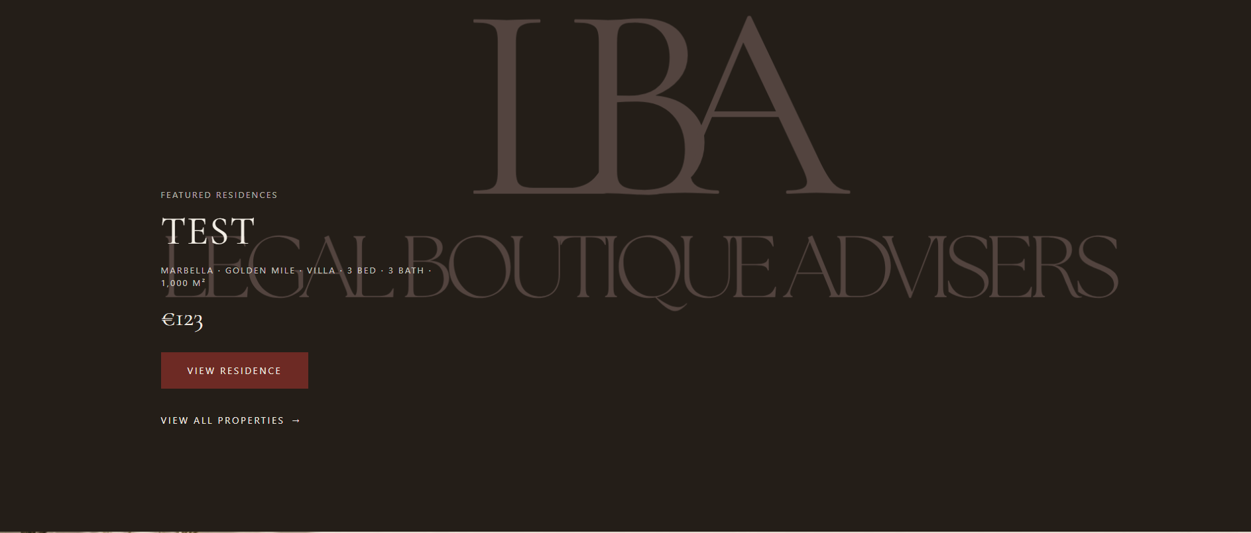
Quita las Properties aquí


Aquí poner: LAW FIRM, REAL ESTATE, PRIVATE CLIENT ADVISORY

Aqui quita la imagen y el texto solo deja MAKE A PRIVATE INQUIRY

PAGINA LEGAL:

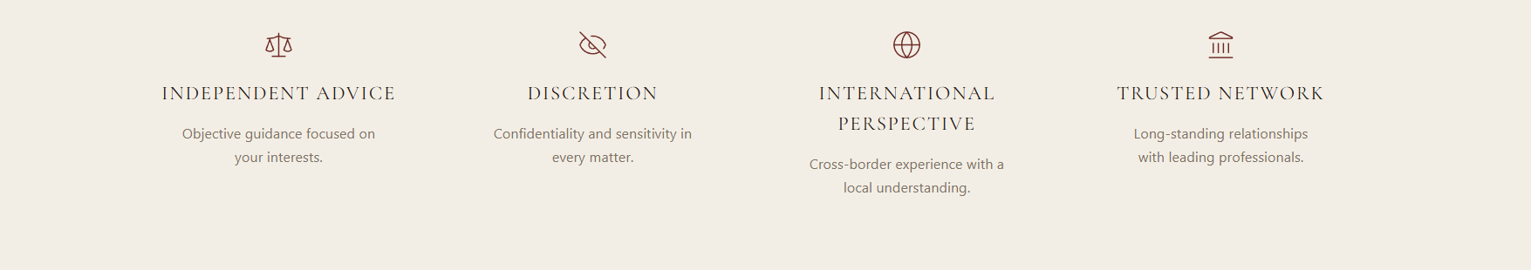
ESTO QUITARLO Y subir el resto
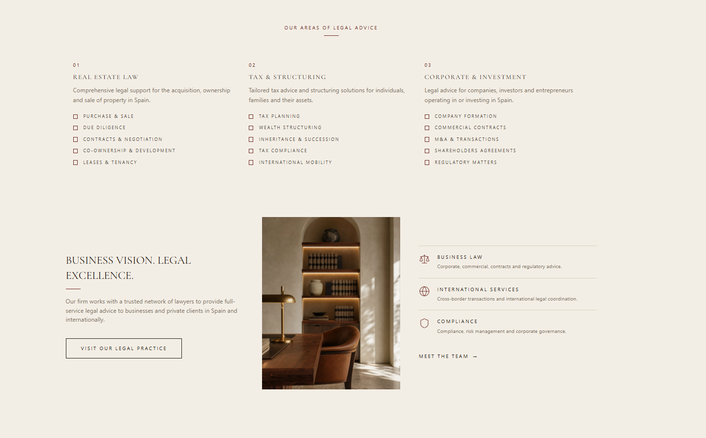
Eso quitarlo y poner this instead:
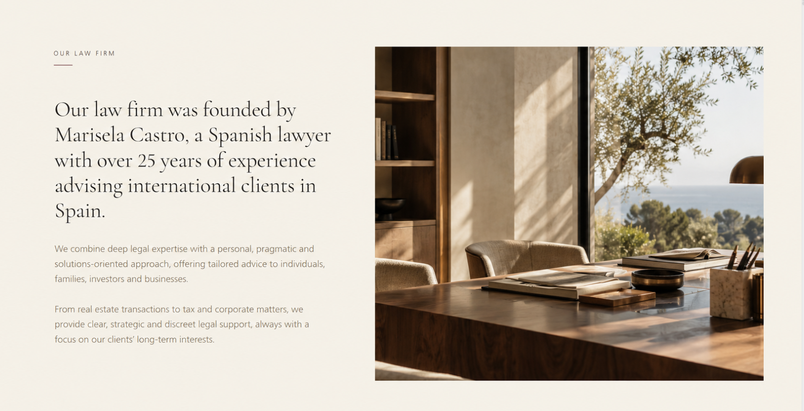
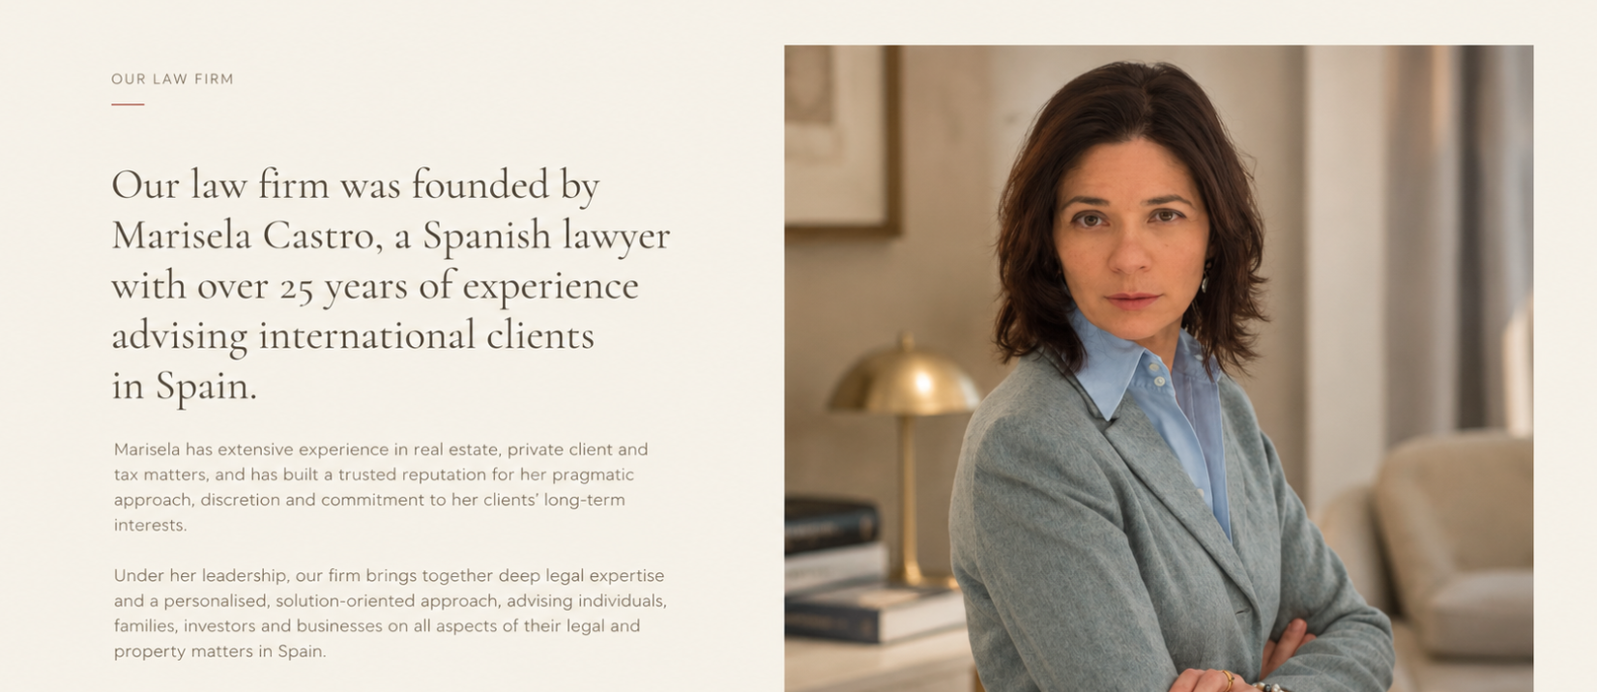
Este es el texto:
OUR LAW FIRM
-
Our law firm was founded by Marisela Castro, a Spanish lawyer with over 25 years of experience advising international clients in Spain.
Under her leadership, our firm combines a deep legal expertise with a personal, pragmatic and solutions-oriented approach, offering tailored advice to individuals, families, investors and businesses on all aspects of their legal and property matters in Spain.
From real estate transactions to tax and corporate matters, we provide clear, strategic and discreet legal support, always with a focus on our client’s long-term interests.
Y al lado pones una foto que te voy a enviar de mama (no pongas la foto super grande)

Aquí same quita y solo deja la caja en rojo, intenta subirlo para que no haya tantos espacios

REAL ESTATE PAGE:
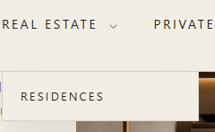PON PROPERTIES (instead of residences)

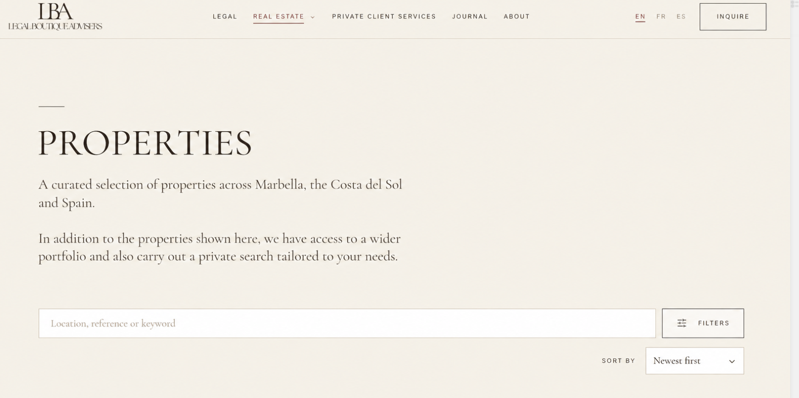
PROPERTIES
A curated selection of properties across Marbella, Sotogrande and Spain.
In addition to the properties shown here, we have access to a wider portfolio and also carry out a private search tailored to your needs.

