CONTINUACION DESDE REAL ESTATE PAGE
REAL ESTATE PAGE:
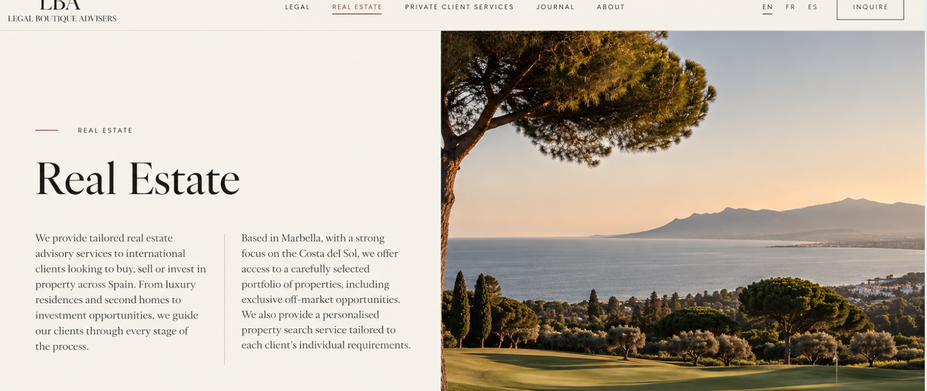
- REAL ESTATE
We provide tailored real estate advisory services to international clients looking to buy, sell or invest in property across Spain. From luxury residences and second homes to investment opportunities, we guide our clients through every stage of the process.
Based in Marbella, with a strong focus on the Costa del Sol, we offer access to a carefully selected portfolio of properties, including exclusive off-market opportunities. We also provide a personalised property search service tailored to each client's individual requirements.
Y te enviare la foto de golf a la derecha
QUITAR ESTO:

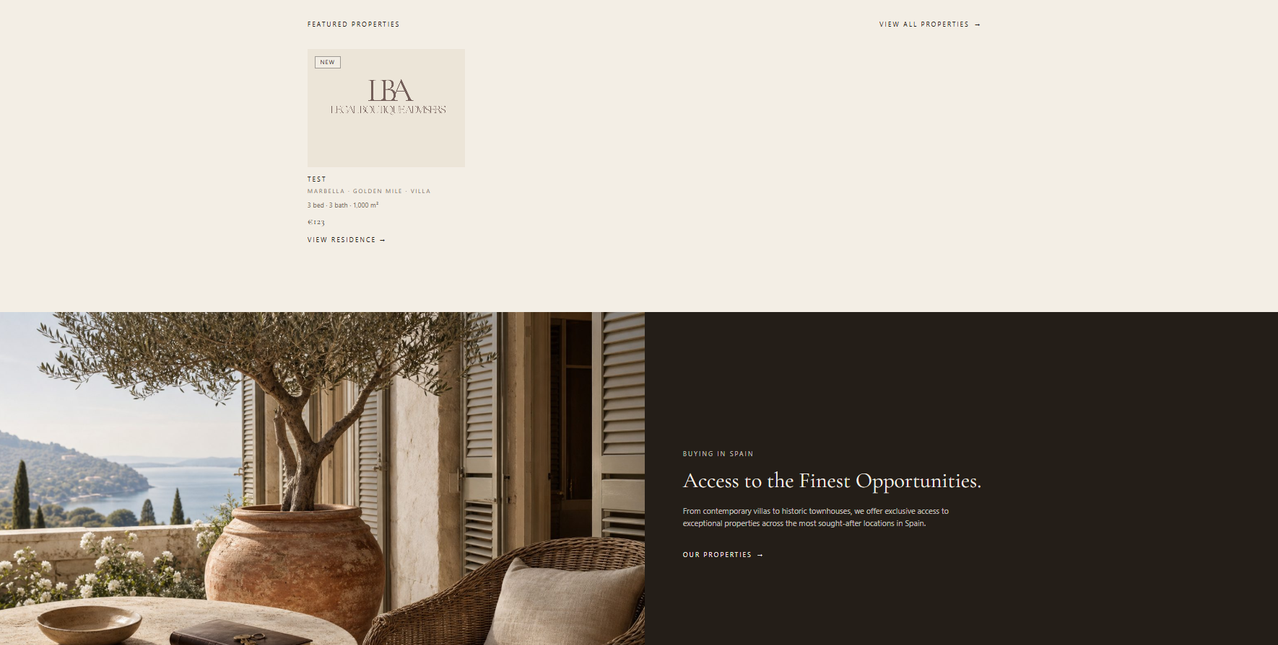
Quitar eso ya que es lo mismo que abajo:
Poner esta foto que te voy a enviar de una casa en vez de esa maceta, y poner las letras mas grande, y si es posible un marron menos oscuro

Ponerlo mas arriba justo debajo del primero real estate text y foto de golf
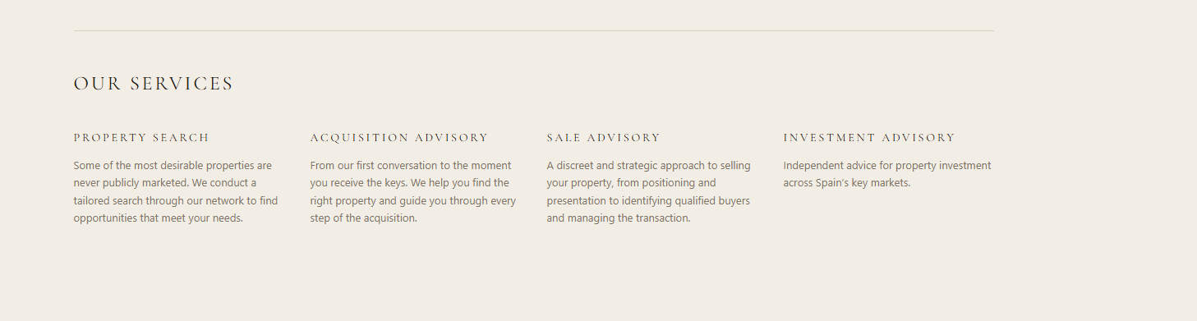
Cambiar Acquisition Advisory – BUYING
SALE ADVISORY – SELLING
Orden es: portada, our services, caja marron de opportunities y luego esto:
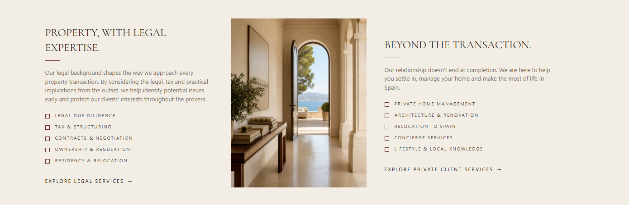
Que ahora va a ser así: (no cambies la foto solo el text, quiero que se vea así, pero con la foto antigua)
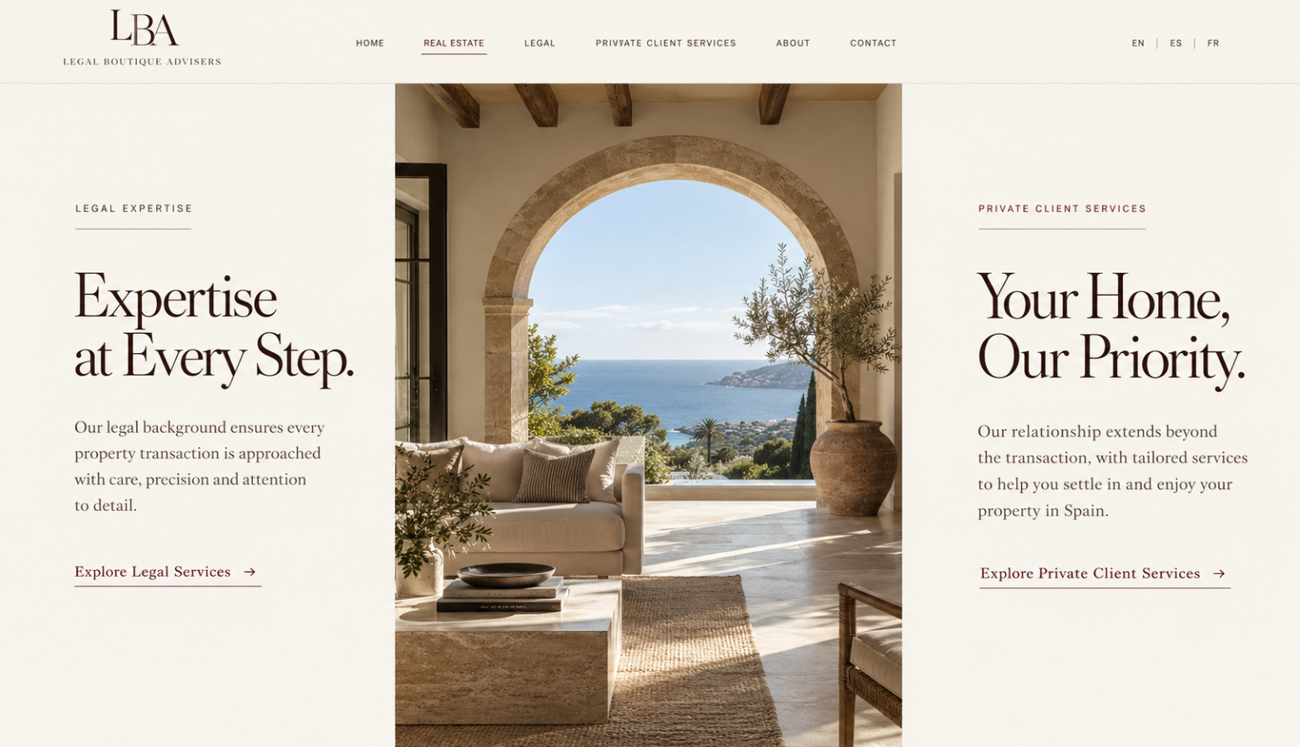
LEFT — LEGAL EXPERTISE
Expertise at Every Step.
Our legal background ensures every property transaction is approached with care, precision and attention to detail.
Explore Legal Services →
RIGHT — PRIVATE CLIENT SERVICES
Your Home, Our Priority.
Our relationship extends beyond the transaction, with tailored services to help you settle in and enjoy your property in Spain.
Explore Private Client Services →


Aquí igual q en los otros, quita la imagen y solo deja la cajita

PRIVATE CLIENT SERVICES:

Your Home, Our Priority.
Our relationship extends beyond the transaction, with taiored services to help you settle in and enjoy your property in Spain.
No pongas lo de discover ..
AHORA TE ENVIO LA IMAGEN:

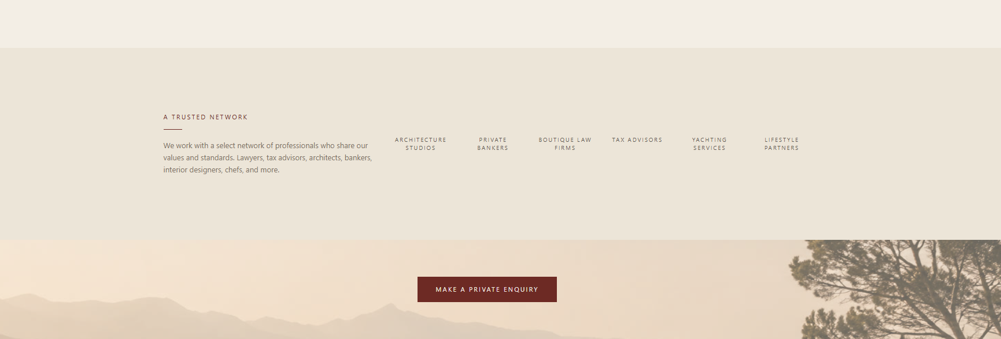
ESTO QUITARLO TODO, solo deja la cajita
Y en about también quitarlo y dejar cajita 

