Learner Report: BT10

Report generated on: 2025-07-07 22:28:41

# Final Cumulative Scores

## Final KC Scores

|  |  |
| --- | --- |
| Knowledge Component (KC) | Final Score |
| KC10 | 0.0 |
| KC11a | 0.6 |
| KC4 | 0.0 |
| KC5 | 2.2 |
| KC6 | 0.0 |
| KC7 | 0.0 |

## Final Metric Scores

|  |  |
| --- | --- |
| Metric | Final Value |
| Customer Satisfaction | 18.199999999999996 |
| Reputation | 0.7839999999999999 |
| Revenue | 3450 |

# Performance Over Time

## KC Scores per Decision Point

|  |  |  |  |  |  |  |
| --- | --- | --- | --- | --- | --- | --- |
| Decision Point | KC10 | KC11a | KC4 | KC5 | KC6 | KC7 |
| G6-S1-D1 | 0.0 | 0.2 | 0.0 | 0.5 | 0.0 | 0.0 |
| G6-S1-D2 | 0.0 | 0.2 | 0.0 | 1.0 | 0.1 | 0.0 |
| G6-S1-D3 | 0.0 | 0.5 | 0.0 | 1.6 | 0.1 | 0.0 |
| G6-S2-D1 | 0.0 | 0.3 | 0.0 | 1.5 | 0.1 | 0.0 |
| G6-S2-D2 | 0.0 | 0.0 | 0.0 | 1.3 | 0.1 | 0.0 |
| G6-S2-D3 | 0.0 | 0.0 | 0.0 | 1.4 | 0.3 | 0.0 |
| G6-S3-D1 | 0.0 | 0.0 | 0.0 | 1.0 | 0.0 | 0.0 |
| G6-S3-D2 | 0.0 | 0.3 | 0.0 | 1.6 | 0.0 | 0.0 |
| G6-S3-D3 | 0.0 | 0.6 | 0.0 | 2.2 | 0.0 | 0.0 |

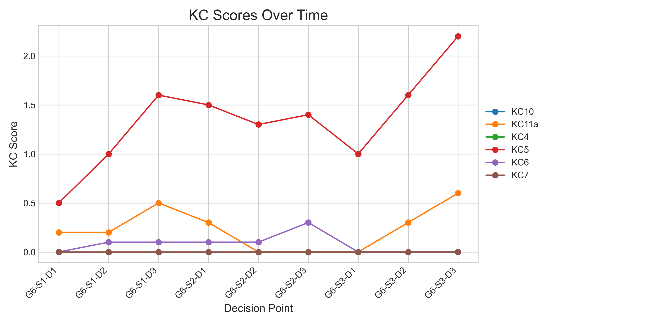

## Metric Values per Decision Point

|  |  |  |  |
| --- | --- | --- | --- |
| Decision Point | Customer Satisfaction | Reputation | Revenue |
| G6-S1-D1 | 4.55 | 0.196 | 1150 |
| G6-S1-D2 | 7.8 | 0.336 | 1725 |
| G6-S1-D3 | 13.649999999999999 | 0.588 | 3450 |
| G6-S2-D1 | 11.699999999999998 | 0.5039999999999999 | 2300 |
| G6-S2-D2 | 8.449999999999998 | 0.3639999999999999 | 575 |
| G6-S2-D3 | 9.099999999999998 | 0.3919999999999999 | 1725 |
| G6-S3-D1 | 6.499999999999998 | 0.2799999999999999 | 0 |
| G6-S3-D2 | 12.349999999999998 | 0.5319999999999999 | 1725 |
| G6-S3-D3 | 18.199999999999996 | 0.7839999999999999 | 3450 |

