Learner Report: BT13

Goal Attempted: Price with Purpose

Report generated on: 2025-07-07 23:02:54

# Final Cumulative Scores

This section shows the learner's final score compared to the average, min, and max of all learners who attempted THIS SAME GOAL.

## Final KC Scores

|  |  |  |  |  |
| --- | --- | --- | --- | --- |
| index | Your Score | Class Avg | Class Min | Class Max |
| KC10 | 0.7 | 1.57 | 0.5 | 2.7 |
| KC4 | 0.4 | 0.03 | -0.8 | 0.9 |
| KC7 | 1.1 | 1.19 | -0.1 | 2.3 |

## Final Metric Values

|  |  |  |  |  |
| --- | --- | --- | --- | --- |
| index | Your Value | Class Avg | Class Min | Class Max |
| Customer Satisfaction | 13.0 | 18.48 | 3.9 | 27.3 |
| Reputation | 0.56 | 0.8 | 0.17 | 1.18 |
| Revenue | 12650 | 16017.86 | -1150.0 | 27600.0 |

# Performance Over Time

## KC Scores per Decision Point

|  |  |  |  |
| --- | --- | --- | --- |
| Decision Point | KC10 | KC4 | KC7 |
| Genesis | 0.0 | 0.0 | 0.0 |
| G7-S1-D1 | -0.2 | 0.0 | 0.3 |
| G7-S1-D2 | 0.3 | 0.0 | 0.0 |
| G7-S1-D3 | 0.3 | -0.3 | 0.1 |
| G7-S2-D1 | 0.0 | -0.3 | 0.6 |
| G7-S2-D2 | -0.6 | -0.3 | 0.4 |
| G7-S2-D3 | -0.4 | 0.0 | 0.4 |
| G7-S3-D1 | -0.4 | 0.3 | 0.9 |
| G7-S3-D2 | 0.1 | 0.4 | 0.9 |
| G7-S3-D3 | 0.7 | 0.4 | 1.1 |

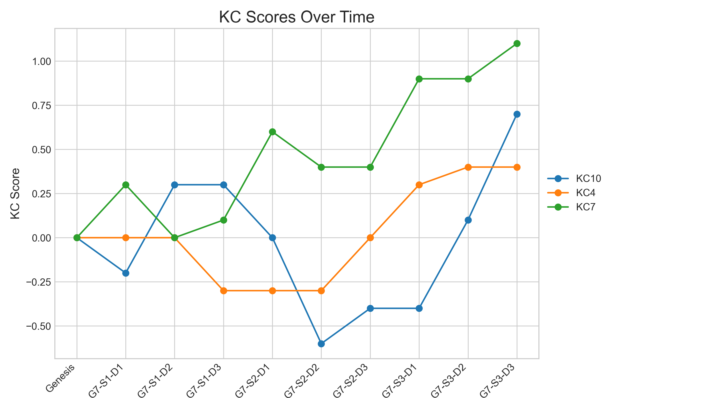

## Metric Values per Decision Point

|  |  |  |  |
| --- | --- | --- | --- |
| Decision Point | Customer Satisfaction | Reputation | Revenue |
| Genesis | 0.0 | 0.0 | 0 |
| G7-S1-D1 | 0.65 | 0.03 | 575 |
| G7-S1-D2 | 1.95 | 0.08 | 1725 |
| G7-S1-D3 | 2.6 | 0.11 | 575 |
| G7-S2-D1 | 3.9 | 0.17 | 1725 |
| G7-S2-D2 | 0.0 | 0.0 | -2875 |
| G7-S2-D3 | 1.3 | 0.06 | 0 |
| G7-S3-D1 | 4.55 | 0.2 | 4600 |
| G7-S3-D2 | 7.8 | 0.34 | 8050 |
| G7-S3-D3 | 13.0 | 0.56 | 12650 |

### Revenue Progression

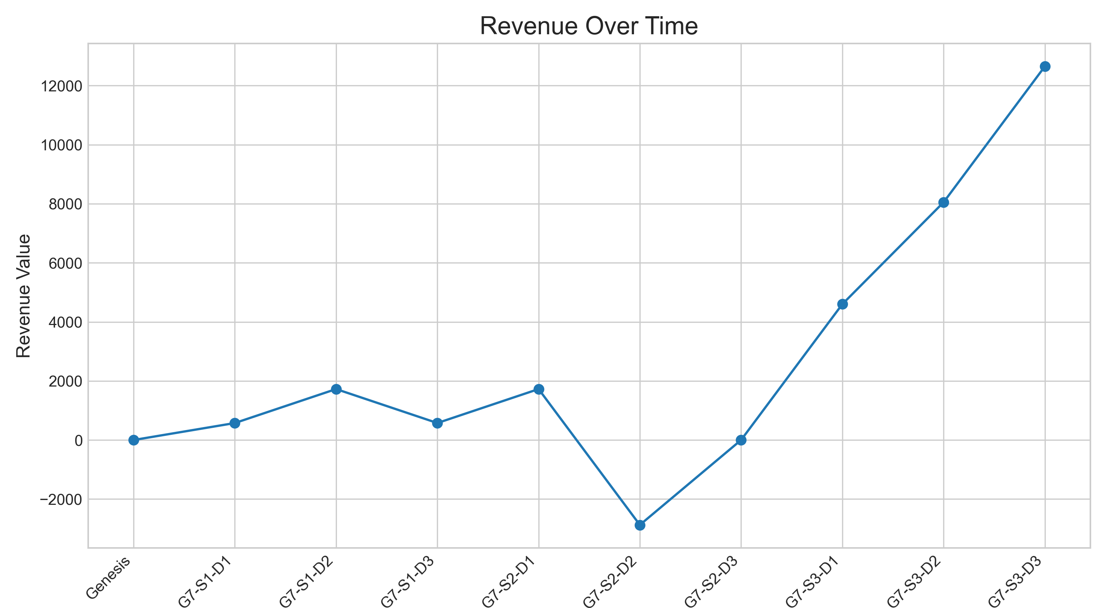

### Reputation Progression

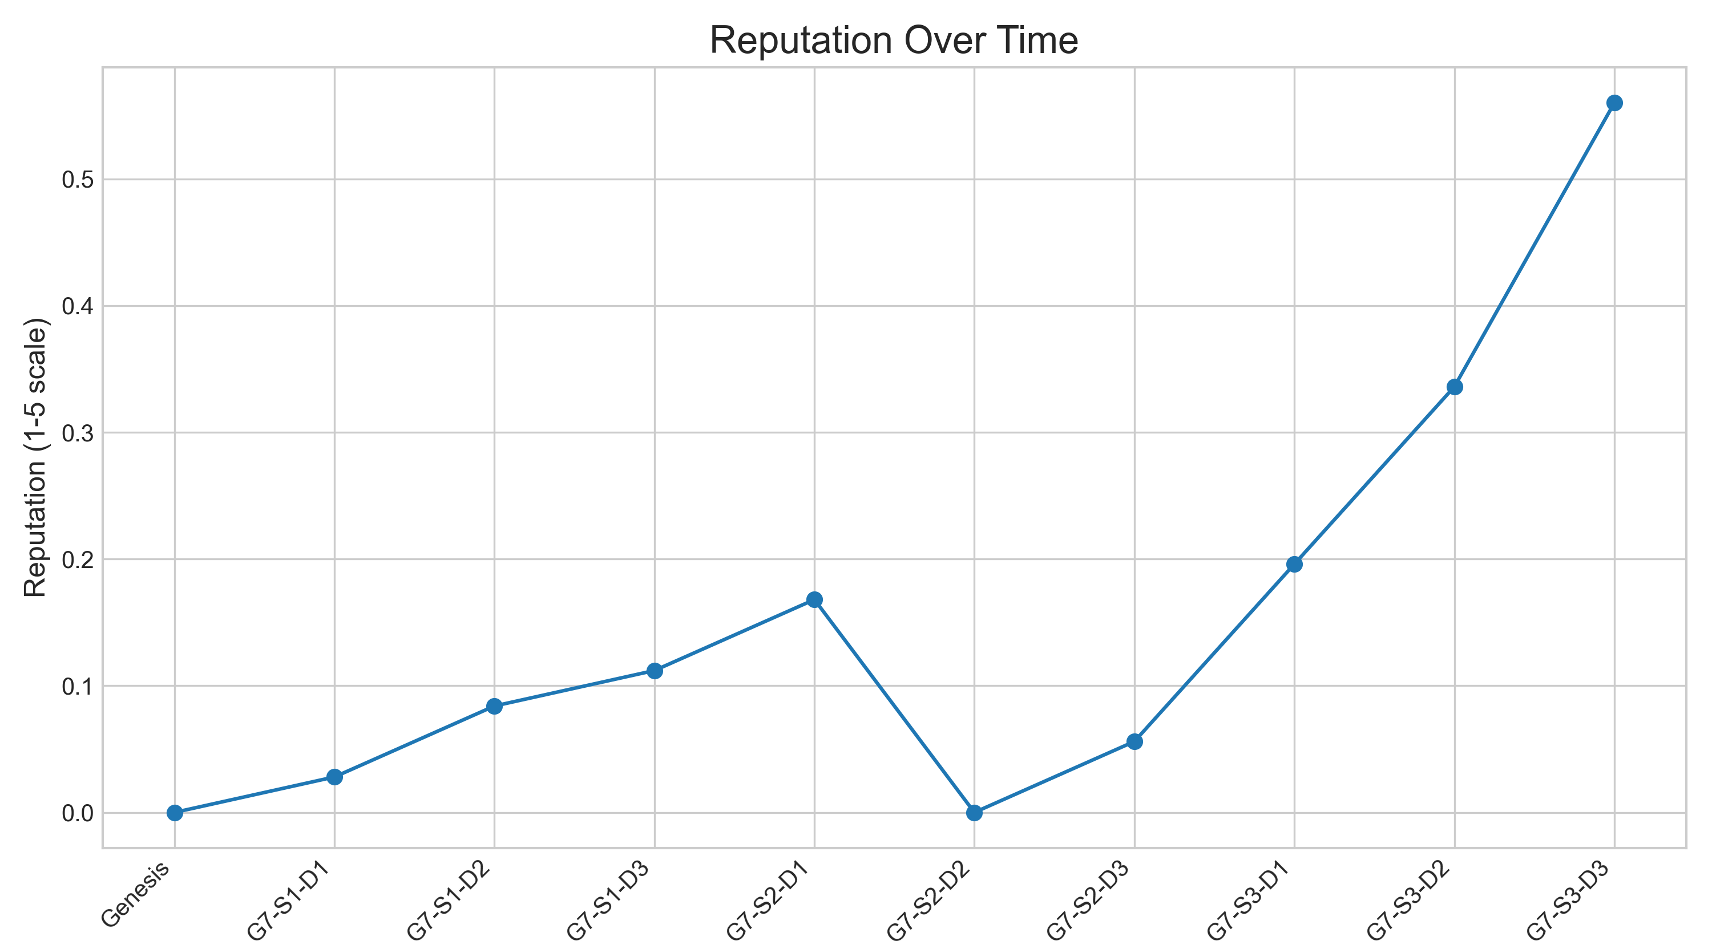

### High-Scale Metrics Progression

