Learner Report: BT14

Report generated on: 2025-07-07 22:28:37

# Final Cumulative Scores

## Final KC Scores

|  |  |
| --- | --- |
| Knowledge Component (KC) | Final Score |
| KC10 | 2.7 |
| KC11a | 0.0 |
| KC4 | 0.9 |
| KC5 | 0.0 |
| KC6 | 0.0 |
| KC7 | 1.2 |

## Final Metric Scores

|  |  |
| --- | --- |
| Metric | Final Value |
| Customer Satisfaction | 25.349999999999998 |
| Reputation | 1.092 |
| Revenue | 27600 |

# Performance Over Time

## KC Scores per Decision Point

|  |  |  |  |  |  |  |
| --- | --- | --- | --- | --- | --- | --- |
| Decision Point | KC10 | KC11a | KC4 | KC5 | KC6 | KC7 |
| G7-S1-D1 | 0.2 | 0.0 | 0.0 | 0.0 | 0.0 | 0.6 |
| G7-S1-D2 | 0.5 | 0.0 | 0.4 | 0.0 | 0.0 | 0.6 |
| G7-S1-D3 | 0.8 | 0.0 | 0.4 | 0.0 | 0.0 | 1.1 |
| G7-S2-D1 | 1.2 | 0.0 | 0.4 | 0.0 | 0.0 | 0.9 |
| G7-S2-D2 | 1.5 | 0.0 | 0.9 | 0.0 | 0.0 | 0.9 |
| G7-S2-D3 | 1.3 | 0.0 | 0.9 | 0.0 | 0.0 | 1.2 |
| G7-S3-D1 | 1.8 | 0.0 | 0.9 | 0.0 | 0.0 | 0.9 |
| G7-S3-D2 | 2.3 | 0.0 | 0.9 | 0.0 | 0.0 | 1.1 |
| G7-S3-D3 | 2.7 | 0.0 | 0.9 | 0.0 | 0.0 | 1.2 |

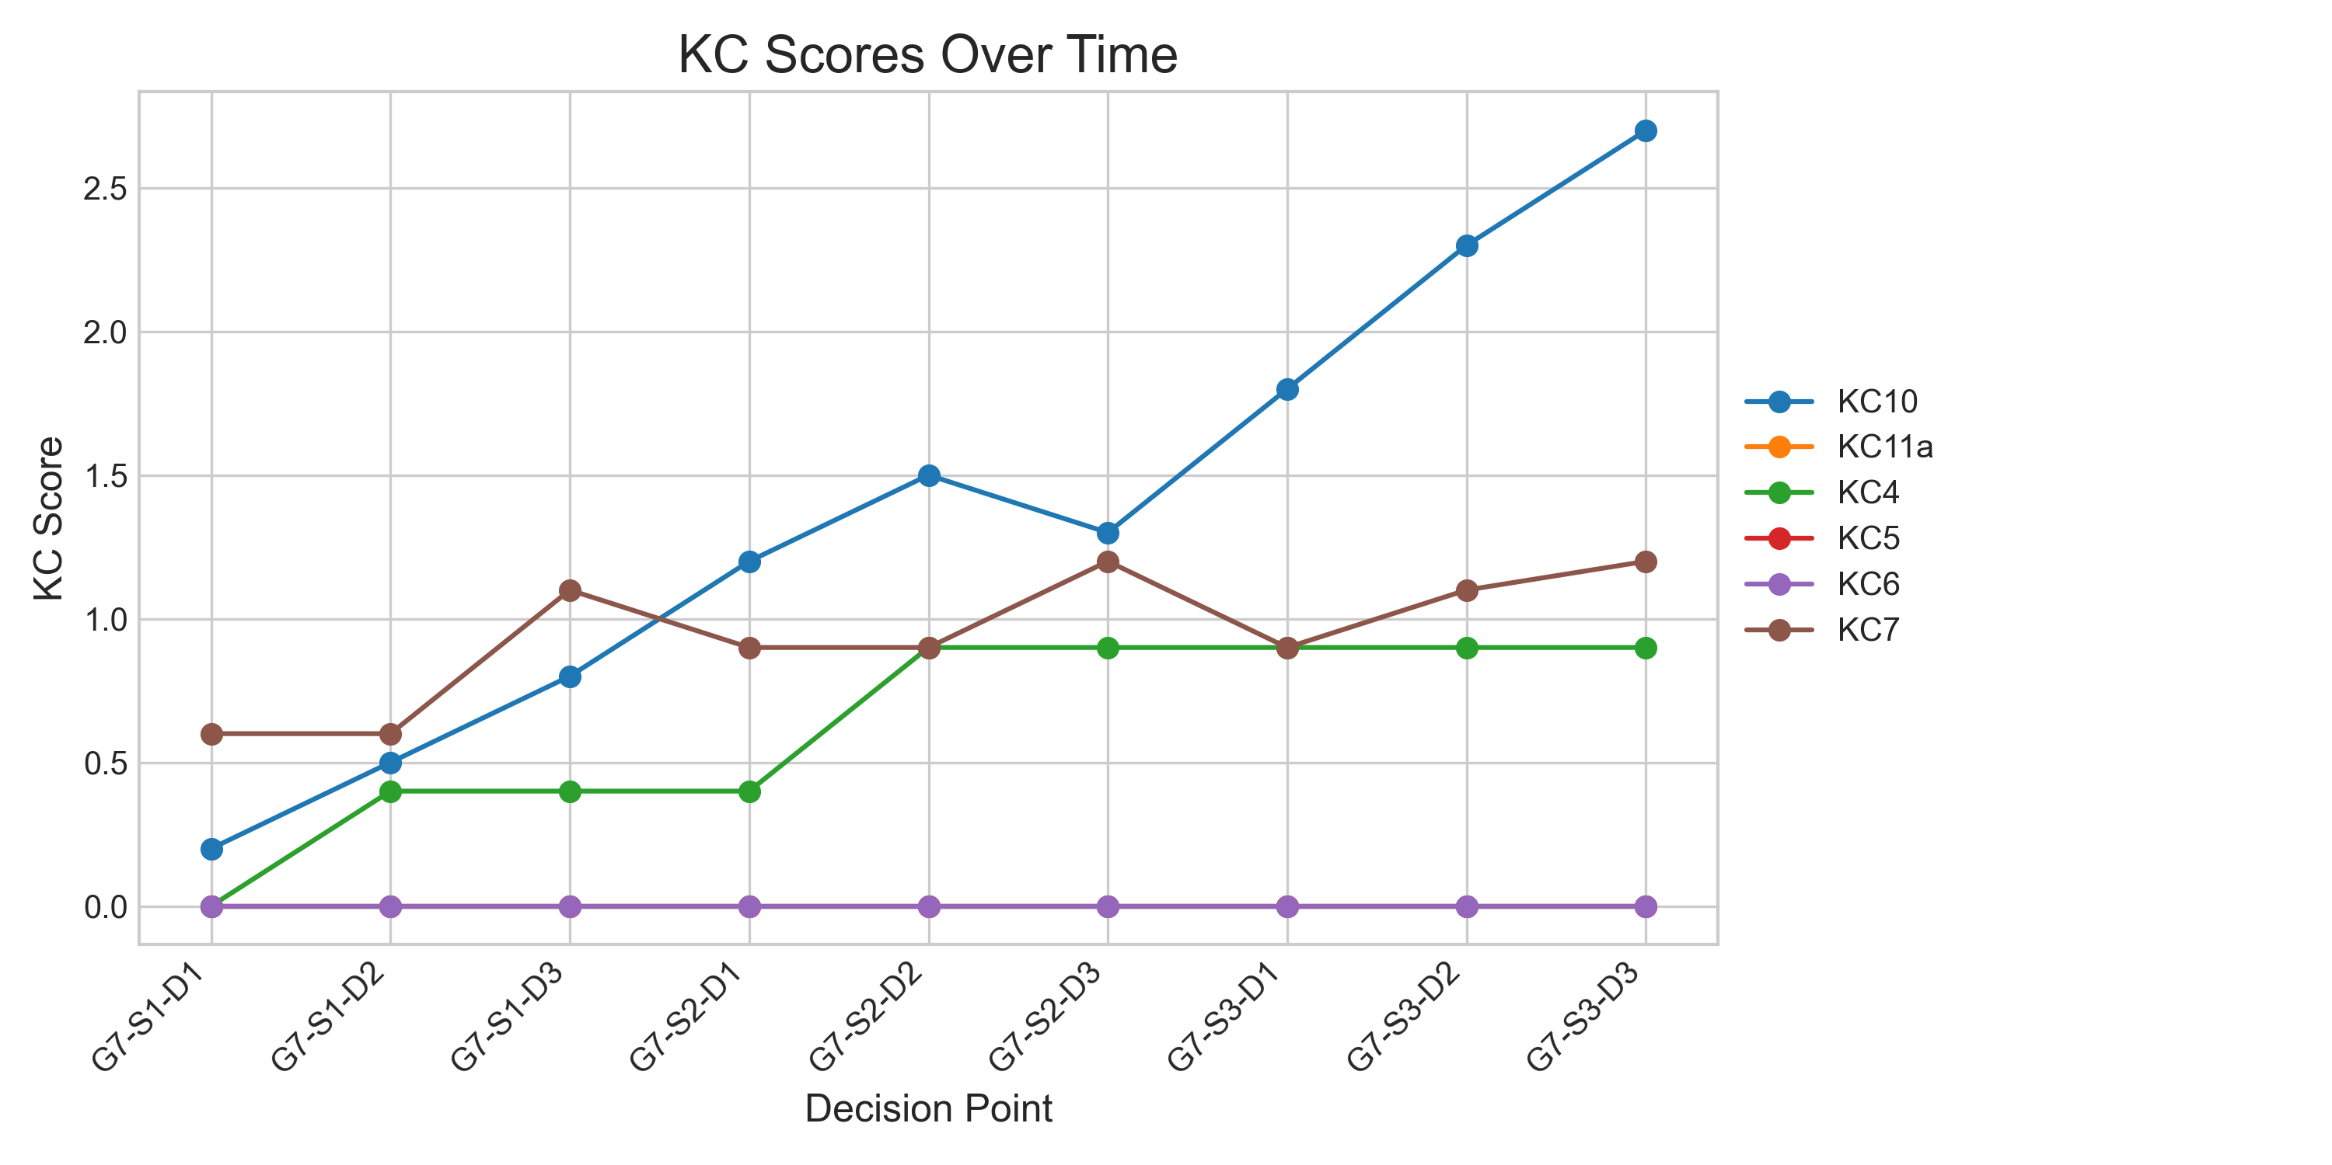

## Metric Values per Decision Point

|  |  |  |  |
| --- | --- | --- | --- |
| Decision Point | Customer Satisfaction | Reputation | Revenue |
| G7-S1-D1 | 5.2 | 0.22400000000000003 | 4600 |
| G7-S1-D2 | 7.15 | 0.30800000000000005 | 8625 |
| G7-S1-D3 | 12.35 | 0.532 | 13225 |
| G7-S2-D1 | 13.649999999999999 | 0.5880000000000001 | 14375 |
| G7-S2-D2 | 15.599999999999998 | 0.672 | 18975 |
| G7-S2-D3 | 16.249999999999996 | 0.7 | 19550 |
| G7-S3-D1 | 17.549999999999997 | 0.756 | 20700 |
| G7-S3-D2 | 22.099999999999998 | 0.9520000000000001 | 24725 |
| G7-S3-D3 | 25.349999999999998 | 1.092 | 27600 |

