Learner Report: BT15BT16

Report generated on: 2025-07-07 22:28:36

# Final Cumulative Scores

## Final KC Scores

|  |  |
| --- | --- |
| Knowledge Component (KC) | Final Score |
| KC10 | 0.0 |
| KC11a | 1.5 |
| KC4 | 0.0 |
| KC5 | 1.9 |
| KC6 | 1.3 |
| KC7 | 0.0 |

## Final Metric Scores

|  |  |
| --- | --- |
| Metric | Final Value |
| Customer Satisfaction | 25.35 |
| Reputation | 1.092 |
| Revenue | 16100 |

# Performance Over Time

## KC Scores per Decision Point

|  |  |  |  |  |  |  |
| --- | --- | --- | --- | --- | --- | --- |
| Decision Point | KC10 | KC11a | KC4 | KC5 | KC6 | KC7 |
| G6-S1-D1 | 0.0 | 0.4 | 0.0 | -0.5 | 0.0 | 0.0 |
| G6-S1-D2 | 0.0 | 0.4 | 0.0 | -0.2 | 0.3 | 0.0 |
| G6-S1-D3 | 0.0 | 0.6 | 0.0 | 0.2 | 0.3 | 0.0 |
| G6-S2-D1 | 0.0 | 0.8 | 0.0 | -0.1 | 0.3 | 0.0 |
| G6-S2-D2 | 0.0 | 0.8 | 0.0 | 0.4 | 0.5 | 0.0 |
| G6-S2-D3 | 0.0 | 0.8 | 0.0 | 0.4 | 0.8 | 0.0 |
| G6-S3-D1 | 0.0 | 1.2 | 0.0 | 0.9 | 0.8 | 0.0 |
| G6-S3-D2 | 0.0 | 1.2 | 0.0 | 1.3 | 1.3 | 0.0 |
| G6-S3-D3 | 0.0 | 1.5 | 0.0 | 1.9 | 1.3 | 0.0 |

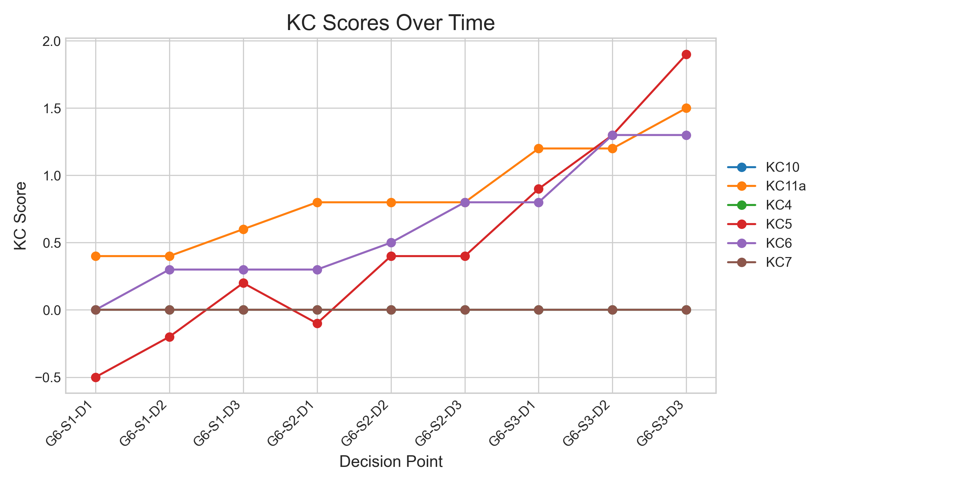

## Metric Values per Decision Point

|  |  |  |  |
| --- | --- | --- | --- |
| Decision Point | Customer Satisfaction | Reputation | Revenue |
| G6-S1-D1 | 2.6 | 0.11200000000000002 | 2300 |
| G6-S1-D2 | 4.55 | 0.196 | 4025 |
| G6-S1-D3 | 8.450000000000001 | 0.36400000000000005 | 5175 |
| G6-S2-D1 | 7.800000000000002 | 0.336 | 6325 |
| G6-S2-D2 | 11.05 | 0.47600000000000003 | 7475 |
| G6-S2-D3 | 11.05 | 0.47600000000000003 | 9200 |
| G6-S3-D1 | 16.900000000000002 | 0.7280000000000001 | 11500 |
| G6-S3-D2 | 19.500000000000004 | 0.8400000000000001 | 14375 |
| G6-S3-D3 | 25.35 | 1.092 | 16100 |

