Learner Report: BT15BT16

Goal Attempted: Break Even and Build Trust

Report generated on: 2025-07-07 23:43:42

# Final Cumulative Scores

This section shows the learner's final score compared to the average, min, and max of all learners who attempted THIS SAME GOAL.

## Final KC Scores

|  |  |  |  |  |
| --- | --- | --- | --- | --- |
| index | Your Score | Class Avg | Class Min | Class Max |
| KC11a | 1.5 | 1.03 | 0.1 | 1.7 |
| KC5 | 1.9 | 1.93 | 0.6 | 3.2 |
| KC6 | 1.3 | 0.87 | 0.0 | 1.5 |

## Final Metric Values

|  |  |  |  |  |
| --- | --- | --- | --- | --- |
| index | Your Value | Class Avg | Class Min | Class Max |
| Customer Satisfaction | 25.35 | 20.37 | 11.7 | 25.35 |
| Reputation | 1.092 | 0.88 | 0.5 | 1.09 |
| Revenue | 16100 | 10925.0 | 3450.0 | 16100.0 |

# Performance Over Time

## KC Scores per Decision Point

|  |  |  |  |
| --- | --- | --- | --- |
| Decision Point | KC11a | KC5 | KC6 |
| Genesis | 0.0 | 0.0 | 0.0 |
| G6-S1-D1 | 0.4 | -0.5 | 0.0 |
| G6-S1-D2 | 0.4 | -0.2 | 0.3 |
| G6-S1-D3 | 0.6 | 0.2 | 0.3 |
| G6-S2-D1 | 0.8 | -0.1 | 0.3 |
| G6-S2-D2 | 0.8 | 0.4 | 0.5 |
| G6-S2-D3 | 0.8 | 0.4 | 0.8 |
| G6-S3-D1 | 1.2 | 0.9 | 0.8 |
| G6-S3-D2 | 1.2 | 1.3 | 1.3 |
| G6-S3-D3 | 1.5 | 1.9 | 1.3 |

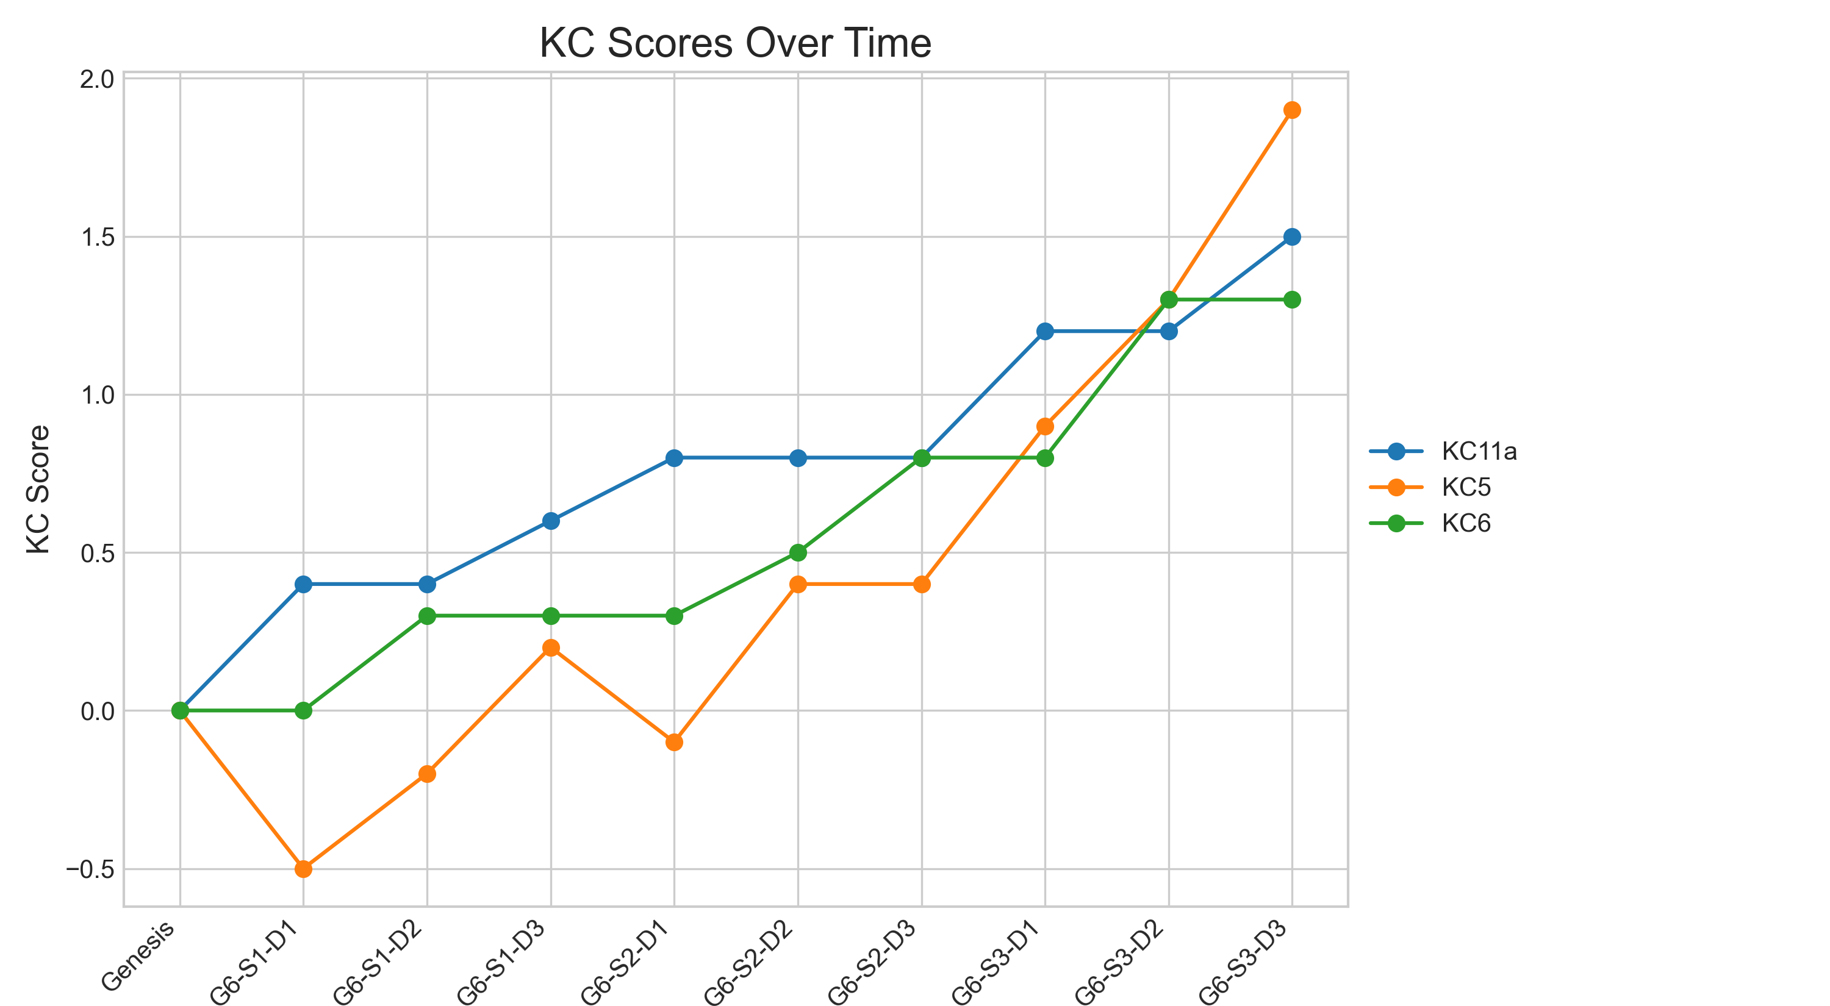

## Metric Values per Decision Point

|  |  |  |  |
| --- | --- | --- | --- |
| Decision Point | Customer Satisfaction | Reputation | Revenue |
| Genesis | 0.0 | 0.0 | 0 |
| G6-S1-D1 | 2.6 | 0.11 | 2300 |
| G6-S1-D2 | 4.55 | 0.2 | 4025 |
| G6-S1-D3 | 8.45 | 0.36 | 5175 |
| G6-S2-D1 | 7.8 | 0.34 | 6325 |
| G6-S2-D2 | 11.05 | 0.48 | 7475 |
| G6-S2-D3 | 11.05 | 0.48 | 9200 |
| G6-S3-D1 | 16.9 | 0.73 | 11500 |
| G6-S3-D2 | 19.5 | 0.84 | 14375 |
| G6-S3-D3 | 25.35 | 1.09 | 16100 |

### Revenue Progression

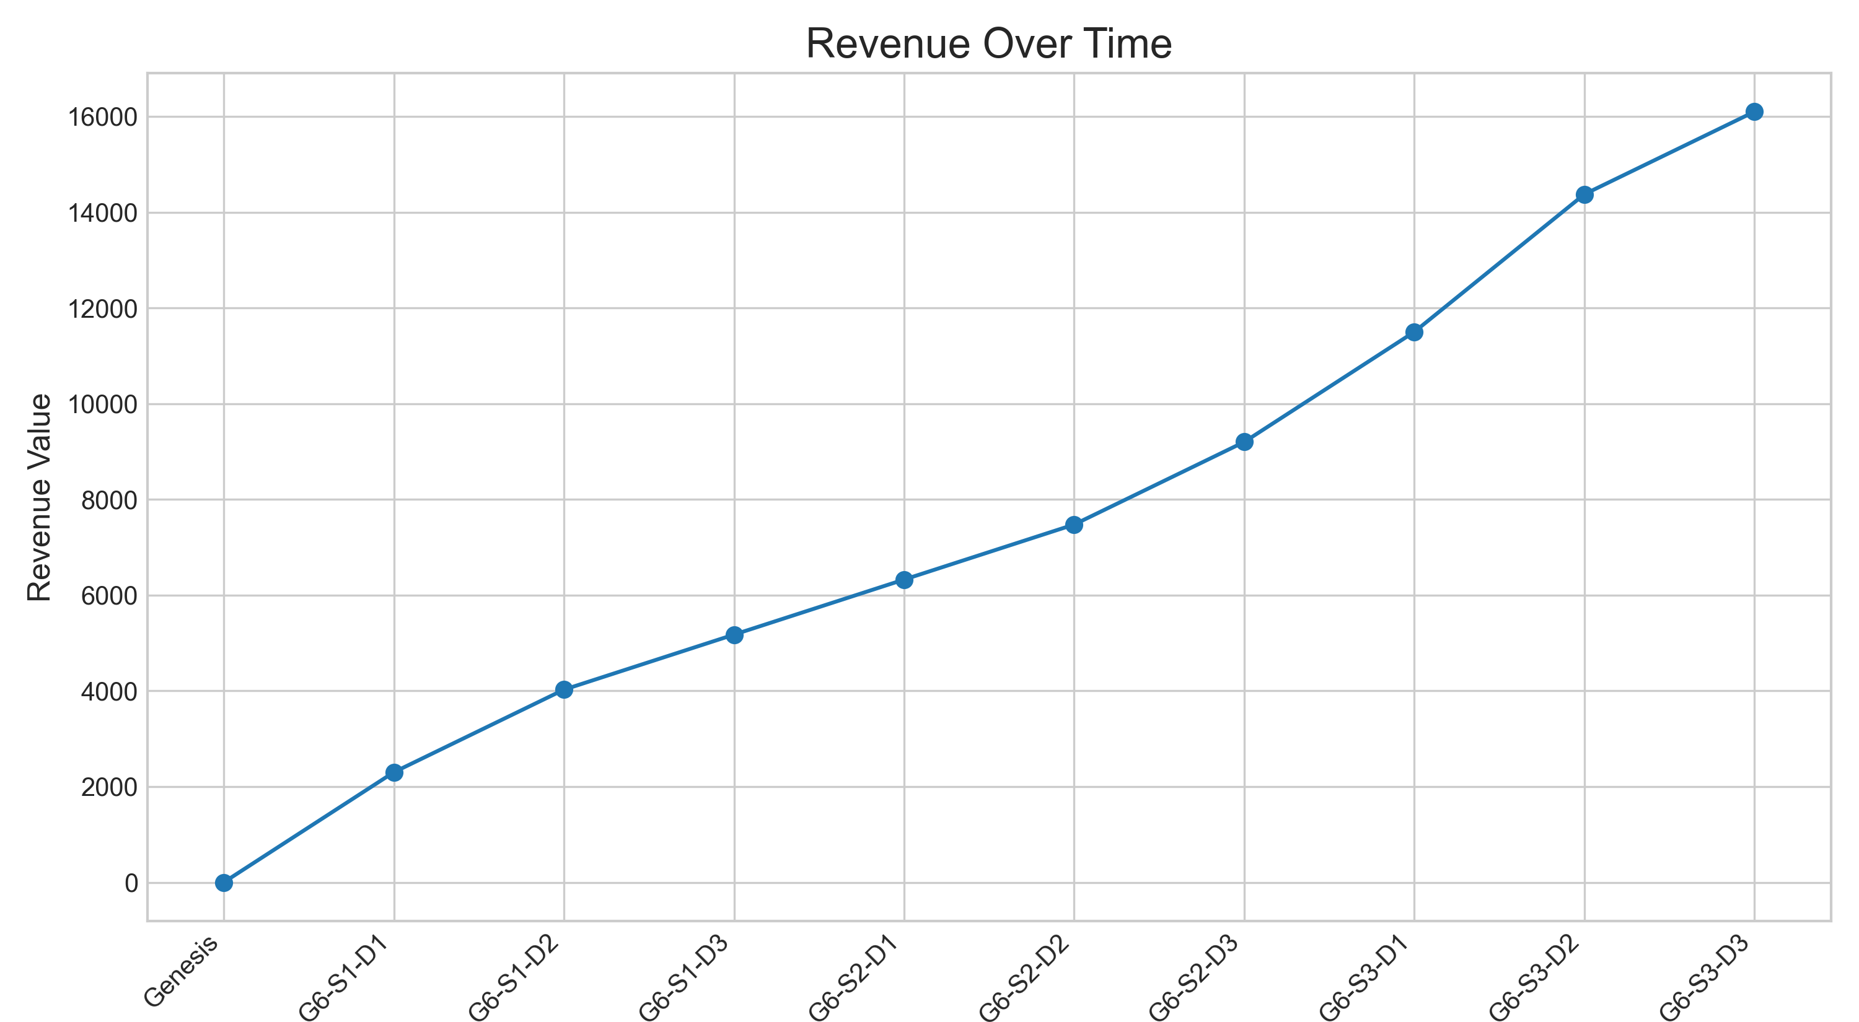

### Reputation Progression

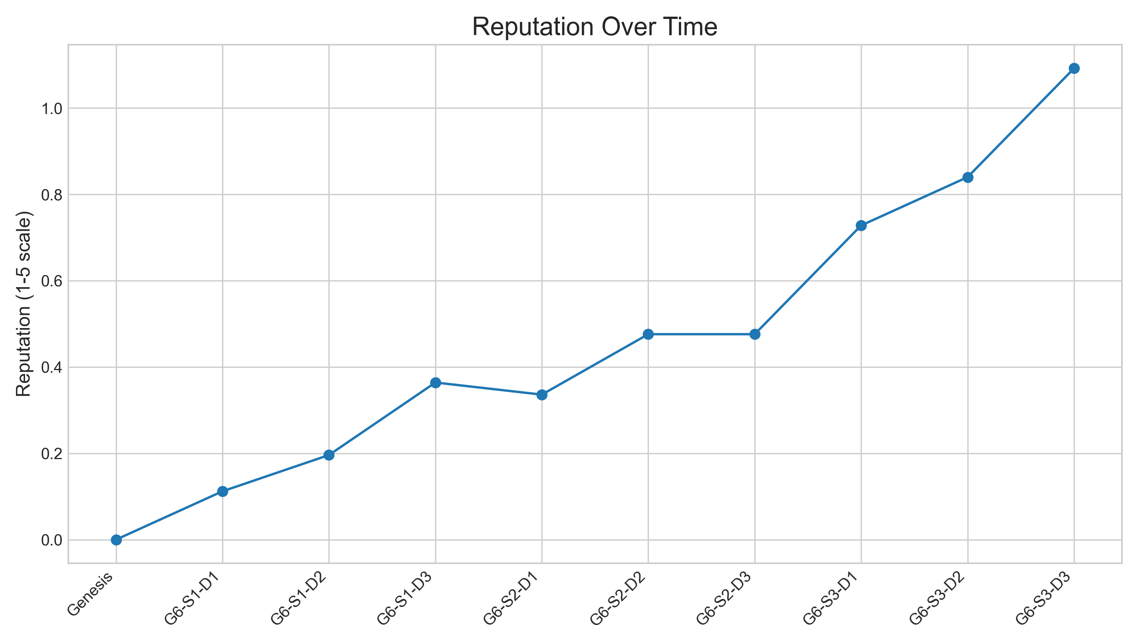

### Customer Satisfaction Progression

