Learner Report: BT1

Goal Attempted: Break Even and Build Trust

Report generated on: 2025-07-07 22:52:15

# Final Cumulative Scores

This section shows the learner's final score for each item compared to the class average, minimum, and maximum.

## Final KC Scores

|  |  |  |  |  |
| --- | --- | --- | --- | --- |
| Knowledge Component (KC) | Your Score | Class Avg | Class Min | Class Max |
| KC11a | 0.1 | 0.48 | 0.0 | 1.7 |
| KC5 | 3.2 | 0.89 | 0.0 | 3.2 |
| KC6 | 0.6 | 0.4 | 0.0 | 1.5 |

## Final Metric Values

|  |  |  |  |  |
| --- | --- | --- | --- | --- |
| Metric | Your Value | Class Avg | Class Min | Class Max |
| Customer Satisfaction | 21.45 | 19.35 | 3.9 | 27.3 |
| Reputation | 0.924 | 0.83 | 0.17 | 1.18 |
| Revenue | 4025 | 13667.31 | -1150.0 | 27600.0 |

# Performance Over Time

## KC Scores per Decision Point

|  |  |  |  |
| --- | --- | --- | --- |
| Decision Point | KC11a | KC5 | KC6 |
| Genesis | 0.0 | 0.0 | 0.0 |
| G6-S1-D1 | 0.3 | 0.5 | 0.0 |
| G6-S1-D2 | -0.1 | 0.2 | 0.0 |
| G6-S1-D3 | -0.1 | 0.9 | 0.1 |
| G6-S2-D1 | -0.4 | 0.9 | 0.5 |
| G6-S2-D2 | -0.4 | 1.2 | 0.2 |
| G6-S2-D3 | -0.4 | 1.8 | 0.6 |
| G6-S3-D1 | -0.1 | 2.2 | 0.6 |
| G6-S3-D2 | 0.2 | 2.8 | 0.6 |
| G6-S3-D3 | 0.1 | 3.2 | 0.6 |

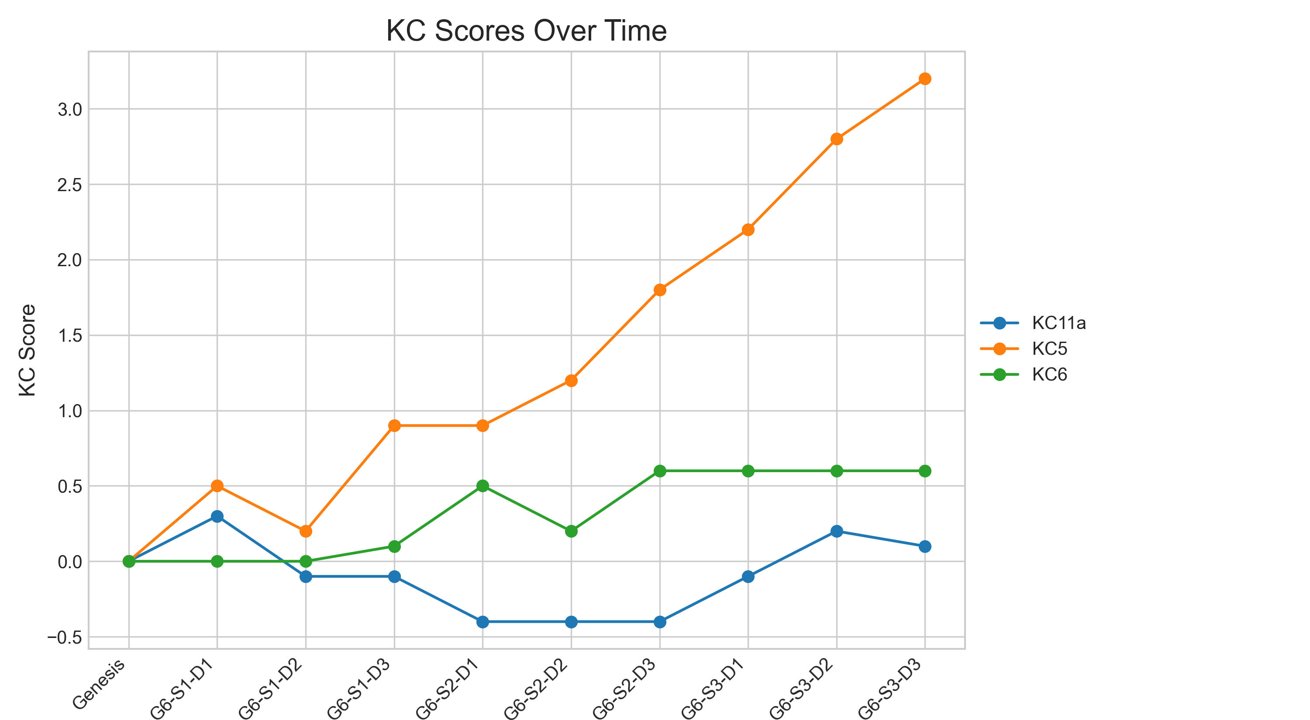

## Metric Values per Decision Point

|  |  |  |  |
| --- | --- | --- | --- |
| Decision Point | Customer Satisfaction | Reputation | Revenue |
| Genesis | 0.0 | 0.0 | 0 |
| G6-S1-D1 | 5.2 | 0.22 | 1725 |
| G6-S1-D2 | 0.65 | 0.03 | -575 |
| G6-S1-D3 | 5.2 | 0.22 | 0 |
| G6-S2-D1 | 3.25 | 0.14 | 575 |
| G6-S2-D2 | 5.2 | 0.22 | -1150 |
| G6-S2-D3 | 9.1 | 0.39 | 1150 |
| G6-S3-D1 | 13.65 | 0.59 | 2875 |
| G6-S3-D2 | 19.5 | 0.84 | 4600 |
| G6-S3-D3 | 21.45 | 0.92 | 4025 |

### Revenue Progression

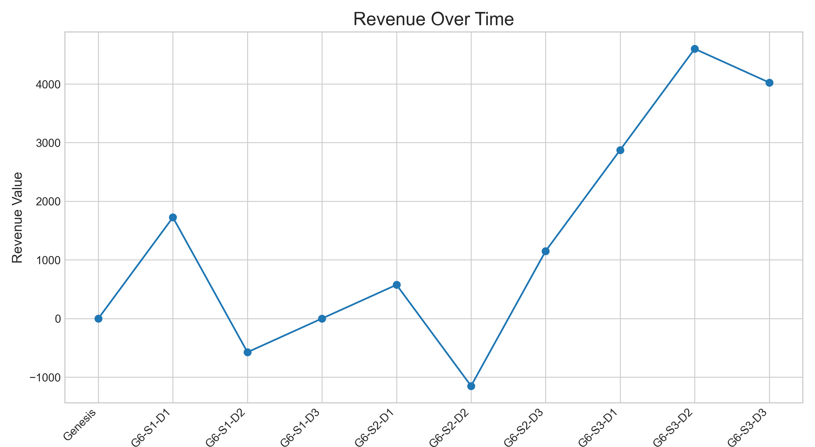

### Other Metrics Progression

