Learner Report: BT2

Report generated on: 2025-07-07 22:28:37

# Final Cumulative Scores

## Final KC Scores

|  |  |
| --- | --- |
| Knowledge Component (KC) | Final Score |
| KC10 | 0.0 |
| KC11a | 1.1 |
| KC4 | 0.0 |
| KC5 | 1.9 |
| KC6 | 1.5 |
| KC7 | 0.0 |

## Final Metric Scores

|  |  |
| --- | --- |
| Metric | Final Value |
| Customer Satisfaction | 22.75 |
| Reputation | 0.9800000000000002 |
| Revenue | 14950 |

# Performance Over Time

## KC Scores per Decision Point

|  |  |  |  |  |  |  |
| --- | --- | --- | --- | --- | --- | --- |
| Decision Point | KC10 | KC11a | KC4 | KC5 | KC6 | KC7 |
| G6-S1-D1 | 0.0 | 0.3 | 0.0 | -0.5 | 0.0 | 0.0 |
| G6-S1-D2 | 0.0 | 0.3 | 0.0 | 0.1 | 0.5 | 0.0 |
| G6-S1-D3 | 0.0 | -0.1 | 0.0 | -0.4 | 0.5 | 0.0 |
| G6-S2-D1 | 0.0 | 0.4 | 0.0 | 0.2 | 0.5 | 0.0 |
| G6-S2-D2 | 0.0 | 0.4 | 0.0 | 0.7 | 0.8 | 0.0 |
| G6-S2-D3 | 0.0 | 0.4 | 0.0 | 0.7 | 0.6 | 0.0 |
| G6-S3-D1 | 0.0 | 0.6 | 0.0 | 0.7 | 1.2 | 0.0 |
| G6-S3-D2 | 0.0 | 0.6 | 0.0 | 1.3 | 1.5 | 0.0 |
| G6-S3-D3 | 0.0 | 1.1 | 0.0 | 1.9 | 1.5 | 0.0 |

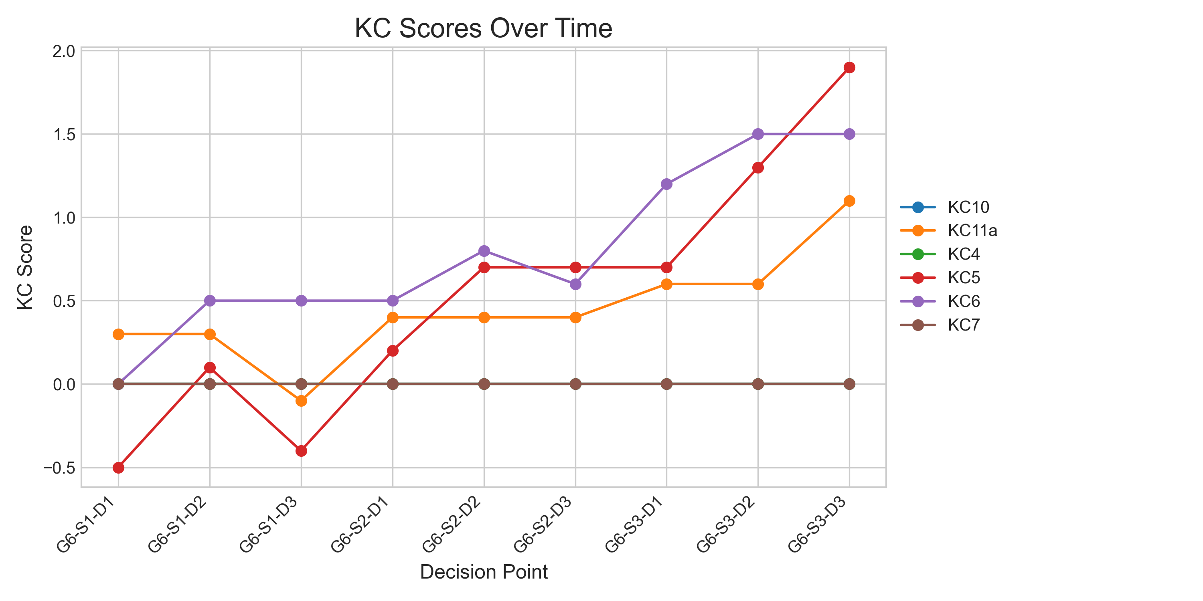

## Metric Values per Decision Point

|  |  |  |  |
| --- | --- | --- | --- |
| Decision Point | Customer Satisfaction | Reputation | Revenue |
| G6-S1-D1 | 1.95 | 0.084 | 1725 |
| G6-S1-D2 | 5.85 | 0.252 | 4600 |
| G6-S1-D3 | 0.0 | 0.0 | 2300 |
| G6-S2-D1 | 7.15 | 0.30800000000000005 | 5175 |
| G6-S2-D2 | 10.4 | 0.44800000000000006 | 6900 |
| G6-S2-D3 | 10.4 | 0.44800000000000006 | 5750 |
| G6-S3-D1 | 11.700000000000001 | 0.5040000000000001 | 10350 |
| G6-S3-D2 | 15.600000000000001 | 0.6720000000000002 | 12075 |
| G6-S3-D3 | 22.75 | 0.9800000000000002 | 14950 |

