Learner Report: BT4

Goal Attempted: Break Even and Build Trust

Report generated on: 2025-07-07 23:02:53

# Final Cumulative Scores

This section shows the learner's final score compared to the average, min, and max of all learners who attempted THIS SAME GOAL.

## Final KC Scores

|  |  |  |  |  |
| --- | --- | --- | --- | --- |
| index | Your Score | Class Avg | Class Min | Class Max |
| KC11a | 1.2 | 1.03 | 0.1 | 1.7 |
| KC5 | 0.6 | 1.93 | 0.6 | 3.2 |
| KC6 | 1.0 | 0.87 | 0.0 | 1.5 |

## Final Metric Values

|  |  |  |  |  |
| --- | --- | --- | --- | --- |
| index | Your Value | Class Avg | Class Min | Class Max |
| Customer Satisfaction | 11.700000000000003 | 20.37 | 11.7 | 25.35 |
| Reputation | 0.5040000000000002 | 0.88 | 0.5 | 1.09 |
| Revenue | 12650 | 10925.0 | 3450.0 | 16100.0 |

# Performance Over Time

## KC Scores per Decision Point

|  |  |  |  |
| --- | --- | --- | --- |
| Decision Point | KC11a | KC5 | KC6 |
| Genesis | 0.0 | 0.0 | 0.0 |
| G6-S1-D1 | 0.3 | 0.5 | 0.0 |
| G6-S1-D2 | 0.7 | 0.3 | 0.0 |
| G6-S1-D3 | 0.7 | 0.7 | 0.2 |
| G6-S2-D1 | 1.0 | 0.3 | 0.2 |
| G6-S2-D2 | 1.0 | 0.4 | 0.7 |
| G6-S2-D3 | 1.2 | 1.0 | 0.7 |
| G6-S3-D1 | 0.9 | 1.4 | 0.7 |
| G6-S3-D2 | 0.9 | 1.0 | 1.0 |
| G6-S3-D3 | 1.2 | 0.6 | 1.0 |

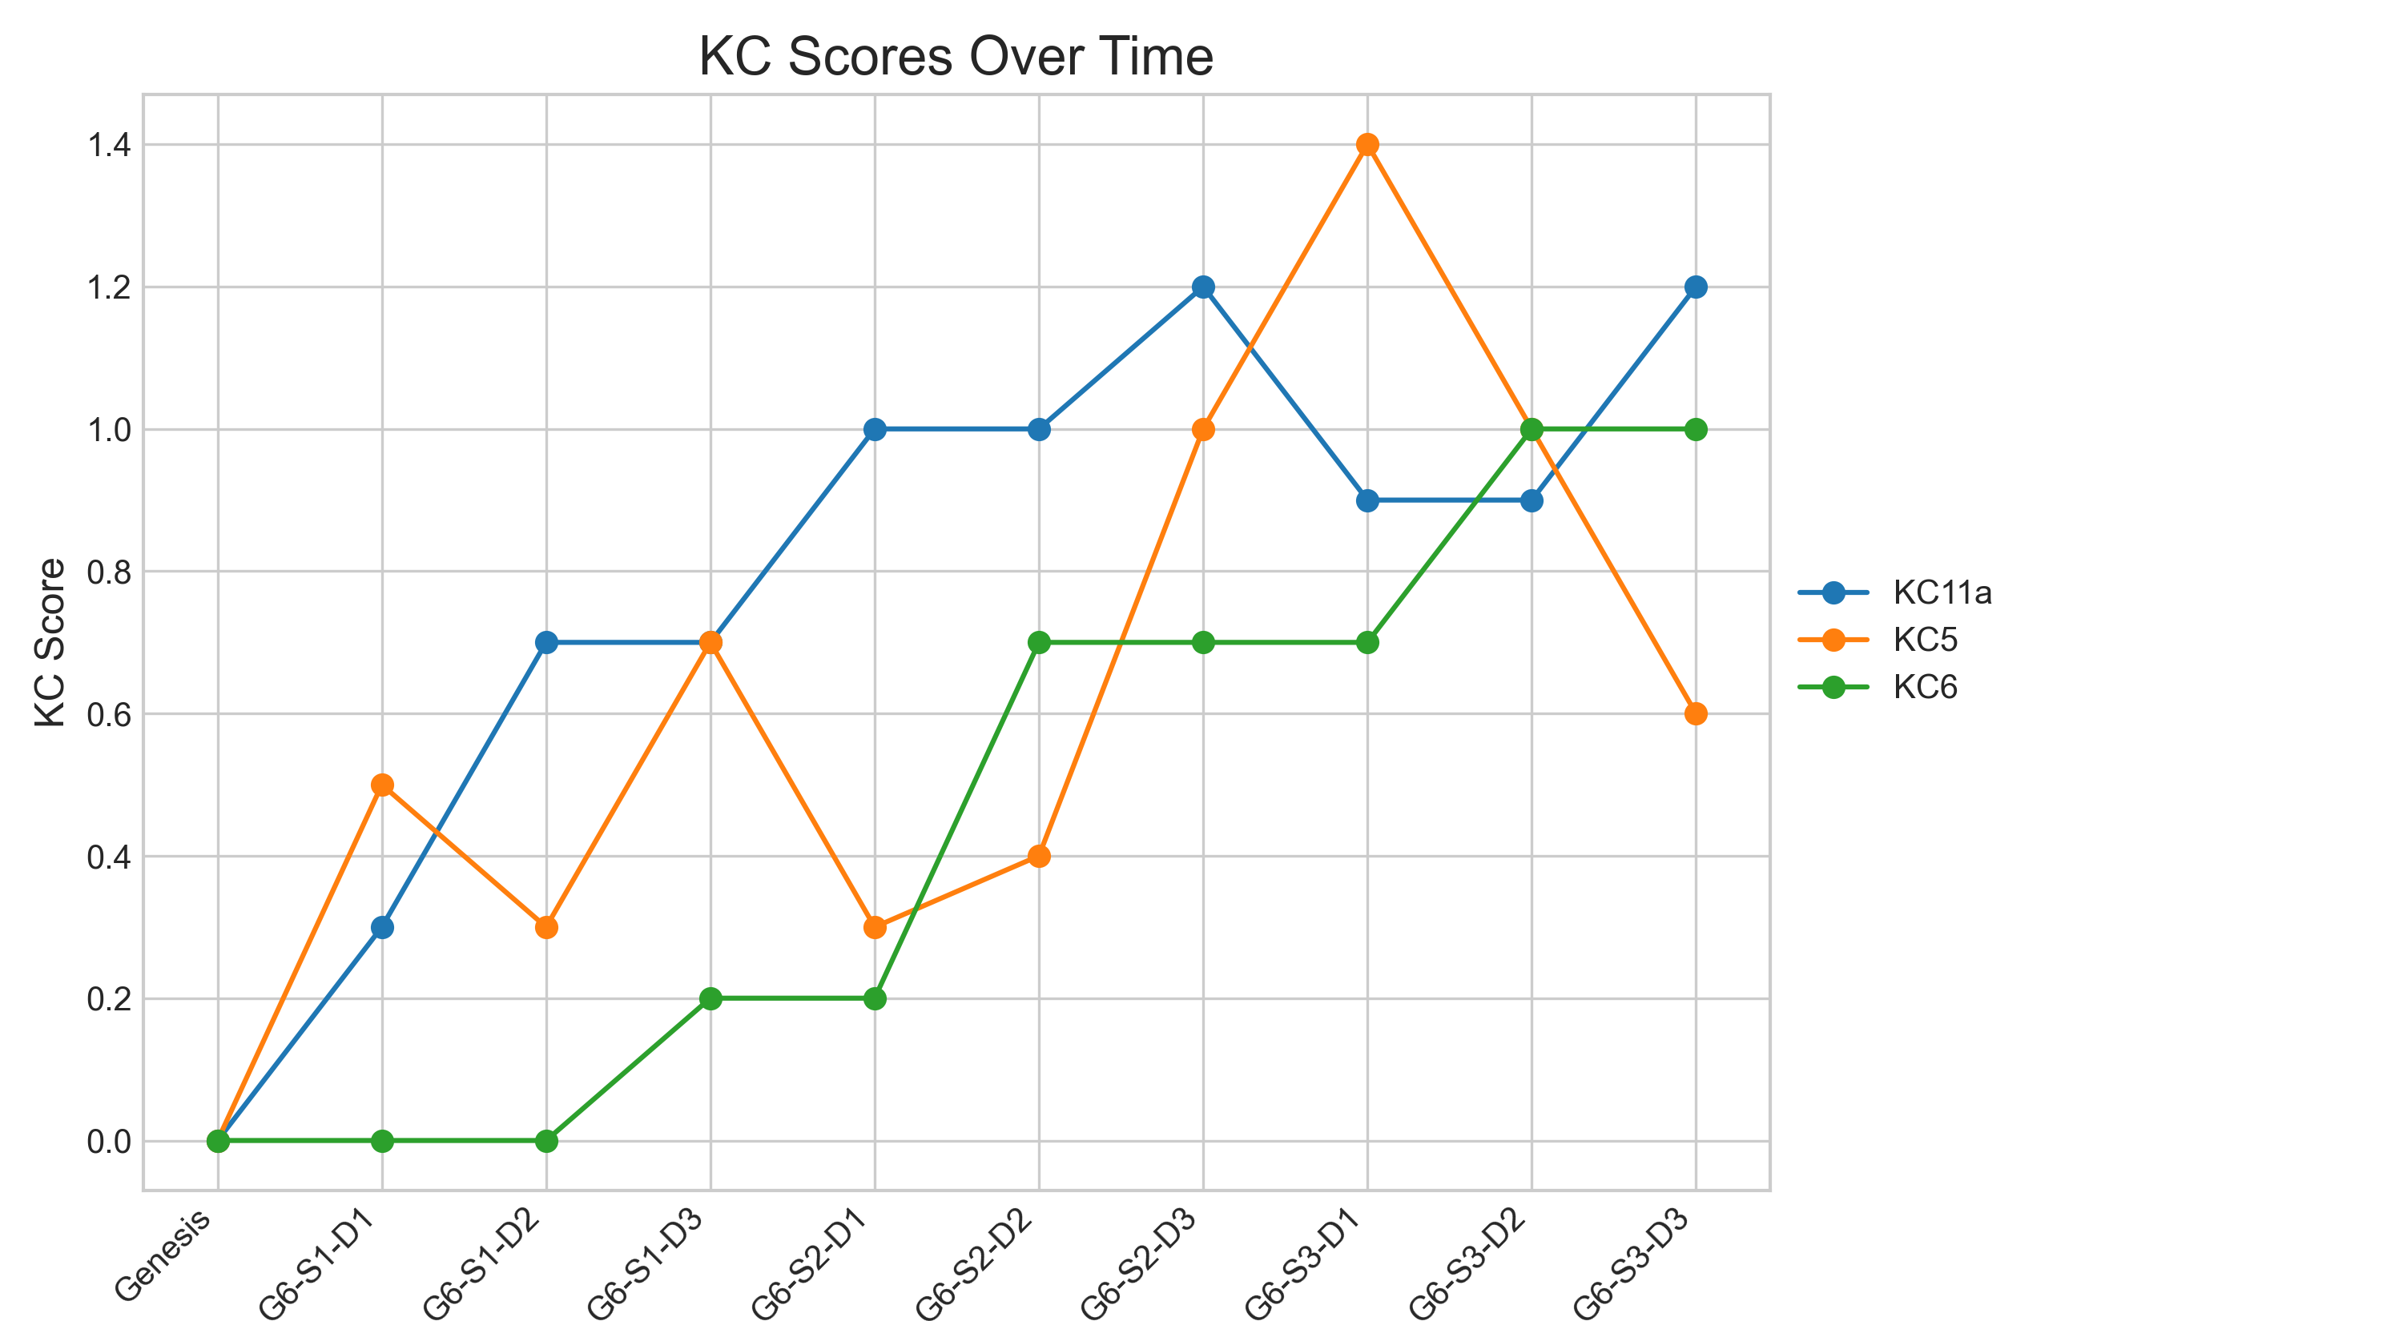

## Metric Values per Decision Point

|  |  |  |  |
| --- | --- | --- | --- |
| Decision Point | Customer Satisfaction | Reputation | Revenue |
| Genesis | 0.0 | 0.0 | 0 |
| G6-S1-D1 | 5.2 | 0.22 | 1725 |
| G6-S1-D2 | 6.5 | 0.28 | 4025 |
| G6-S1-D3 | 9.1 | 0.39 | 5175 |
| G6-S2-D1 | 8.45 | 0.36 | 6900 |
| G6-S2-D2 | 9.1 | 0.39 | 9775 |
| G6-S2-D3 | 14.3 | 0.62 | 10925 |
| G6-S3-D1 | 14.95 | 0.64 | 9200 |
| G6-S3-D2 | 12.35 | 0.53 | 10925 |
| G6-S3-D3 | 11.7 | 0.5 | 12650 |

### Revenue Progression

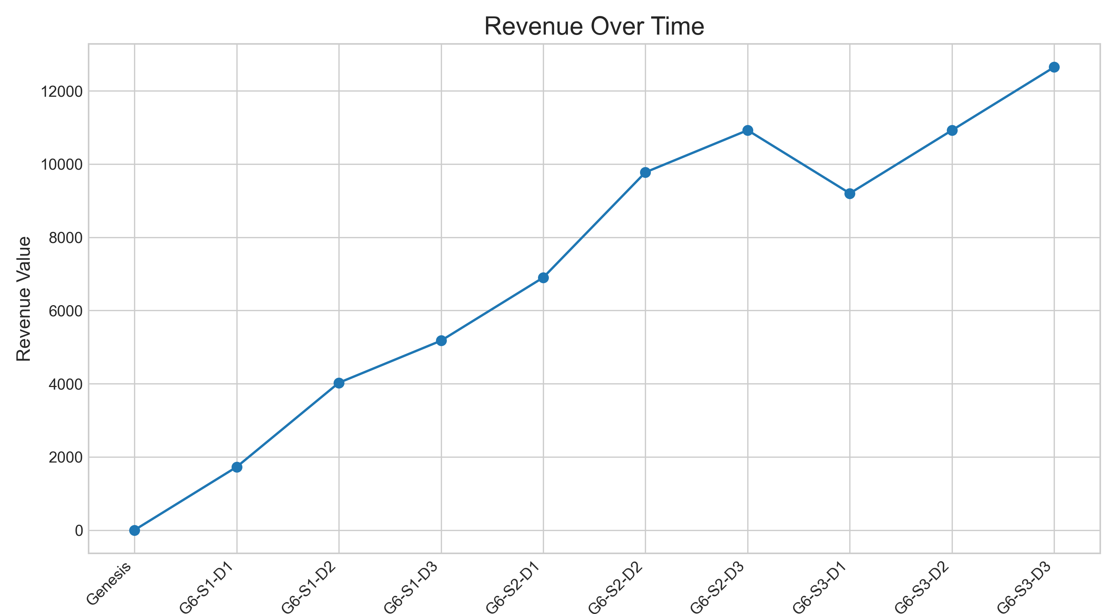

### Reputation Progression

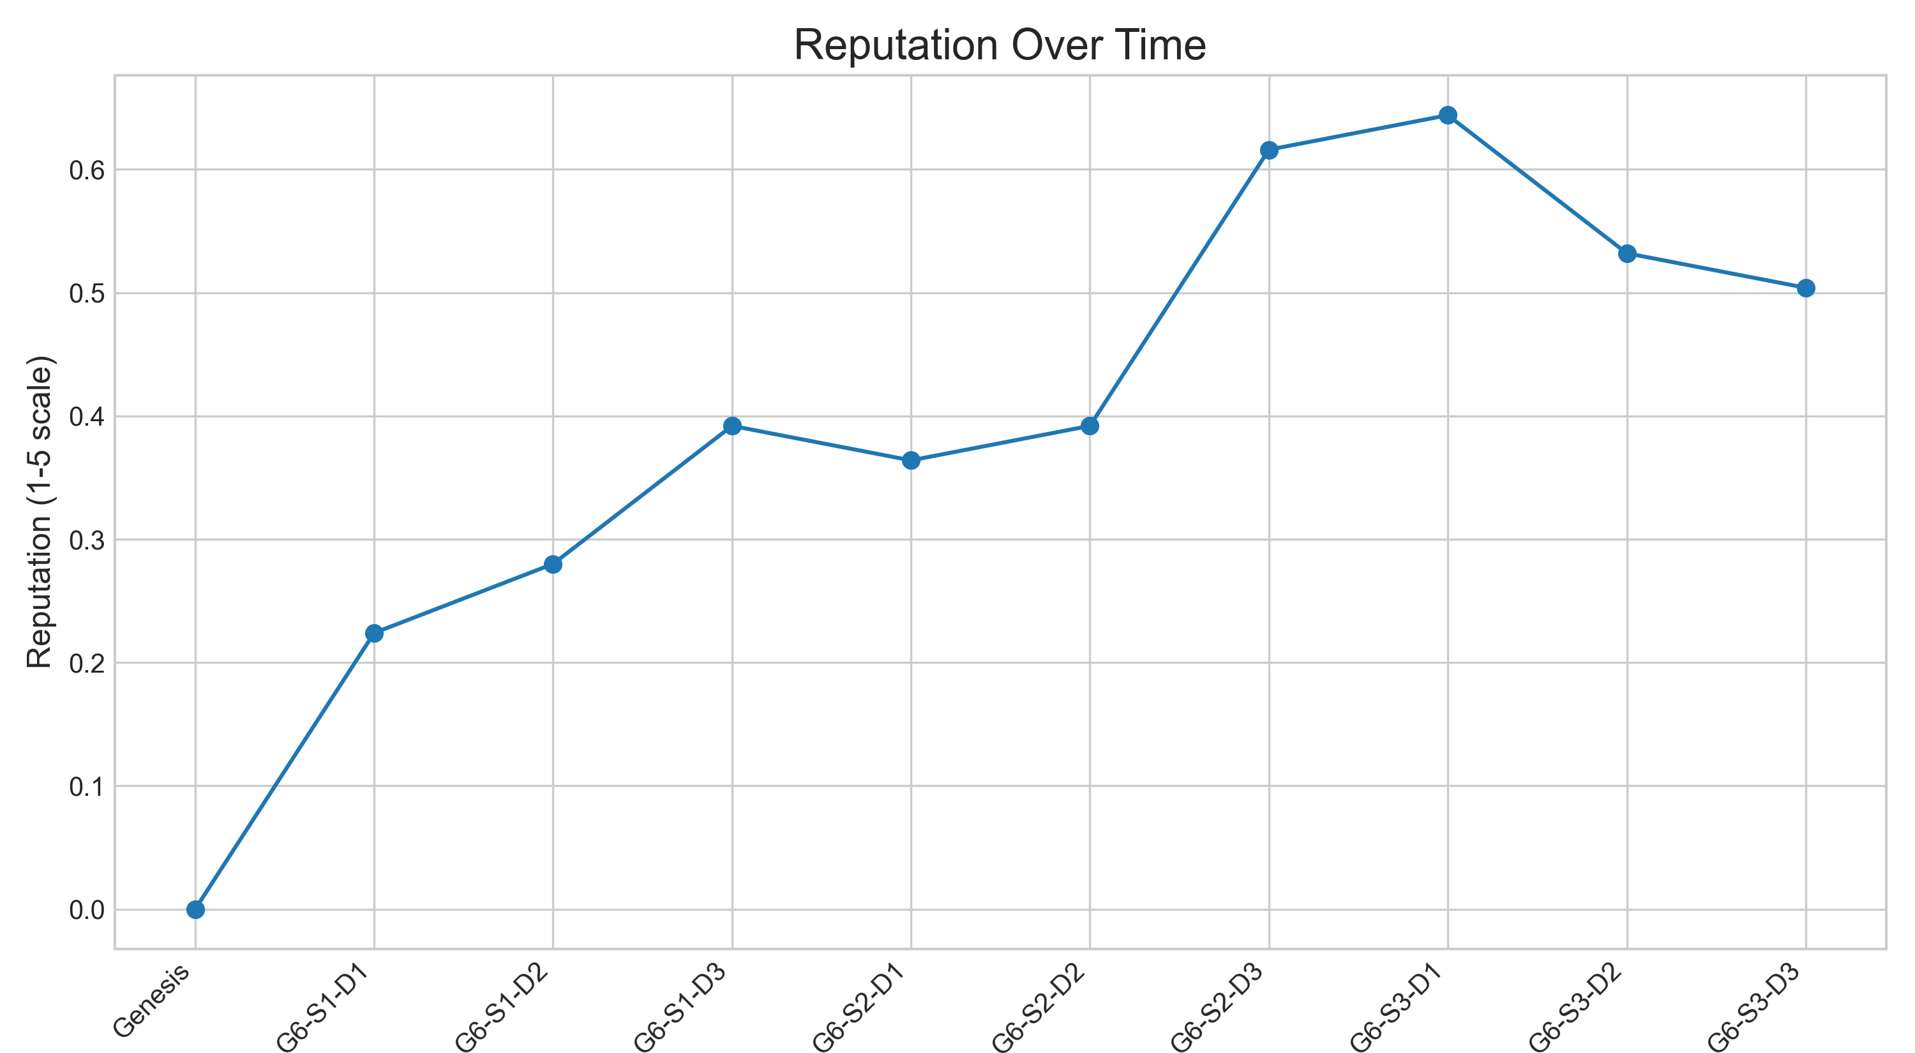

### High-Scale Metrics Progression

