Learner Report: BT7

Report generated on: 2025-07-07 22:28:40

# Final Cumulative Scores

## Final KC Scores

|  |  |
| --- | --- |
| Knowledge Component (KC) | Final Score |
| KC10 | 2.2 |
| KC11a | 0.0 |
| KC4 | -0.4 |
| KC5 | 0.0 |
| KC6 | 0.0 |
| KC7 | 2.0 |

## Final Metric Scores

|  |  |
| --- | --- |
| Metric | Final Value |
| Customer Satisfaction | 27.3 |
| Reputation | 1.1760000000000002 |
| Revenue | 21850.0 |

# Performance Over Time

## KC Scores per Decision Point

|  |  |  |  |  |  |  |
| --- | --- | --- | --- | --- | --- | --- |
| Decision Point | KC10 | KC11a | KC4 | KC5 | KC6 | KC7 |
| G7-S1-D1 | -0.4 | 0.0 | 0.0 | 0.0 | 0.0 | 0.7 |
| G7-S1-D2 | 0.3 | 0.0 | -0.3 | 0.0 | 0.0 | 0.7 |
| G7-S1-D3 | 0.8 | 0.0 | 0.0 | 0.0 | 0.0 | 0.7 |
| G7-S2-D1 | 0.6 | 0.0 | 0.0 | 0.0 | 0.0 | 1.3 |
| G7-S2-D2 | 1.1 | 0.0 | 0.0 | 0.0 | 0.0 | 1.6 |
| G7-S2-D3 | 1.4 | 0.0 | -0.2 | 0.0 | 0.0 | 1.6 |
| G7-S3-D1 | 1.4 | 0.0 | -0.4 | 0.0 | 0.0 | 1.3 |
| G7-S3-D2 | 1.6 | 0.0 | -0.4 | 0.0 | 0.0 | 1.7 |
| G7-S3-D3 | 2.2 | 0.0 | -0.4 | 0.0 | 0.0 | 2.0 |

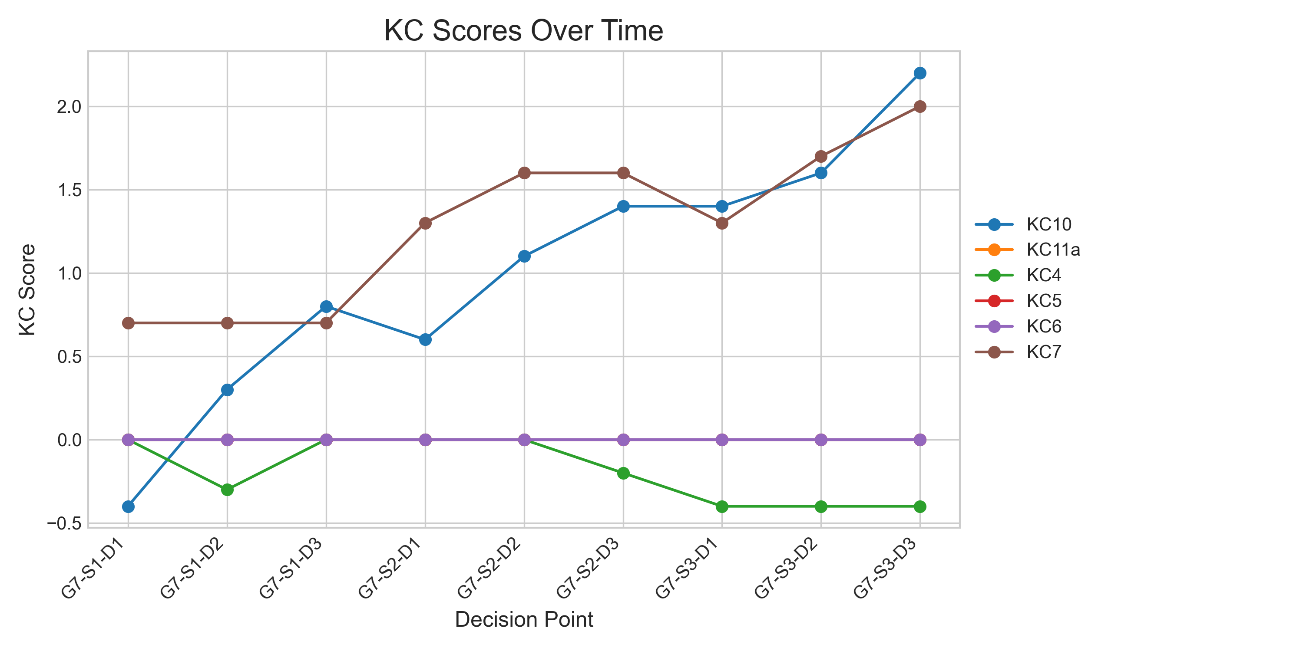

## Metric Values per Decision Point

|  |  |  |  |
| --- | --- | --- | --- |
| Decision Point | Customer Satisfaction | Reputation | Revenue |
| G7-S1-D1 | 1.9499999999999997 | 0.08399999999999999 | 1724.9999999999995 |
| G7-S1-D2 | 6.5 | 0.28 | 4024.999999999999 |
| G7-S1-D3 | 9.75 | 0.42000000000000004 | 8625.0 |
| G7-S2-D1 | 12.35 | 0.532 | 10925.0 |
| G7-S2-D2 | 17.55 | 0.756 | 15525.0 |
| G7-S2-D3 | 19.5 | 0.84 | 16100.0 |
| G7-S3-D1 | 17.55 | 0.756 | 13225.0 |
| G7-S3-D2 | 21.450000000000003 | 0.924 | 16675.0 |
| G7-S3-D3 | 27.3 | 1.1760000000000002 | 21850.0 |

