Learner Report: BT7

Goal Attempted: Price with Purpose

Report generated on: 2025-07-07 22:52:16

# Final Cumulative Scores

This section shows the learner's final score for each item compared to the class average, minimum, and maximum.

## Final KC Scores

|  |  |  |  |  |
| --- | --- | --- | --- | --- |
| Knowledge Component (KC) | Your Score | Class Avg | Class Min | Class Max |
| KC10 | 2.2 | 0.85 | 0.0 | 2.7 |
| KC4 | -0.4 | 0.02 | -0.8 | 0.9 |
| KC7 | 2.0 | 0.64 | -0.1 | 2.3 |

## Final Metric Values

|  |  |  |  |  |
| --- | --- | --- | --- | --- |
| Metric | Your Value | Class Avg | Class Min | Class Max |
| Customer Satisfaction | 27.3 | 19.35 | 3.9 | 27.3 |
| Reputation | 1.1760000000000002 | 0.83 | 0.17 | 1.18 |
| Revenue | 21850.0 | 13667.31 | -1150.0 | 27600.0 |

# Performance Over Time

## KC Scores per Decision Point

|  |  |  |  |
| --- | --- | --- | --- |
| Decision Point | KC10 | KC4 | KC7 |
| Genesis | 0.0 | 0.0 | 0.0 |
| G7-S1-D1 | -0.4 | 0.0 | 0.7 |
| G7-S1-D2 | 0.3 | -0.3 | 0.7 |
| G7-S1-D3 | 0.8 | 0.0 | 0.7 |
| G7-S2-D1 | 0.6 | 0.0 | 1.3 |
| G7-S2-D2 | 1.1 | 0.0 | 1.6 |
| G7-S2-D3 | 1.4 | -0.2 | 1.6 |
| G7-S3-D1 | 1.4 | -0.4 | 1.3 |
| G7-S3-D2 | 1.6 | -0.4 | 1.7 |
| G7-S3-D3 | 2.2 | -0.4 | 2.0 |

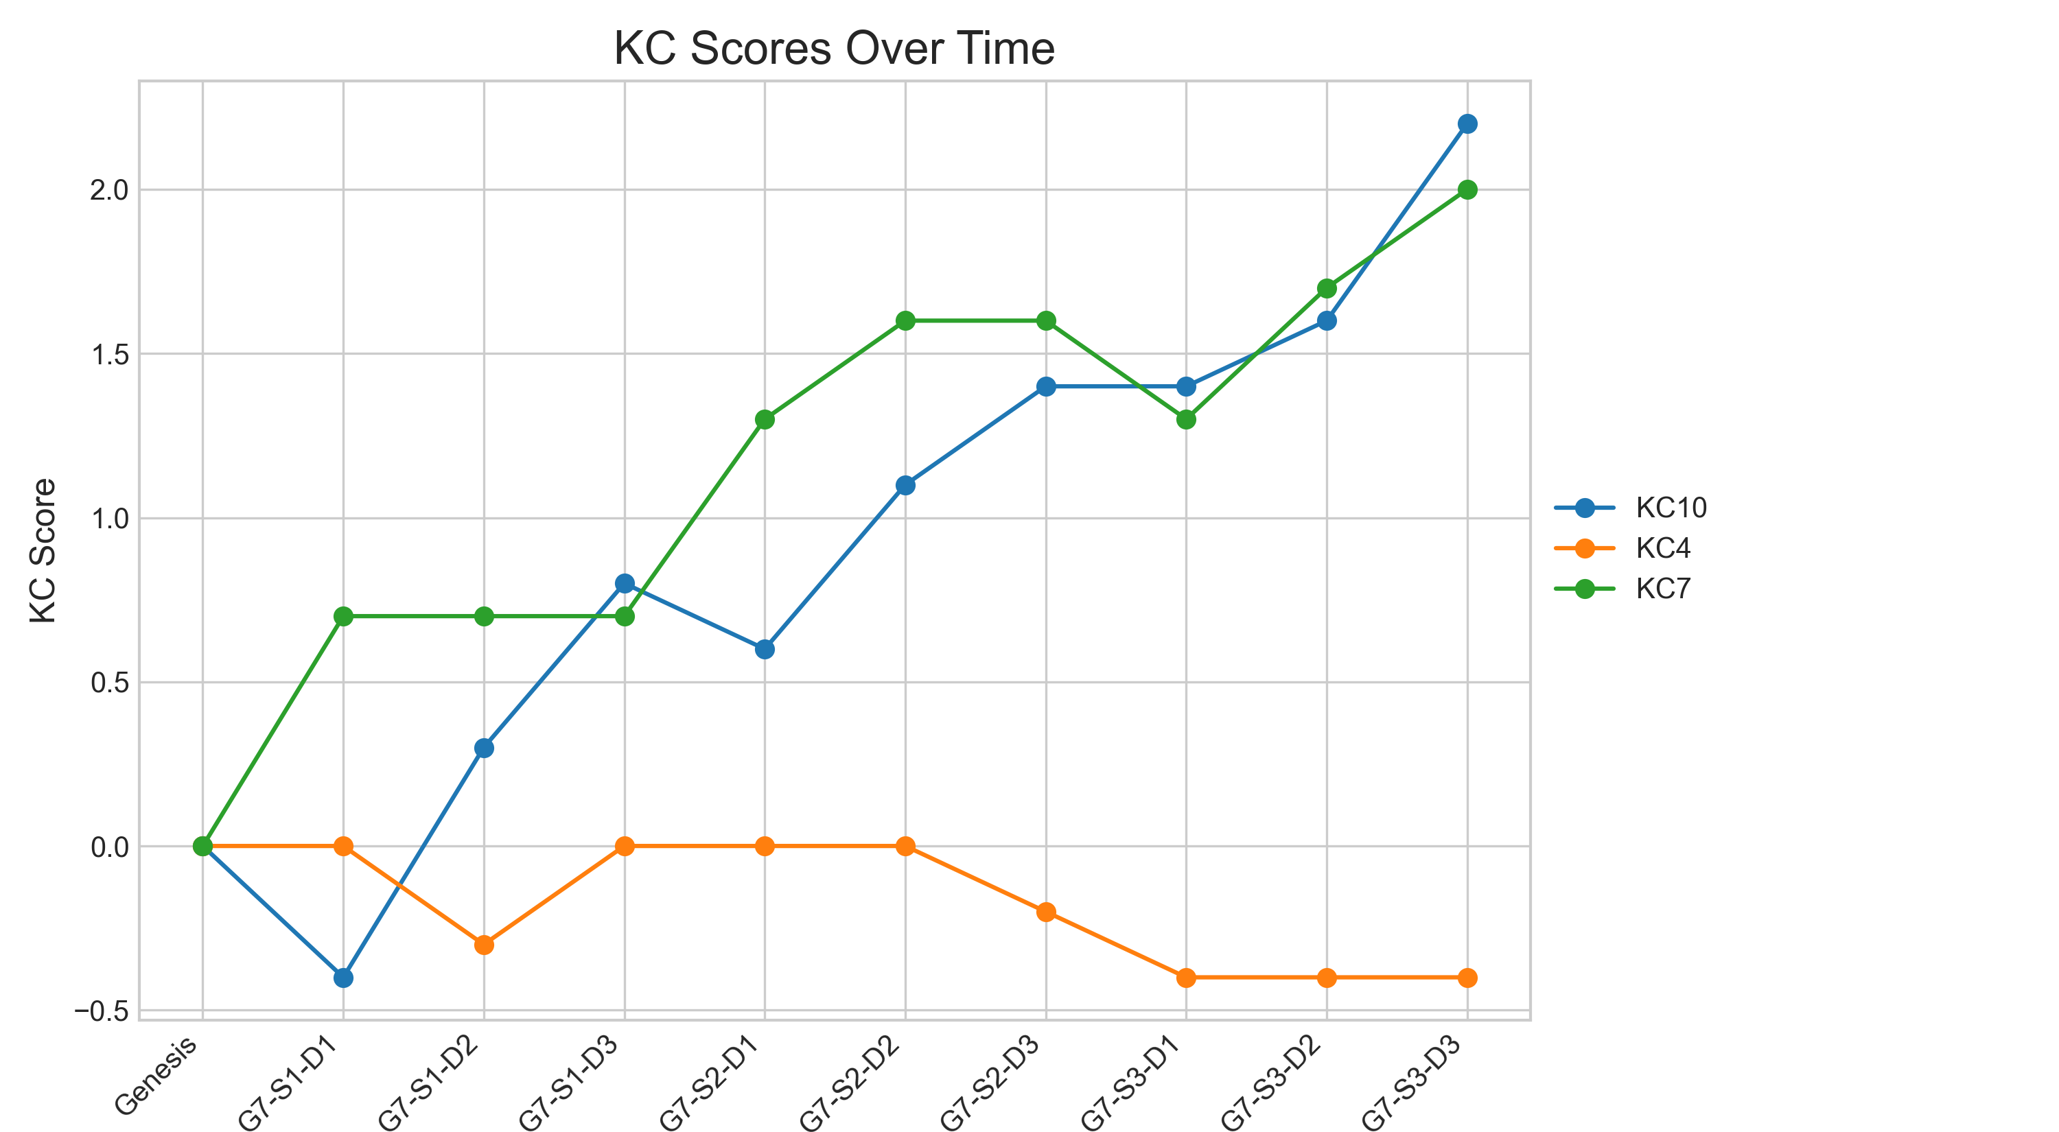

## Metric Values per Decision Point

|  |  |  |  |
| --- | --- | --- | --- |
| Decision Point | Customer Satisfaction | Reputation | Revenue |
| Genesis | 0.0 | 0.0 | 0.0 |
| G7-S1-D1 | 1.95 | 0.08 | 1725.0 |
| G7-S1-D2 | 6.5 | 0.28 | 4025.0 |
| G7-S1-D3 | 9.75 | 0.42 | 8625.0 |
| G7-S2-D1 | 12.35 | 0.53 | 10925.0 |
| G7-S2-D2 | 17.55 | 0.76 | 15525.0 |
| G7-S2-D3 | 19.5 | 0.84 | 16100.0 |
| G7-S3-D1 | 17.55 | 0.76 | 13225.0 |
| G7-S3-D2 | 21.45 | 0.92 | 16675.0 |
| G7-S3-D3 | 27.3 | 1.18 | 21850.0 |

### Revenue Progression

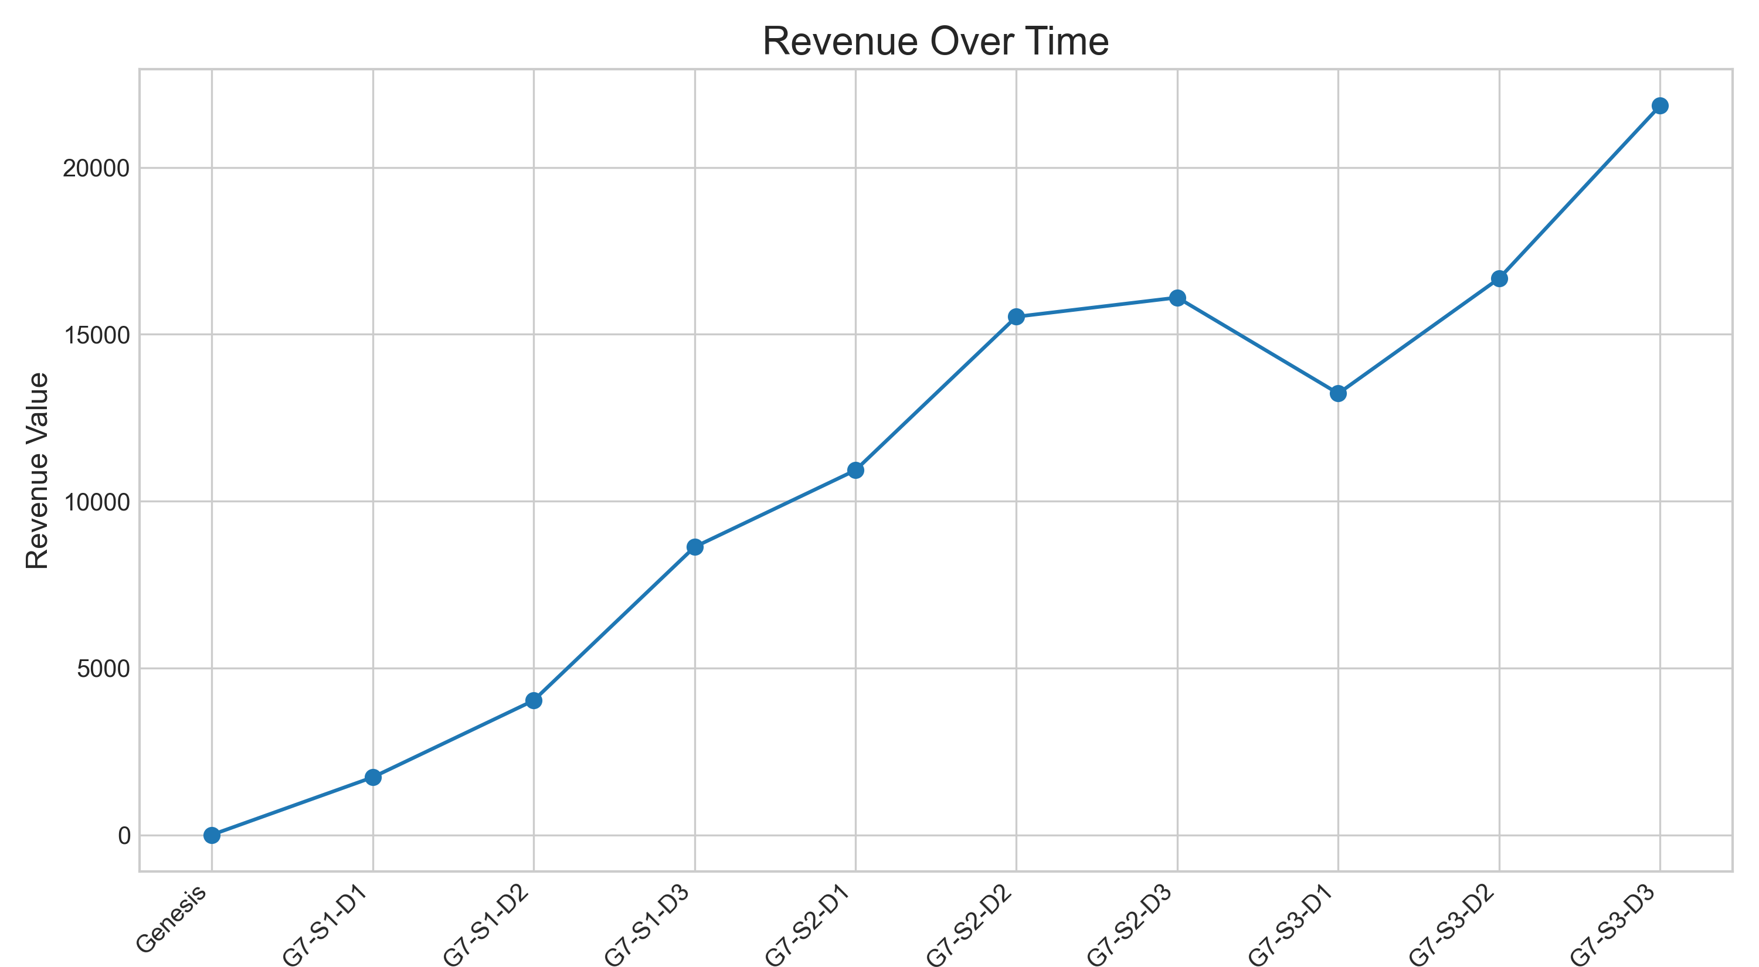

### Other Metrics Progression

