Learner Report: BT1

Report generated on: 2025-07-07 22:28:39

# Final Cumulative Scores

## Final KC Scores

|  |  |
| --- | --- |
| Knowledge Component (KC) | Final Score |
| KC10 | 0.0 |
| KC11a | 0.1 |
| KC4 | 0.0 |
| KC5 | 3.2 |
| KC6 | 0.6 |
| KC7 | 0.0 |

## Final Metric Scores

|  |  |
| --- | --- |
| Metric | Final Value |
| Customer Satisfaction | 21.45 |
| Reputation | 0.924 |
| Revenue | 4025 |

# Performance Over Time

## KC Scores per Decision Point

|  |  |  |  |  |  |  |
| --- | --- | --- | --- | --- | --- | --- |
| Decision Point | KC10 | KC11a | KC4 | KC5 | KC6 | KC7 |
| G6-S1-D1 | 0.0 | 0.3 | 0.0 | 0.5 | 0.0 | 0.0 |
| G6-S1-D2 | 0.0 | -0.1 | 0.0 | 0.2 | 0.0 | 0.0 |
| G6-S1-D3 | 0.0 | -0.1 | 0.0 | 0.9 | 0.1 | 0.0 |
| G6-S2-D1 | 0.0 | -0.4 | 0.0 | 0.9 | 0.5 | 0.0 |
| G6-S2-D2 | 0.0 | -0.4 | 0.0 | 1.2 | 0.2 | 0.0 |
| G6-S2-D3 | 0.0 | -0.4 | 0.0 | 1.8 | 0.6 | 0.0 |
| G6-S3-D1 | 0.0 | -0.1 | 0.0 | 2.2 | 0.6 | 0.0 |
| G6-S3-D2 | 0.0 | 0.2 | 0.0 | 2.8 | 0.6 | 0.0 |
| G6-S3-D3 | 0.0 | 0.1 | 0.0 | 3.2 | 0.6 | 0.0 |

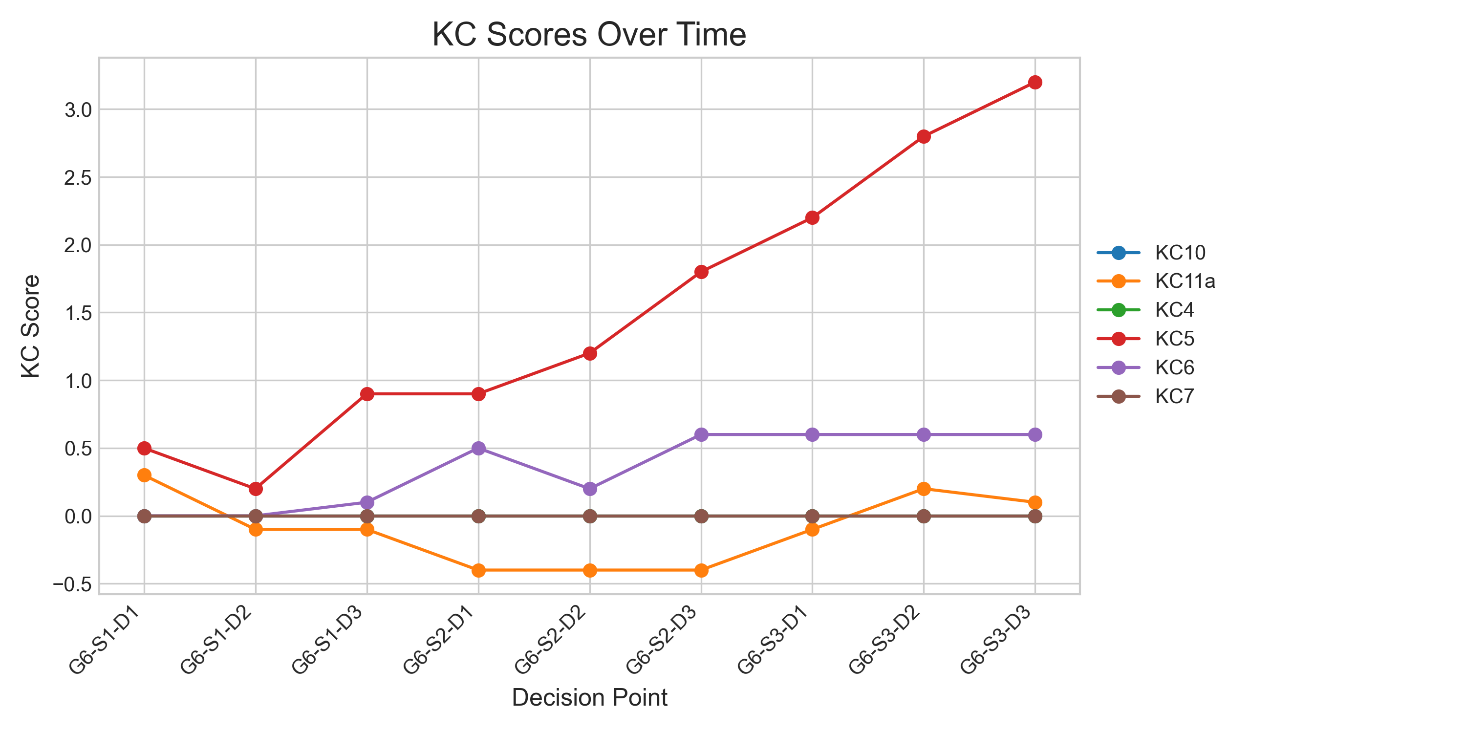

## Metric Values per Decision Point

|  |  |  |  |
| --- | --- | --- | --- |
| Decision Point | Customer Satisfaction | Reputation | Revenue |
| G6-S1-D1 | 5.2 | 0.22400000000000003 | 1725 |
| G6-S1-D2 | 0.6499999999999999 | 0.027999999999999997 | -575 |
| G6-S1-D3 | 5.199999999999999 | 0.224 | 0 |
| G6-S2-D1 | 3.249999999999999 | 0.14 | 575 |
| G6-S2-D2 | 5.199999999999999 | 0.22400000000000003 | -1150 |
| G6-S2-D3 | 9.1 | 0.392 | 1150 |
| G6-S3-D1 | 13.649999999999999 | 0.5880000000000001 | 2875 |
| G6-S3-D2 | 19.499999999999996 | 0.8400000000000001 | 4600 |
| G6-S3-D3 | 21.45 | 0.924 | 4025 |

