Learner Report: BT11BT12

Report generated on: 2025-07-07 22:28:39

# Final Cumulative Scores

## Final KC Scores

|  |  |
| --- | --- |
| Knowledge Component (KC) | Final Score |
| KC10 | 1.4 |
| KC11a | 0.0 |
| KC4 | 0.8 |
| KC5 | 0.0 |
| KC6 | 0.0 |
| KC7 | 2.3 |

## Final Metric Scores

|  |  |
| --- | --- |
| Metric | Final Value |
| Customer Satisfaction | 24.05 |
| Reputation | 1.036 |
| Revenue | 25875 |

# Performance Over Time

## KC Scores per Decision Point

|  |  |  |  |  |  |  |
| --- | --- | --- | --- | --- | --- | --- |
| Decision Point | KC10 | KC11a | KC4 | KC5 | KC6 | KC7 |
| G7-S1-D1 | 0.0 | 0.0 | 0.2 | 0.0 | 0.0 | 0.4 |
| G7-S1-D2 | 0.0 | 0.0 | 0.4 | 0.0 | 0.0 | 1.0 |
| G7-S1-D3 | 0.0 | 0.0 | 0.6 | 0.0 | 0.0 | 0.5 |
| G7-S2-D1 | 0.3 | 0.0 | 0.6 | 0.0 | 0.0 | 0.9 |
| G7-S2-D2 | 0.0 | 0.0 | 0.6 | 0.0 | 0.0 | 1.1 |
| G7-S2-D3 | 0.0 | 0.0 | 0.8 | 0.0 | 0.0 | 1.4 |
| G7-S3-D1 | 0.4 | 0.0 | 0.8 | 0.0 | 0.0 | 1.8 |
| G7-S3-D2 | 1.0 | 0.0 | 0.8 | 0.0 | 0.0 | 1.8 |
| G7-S3-D3 | 1.4 | 0.0 | 0.8 | 0.0 | 0.0 | 2.3 |

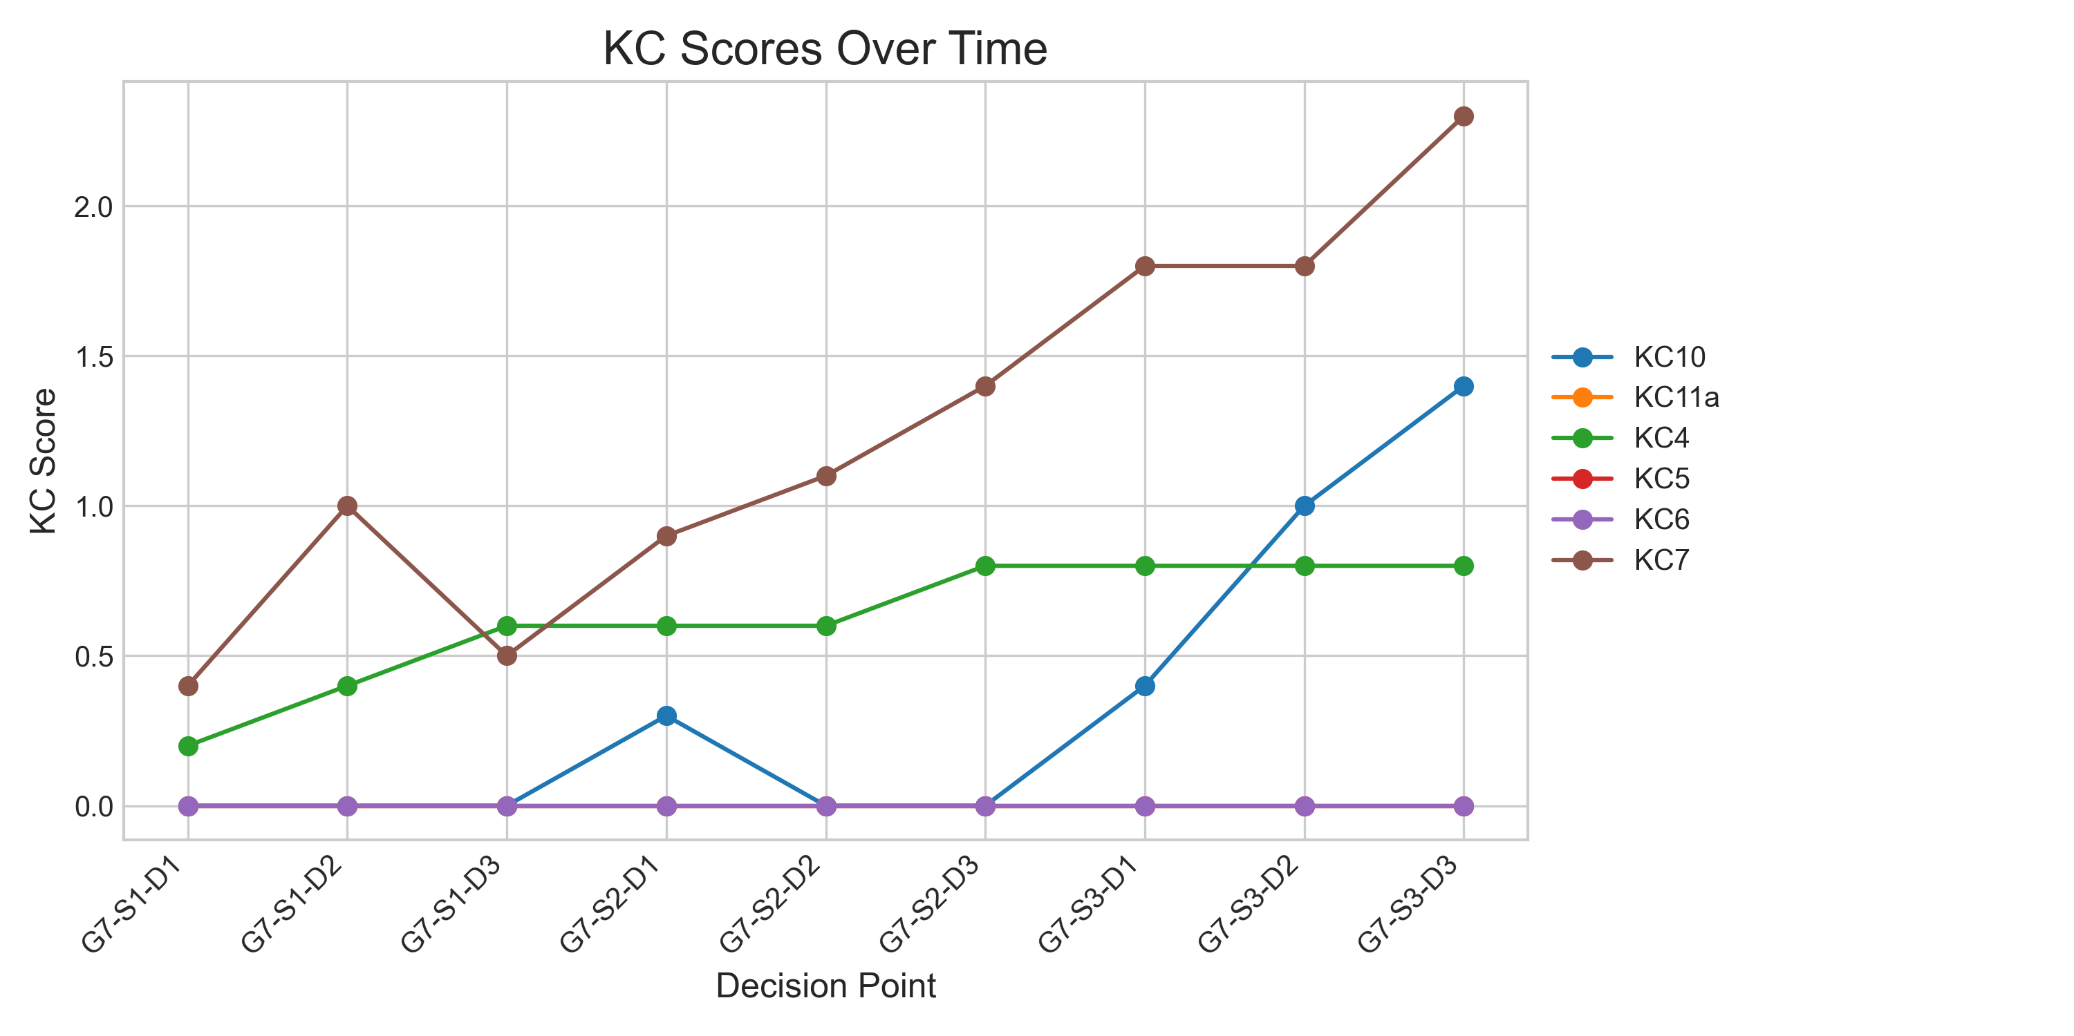

## Metric Values per Decision Point

|  |  |  |  |
| --- | --- | --- | --- |
| Decision Point | Customer Satisfaction | Reputation | Revenue |
| G7-S1-D1 | 2.6 | 0.11200000000000002 | 3450 |
| G7-S1-D2 | 6.5 | 0.28 | 8050 |
| G7-S1-D3 | 3.25 | 0.14 | 6325 |
| G7-S2-D1 | 7.8 | 0.336 | 10350 |
| G7-S2-D2 | 7.1499999999999995 | 0.308 | 9775 |
| G7-S2-D3 | 9.1 | 0.392 | 12650 |
| G7-S3-D1 | 14.299999999999999 | 0.616 | 17250 |
| G7-S3-D2 | 18.2 | 0.784 | 20700 |
| G7-S3-D3 | 24.05 | 1.036 | 25875 |

