Learner Report: BT13

Report generated on: 2025-07-07 22:28:38

# Final Cumulative Scores

## Final KC Scores

|  |  |
| --- | --- |
| Knowledge Component (KC) | Final Score |
| KC10 | 0.7 |
| KC11a | 0.0 |
| KC4 | 0.4 |
| KC5 | 0.0 |
| KC6 | 0.0 |
| KC7 | 1.1 |

## Final Metric Scores

|  |  |
| --- | --- |
| Metric | Final Value |
| Customer Satisfaction | 13.0 |
| Reputation | 0.56 |
| Revenue | 12650 |

# Performance Over Time

## KC Scores per Decision Point

|  |  |  |  |  |  |  |
| --- | --- | --- | --- | --- | --- | --- |
| Decision Point | KC10 | KC11a | KC4 | KC5 | KC6 | KC7 |
| G7-S1-D1 | -0.2 | 0.0 | 0.0 | 0.0 | 0.0 | 0.3 |
| G7-S1-D2 | 0.3 | 0.0 | 0.0 | 0.0 | 0.0 | 0.0 |
| G7-S1-D3 | 0.3 | 0.0 | -0.3 | 0.0 | 0.0 | 0.1 |
| G7-S2-D1 | 0.0 | 0.0 | -0.3 | 0.0 | 0.0 | 0.6 |
| G7-S2-D2 | -0.6 | 0.0 | -0.3 | 0.0 | 0.0 | 0.4 |
| G7-S2-D3 | -0.4 | 0.0 | 0.0 | 0.0 | 0.0 | 0.4 |
| G7-S3-D1 | -0.4 | 0.0 | 0.3 | 0.0 | 0.0 | 0.9 |
| G7-S3-D2 | 0.1 | 0.0 | 0.4 | 0.0 | 0.0 | 0.9 |
| G7-S3-D3 | 0.7 | 0.0 | 0.4 | 0.0 | 0.0 | 1.1 |

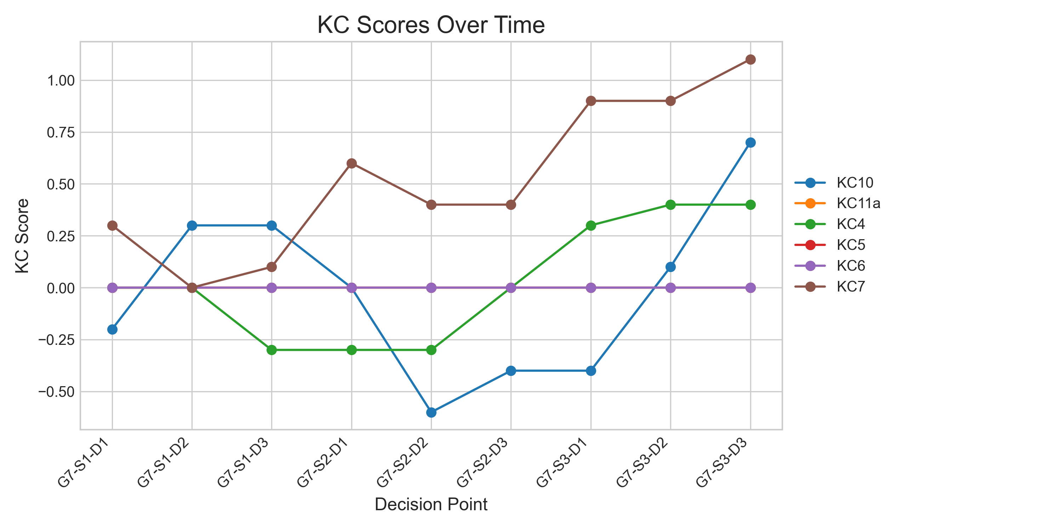

## Metric Values per Decision Point

|  |  |  |  |
| --- | --- | --- | --- |
| Decision Point | Customer Satisfaction | Reputation | Revenue |
| G7-S1-D1 | 0.6499999999999999 | 0.027999999999999997 | 575 |
| G7-S1-D2 | 1.95 | 0.084 | 1725 |
| G7-S1-D3 | 2.6 | 0.11200000000000002 | 575 |
| G7-S2-D1 | 3.8999999999999995 | 0.16799999999999998 | 1725 |
| G7-S2-D2 | 0.0 | 0.0 | -2875 |
| G7-S2-D3 | 1.3 | 0.05600000000000001 | 0 |
| G7-S3-D1 | 4.55 | 0.196 | 4600 |
| G7-S3-D2 | 7.8 | 0.336 | 8050 |
| G7-S3-D3 | 13.0 | 0.56 | 12650 |

