Learner Report: BT3+BT6

Report generated on: 2025-07-07 22:28:41

# Final Cumulative Scores

## Final KC Scores

|  |  |
| --- | --- |
| Knowledge Component (KC) | Final Score |
| KC10 | 2.1 |
| KC11a | 0.0 |
| KC4 | -0.5 |
| KC5 | 0.0 |
| KC6 | 0.0 |
| KC7 | 1.7 |

## Final Metric Scores

|  |  |
| --- | --- |
| Metric | Final Value |
| Customer Satisfaction | 24.7 |
| Reputation | 1.064 |
| Revenue | 18975 |

# Performance Over Time

## KC Scores per Decision Point

|  |  |  |  |  |  |  |
| --- | --- | --- | --- | --- | --- | --- |
| Decision Point | KC10 | KC11a | KC4 | KC5 | KC6 | KC7 |
| G7-S1-D1 | 0.5 | 0.0 | 0.0 | 0.0 | 0.0 | 0.5 |
| G7-S1-D2 | 1.0 | 0.0 | -0.3 | 0.0 | 0.0 | 0.5 |
| G7-S3-D1 | 1.4 | 0.0 | -0.3 | 0.0 | 0.0 | 1.1 |
| G7-S3-D2 | 1.8 | 0.0 | -0.3 | 0.0 | 0.0 | 1.7 |
| G7-S3-D3 | 2.1 | 0.0 | -0.5 | 0.0 | 0.0 | 1.7 |

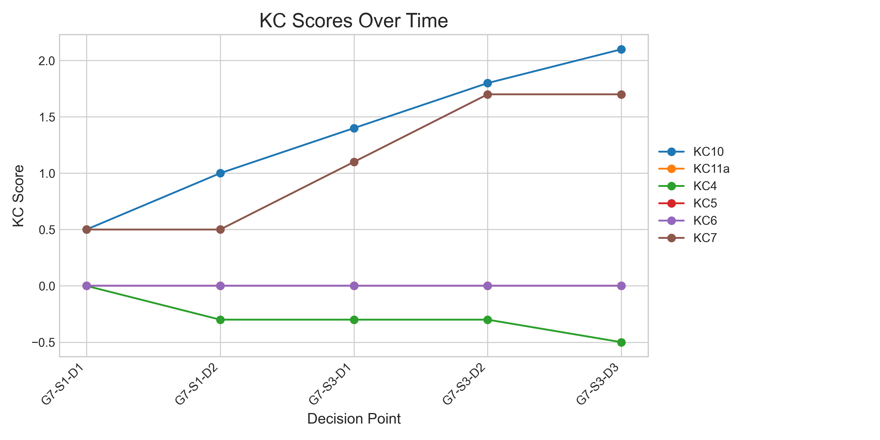

## Metric Values per Decision Point

|  |  |  |  |
| --- | --- | --- | --- |
| Decision Point | Customer Satisfaction | Reputation | Revenue |
| G7-S1-D1 | 6.5 | 0.28 | 5750 |
| G7-S1-D2 | 9.75 | 0.42000000000000004 | 6900 |
| G7-S3-D1 | 16.25 | 0.7000000000000001 | 12650 |
| G7-S3-D2 | 22.75 | 0.9800000000000001 | 18400 |
| G7-S3-D3 | 24.7 | 1.064 | 18975 |

