Learner Report: BT4

Report generated on: 2025-07-07 22:28:38

# Final Cumulative Scores

## Final KC Scores

|  |  |
| --- | --- |
| Knowledge Component (KC) | Final Score |
| KC10 | 0.0 |
| KC11a | 1.2 |
| KC4 | 0.0 |
| KC5 | 0.6 |
| KC6 | 1.0 |
| KC7 | 0.0 |

## Final Metric Scores

|  |  |
| --- | --- |
| Metric | Final Value |
| Customer Satisfaction | 11.700000000000003 |
| Reputation | 0.5040000000000002 |
| Revenue | 12650 |

# Performance Over Time

## KC Scores per Decision Point

|  |  |  |  |  |  |  |
| --- | --- | --- | --- | --- | --- | --- |
| Decision Point | KC10 | KC11a | KC4 | KC5 | KC6 | KC7 |
| G6-S1-D1 | 0.0 | 0.3 | 0.0 | 0.5 | 0.0 | 0.0 |
| G6-S1-D2 | 0.0 | 0.7 | 0.0 | 0.3 | 0.0 | 0.0 |
| G6-S1-D3 | 0.0 | 0.7 | 0.0 | 0.7 | 0.2 | 0.0 |
| G6-S2-D1 | 0.0 | 1.0 | 0.0 | 0.3 | 0.2 | 0.0 |
| G6-S2-D2 | 0.0 | 1.0 | 0.0 | 0.4 | 0.7 | 0.0 |
| G6-S2-D3 | 0.0 | 1.2 | 0.0 | 1.0 | 0.7 | 0.0 |
| G6-S3-D1 | 0.0 | 0.9 | 0.0 | 1.4 | 0.7 | 0.0 |
| G6-S3-D2 | 0.0 | 0.9 | 0.0 | 1.0 | 1.0 | 0.0 |
| G6-S3-D3 | 0.0 | 1.2 | 0.0 | 0.6 | 1.0 | 0.0 |

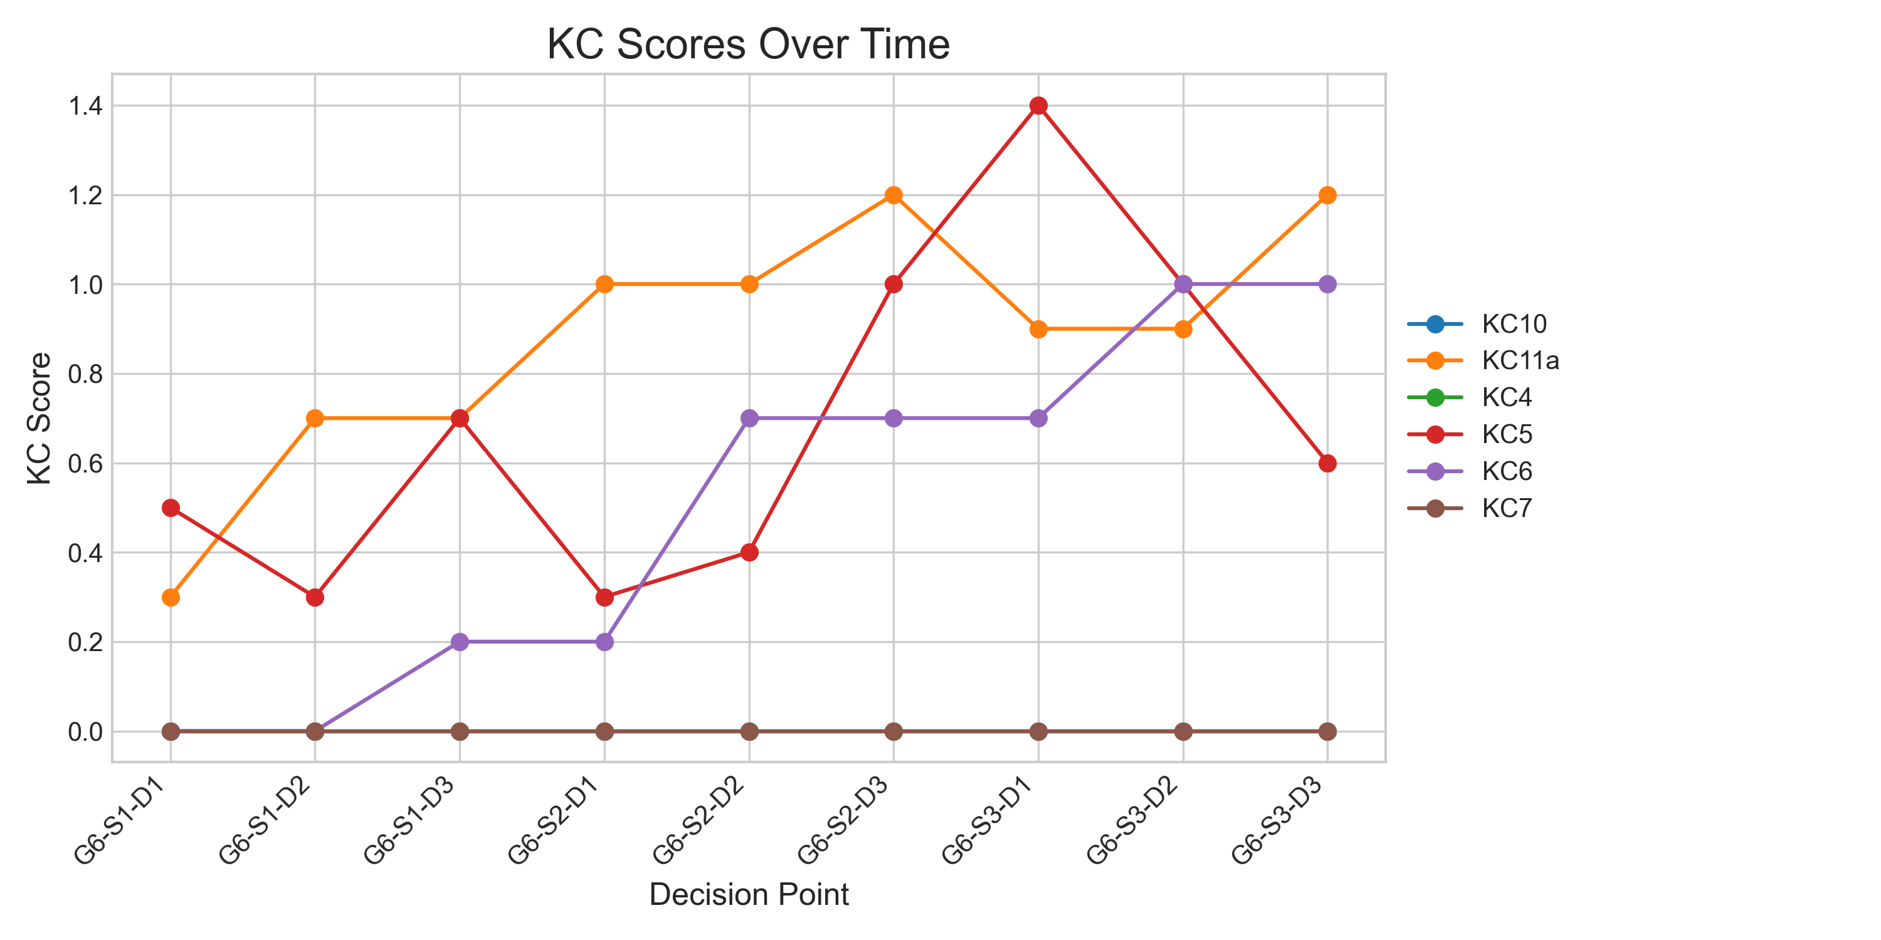

## Metric Values per Decision Point

|  |  |  |  |
| --- | --- | --- | --- |
| Decision Point | Customer Satisfaction | Reputation | Revenue |
| G6-S1-D1 | 5.2 | 0.22400000000000003 | 1725 |
| G6-S1-D2 | 6.500000000000001 | 0.2800000000000001 | 4025 |
| G6-S1-D3 | 9.100000000000001 | 0.3920000000000001 | 5175 |
| G6-S2-D1 | 8.450000000000001 | 0.3640000000000001 | 6900 |
| G6-S2-D2 | 9.100000000000001 | 0.3920000000000001 | 9775 |
| G6-S2-D3 | 14.300000000000002 | 0.6160000000000002 | 10925 |
| G6-S3-D1 | 14.950000000000003 | 0.6440000000000002 | 9200 |
| G6-S3-D2 | 12.350000000000003 | 0.5320000000000003 | 10925 |
| G6-S3-D3 | 11.700000000000003 | 0.5040000000000002 | 12650 |

