Learner Report: BT5

Report generated on: 2025-07-07 22:28:41

# Final Cumulative Scores

## Final KC Scores

|  |  |
| --- | --- |
| Knowledge Component (KC) | Final Score |
| KC10 | 0.5 |
| KC11a | 0.0 |
| KC4 | -0.8 |
| KC5 | 0.0 |
| KC6 | 0.0 |
| KC7 | 0.1 |

## Final Metric Scores

|  |  |
| --- | --- |
| Metric | Final Value |
| Customer Satisfaction | 3.8999999999999995 |
| Reputation | 0.16800000000000004 |
| Revenue | -1150 |

# Performance Over Time

## KC Scores per Decision Point

|  |  |  |  |  |  |  |
| --- | --- | --- | --- | --- | --- | --- |
| Decision Point | KC10 | KC11a | KC4 | KC5 | KC6 | KC7 |
| G7-S1-D1 | 0.4 | 0.0 | 0.0 | 0.0 | 0.0 | 0.3 |
| G7-S1-D2 | 0.8 | 0.0 | 0.0 | 0.0 | 0.0 | 0.0 |
| G7-S1-D3 | 0.6 | 0.0 | -0.3 | 0.0 | 0.0 | 0.0 |
| G7-S2-D1 | 1.1 | 0.0 | -0.3 | 0.0 | 0.0 | 0.3 |
| G7-S2-D2 | 0.5 | 0.0 | -0.3 | 0.0 | 0.0 | 0.5 |
| G7-S2-D3 | 1.1 | 0.0 | -0.3 | 0.0 | 0.0 | 0.3 |
| G7-S3-D1 | 1.1 | 0.0 | -0.5 | 0.0 | 0.0 | -0.2 |
| G7-S3-D2 | 0.9 | 0.0 | -0.8 | 0.0 | 0.0 | -0.2 |
| G7-S3-D3 | 0.5 | 0.0 | -0.8 | 0.0 | 0.0 | 0.1 |

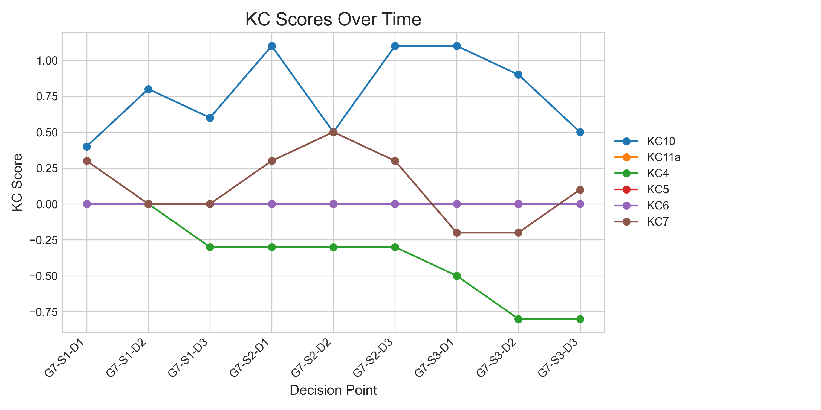

## Metric Values per Decision Point

|  |  |  |  |
| --- | --- | --- | --- |
| Decision Point | Customer Satisfaction | Reputation | Revenue |
| G7-S1-D1 | 4.55 | 0.196 | 4025 |
| G7-S1-D2 | 5.2 | 0.22400000000000003 | 4600 |
| G7-S1-D3 | 3.9000000000000004 | 0.16800000000000004 | 1725 |
| G7-S2-D1 | 9.100000000000001 | 0.39200000000000007 | 6325 |
| G7-S2-D2 | 6.500000000000001 | 0.2800000000000001 | 4025 |
| G7-S2-D3 | 9.1 | 0.39200000000000007 | 6325 |
| G7-S3-D1 | 5.85 | 0.25200000000000006 | 2300 |
| G7-S3-D2 | 4.55 | 0.19600000000000006 | -575 |
| G7-S3-D3 | 3.8999999999999995 | 0.16800000000000004 | -1150 |

