Learner Report: BT8BT9

Report generated on: 2025-07-07 22:28:35

# Final Cumulative Scores

## Final KC Scores

|  |  |
| --- | --- |
| Knowledge Component (KC) | Final Score |
| KC10 | 0.0 |
| KC11a | 1.7 |
| KC4 | 0.0 |
| KC5 | 1.8 |
| KC6 | 0.8 |
| KC7 | 0.0 |

## Final Metric Scores

|  |  |
| --- | --- |
| Metric | Final Value |
| Customer Satisfaction | 22.75 |
| Reputation | 0.9800000000000001 |
| Revenue | 14375 |

# Performance Over Time

## KC Scores per Decision Point

|  |  |  |  |  |  |  |
| --- | --- | --- | --- | --- | --- | --- |
| Decision Point | KC10 | KC11a | KC4 | KC5 | KC6 | KC7 |
| G6-S1-D1 | 0.0 | 0.3 | 0.0 | 0.6 | 0.0 | 0.0 |
| G6-S1-D2 | 0.0 | 0.5 | 0.0 | 0.9 | 0.0 | 0.0 |
| G6-S1-D3 | 0.0 | 0.5 | 0.0 | 1.5 | 0.2 | 0.0 |
| G6-S2-D1 | 0.0 | 1.0 | 0.0 | 1.7 | 0.2 | 0.0 |
| G6-S2-D2 | 0.0 | 0.8 | 0.0 | 1.7 | 0.7 | 0.0 |
| G6-S2-D3 | 0.0 | 0.4 | 0.0 | 1.7 | 1.3 | 0.0 |
| G6-S3-D1 | 0.0 | 0.7 | 0.0 | 2.3 | 1.3 | 0.0 |
| G6-S3-D2 | 0.0 | 1.2 | 0.0 | 1.8 | 1.3 | 0.0 |
| G6-S3-D3 | 0.0 | 1.7 | 0.0 | 1.8 | 0.8 | 0.0 |

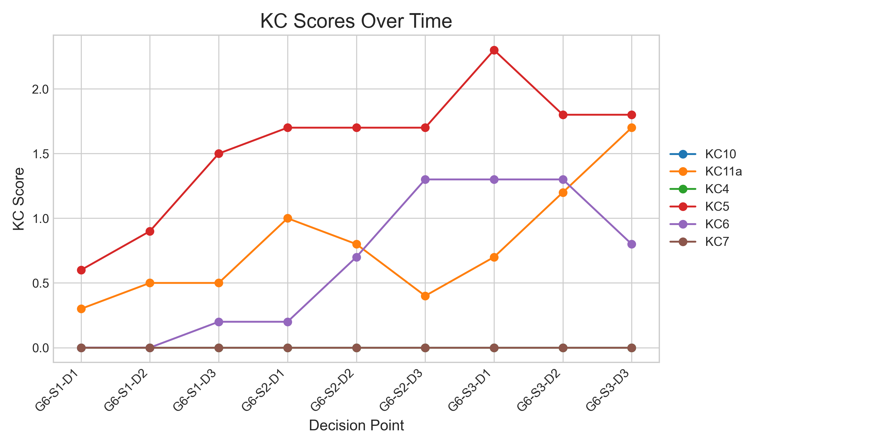

## Metric Values per Decision Point

|  |  |  |  |
| --- | --- | --- | --- |
| Decision Point | Customer Satisfaction | Reputation | Revenue |
| G6-S1-D1 | 5.85 | 0.252 | 1725 |
| G6-S1-D2 | 9.1 | 0.392 | 2875 |
| G6-S1-D3 | 13.0 | 0.56 | 4025 |
| G6-S2-D1 | 17.55 | 0.7560000000000001 | 6900 |
| G6-S2-D2 | 16.25 | 0.7000000000000001 | 8625 |
| G6-S2-D3 | 13.65 | 0.5880000000000001 | 9775 |
| G6-S3-D1 | 19.5 | 0.8400000000000001 | 11500 |
| G6-S3-D2 | 19.5 | 0.8400000000000001 | 14375 |
| G6-S3-D3 | 22.75 | 0.9800000000000001 | 14375 |

