AI Entrepreneurship Game: Learning Report

# Participant: P10

## 1. Executive Summary & Overall Performance

**Final Key Metrics (vs. Peers):**

* Reputation: 1.80 (Peer Min: 0.90, Avg: 2.35, Max: 3.45)
* Customer Satisfaction: 24.00 (Peer Min: 24.00, Avg: 37.00, Max: 48.00)
* Ethical Decision Making: 4.00 (Peer Min: 2.00, Avg: 3.67, Max: 4.00)
* Revenue: 6300.00 (Peer Min: 4950.00, Avg: 6840.00, Max: 9900.00)

**Key Strengths (Top KCs):**

* Calculate revenue, costs, and profit - Final Score: 7
* Recognize how trust and reputation grow business - Final Score: 6
* Differentiate fixed vs. variable costs - Final Score: 3

**Areas for Improvement (Lowest KCs):**

* Invest in employee training - Final Score: 2
* Apply pricing strategies - Final Score: 2
* Adapt services to match local needs - Final Score: 2

## 2. Decision & KC Impact Analysis

### Goal: Price with Purpose

Status: failed_needs_retry, Attempts: 3

|  |  |  |  |
| --- | --- | --- | --- |
| Decision # | KC Impacted | KC Score Change | Metric Change |
| 1 | Recognize how trust and reputation grow business | +0.83 | +1.67 Customer Satisfaction +0.12 Reputation |
| 1 | Invest in employee training | +0.00 | +0.00 Customer Satisfaction +0.00 Reputation +0.00 Ethical Decision Making |
| 1 | Calculate revenue, costs, and profit | +0.67 | +300.00 Revenue |
| 1 | Differentiate fixed vs. variable costs | +0.00 | +0.00 Revenue |
| 2 | Recognize how trust and reputation grow business | +0.83 | +1.67 Customer Satisfaction +0.12 Reputation |
| 2 | Invest in employee training | +0.00 | +0.00 Customer Satisfaction +0.00 Reputation +0.00 Ethical Decision Making |
| 2 | Calculate revenue, costs, and profit | +0.67 | +300.00 Revenue |
| 2 | Differentiate fixed vs. variable costs | +0.00 | +0.00 Revenue |
| 3 | Recognize how trust and reputation grow business | +0.83 | +1.67 Customer Satisfaction +0.12 Reputation |
| 3 | Invest in employee training | +0.00 | +0.00 Customer Satisfaction +0.00 Reputation +0.00 Ethical Decision Making |
| 3 | Calculate revenue, costs, and profit | +0.67 | +300.00 Revenue |
| 3 | Differentiate fixed vs. variable costs | +0.00 | +0.00 Revenue |
| 4 | Recognize how trust and reputation grow business | +0.83 | +1.67 Customer Satisfaction +0.12 Reputation |
| 4 | Invest in employee training | +0.00 | +0.00 Customer Satisfaction +0.00 Reputation +0.00 Ethical Decision Making |
| 4 | Calculate revenue, costs, and profit | +0.67 | +300.00 Revenue |
| 4 | Differentiate fixed vs. variable costs | +0.00 | +0.00 Revenue |
| 5 | Recognize how trust and reputation grow business | +0.83 | +1.67 Customer Satisfaction +0.12 Reputation |
| 5 | Invest in employee training | +0.00 | +0.00 Customer Satisfaction +0.00 Reputation +0.00 Ethical Decision Making |
| 5 | Calculate revenue, costs, and profit | +0.67 | +300.00 Revenue |
| 5 | Differentiate fixed vs. variable costs | +0.00 | +0.00 Revenue |
| 6 | Recognize how trust and reputation grow business | +0.83 | +1.67 Customer Satisfaction +0.12 Reputation |
| 6 | Invest in employee training | +0.00 | +0.00 Customer Satisfaction +0.00 Reputation +0.00 Ethical Decision Making |
| 6 | Calculate revenue, costs, and profit | +0.67 | +300.00 Revenue |
| 6 | Differentiate fixed vs. variable costs | +0.00 | +0.00 Revenue |
| 7 | Calculate revenue, costs, and profit | +2.00 | +900.00 Revenue |
| 7 | Differentiate fixed vs. variable costs | +1.00 | +450.00 Revenue |
| 8 | Differentiate fixed vs. variable costs | +2.00 | +900.00 Revenue |
| 8 | Calculate revenue, costs, and profit | +1.00 | +450.00 Revenue |
| 9 | Invest in employee training | +2.00 | +4.00 Customer Satisfaction +0.30 Reputation +4.00 Ethical Decision Making |
| 9 | Recognize how trust and reputation grow business | +1.00 | +2.00 Customer Satisfaction +0.15 Reputation |

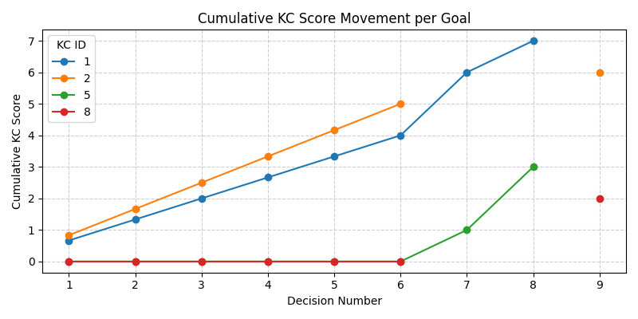

KC ID Legend:

|  |  |
| --- | --- |
| KC ID | KC Name |
| 2 | Recognize how trust and reputation grow business |
| 8 | Invest in employee training |
| 1 | Calculate revenue, costs, and profit |
| 5 | Differentiate fixed vs. variable costs |

## 3. Learning Performance Leaderboard

This ranks participants by their total cumulative score across all Knowledge Components.

|  |  |  |
| --- | --- | --- |
| Rank | Participant | Total KC Score |
| 1 | P4 | 27 |
| 2 | P5 | 26 |
| 3 | P9 | 25 |
| 4 | P3 | 25 |
| 5 | P6 | 23 |
| 6 | P7 | 23 |
| **7** | **P10** | **22** |
| 8 | P8 | 22 |
| 9 | P2 | 16 |
| 10 | P1 | 16 |