AI Entrepreneurship Game: Learning Report

# Participant: P2

## 1. Executive Summary & Overall Performance

**Final Key Metrics (vs. Peers):**

* Reputation: 1.65 (Peer Min: 0.90, Avg: 2.35, Max: 3.45)
* Customer Satisfaction: 28.00 (Peer Min: 24.00, Avg: 37.00, Max: 48.00)
* Revenue: 5400.00 (Peer Min: 4950.00, Avg: 6840.00, Max: 9900.00)
* Risk-Taking: 6.00 (Peer Min: 2.00, Avg: 6.00, Max: 12.00)

**Key Strengths (Top KCs):**

* Recognize how trust and reputation grow business - Final Score: 4
* Identify customer segment - Final Score: 4
* Solve problems creatively - Final Score: 3

**Areas for Improvement (Lowest KCs):**

* Differentiate fixed vs. variable costs - Final Score: 0
* Identify new customer segments - Final Score: 1
* Calculate revenue, costs, and profit - Final Score: 2

## 2. Decision & KC Impact Analysis

### Goal: Price with Purpose

Status: active, Attempts: 0

|  |  |  |  |
| --- | --- | --- | --- |
| Decision # | KC Impacted | KC Score Change | Metric Change |

### Goal: Break Even and Build Trust

Status: active, Attempts: 2

|  |  |  |  |
| --- | --- | --- | --- |
| Decision # | KC Impacted | KC Score Change | Metric Change |
| 1 | Recognize how trust and reputation grow business | +0.33 | +0.67 Customer Satisfaction +0.05 Reputation |
| 1 | Identify customer segment | +0.67 | +300.00 Revenue +1.33 Customer Satisfaction +0.10 Reputation |
| 1 | Solve problems creatively | +0.67 | +300.00 Revenue +1.33 Customer Satisfaction +1.33 Risk-Taking |
| 1 | Calculate revenue, costs, and profit | +0.00 | +0.00 Revenue |
| 1 | Apply pricing strategies | +0.33 | +150.00 Revenue +0.67 Customer Satisfaction +0.05 Reputation |
| 2 | Recognize how trust and reputation grow business | +0.33 | +0.67 Customer Satisfaction +0.05 Reputation |
| 2 | Identify customer segment | +0.67 | +300.00 Revenue +1.33 Customer Satisfaction +0.10 Reputation |
| 2 | Solve problems creatively | +0.67 | +300.00 Revenue +1.33 Customer Satisfaction +1.33 Risk-Taking |
| 2 | Calculate revenue, costs, and profit | +0.00 | +0.00 Revenue |
| 2 | Apply pricing strategies | +0.33 | +150.00 Revenue +0.67 Customer Satisfaction +0.05 Reputation |
| 3 | Recognize how trust and reputation grow business | +0.33 | +0.67 Customer Satisfaction +0.05 Reputation |
| 3 | Identify customer segment | +0.67 | +300.00 Revenue +1.33 Customer Satisfaction +0.10 Reputation |
| 3 | Solve problems creatively | +0.67 | +300.00 Revenue +1.33 Customer Satisfaction +1.33 Risk-Taking |
| 3 | Calculate revenue, costs, and profit | +0.00 | +0.00 Revenue |
| 3 | Apply pricing strategies | +0.33 | +150.00 Revenue +0.67 Customer Satisfaction +0.05 Reputation |
| 4 | Apply pricing strategies | +1.00 | +450.00 Revenue +2.00 Customer Satisfaction +0.15 Reputation |
| 4 | Calculate revenue, costs, and profit | +2.00 | +900.00 Revenue |
| 5 | Recognize how trust and reputation grow business | +2.00 | +4.00 Customer Satisfaction +0.30 Reputation |
| 5 | Solve problems creatively | +1.00 | +450.00 Revenue +2.00 Customer Satisfaction +2.00 Risk-Taking |
| 6 | Identify customer segment | +2.00 | +900.00 Revenue +4.00 Customer Satisfaction +0.30 Reputation |
| 6 | Recognize how trust and reputation grow business | +1.00 | +2.00 Customer Satisfaction +0.15 Reputation |

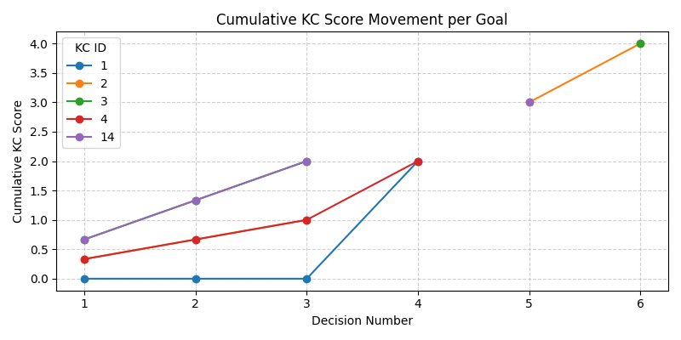

KC ID Legend:

|  |  |
| --- | --- |
| KC ID | KC Name |
| 2 | Recognize how trust and reputation grow business |
| 3 | Identify customer segment |
| 14 | Solve problems creatively |
| 1 | Calculate revenue, costs, and profit |
| 4 | Apply pricing strategies |

## 3. Learning Performance Leaderboard

This ranks participants by their total cumulative score across all Knowledge Components.

|  |  |  |
| --- | --- | --- |
| Rank | Participant | Total KC Score |
| 1 | P4 | 27 |
| 2 | P5 | 26 |
| 3 | P9 | 25 |
| 4 | P3 | 25 |
| 5 | P6 | 23 |
| 6 | P7 | 23 |
| 7 | P10 | 22 |
| 8 | P8 | 22 |
| **9** | **P2** | **16** |
| 10 | P1 | 16 |