AI Entrepreneurship Game: Learning Report

# Participant: P8

## 1. Executive Summary & Overall Performance

**Final Key Metrics (vs. Peers):**

* Risk-Taking: 2.00 (Peer Min: 2.00, Avg: 6.00, Max: 12.00)
* Customer Satisfaction: 36.00 (Peer Min: 24.00, Avg: 37.00, Max: 48.00)
* Revenue: 7200.00 (Peer Min: 4950.00, Avg: 6840.00, Max: 9900.00)
* Ethical Decision Making: 4.00 (Peer Min: 2.00, Avg: 3.67, Max: 4.00)
* Reputation: 2.40 (Peer Min: 0.90, Avg: 2.35, Max: 3.45)

**Key Strengths (Top KCs):**

* Adapt services to match local needs - Final Score: 6
* Calculate revenue, costs, and profit - Final Score: 4
* Recognize how trust and reputation grow business - Final Score: 4

**Areas for Improvement (Lowest KCs):**

* Solve problems creatively - Final Score: 1
* Balance workforce and demand - Final Score: 1
* Identify customer segment - Final Score: 1

## 2. Decision & KC Impact Analysis

### Goal: Price with Purpose

Status: failed_needs_retry, Attempts: 3

|  |  |  |  |
| --- | --- | --- | --- |
| Decision # | KC Impacted | KC Score Change | Metric Change |
| 1 | Solve problems creatively | +0.00 | +0.00 Revenue +0.00 Customer Satisfaction +0.00 Risk-Taking |
| 1 | Invest in employee training | +0.00 | +0.00 Customer Satisfaction +0.00 Reputation +0.00 Ethical Decision Making |
| 1 | Balance workforce and demand | +0.00 | +0.00 Revenue +0.00 Customer Satisfaction |
| 1 | Identify customer segment | +0.00 | +0.00 Revenue +0.00 Customer Satisfaction +0.00 Reputation |
| 1 | Calculate revenue, costs, and profit | +0.50 | +225.00 Revenue |
| 2 | Solve problems creatively | +0.00 | +0.00 Revenue +0.00 Customer Satisfaction +0.00 Risk-Taking |
| 2 | Invest in employee training | +0.00 | +0.00 Customer Satisfaction +0.00 Reputation +0.00 Ethical Decision Making |
| 2 | Balance workforce and demand | +0.00 | +0.00 Revenue +0.00 Customer Satisfaction |
| 2 | Identify customer segment | +0.00 | +0.00 Revenue +0.00 Customer Satisfaction +0.00 Reputation |
| 2 | Calculate revenue, costs, and profit | +0.50 | +225.00 Revenue |
| 3 | Solve problems creatively | +0.00 | +0.00 Revenue +0.00 Customer Satisfaction +0.00 Risk-Taking |
| 3 | Invest in employee training | +0.00 | +0.00 Customer Satisfaction +0.00 Reputation +0.00 Ethical Decision Making |
| 3 | Balance workforce and demand | +0.00 | +0.00 Revenue +0.00 Customer Satisfaction |
| 3 | Identify customer segment | +0.00 | +0.00 Revenue +0.00 Customer Satisfaction +0.00 Reputation |
| 3 | Calculate revenue, costs, and profit | +0.50 | +225.00 Revenue |
| 4 | Solve problems creatively | +0.00 | +0.00 Revenue +0.00 Customer Satisfaction +0.00 Risk-Taking |
| 4 | Invest in employee training | +0.00 | +0.00 Customer Satisfaction +0.00 Reputation +0.00 Ethical Decision Making |
| 4 | Balance workforce and demand | +0.00 | +0.00 Revenue +0.00 Customer Satisfaction |
| 4 | Identify customer segment | +0.00 | +0.00 Revenue +0.00 Customer Satisfaction +0.00 Reputation |
| 4 | Calculate revenue, costs, and profit | +0.50 | +225.00 Revenue |
| 5 | Solve problems creatively | +0.00 | +0.00 Revenue +0.00 Customer Satisfaction +0.00 Risk-Taking |
| 5 | Invest in employee training | +0.00 | +0.00 Customer Satisfaction +0.00 Reputation +0.00 Ethical Decision Making |
| 5 | Balance workforce and demand | +0.00 | +0.00 Revenue +0.00 Customer Satisfaction |
| 5 | Identify customer segment | +0.00 | +0.00 Revenue +0.00 Customer Satisfaction +0.00 Reputation |
| 5 | Calculate revenue, costs, and profit | +0.50 | +225.00 Revenue |
| 6 | Solve problems creatively | +0.00 | +0.00 Revenue +0.00 Customer Satisfaction +0.00 Risk-Taking |
| 6 | Invest in employee training | +0.00 | +0.00 Customer Satisfaction +0.00 Reputation +0.00 Ethical Decision Making |
| 6 | Balance workforce and demand | +0.00 | +0.00 Revenue +0.00 Customer Satisfaction |
| 6 | Identify customer segment | +0.00 | +0.00 Revenue +0.00 Customer Satisfaction +0.00 Reputation |
| 6 | Calculate revenue, costs, and profit | +0.50 | +225.00 Revenue |
| 7 | Calculate revenue, costs, and profit | +1.00 | +450.00 Revenue |
| 7 | Identify customer segment | +1.00 | +450.00 Revenue +2.00 Customer Satisfaction +0.15 Reputation |
| 8 | Balance workforce and demand | +1.00 | +450.00 Revenue +2.00 Customer Satisfaction |
| 8 | Invest in employee training | +1.00 | +2.00 Customer Satisfaction +0.15 Reputation +2.00 Ethical Decision Making |
| 9 | Invest in employee training | +1.00 | +2.00 Customer Satisfaction +0.15 Reputation +2.00 Ethical Decision Making |
| 9 | Solve problems creatively | +1.00 | +450.00 Revenue +2.00 Customer Satisfaction +2.00 Risk-Taking |

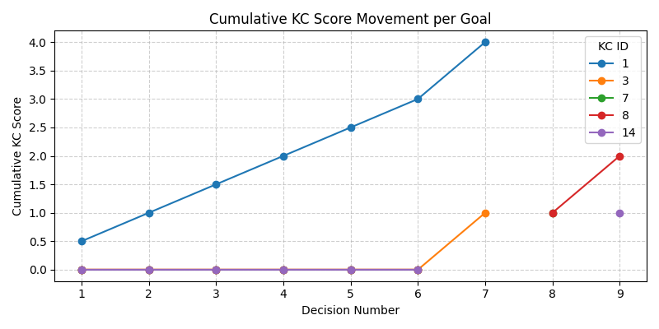

KC ID Legend:

|  |  |
| --- | --- |
| KC ID | KC Name |
| 14 | Solve problems creatively |
| 8 | Invest in employee training |
| 7 | Balance workforce and demand |
| 3 | Identify customer segment |
| 1 | Calculate revenue, costs, and profit |

## 3. Learning Performance Leaderboard

This ranks participants by their total cumulative score across all Knowledge Components.

|  |  |  |
| --- | --- | --- |
| Rank | Participant | Total KC Score |
| 1 | P4 | 27 |
| 2 | P5 | 26 |
| 3 | P9 | 25 |
| 4 | P3 | 25 |
| 5 | P6 | 23 |
| 6 | P7 | 23 |
| 7 | P10 | 22 |
| **8** | **P8** | **22** |
| 9 | P2 | 16 |
| 10 | P1 | 16 |