AI Entrepreneurship Game: Learning Report

# Participant: P5

## 1. Executive Summary & Overall Performance

**Final Key Metrics (vs. Peers):**

* Revenue: 4950.00 (Peer Min: 4950.00, Avg: 6840.00, Max: 9900.00)
* Reputation: 3.15 (Peer Min: 0.90, Avg: 2.35, Max: 3.45)
* Customer Satisfaction: 42.00 (Peer Min: 24.00, Avg: 37.00, Max: 48.00)
* Risk-Taking: 4.00 (Peer Min: 2.00, Avg: 6.00, Max: 12.00)
* Ethical Decision Making: 4.00 (Peer Min: 2.00, Avg: 3.67, Max: 4.00)

**Key Strengths (Top KCs):**

* Recognize how trust and reputation grow business - Final Score: 13
* Adapt services to match local needs - Final Score: 4
* Calculate revenue, costs, and profit - Final Score: 3

**Areas for Improvement (Lowest KCs):**

* Balance workforce and demand - Final Score: 0
* Apply pricing strategies - Final Score: 1
* Navigate ethical dilemmas - Final Score: 1

## 2. Decision & KC Impact Analysis

### Goal: Break Even and Build Trust

Status: failed_needs_retry, Attempts: 3

|  |  |  |  |
| --- | --- | --- | --- |
| Decision # | KC Impacted | KC Score Change | Metric Change |
| 1 | Calculate revenue, costs, and profit | +0.17 | +75.00 Revenue |
| 1 | Recognize how trust and reputation grow business | +1.50 | +3.00 Customer Satisfaction +0.22 Reputation |
| 1 | Adapt services to match local needs | +0.33 | +150.00 Revenue +0.67 Customer Satisfaction +0.05 Reputation |
| 2 | Calculate revenue, costs, and profit | +0.17 | +75.00 Revenue |
| 2 | Recognize how trust and reputation grow business | +1.50 | +3.00 Customer Satisfaction +0.22 Reputation |
| 2 | Adapt services to match local needs | +0.33 | +150.00 Revenue +0.67 Customer Satisfaction +0.05 Reputation |
| 3 | Calculate revenue, costs, and profit | +0.17 | +75.00 Revenue |
| 3 | Recognize how trust and reputation grow business | +1.50 | +3.00 Customer Satisfaction +0.22 Reputation |
| 3 | Adapt services to match local needs | +0.33 | +150.00 Revenue +0.67 Customer Satisfaction +0.05 Reputation |
| 4 | Calculate revenue, costs, and profit | +0.17 | +75.00 Revenue |
| 4 | Recognize how trust and reputation grow business | +1.50 | +3.00 Customer Satisfaction +0.22 Reputation |
| 4 | Adapt services to match local needs | +0.33 | +150.00 Revenue +0.67 Customer Satisfaction +0.05 Reputation |
| 5 | Calculate revenue, costs, and profit | +0.17 | +75.00 Revenue |
| 5 | Recognize how trust and reputation grow business | +1.50 | +3.00 Customer Satisfaction +0.22 Reputation |
| 5 | Adapt services to match local needs | +0.33 | +150.00 Revenue +0.67 Customer Satisfaction +0.05 Reputation |
| 6 | Calculate revenue, costs, and profit | +0.17 | +75.00 Revenue |
| 6 | Recognize how trust and reputation grow business | +1.50 | +3.00 Customer Satisfaction +0.22 Reputation |
| 6 | Adapt services to match local needs | +0.33 | +150.00 Revenue +0.67 Customer Satisfaction +0.05 Reputation |
| 7 | Calculate revenue, costs, and profit | +1.00 | +450.00 Revenue |
| 7 | Adapt services to match local needs | +1.00 | +450.00 Revenue +2.00 Customer Satisfaction +0.15 Reputation |
| 8 | Adapt services to match local needs | +1.00 | +450.00 Revenue +2.00 Customer Satisfaction +0.15 Reputation |
| 8 | Recognize how trust and reputation grow business | +2.00 | +4.00 Customer Satisfaction +0.30 Reputation |
| 9 | Recognize how trust and reputation grow business | +2.00 | +4.00 Customer Satisfaction +0.30 Reputation |
| 9 | Calculate revenue, costs, and profit | +1.00 | +450.00 Revenue |

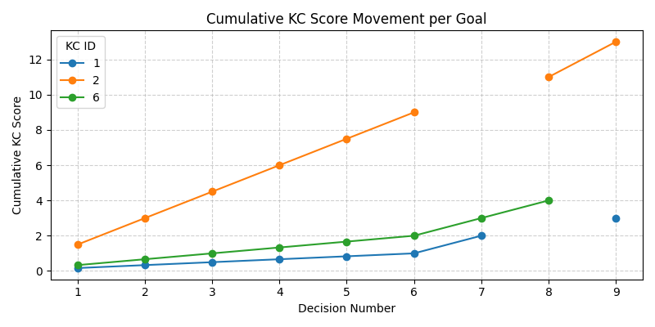

KC ID Legend:

|  |  |
| --- | --- |
| KC ID | KC Name |
| 1 | Calculate revenue, costs, and profit |
| 2 | Recognize how trust and reputation grow business |
| 6 | Adapt services to match local needs |

## 3. Learning Performance Leaderboard

This ranks participants by their total cumulative score across all Knowledge Components.

|  |  |  |
| --- | --- | --- |
| Rank | Participant | Total KC Score |
| 1 | P4 | 27 |
| **2** | **P5** | **26** |
| 3 | P9 | 25 |
| 4 | P3 | 25 |
| 5 | P6 | 23 |
| 6 | P7 | 23 |
| 7 | P10 | 22 |
| 8 | P8 | 22 |
| 9 | P2 | 16 |
| 10 | P1 | 16 |