Objectives

* Get emotions
  + How
    - Through the camera. 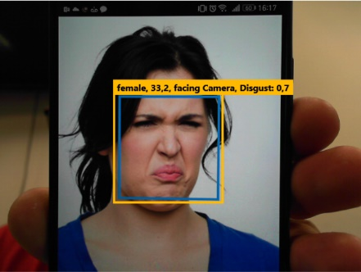

We need to gather information of emotions (**red** rectangle) and combine it with information of the person looking for camera (**green** rectangle).

With these two information, a new parameter must be created, "engaged". If the person is “looking at the camera” and is “happy”, it is "engaged".

Engaged will be the average of, "looking at the camera" + "happy".

Example.: Happiness (0.6) + Facing camera (0.9)/2 = engaged (0.7).

* Save data to the database.
  + We created a stand alone database for this
* We need to gather information from another database to cross-reference information.
  + We need this application to be able to connect to another database and bring some information.
* We need to create a table to store time information for classes. You may be able to use the "tbClass" table for this and add a field to the time of the class.
  + This information will be consulted from another database.
  + We will use this to calculate the student's frequency.
  + Example: A class will have 60 minutes, so that the student has confirmed presence in the room, it needs to be more than 75% of the time being detected by the camera.