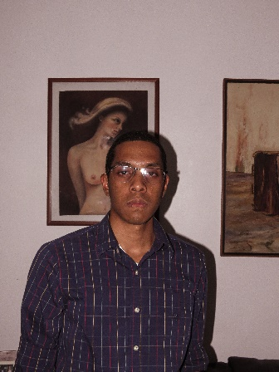

Eduardo Enrique Ugueto Segovia

Details

Los Ruices

Caracas, 1071

Venezuela, Bolivarian Republic

0412-6014662

[eduardoeus@gmail.com](mailto:eduardoeus@gmail.com)

NATIONALITY

Venezuelan

DATE OF BIRTH

29/08/2001

Languages

English: intermediate

Spanish: Native speaker

**Employment History**

Deputy manager, Inversiones Katango, C.A., Caracas

Since DECEMBER 2021

Responsible for executing administrative activities related to:

* Income ratio, working fund, petty cash.
* Execute physical inventory taking.
* Follow up assigned budgets, in order to orient it towards the achievement of results.

**Education**

**High School Graduate, Colegio Francia, Caracas.**

June 2019

Platzi.com

https://platzi.com/p/edueus01/

Currently studying web development, with basic and practical skills about HTML & CSS.

Learning the basics of JavaScript, and the practical knowledge.

**Courses**

**Basic HTML & CSS / platzi**

**Practical course of HTML & CSS.**

**Basic course of CSS Grid / platzi**

**CSS Grid Layout / platzi**

**Git & GitHub / platzi**

**Responsive Design: Mobile First / platzi**

**CSS Grid & Flexbox / platzi**