ALGET Framework Implementation Walkthrough
We have successfully implemented the mockup features requested for the "Foundation of Instructional Design" module. Here is a walkthrough of what has been accomplished.

1. Landing Page Redesign
- The landing page layout has been reimagined and restyled using modern, cohesive UI aesthetics inspired by the Stitch design system.
- The title has been formally changed to **Generative Intelligent Textbook**.
- Replaced the abstract UI placeholder with a highly-polished, animated custom SVG component (`<GenerativeIllustration />`) featuring a pulsating core, data lines, orbiting nodes, and floating documents.
- The "Skip for testing" logic was preserved and seamlessly integrated into the new layout without breaking existing workflows.
- The dashboard drop-downs were extended so that users can smoothly transition from the engineering mode to the new "Education Module" curriculum.

2. Interactive Annotation & "Stealth" AI Peers
Architectural Flow: Interactive Annotation & Stealth AI Peers
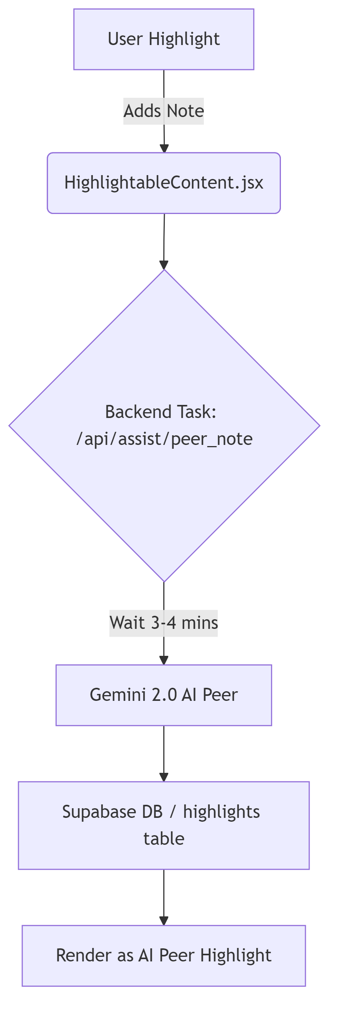
- **Highlight-to-Action Toolkit:** Wrapped the `ReadingPane` in a new `TextAnnotator` component, letting users select any passage of text to trigger an elegant floating action menu.
- **Direct Pipeline to Chat:** Selecting the "Ask AI" option inside the tooltip automatically pipes the highlighted text into the ALGET ChatBox on the right, removing friction.
- **Stealth Peer Annotation Mockup:** We’ve designed a mockup behavior via a delayed state transition inside `HighlightableContent.jsx`. Adding a note to a highlight triggers a background generation process that subtly populates an "AI Peer" response, providing constructive reflection precisely when the student attempts to interact.

3. Constructive Friction ("Explain First" Gate)
Architectural Flow: Socratic Gate
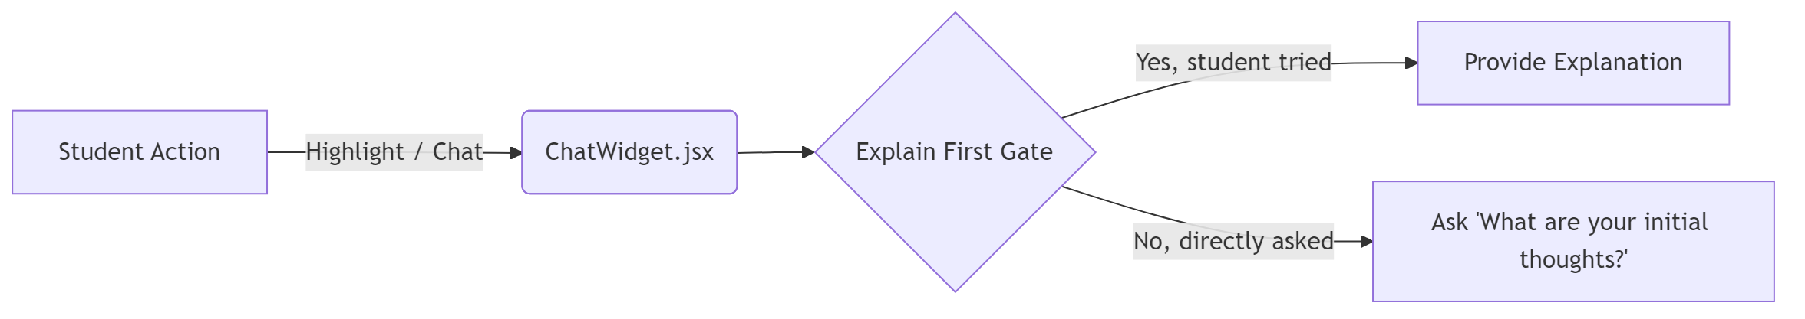
- Built a system to counteract the "Fluency Trap." The `ChatWidget.jsx` now listens for questions generated specifically via highlighting context.
- Rather than giving the student the direct answer immediately, the backend `OrchestratorAgent` intercepts the request and injects an interactive **Socratic Gate**. The agent responds with: *"That's a great passage to focus on! Before I break it down, I'd love to hear your initial thoughts."*
- This pushes learners to commit their understanding first prior to passively absorbing AI explanations.

4. Hallucination-Free Deep Personalization
- Configured a new custom component `<DynamicScenario />` which intercepts Markdown shortcodes mapping to core textbook locations perfectly.
- Integrated the `/api/generate_scenario` explicitly built to restrict LLM reasoning to strict application of a theory into practice (e.g., turning *Cognitivism* into an example of *corporate training design* upon request). This ensures core academic definitions remain pure (hard-coded in MDX files) while the applications remain maximally dynamic to student context.

5. Custom Diagnostic Assessment
- Added a dedicated question bank specifically designed for the Foundation of Instructional Design module to the Prerequisite Assessment system.
- Replaced the hardcoded legacy styling (maroon/red theme) with the cohesive modern ALGET indigo styling for UI components such as progress bars, option hovers, CTA buttons, and diagnostic level badges.

6. Research Behavior Logging
- Added precision latency tracking within the React layers (`latencyMs`) sent directly onto `loggingService.js` for "Highlight-to-Chat" duration recording.
- Implemented an `IntersectionObserver` directly inside `ReadingPane.jsx` to dynamically track which subsection title is nearest to the top of the viewport when an action is fired. This adds rich contextual metadata when analyzing at which points students required assistance.

7. Multi-Agent Content Generation Pipeline
- The curriculum for `inst-design` was dynamically expanded from a single module to multiple chapters.
- Generated a new Chapter ("The ADDIE Framework") comprising three robust sections using a simulated multi-agent validation strategy:
- **Persona 1 (Academic/Theorist):** Instructed the expansion to frame the ADDIE model clearly by emphasizing that Analysis encompasses more than learner background; it targets the core performance gaps.
- **Persona 2 (Student/UX Evaluator):** Interevened to ensure sections (like Development & Implementation) don't become text-walls by embedding interactive `<dynamic-scenario>` hooks logically placed throughout the content.
- **Persona 3 (Platform Integration):** Guaranteed all newly provisioned curriculum chunks properly generated valid `X.meta.json` files correctly linking the MDX payloads explicitly into the course TOC tree.
- These newly minted content files successfully compile inside the application enabling the user to natively navigate past Chapter 1 without encountering the "Section Not Found" wall.

8. Custom SVG Concept Diagrams
- Injected visually appealing, responsive SVG diagrams directly into the Markdown flow of the ID course to illustrate abstract concepts.
- Created a `<ConceptDiagrams />` component serving distinct, styled SVGs mapped to custom MDX tags (e.g., `<concept-diagram type="addie-model" />`).
- Covered key instructional design topics including foundational Learning Theories, Cognitive Load Theory, the ADDIE Model, Kirkpatrick's Evaluation Levels, and Agile ID.

9. Logging System Verification & Expansion
- Audited the core telemetry pipeline to ensure the newly introduced `inst-design` module is appropriately monitored.
- Confirmed that the `loggingService.js` and `supabase_logging.sql` schema (`section_id` configured as `TEXT` not bound by strict static tables) accept dynamic paths natively (e.g., `inst-design/01/01`).
- Interactions on the new SVG diagrams, dynamic scenarios, and highlighting will all be captured seamlessly in the existing research logs.

10. Interactive Formative Assessments
- Designed a highly polished, interactive `<InteractiveQuiz />` component wrapped in ALGET branding (indigo themes, clear success/failure states) that renders seamlessly within `.mdx` files.
- Injected these "Active Recall" checkpoints directly at the end of fundamental concepts in Chapter 1 (e.g., Constructivism, Schema Theory) and Chapter 2 (e.g., Design Phase, Evaluation Phase) to dramatically combat reading fatigue.

11. Hybrid Collaborative Annotation
- Upgraded `HighlightableContent.jsx` to render **both real user highlights and AI peer highlights** asynchronously.
- Integrated a new backend route `/api/assist/peer_note` utilizing Python `BackgroundTasks`. When a user leaves a note, the backend waits a random duration (3-4 mins) before invoking Gemini 2.0 to generate a contextual, peer-like response.
- **Durable AI Persistence:** To prevent "ghosting," these AI notes are instantly committed to the Supabase `highlights` table with a custom `ai_peer_system` user ID. This ensures the AI's contribution permanently bounds to the session context.
- Enhanced the UI to render these peer/AI highlights with distinct visual telemetry (green backgrounds vs. yellow for personal), displaying anonymous "Peer Note" or "AI Peer" tooltips on hover.

12. UX & Progress Tracking
- Bootstrapped a lightweight `useCourseProgress.js` hook managing a structured completion topology in `localStorage`.
- Updated the main Sidebar (`BookToc.jsx`) to visually inject emerald checkmarks (✓) dynamically when a student clears a section.
- Integrated "Estimated Time" (e.g., *⏱️ 10 min read*) in the top `ReadingPane.jsx` header if provided by the metadata.
- Implemented an elegant `[ Mark as Complete ]` sticky button to explicitly push users into actively indexing their cognitive closure per module block.
All requested MOOC gap items (#2, #3, #5) are fully integrated into the architecture!

13. Explicit Learning Objective Alignment
- Modified `ReadingPane.jsx` to parse and extract `learning_objectives` from the MDX `meta.json` files.
- Upgraded `KnowledgeCheck.jsx` to pass these objectives directly to the `/api/generate_assessment` backend endpoint.
- Adjusted the backend `AssessmentAgent`'s prompt in `assessment_agent.py` to explicitly map generated check questions against these precise learning outcomes.

14. Generative Formative Assessment
Architectural Flow: Multi-Dimensional Process Scoring
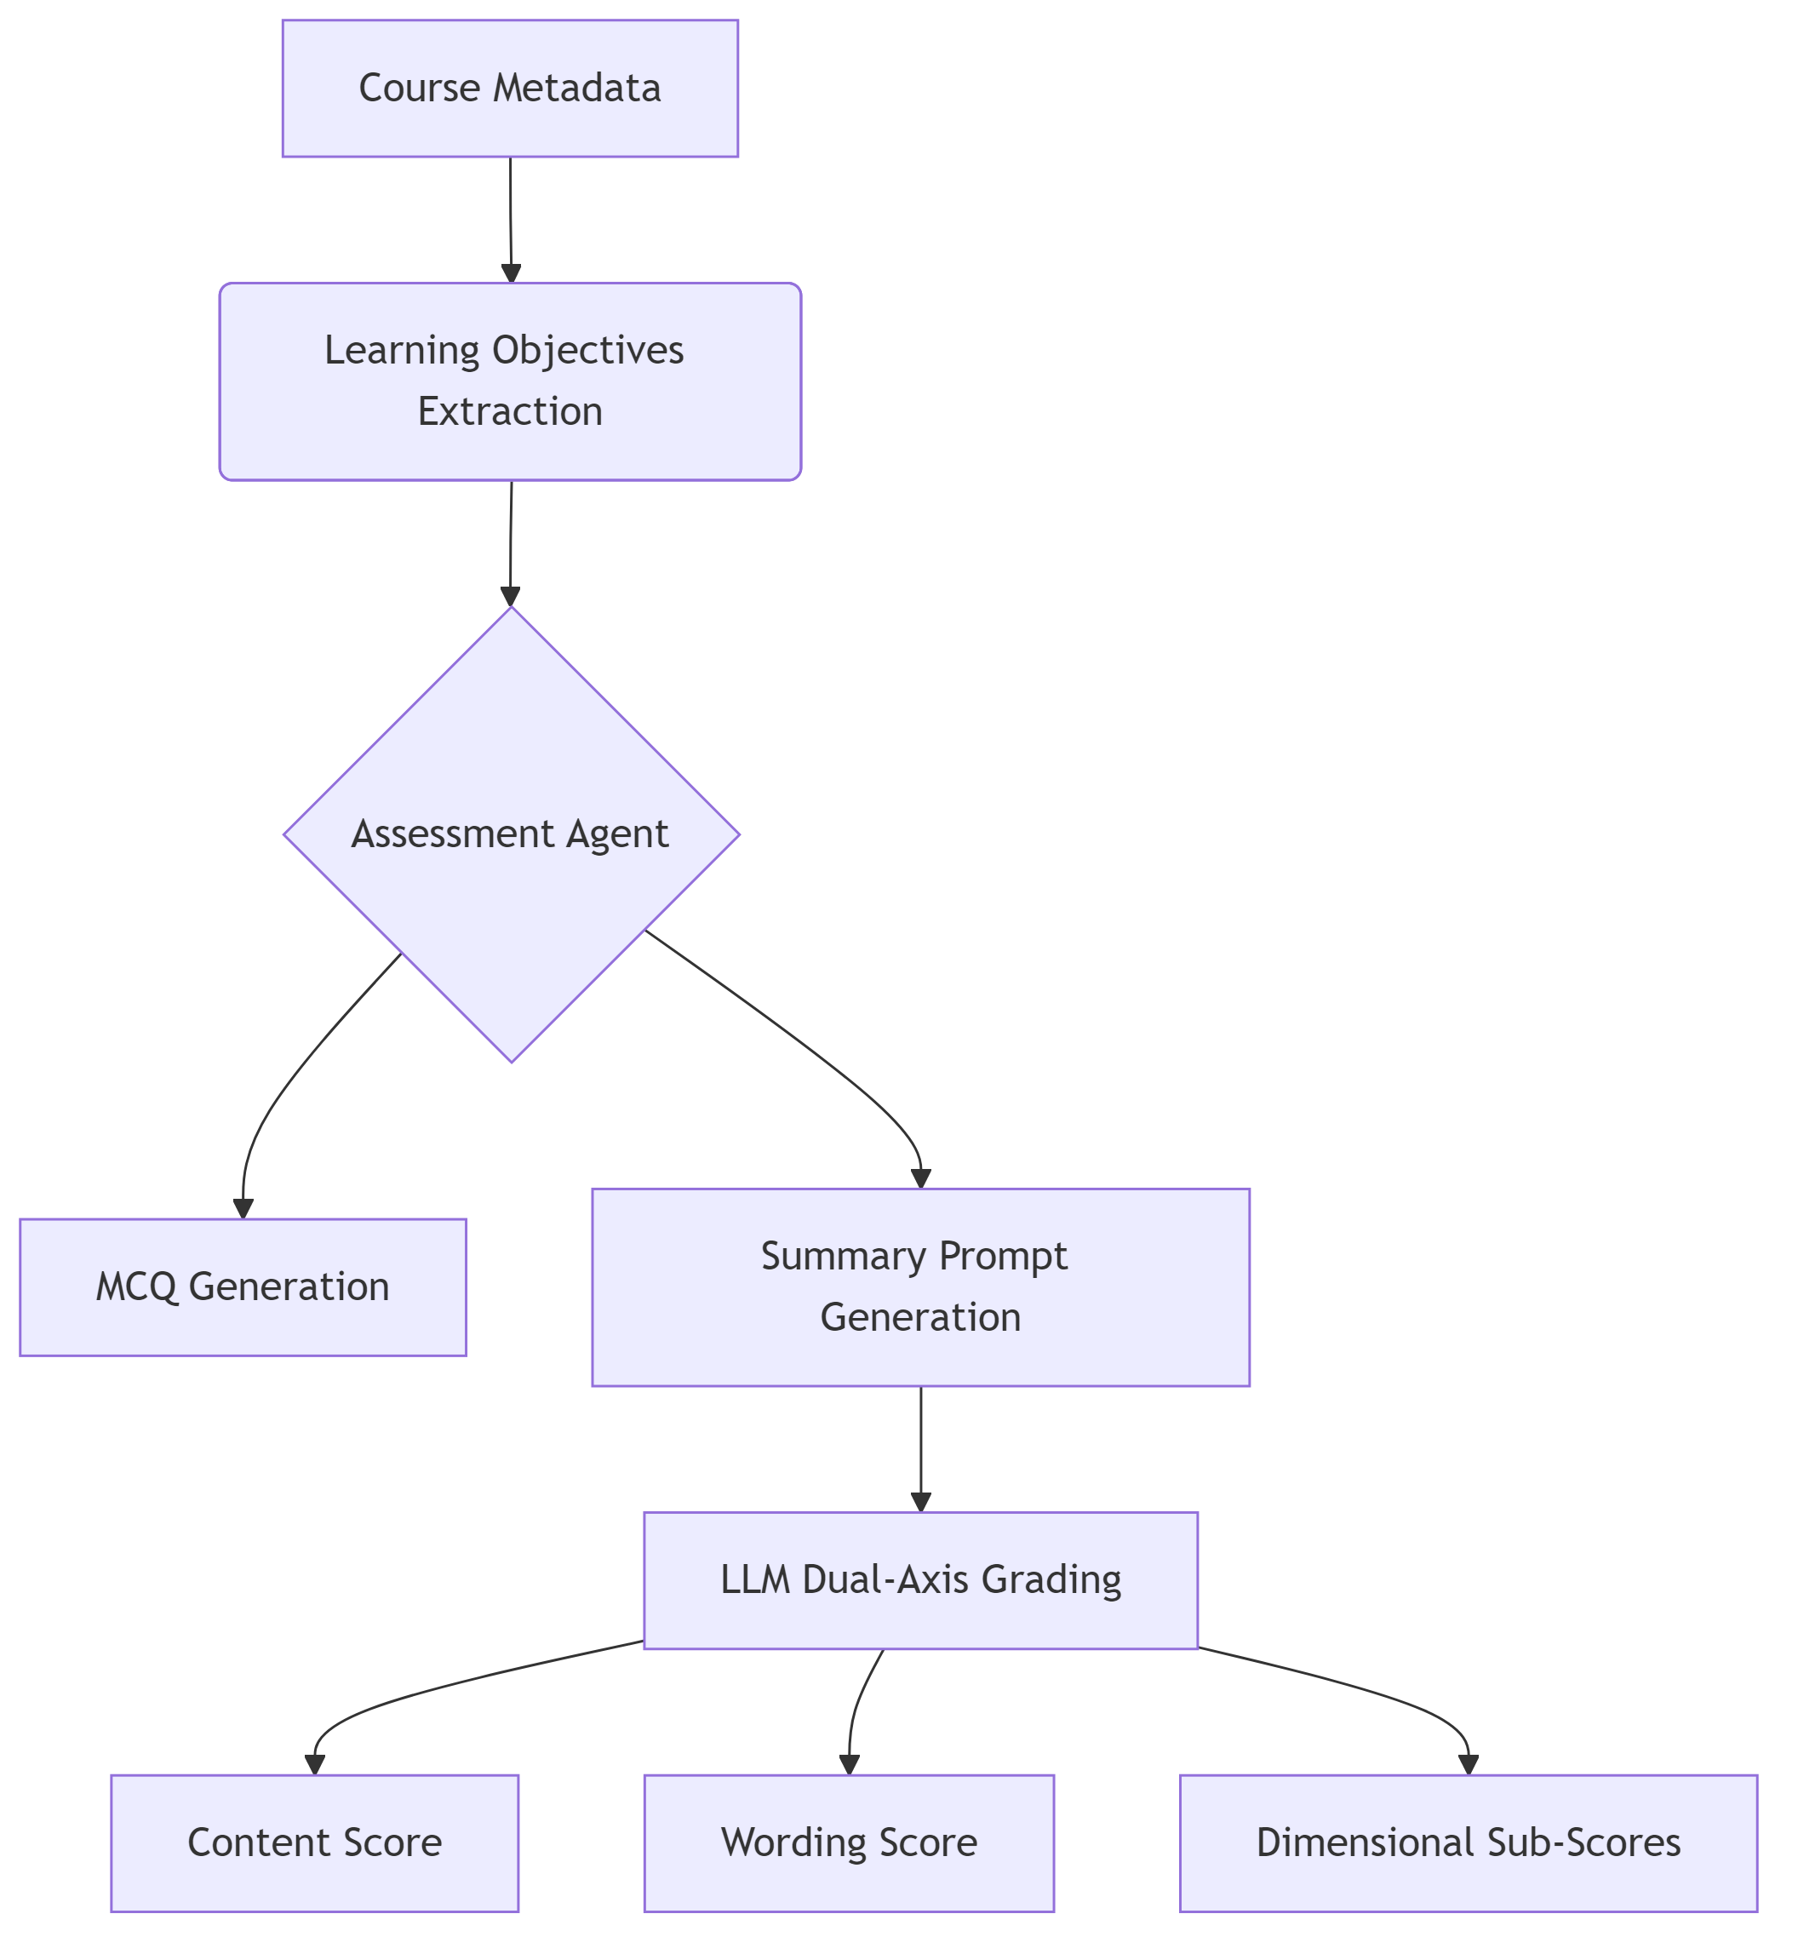
- Implemented an industry-standard LLM grading workflow utilizing a new `/api/grade_summary` backend endpoint.
- Updated `KnowledgeCheckForm` to dynamically generate a mix of Multiple Choice Questions (MCQ) and short-answer (Summary) prompts based on the learning objective rubric.
- Built a native short-answer interface into `KnowledgeCheck.jsx` which automatically calculates a passing threshold using dual-axis LLM metrics (Content Score & Wording Score) and provides constructive feedback.

15. Socratic Hinting (Constructive Friction)
Architectural Flow: Socratic Gate

- Refactored `PracticeBlock.jsx`'s hint logic to transition far away from simple tooltip reveals.
- Tapping 'Hint' now invokes a global `open-chat` window event which programmatically opens `<ChatWidget />` on the right side.

16. Database Upgrade for Advanced Psychometrics (ECD Phase 1)
Architectural Flow: Telemetry Fusion & BKT
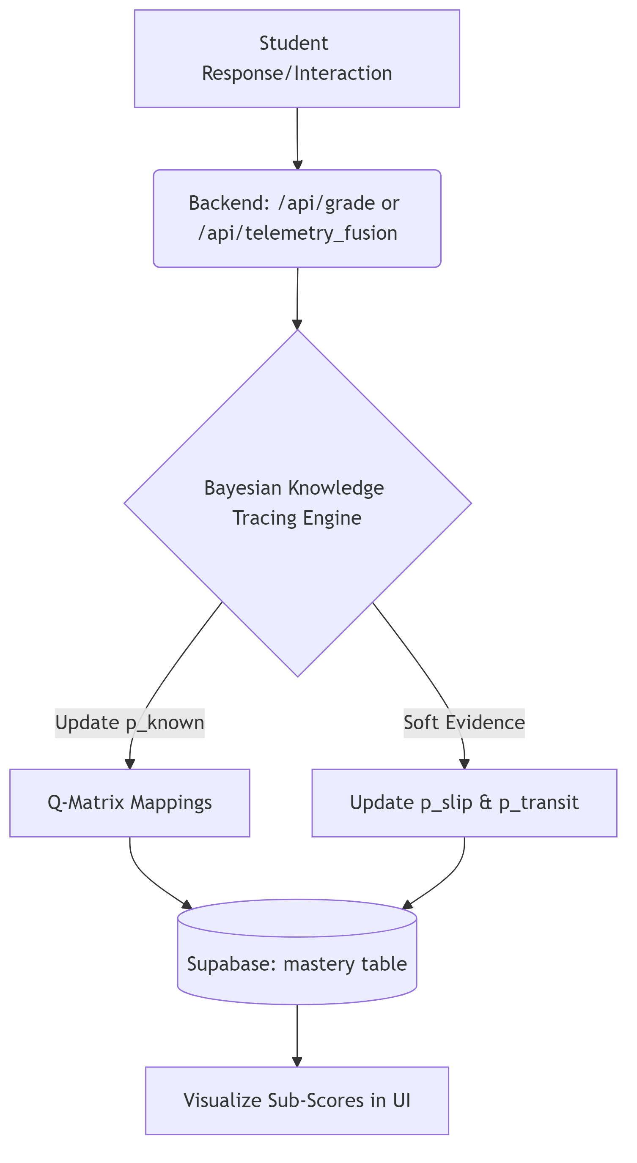
- Expanded native `supabase_schema.sql` `mastery` tables to implement Bayesian Knowledge Tracing (BKT) natively per concept.
- Added explicit psychometric probabilities for cognitive state tracking: `p_known` (mastery), `p_guess` (lucky guess), `p_slip` (careless mistake), and `p_transit` (probability of transitioning from not knowing to knowing).
- Introduced multidimensional `q_matrix` mappings within the `problems` table to allow advanced credit propagation where one complex problem measures several interrelated concepts simultaneously.

17. Python Bayesian Knowledge Tracing Engine (ECD Phase 2)
Architectural Flow: Telemetry Fusion & BKT

- Designed and integrated `knowledge_tracing.py` acting as ALGET’s central Math layer for the Student Model.
- BKT engine automatically utilizes the Q-Matrix to map multi-dimensional knowledge traces and adjust states proportionally based on weighted matrices.
- Hooked this mechanism into a new, dedicated `/api/grade` endpoint in `server.py` replacing naive moving average grading.

18. Telemetry Fusion (Soft-Evidence Integration) (ECD Phase 3)
- Shifted from single-axis outcome evaluation ("Did they get the question right?") into holistic behavioral evaluation.
- Added `/api/telemetry_fusion` endpoint to adjust underlying Bayesian priors based on raw telemetry variables (e.g. active manipulation of simulations vs passive reading vs extensive scaffolding hints).
- For instance, intensive hinting raises `p_slip` (assuring the AI they knew it but needed translation) and boosts `p_transit` indicating reflective progress.

19. LLM Parital Credit & Process Scoring (ECD Phase 4)
- Evolved the Assessment Agent LLM rubric from yielding a single binary string, to processing multiple granular structural evaluations.
- `SummaryGradingFeedback` schema modified to systematically inject multidimensional partial credit tracking map (`sub_scores`).
- By extracting detailed dimensions, the LLM allows our Bayesian model to recognize that a student can successfully apply the 'concept' mechanics while failing completely at the 'mathematical formulation', correctly crediting cognitive processes instead of only absolute outcomes.

