BEGINNER PLAY GUIDE
Virtual Makerspace
Quest 2/3 Setup, Screen Guide, Two-Person Collaboration, and Breadboard Activity
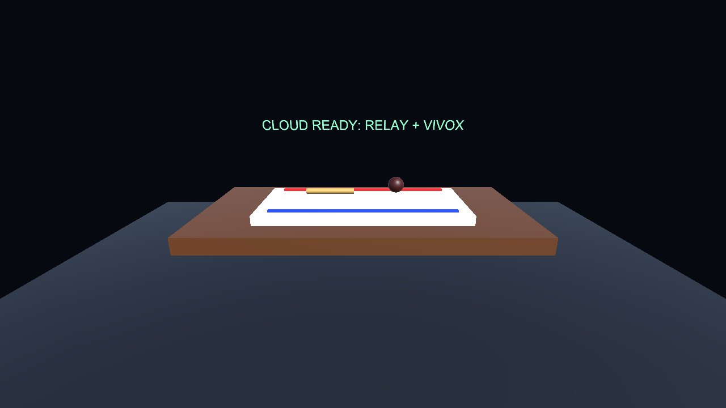
Current Build | Version 1.0.7 | July 23, 2026 | Oklahoma-Alabama Two-Person Pilot Guide

Read This First: Current Capabilities
Release Verification Version 1.0.7 passed 29/29 Unity regression tests and independent Host/Guest Session, Relay/Netcode, and Vivox tests. It also waits for Quest microphone permission before voice startup.

Learner Lobby English CREATE ROOM and JOIN ROOM controls, room-code entry, live participant status, and voice status are included. At 2/2 Connected, the lobby stops intercepting controller rays and displays ACTIVITY UNLOCKED.

This guide explains each visible screen and the action required at every step.

Before You Begin
- Two Meta Quest 2 or Quest 3 headsets with controllers
- A stable internet connection for both headsets
- Developer Mode enabled and initial USB debugging approved on each Quest
- The same VirtualMakerspace.apk installed on both headsets
- Earphones or separate rooms to reduce voice echo

For the Person Installing the App
1) Extract the complete student ZIP. 2) Connect the Quest by USB. 3) Approve USB debugging inside the headset. 4) Run INSTALL_TO_QUEST.cmd. The installer removes older copies, verifies version 1.0.7, and launches the app directly in immersive VR.
What to Tell First-Time Users Learners do not need the project folder or Unity Editor. Launch the installed app on Quest and allow microphone access.

Screen 1. Check the Workbench After Launch
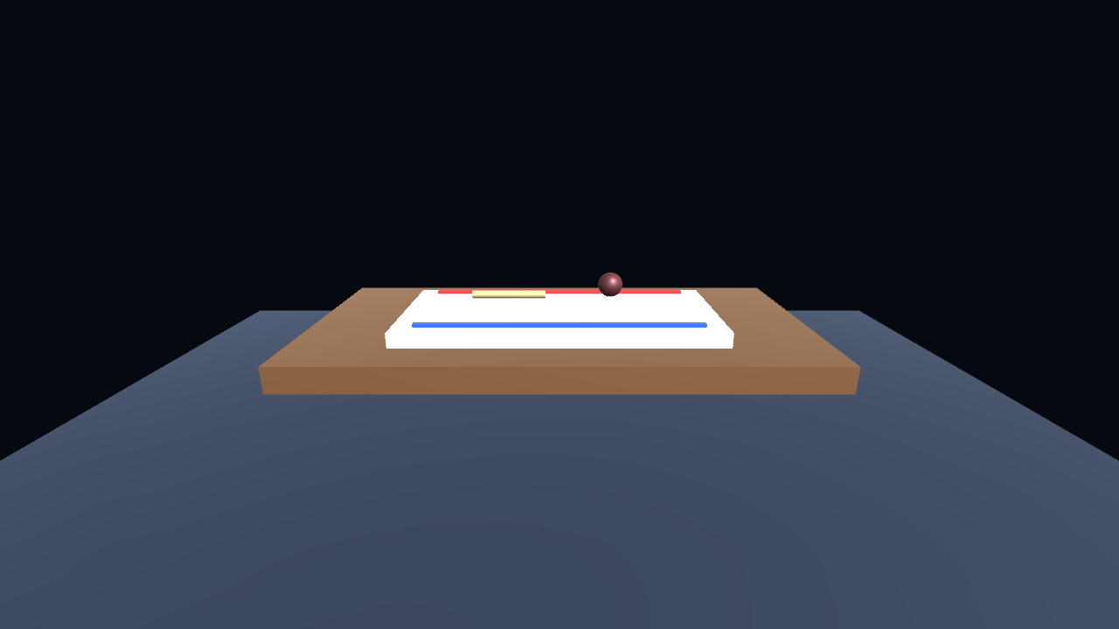
Screen example: Milestone2-Lobby-Relay-Voice.png
What You Should See | A dark workshop floor, brown workbench, white breadboard, red and blue power rails, a resistor, and an LED.
What You Should Do | Move your head slowly left and right and confirm that the view follows. Check that both controllers are connected.
Success Check | The workbench and breadboard remain stable in front of you, and the display does not freeze.
If Something Goes Wrong | If the screen is black, close and relaunch the app. If the breadboard is missing, face forward and reset the view.

Screen 2. Quest Controllers and Snap Sockets

Screen example: Milestone3-Quest-XR-Sockets-Handoff.png
What You Should See | The breadboard power rails and component area appear in front of you. This build includes Quest XR, eight snap sockets, and network handoff support.
What You Should Do | Point at the resistor or LED and press the Trigger button. Move the component near a glowing breadboard socket and release Trigger.
Success Check | The component follows your controller and can be placed at the designated socket.
If Something Goes Wrong | If a controller is not visible, check its battery and connection in Quest Quick Settings.

Screen 3. Beginner Tutorial
Screenshot Note This image is a workbench preview from the build containing the tutorial asset. The tutorial panel itself is not visible in this screenshot.

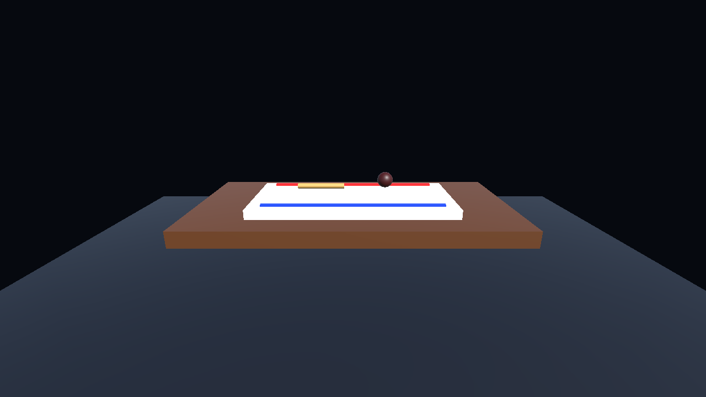
Screen example: Milestone4-Quest-OneClick-Tutorial.png
What You Should See | The screenshot centers on the workbench. The app contains an embedded tutorial video and step-by-step guidance.
What You Should Do | When the tutorial panel or Play button appears, start the video and follow each prompt. If the panel does not appear, tell the facilitator.
Success Check | The video plays, the next-step prompt appears, and the guidance advances after the requested button is pressed.
If Something Goes Wrong | If the video stops, relaunch the app. If there is no sound, check the Quest volume and mute settings.

Screen 4. Check Room, Relay, and Voice Status
Connection Requirement Do not begin until both headsets display the same room code, 2/2 CONNECTED, VOICE | MIC ON, and ACTIVITY UNLOCKED.


Screen example: Milestone5-Cloud-Relay-Vivox.png
What You Should See | The world-space lobby shows a ROOM code, connection state, participant count, voice state, and beginner guidance.
What You Should Do | Learner A selects CREATE ROOM. Learner B enters that exact code and selects JOIN ROOM. Allow microphone access on both Quest headsets.
Success Check | Both headsets show the same code, 2/2 CONNECTED, VOICE | MIC ON, and ACTIVITY UNLOCKED | USE TRIGGER TO GRAB PARTS.
If Something Goes Wrong | Check Wi-Fi and the room code. Rerun the clean installer if the app opens as a 2D panel. Send VirtualMakerspace_Device_Diagnostics.txt if startup still fails.

Screen 5. Collaborative Breadboard Activity


What Both Learners Should Do
Step | Role | Action
1 | Learner A | Pick up the resistor and place it between the designated sockets.
2 | Learner B | Check the LED long and short legs, then place it in the correct sockets.
3 | Both Learners | Explain the power-rail and component connections aloud, then verify each other's work.
CPS Goal Divide roles, explain the reasoning, and verify your partner's placement instead of completing the solution alone.

Final Checklist
- The same app version is installed on both Quest headsets.
- Internet access and microphone permission are enabled on both headsets.
- The workbench, breadboard, resistor, and LED are visible.
- Components can be picked up and placed with the controllers.
- Both headsets show the same ROOM code, 2/2 CONNECTED, VOICE | MIC ON, and ACTIVITY UNLOCKED.
- Use CREATE ROOM on the first headset and JOIN ROOM on the second headset. Begin only after both devices confirm the same room code and the activity unlock message.

Quick Troubleshooting
Problem | What to Do
USB connection is not detected | Approve the USB debugging prompt inside Quest, then reconnect the cable.
The microphone does not work | In Quest Settings > Apps > Permissions, allow microphone access for Virtual Makerspace.
The other person's voice echoes | Use earphones or connect from separate rooms.
The workbench is not in front of you | Use Reset View from the Quest menu.
CREATE/JOIN buttons are missing | Restart the updated app. The English lobby should appear automatically when the scene loads.
The app opens as a floating 2D panel | Discard older packages and run the version 1.0.7 INSTALL_TO_QUEST.cmd. It performs a clean install and uses the Quest VR launch category.
Player is already a member of the lobby | Version 1.0.7 cleans the stale membership and retries once. If it repeats, rerun the clean installer and send the diagnostics file.

Screen 6. Create or Join a Two-Person Room
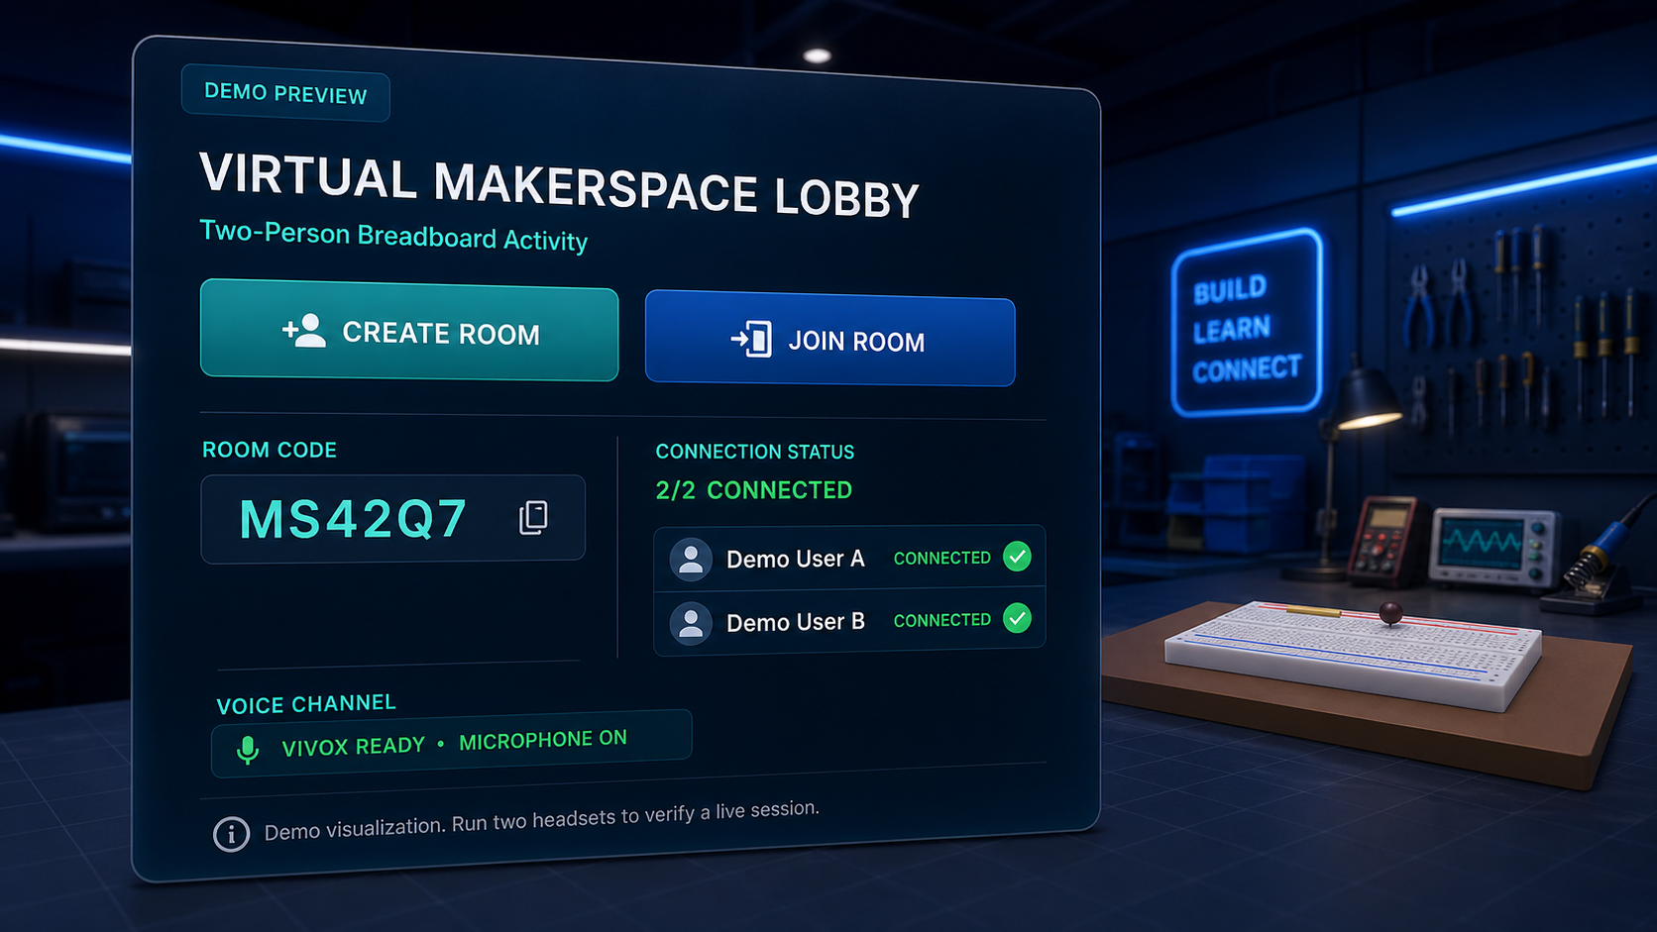
DEMO PREVIEW: This image demonstrates the completed English lobby layout. It is not evidence of a live Oklahoma-Alabama session.

What Both Learners Should Do
- 1. Demo User A selects CREATE ROOM and reads the displayed room code aloud.
- 2. Demo User B enters the same code and selects JOIN ROOM.
- 3. Both learners confirm that the same room code appears on both headsets.
- 4. Confirm 2/2 CONNECTED, VOICE | MIC ON, and ACTIVITY UNLOCKED | USE TRIGGER TO GRAB PARTS.
- 5. Use earphones or separate rooms if voice echo occurs.

Live Quest Verification Requirement
The automated two-process test has verified one Host and one Guest in the same Session, Relay/Netcode connection, and Vivox channel. After the physical test, run COLLECT_TEST_RESULTS.cmd on both headset computers and send both reports to the instructor.

