- Current
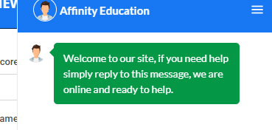
Expected
Need change in this message.
Ex : - Hello, Welcome to Affinity Education . How can we assist you?
Left and Right scroll bar is not visible
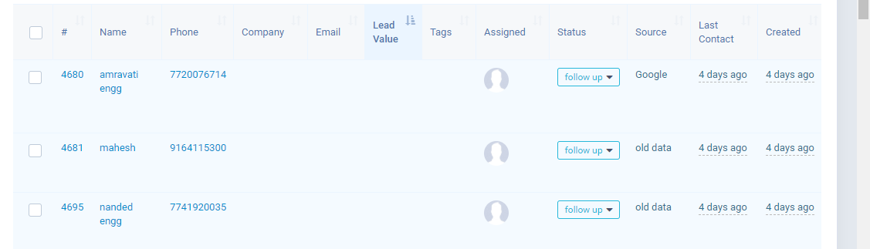
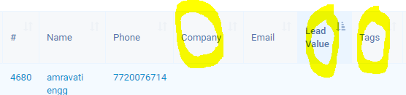
Tags - IELTS/MBBS ABROAD/ MD MS INDIA/ MBA INDIA/ BTECH INDIA
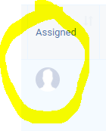

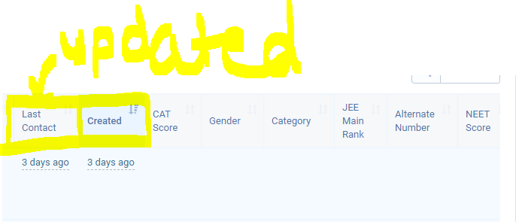
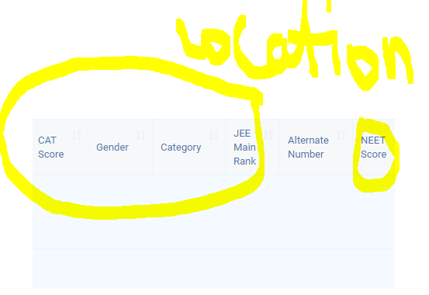
Remove Highlighted
Alternative no parents no
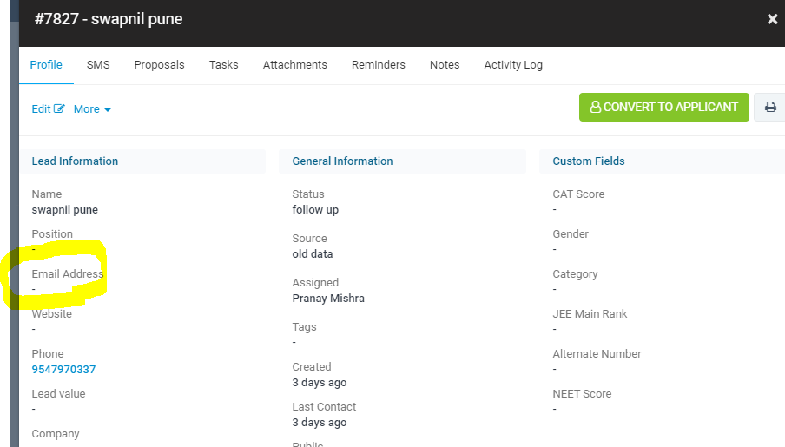

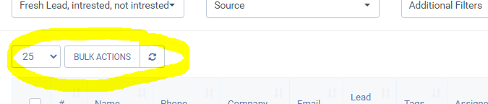
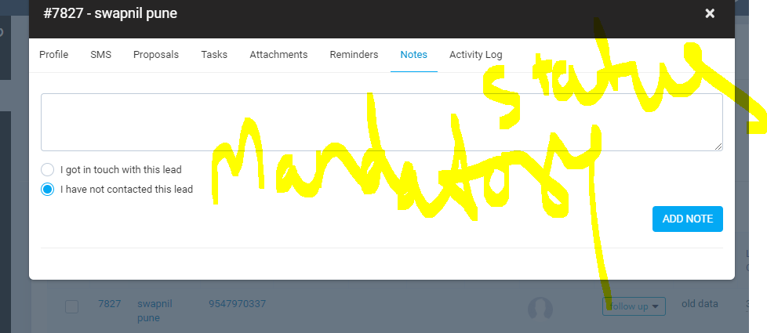
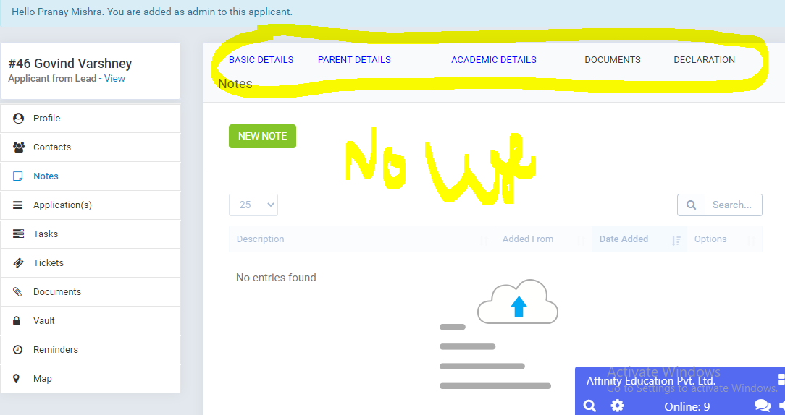
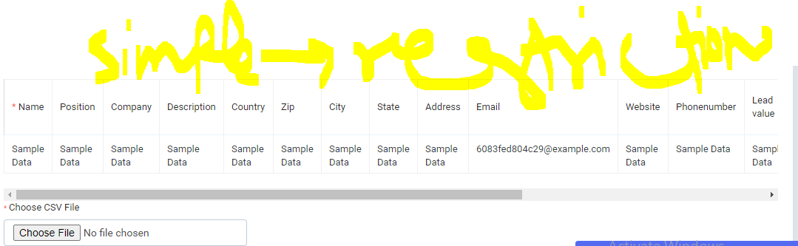
- Archival of previous month data based on status = not interested
- Monthly data viewership based on created on
- Total lead worked on a day counter based on notes update
